Pharmaceutical Benefits Advisory Committee
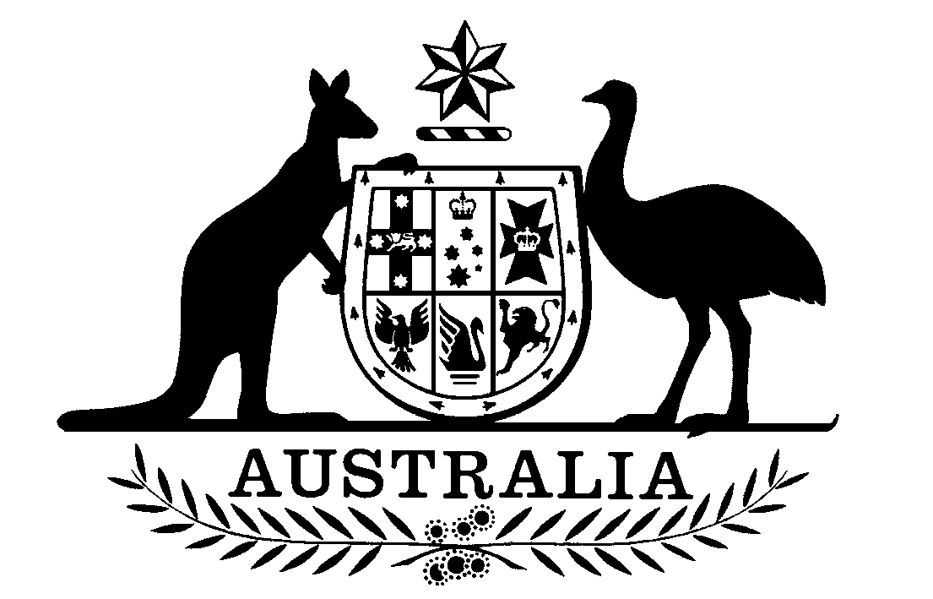

Telephone: (02) 6289 7099 Address all mail to:
Facsimile: (02) 6289 4175 THE SECRETARY
PBAC
GPO Box 9848
Canberra ACT 2601

DELETION OF PHARMACEUTICAL BENEFIT ITEM
EFFECTIVE 1 DECEMBER 2012

Following is the advice of the Pharmaceutical Benefits Advisory Committee concerning the deletion of an item from the declaration under subsection 85(2) of the National Health Act 1953, with effect from the above date.

Item | PBAC Advice
NEOMYCIN with BACITRACIN | The PBAC agreed to the deletion after noting that the sponsor advised that it is unable to source a reliable supply of the product and therefore must discontinue it.

Mariana Crank
Senior Pharmacist
22 November 2012

