Australian Government
Australian Transport Safety Bureau
Our reference: F2012LO2278ES
Contact:
15 April 2013
The Assistant Legislation Officer
Senate Table Office
Department of the Senate
Suite SG25
PARLIAMENT HOUSE
CANBERRA act 2600
Dear Madam/Sir
Transport Safety Investigation Amendment 2012 (No. 1) [Select Legislative Instrument 2012 No 263] [F201202278]
Please find attached two (2) copies of a revised Explanatory Statement (ES) for the above named instrument. The ES has been revised for the purposes of compliance with the Legislative Instruments Act 2003 to insert details of the consultation undertaken by the ATSB.
This material has also been provided to the Federal Register of Legislative Instruments (FRLI) for lodgement. I would be grateful if you could arrange for this material to be tabled on the next available day, which I understand is 14 May 2013.
Yours sincerely
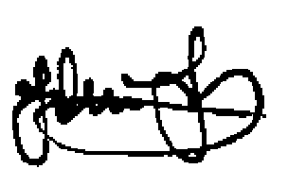
John Taylor
Principal Lawyer
ATSB Legal Services.

62 Northbourne Ave  Canberra ACT 2601  Australia | PO Box 967  Civic Square  ACT 2608 Australia | Telephone 02 6257 4150  24 hours 1800 020 616  Fax 02 62473117 | Web www.atsb.gov.au  Email atsbinfo@atsb.gov.au  Twitter @ATSBinfo
ABN 65 061 156 887

