EXPLANATORY STATEMENT
(Issued by Authority of the Minister for Sustainability, Environment, Water, Population and Communities)
Environment Protection and Biodiversity Conservation Act 1999
Environment Protection and Biodiversity Conservation (Commonwealth Marine Reserves) Proclamation 2012

Environment Protection and Biodiversity Conservation (Mermaid Reef Marine National Nature Reserve) Amendment Proclamation 2012 (No. 1)

Environment Protection and Biodiversity Conservation (Ningaloo Marine Park - Commonwealth Waters) Amendment Proclamation 2012 (No. 1)

Environment Protection and Biodiversity Conservation (Ashmore Reef National Nature Reserve) Amendment Proclamation 2012 (No. 1)

Environment Protection and Biodiversity Conservation (Cartier Island Marine Reserve) Amendment Proclamation 2012 (No. 1)

Subsection 344(1) of the Environment Protection and Biodiversity Conservation Act 1999 (the Act) provides that the Governor-General may, by Proclamation, declare as a Commonwealth reserve an area of land or sea, including an area of sea in a Commonwealth marine area (as defined in section 24 of the Act).
Subsection 346(1) of the Act provides that a Proclamation declaring an area to be a Commonwealth reserve must give the reserve a name, state the purposes for which the reserve is declared, state the depth of any land or seabed included in the reserve and assign the reserve to an International Union for Conservation of Nature (IUCN) category. In addition, subsection 346(2) of the Act allows a Proclamation to divide a reserve into zones and assign each zone to an IUCN category.
Subsection 350(1) of the Act provides that the Governor-General may revoke or amend such a Proclamation by another Proclamation.
Subsection 390J(5) of the Act provides for the Governor-General to make a Proclamation revoking or amending the Proclamation of a conservation zone established under the Act.
The purpose of the Proclamations is to:
- declare 40 areas of sea as Commonwealth reserves (a list of the reserves is at Attachment A along with zoning information and maps showing the locations of the reserves are at Attachments D-I);
- specify the purposes of the Commonwealth reserves as the protection and maintenance of biological diversity and to form part of the National Representative System of Marine Protected Areas;
- specify that the seabed to a depth of 1000 metres is to be included in each Commonwealth reserve;
- assign each Commonwealth reserve to an IUCN category;
- where applicable, divide the Commonwealth reserves into zones and assign IUCN categories to those zones;
- revoke the Proclamation of seven Commonwealth reserves as the area of each reserve is to be included in the area of another Commonwealth reserve (details are set out in Attachment B);
- revoke the Proclamation of the Coral Sea Conservation Zone as the area is to be included in the Coral Sea Commonwealth Marine Reserve; and
- amend the Proclamation of four Commonwealth reserves to change the name of the reserves to be consistent with the naming of the new reserves (detailed at Attachment C)

The reserves, apart from the Coral Sea Commonwealth Marine Reserve, are grouped into four networks of reserves as shown in Attachments D to I.
The Commonwealth reserves would contribute to the National Representative System of Marine Protected Areas (NRSMPA) in Australia’s marine jurisdiction. The primary goal of the NRSMPA is to establish and manage a comprehensive, adequate and representative system of marine protected areas to contribute to the long term ecological viability of marine and estuarine systems, to maintain ecological processes and systems, and to protect Australia’s biological diversity at all levels. Each of the reserves aims to contain and protect a representative sample of the marine ecosystems of its associated bioregion.
The Proclamation declares the area of the Coral Sea Conservation Zone as a Commonwealth Marine Reserve. The Conservation Zone was declared by Proclamation under subsection 390D(1) of the Act and took effect on 26 May 2009. Subsection 390J(3) of the Act provides that an area ceases to be a conservation zone if the area becomes, or is included in, a Commonwealth reserve. However, subsection 390J(5) requires that the Governor-General must make a Proclamation revoking or amending the Proclamation of the conservation zone, to reflect the fact that the area is no longer part of the conservation zone. The area was declared a Conservation Zone as an interim measure while the area was being assessed for possible inclusion into a marine reserve.

Subsection 351(1) of the Act requires the Minister to consider a report from the Director of National Parks (the Director) on a Commonwealth reserve proposal before the Governor-General makes a Proclamation to declare a reserve, or a Proclamation to revoke or amend a Proclamation. Under section 351(2)(b), the Director must consider any comments made in response to the invitation for public comment and must include the comments and the Director’s views on them in the report to the Minister. Section 351(5) provides for a period of at least 60 days after the notice is published for public comments to be made.
The Commonwealth reserves that have been revoked (at Attachment B) were either declared by a Proclamation made under the Act or by subsection 7(2) of the former National Parks and Wildlife Conservation Act 1975. These Proclamations continued in force under the Act, as if made under section 344 of the Act, by item 3 of Part 2 of Schedule 4 to the Environmental Reform (Consequential Provisions) Act 1999.

The requirements for the Proclamation revoking a Commonwealth reserve, including tabling the motion in Parliament for at least 15 days, do not apply to a Proclamation that results in land, sea or seabed ceasing to be included in one Commonwealth reserve or zone and being included in another Commonwealth reserve or zone (subsection 350(3) of the Act). The area covered by each of the Commonwealth Marine Reserves revoked has been wholly included in a Commonwealth Marine Reserve.

A notice inviting comment on the proposed Proclamations was published in the Gazette on 11 July 2012 in accordance with Subsection 351(2) of the Act. A notice was also published in the Norfolk Island Government Gazette on the same day in accordance with regulation 16.02 of the Environment Protection and Biodiversity Conservation Regulations 2000. A report prepared by the Director, including comments received in response to the notices and the Director’s views on the comments, has been considered by the Minister.
The Proclamations will not affect the exercise of any native title rights in accordance with the Native Title Act 1993 that may exist within the areas of the reserves.
The Proclamations are a legislative instrument for the purposes of the Legislative Instruments Act 2003.
The Proclamations commenced the day after registration on the Federal Register of Legislative Instruments.

Attachment A

ZONING SPECIFIC DETAILS FOR RESERVES IN THE FIVE PLANNING -REGIONS

For ease of reference the 40 new Commonwealth Marine Reserves are grouped into regional networks as follows:

South-west Network of Commonwealth Marine Reserves
- Southern Kangaroo Island Commonwealth Marine Reserve
- Western Kangaroo Island Commonwealth Marine Reserve
- Western Eyre Commonwealth Marine Reserve
- Murat Commonwealth Marine Reserve
- Great Australian Bight Commonwealth Marine Reserve
- Twilight Commonwealth Marine Reserve
- Eastern Recherche Commonwealth Marine Reserve
- South-west Corner Commonwealth Marine Reserve
- Bremer Commonwealth Marine Reserve
- Geographe Commonwealth Marine Reserve
- Perth Canyon Commonwealth Marine Reserve
- Two Rocks Commonwealth Marine Reserve
- Jurien Commonwealth Marine Reserve
- Abrolhos Commonwealth Marine Reserve
North-west Network of Commonwealth Marine Reserves*
- Shark Bay Commonwealth Marine Reserve
- Carnarvon Canyon Commonwealth Marine Reserve
- Gascoyne Commonwealth Marine Reserve
- Montebello Commonwealth Marine Reserve
- Dampier Commonwealth Marine Reserve
- Eighty Mile Beach Commonwealth Marine Reserve
- Roebuck Commonwealth Marine Reserve
- Argo-Rowley Terrace Commonwealth Marine Reserve
- Kimberley Commonwealth Marine Reserve
North Network of Commonwealth Marine Reserves
- Joseph Bonaparte Gulf Commonwealth Marine Reserve
- Oceanic Shoals Commonwealth Marine Reserve
- Arafura Commonwealth Marine Reserve
- Arnhem Commonwealth Marine Reserve
- Wessel Commonwealth Marine Reserve
- Limmen Commonwealth Marine Reserve
- Gulf of Carpentaria Commonwealth Marine Reserve
- West Cape York Commonwealth Marine Reserve
Coral Sea Commonwealth Marine Reserve
- Coral Sea Commonwealth Marine Reserve
Temperate East Network of Commonwealth Marine Reserves
- Gifford Commonwealth Marine Reserve
- Norfolk Commonwealth Marine Reserve
- Lord Howe Commonwealth Marine Reserve
- Central Eastern Commonwealth Marine Reserve
- Solitary Islands Commonwealth Marine Reserve
- Cod Grounds Commonwealth Marine Reserve
- Hunter Commonwealth Marine Reserve
- Jervis Commonwealth Marine Reserve

* Note: the North-west Network of Commonwealth Marine Reserves includes four existing reserves, detailed in Attachment C.

- South-west Network of Commonwealth Marine Reserves
The reserves in the South-west Network of Commonwealth Marine Reserves, and any zones within them, are intended to be managed and used for the purposes of biodiversity conservation and the conduct of activities consistent with the International Union for Conservation of Nature (IUCN) category to which the area is assigned by the Proclamation and the relevant Australian IUCN reserve management principles prescribed by the Environment Protection and Biodiversity Conservation Regulations 2000 (Schedule 8) as follows:-
- Marine national park zone – IUCN category national park (IUCN II). To be protected and managed to preserve its natural condition. Intended to provide a high level of protection for the ecosystems, habitats and biodiversity within the area. Activities involving the taking or harvesting of either living or non-living resources are intended to be prohibited.
- Habitat protection zone – IUCN category habitat/species management area (IUCN IV). To be managed to ensure maintenance of the habitat conditions necessary to protect significant species, groups of species, biotic communities or physical features of the environment. Intended to provide a heightened level of protection to ensure the maintenance of habitats, particularly habitats of the seafloor. Recreational fishing, other recreational uses, charter fishing, tourism and aquaculture are intended to be allowed. Some forms of commercial fishing are intended to be allowed, but not those using the following gear types: demersal trawl, demersal gillnet, demersal longline, crab and octopus traps and lobster pots. Mining and oil and gas exploration and development involving disturbance of the seabed are intended to be prohibited.
- Multiple use zone – IUCN category managed resource protected area (IUCN VI). Intended to provide a heightened level of protection for ecosystems, habitats and biodiversity, while also allowing activities that are compatible with the primary objective of biodiversity conservation and the protection and maintenance of natural values in the long term. Recreational fishing, other recreational uses, charter fishing, tourism and aquaculture are intended to be allowed. Mining operations, including oil and gas exploration and development, are intended to be allowed (depending on whether the operations have been authorised under the referral, assessment and approval provisions of the EPBC Act). Some forms of commercial fishing are intended to be allowed, but not those using the following gear types: demersal trawl, demersal gillnet and demersal longline.
- Special purpose zone (oil and gas exclusion) - IUCN category managed resource protected area (IUCN VI). Intended to provide a heightened level of protection for ecosystems, habitats and biodiversity, while also allowing activities that are compatible with the primary objective of biodiversity conservation and the protection and maintenance of natural values in the long term. Recreational fishing, other recreational uses, charter fishing, tourism and aquaculture are intended to be allowed. Some forms of commercial fishing are intended to be allowed, but not those using demersal trawl gear. Mining and oil and gas exploration and development are intended to be prohibited.
- Special purpose zone - IUCN category managed resource protected area (IUCN VI). Intended to provide a heightened level of protection for ecosystems, habitats and biodiversity, while also allowing activities that are compatible with the primary objective of biodiversity conservation and the protection and maintenance of natural values in the long term. Recreational fishing, other recreational uses, charter fishing, tourism and aquaculture are intended to be allowed. Mining operations, including oil and gas exploration and development, are intended to be allowed (depending on whether the operations have been authorised under the referral, assessment and approval provisions of the EPBC Act). Some forms of commercial fishing are intended to be allowed, but not those using demersal trawl gear.

- North-west Network of Commonwealth Marine Reserves
The reserves in the North-west Network of Commonwealth Marine Reserves, and any zones within them, are intended to be managed and used for the purposes of biodiversity conservation and the conduct of activities consistent with the IUCN Category to which the area is assigned by the Proclamation and the relevant Australian IUCN reserve management principles prescribed by the Environment Protection and Biodiversity Conservation Regulations 2000 (Schedule 8) as follows:-
- Marine national park zone – IUCN category national park (IUCN II). To be protected and managed to preserve its natural condition. Intended to provide a high level of protection for the ecosystems, habitats and biodiversity within the area. Activities involving the taking or harvesting of either living or non-living resources are intended to be prohibited.
- Habitat protection zone - IUCN category habitat/species management area (IUCN IV). To be managed to ensure maintenance of the habitat conditions necessary to protect significant species, groups of species, biotic communities or physical features of the environment. Intended to provide a heightened level of protection to ensure the maintenance of habitats, particularly habitats of the seafloor. Recreational fishing, other recreational uses, charter fishing, tourism and aquaculture are intended to be allowed. Some forms of commercial fishing are intended to be allowed, but not those using the following gear types: fish trap, crab and lobster pots, demersal gillnet, demersal trawl and demersal longline. Mining and oil and gas exploration and development involving disturbance of the seabed are intended to be prohibited.
- Multiple use zone - IUCN category managed resource protected area (IUCN VI). Intended to provide a heightened level of protection for ecosystems, habitats and biodiversity, while also allowing activities that are compatible with the primary objective of biodiversity conservation and the protection and maintenance of natural values in the long term. Recreational fishing, other recreational uses, charter fishing, tourism and aquaculture are intended to be allowed. Mining operations, including oil and gas exploration and development, are intended to be allowed (depending on whether the operations have been authorised under the referral, assessment and approval provisions of the EPBC Act). Some forms of commercial fishing are intended to be allowed, but not those using the following gear types: demersal gillnet, demersal trawl and demersal longline.

- North Network of Commonwealth Marine Reserves
The reserves in the North Network of Commonwealth Marine Reserves, and any zones within them, are intended to be managed and used for the purposes of biodiversity conservation and the conduct of activities consistent with the IUCN Category to which the area is assigned by the Proclamation and the relevant Australian IUCN reserve management principles prescribed by the Environment Protection and Biodiversity Conservation Regulations 2000 (Schedule 8) as follows:-
- Marine national park zone – IUCN category national park (IUCN II). To be protected and managed to preserve its natural condition. Intended to provide a high level of protection for the ecosystems, habitats and biodiversity within the area. Activities involving the taking or harvesting of either living or non-living resources are intended to be prohibited.
- Multiple use zone – IUCN category managed resource protected area (IUCN VI). Intended to provide a heightened level of protection of ecosystems, habitats and biodiversity, while also allowing activities that are compatible with the primary objective of biodiversity conservation and the protection and maintenance of natural values in the long term. Recreational fishing, other recreational uses, charter fishing, tourism and aquaculture are intended to be allowed. Mining operations, including oil and gas exploration and development, are intended to be allowed (depending on whether the operations have been authorised under the referral, assessment and approval provisions of the EPBC Act). Some forms of commercial fishing are intended to be allowed, but not those using the following gear types: set mesh net, pelagic gillnet, bottom trawl (including semi-demersal and semi-pelagic demersal trawl) and demersal long-line.
- Special purpose zone – IUCN category managed resource protected area (IUCN VI). Intended to provide a heightened level of protection for ecosystems, habitats and biodiversity, while also allowing activities that are compatible with the primary objective of biodiversity conservation and the protection and maintenance of natural values in the long term. Recreational fishing, other recreational uses, charter fishing, tourism and aquaculture are intended to be allowed. Mining operations, including oil and gas exploration and development, are intended to be allowed (depending on whether the operations have been authorised under the referral, assessment and approval provisions of the EPBC Act). Some forms of commercial fishing are intended to be allowed, but not those using the following gear types: bottom trawl (including semi-demersal and semi-pelagic demersal trawl) and demersal long-line.

- Coral Sea Commonwealth Marine Reserve
The reserve, and the zones within the reserve, are intended to be managed and used for the purposes of biodiversity conservation and the conduct of activities consistent with the IUCN Category to which the area is assigned by the Proclamation and the relevant Australian IUCN reserve management principles prescribed by the Environment Protection and Biodiversity Conservation Regulations 2000 (Schedule 8) as follows:-
- Marine national park zone – IUCN category national park (IUCN II). To be protected and managed to preserve its natural condition. Intended to provide a high level of protection for the ecosystems, habitats and biodiversity within the area. Activities involving the taking or harvesting of either living or non-living resources are intended to be prohibited.
- Conservation park zone - IUCN category habitat/species management area (IUCN IV). To be managed to ensure maintenance of the habitat conditions necessary to protect significant species, groups of species, biotic communities or physical features of the environment. Intended to provide a heightened level of protection to ensure the maintenance of habitats, particularly the habitats of reefs. Recreational fishing, other recreational uses, charter fishing and tourism are intended to be allowed. Some forms of commercial fishing are intended to be allowed, but not those using the following gear types: purse seine, pelagic longline, demersal trawl, gillnet (set mesh nets, demersal and pelagic), demersal longline (auto-longline and trotline), minor line/poling, dropline, and crab and fish traps or pots. Aquaculture, mining and oil and gas exploration and development are intended to be prohibited.
- Habitat protection zone (Coral Sea) - IUCN category habitat/species management area (IUCN IV). To be managed to ensure maintenance of the habitat conditions necessary to protect significant species, groups of species, biotic communities or physical features of the environment. Intended to provide a heightened level of protection to ensure the maintenance of habitats, including pelagic habitats. Recreational fishing, other recreational uses, charter fishing and tourism are intended to be allowed. Some forms of commercial fishing are intended to be allowed, but not those using the following gear types: purse seine, pelagic longline, demersal trawl, gillnet (set mesh nets, demersal and pelagic) and demersal longline (auto-longline and trotline). Aquaculture, mining and oil and gas exploration and development are intended to be prohibited.
- Habitat protection zone (Seamounts) - IUCN category habitat/species management area (IUCN IV). To be managed to ensure maintenance of the habitat conditions necessary to protect significant species, groups of species, biotic communities or physical features of the environment. Intended to provide a heightened level of protection to ensure the maintenance of habitats, particularly seamount habitats. Recreational fishing, other recreational uses, charter fishing and tourism are intended to be allowed. Some forms of commercial fishing are intended to be allowed, but not those using the following gear types: crab and fish traps or pots, demersal trawl, gillnet (set mesh nets, demersal and pelagic) and demersal longline (auto-longline and trotline). Aquaculture, mining and oil and gas exploration and development are intended to be prohibited.
- Multiple use zone - IUCN category managed resource protected area (IUCN VI). Intended to provide a heightened level of protection for ecosystems, habitats, and biodiversity, while allowing activities that are compatible with the primary objective of biodiversity conservation and the protection and maintenance of natural values in the long term. Recreational fishing, other recreational uses, charter fishing, tourism and aquaculture are intended to be allowed. Some forms of commercial fishing are intended to be allowed, but not those using the following gear types: demersal trawl, gillnet (set mesh nets, demersal and pelagic) and demersal longline (auto-longline and trotline). Mining and oil and gas exploration and development are intended to be prohibited.
- General use zone - IUCN category managed resource protected area (IUCN VI). Intended to provide some protection for ecosystems, habitats, and biodiversity, while allowing activities broadly compatible with the primary objective of biodiversity conservation. Recreational fishing, other recreational uses, charter fishing, tourism and aquaculture are intended to be allowed. Some forms of commercial fishing are intended to be allowed, but not those using the following gear types: gillnet (set mesh nets, demersal and pelagic) and demersal longline (auto-longline and trotline). Mining and oil and gas exploration and development are intended to be prohibited.

- Temperate East Network of Commonwealth Marine Reserves
The reserves in the Temperate East Network of Commonwealth Marine Reserves, and any zones within them, are intended to be managed and used for the purposes of biodiversity conservation and the conduct of activities consistent with the IUCN Category to which the area is assigned by the Proclamation and the relevant Australian IUCN reserve management principles prescribed by the Environment Protection and Biodiversity Conservation Regulations 2000 (Schedule 8) as follows:-
- Marine national park zone – IUCN category national park (IUCN II). To be protected and managed to preserve its natural condition. Intended to provide a high level of protection for the ecosystems, habitats and biodiversity within the area. Activities involving the taking or harvesting of either living or non-living resources are intended to be prohibited.
- Recreational use zone – IUCN category habitat/species management area (IUCN IV). To be managed to ensure maintenance of the habitat conditions necessary to protect significant species, groups of species, biotic communities or physical features of the environment. Intended to provide a heightened level of protection to ensure the maintenance of habitats. Recreational fishing, other recreational uses and tourism are intended to be allowed. Charter fishing, commercial fishing, aquaculture, mining and oil and gas exploration and development are intended to be prohibited.
- Habitat protection zone (Lord Howe) - IUCN category habitat/species management area (IUCN IV). To be managed to ensure maintenance of the habitat conditions necessary to protect significant species, groups of species, biotic communities or physical features of the environment. Intended to provide a heightened level of protection to ensure the maintenance of habitats, particularly habitats of the seafloor. Recreational fishing, other recreational uses, charter fishing and tourism are intended to be allowed. Some forms of commercial fishing are intended to be allowed, but not those using the following gear types: pelagic longline/driftline, hand collection, purse seine, Danish seine, demersal trawl, gillnet (demersal and pelagic), demersal longline (auto-longline and trotline), lobster, crab and fish traps or pots and spanner crab nets. Aquaculture, mining and oil and gas exploration and development are intended to be prohibited.
- Habitat protection zone - IUCN category habitat/species management area (IUCN IV). To be managed to ensure maintenance of the habitat conditions necessary to protect significant species, groups of species, biotic communities or physical features of the environment. Intended to provide a heightened level of protection to ensure the maintenance of habitats, particularly habitats of the seafloor. Recreational fishing, other recreational uses, charter fishing and tourism are intended to be allowed. Some forms of commercial fishing are intended to be allowed, but not those using the following gear types: Danish seine, demersal trawl, gillnet (demersal and pelagic), demersal longline (auto-longline and trotline), lobster, crab and fish traps or pots and spanner crab net. Aquaculture, mining and oil and gas exploration and development are intended to be prohibited.
- Multiple use zone – IUCN category managed resource protected area (IUCN VI). Intended to provide a heightened level of protection for ecosystems, habitats and biodiversity, while also allowing activities that are compatible with the primary objective of biodiversity conservation and the protection and maintenance of natural values in the long term. Recreational fishing, other recreational uses, charter fishing, tourism and aquaculture are intended to be allowed. Mining operations, including oil and gas exploration and development, are intended to be allowed (depending on whether the operations have been authorised under the referral, assessment and approval provisions of the EPBC Act). Some forms of commercial fishing are intended to be allowed, but not those using the following gear types: Danish seine, demersal trawl, gillnet (demersal and pelagic) and demersal longline (auto-longline, trotline and setline (demersal setline is allowed in Solitary Islands Commonwealth Marine Reserve)).
- Special purpose zone - IUCN category managed resource protected area (IUCN VI). Intended to provide a heightened level of protection for ecosystems, habitats and biodiversity, while also allowing activities that are compatible with the primary objective of biodiversity conservation and the protection and maintenance of natural values in the long term. Recreational fishing, other recreational uses, charter fishing, tourism and aquaculture are intended to be allowed. Mining operations, including oil and gas exploration and development, are intended to be allowed (depending on whether the operations have been authorised under the referral, assessment and approval provisions of the EPBC Act). Some forms of commercial fishing are intended to be allowed, but not those using gillnet (demersal and pelagic).
Attachment B

Details of the Commonwealth reserve Proclamations that have been revoked

The Commonwealth Marine Reserve Proclamations that have been revoked, pursuant to subsection 350(1) of the Act are:

Former Reserve | Incorporated into new Reserve
Great Australian Bight Marine Park (Commonwealth Waters) | Great Australian Bight Commonwealth Marine Reserve
Lord Howe Island Marine Park | Lord Howe Commonwealth Marine Reserve
Elizabeth and Middleton Reefs Marine National Nature Reserve | Lord Howe Commonwealth Marine Reserve
Lihou Reef National Nature Reserve | Coral Sea Commonwealth Marine Reserve
Coringa-Herald National Nature Reserve | Coral Sea Commonwealth Marine Reserve
Solitary Islands Marine Reserve (Commonwealth Waters) | Solitary Islands Commonwealth Marine Reserve
Cod Grounds Commonwealth Marine Reserve | Cod Grounds Commonwealth Marine Reserve

Attachment C

Details of the Amendments Proclamations

The Commonwealth reserve Proclamations that have been amended pursuant to subsection 350(1) of the Environment Protection and Biodiversity Conservation Act 1999 (the EPBC Act) to change the name of the reserve to ensure consistency in the nomenclature of Commonwealth marine reserves are:
- Mermaid Reef Marine National Nature Reserve to Mermaid Reef Commonwealth Marine Reserve
- Ningaloo Marine Park (Commonwealth Waters) to Ningaloo Commonwealth Marine Reserve
- Ashmore Reef National Nature Reserve to Ashmore Reef Commonwealth Marine Reserve
- Cartier Island Marine Reserve to Cartier Island Commonwealth Marine Reserve

The reserves were declared by a Proclamation made under subsection 7(2) of the former National Parks and Wildlife Conservation Act 1975. The Proclamations are continued in force under the Environment Protection and Biodiversity Conservation Act 1999 (the Act), as if made under section 344 of the Act, by item 3 of Part 2 of Schedule 4 to the Environmental Reform (Consequential Provisions) Act 1999.

These reserves are part of the North-west Network of Commonwealth Marine Reserves.

Attachment D
Map showing the overall distribution of the Commonwealth reserves

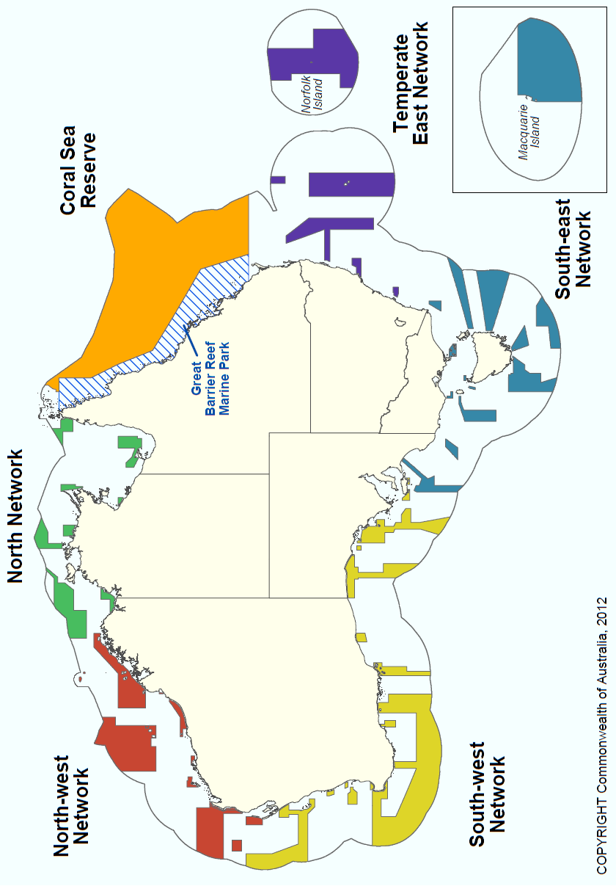

Attachment E
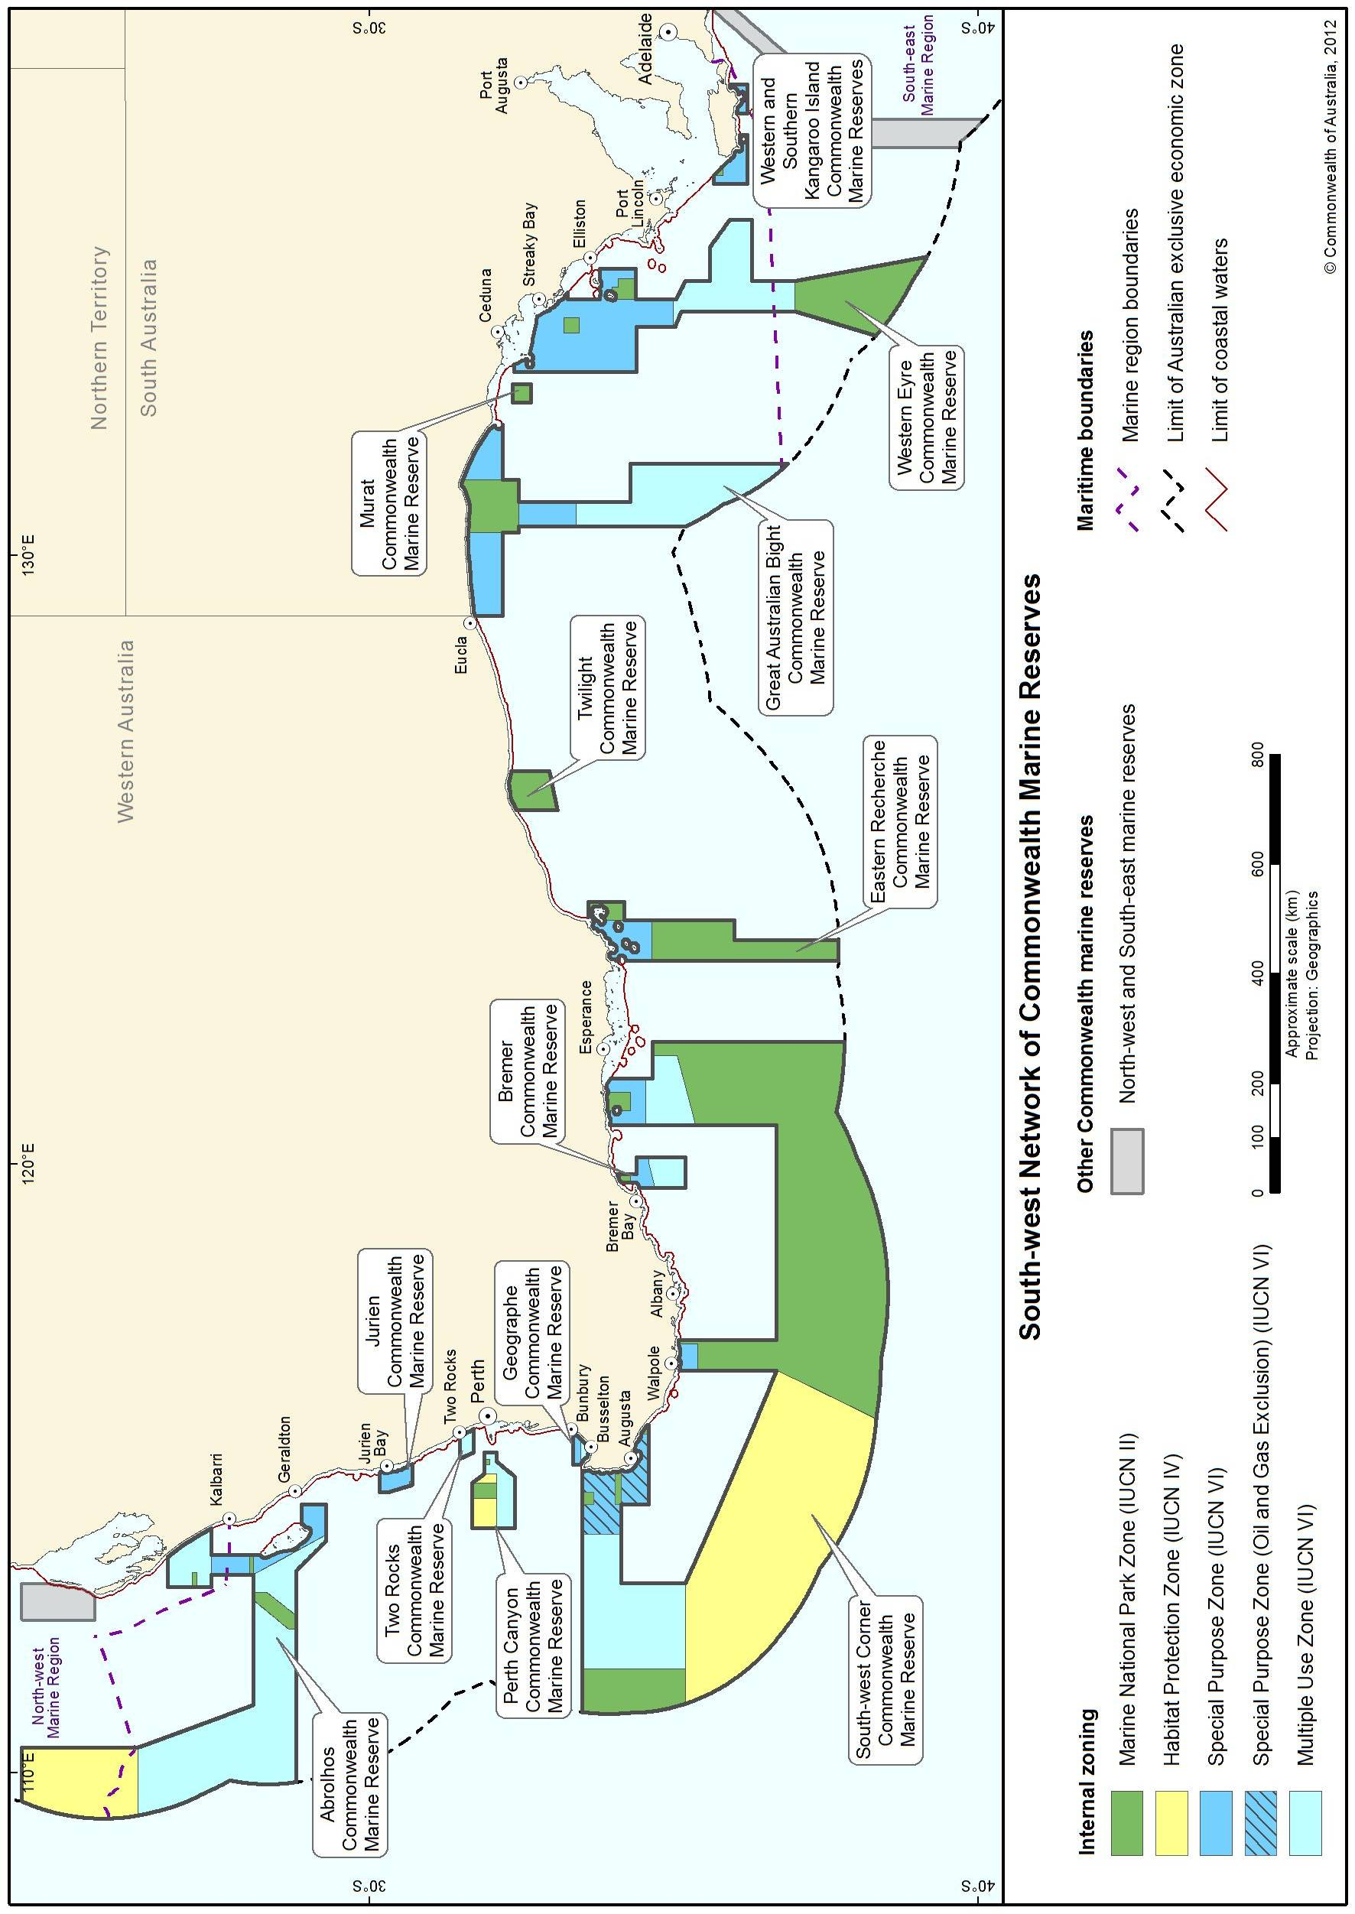
Map showing the location of the Commonwealth reserves in the South-West Network

Attachment F
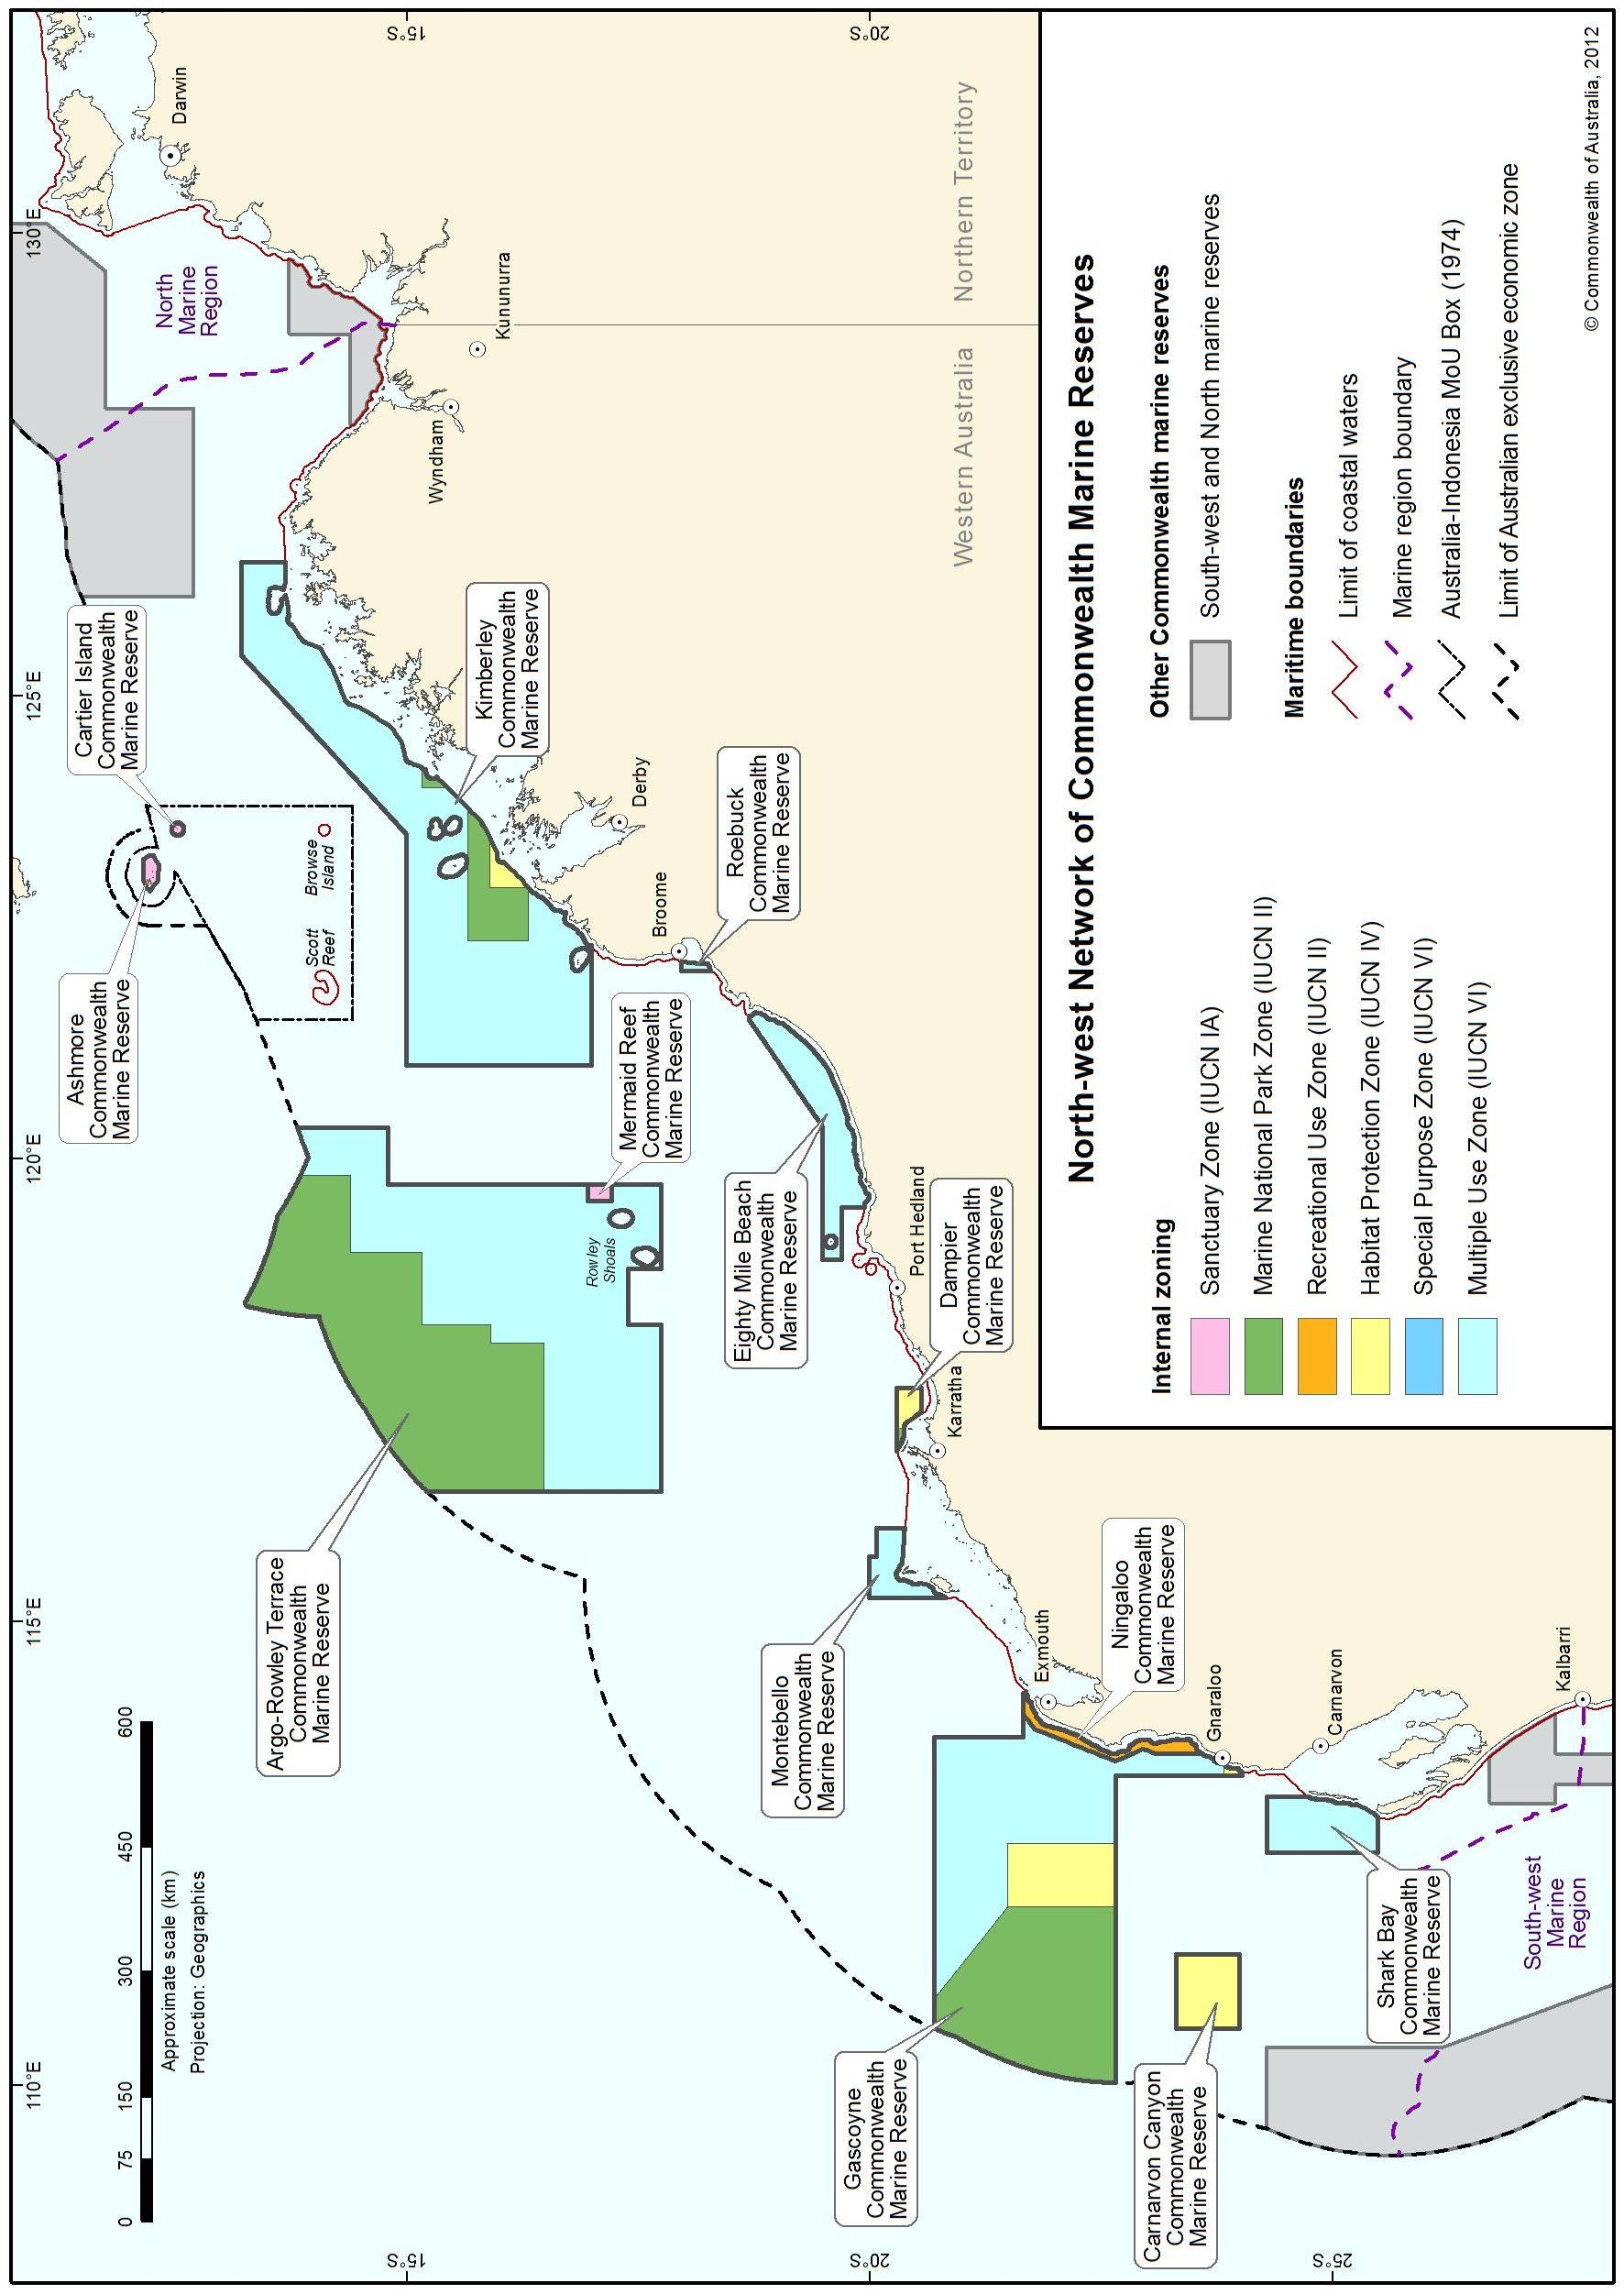
Map showing the location of the Commonwealth reserves in the North-West Network

Attachment G
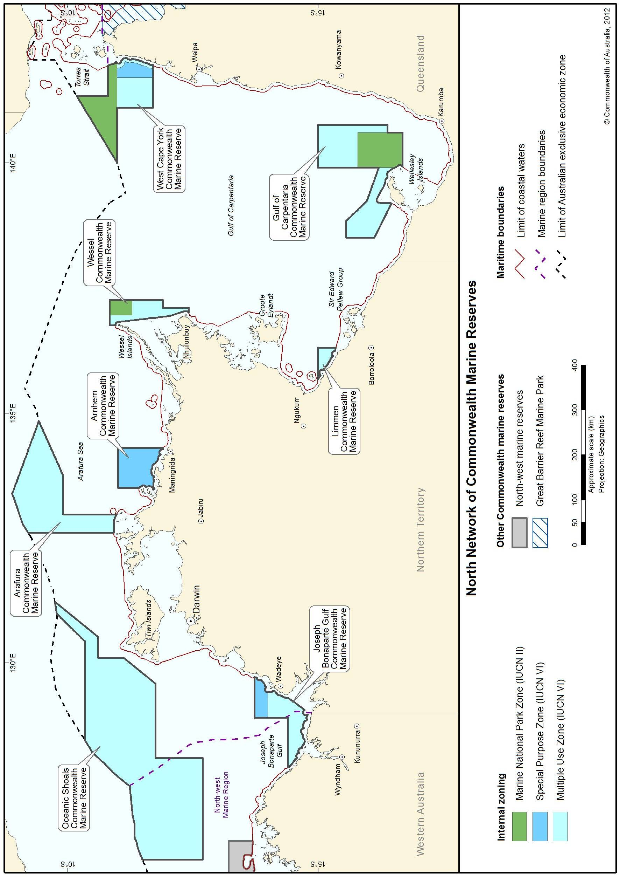
Map showing the location of the Commonwealth reserves in the North Network

Attachment H
Map showing the location of the Coral Sea Commonwealth Marine Reserve
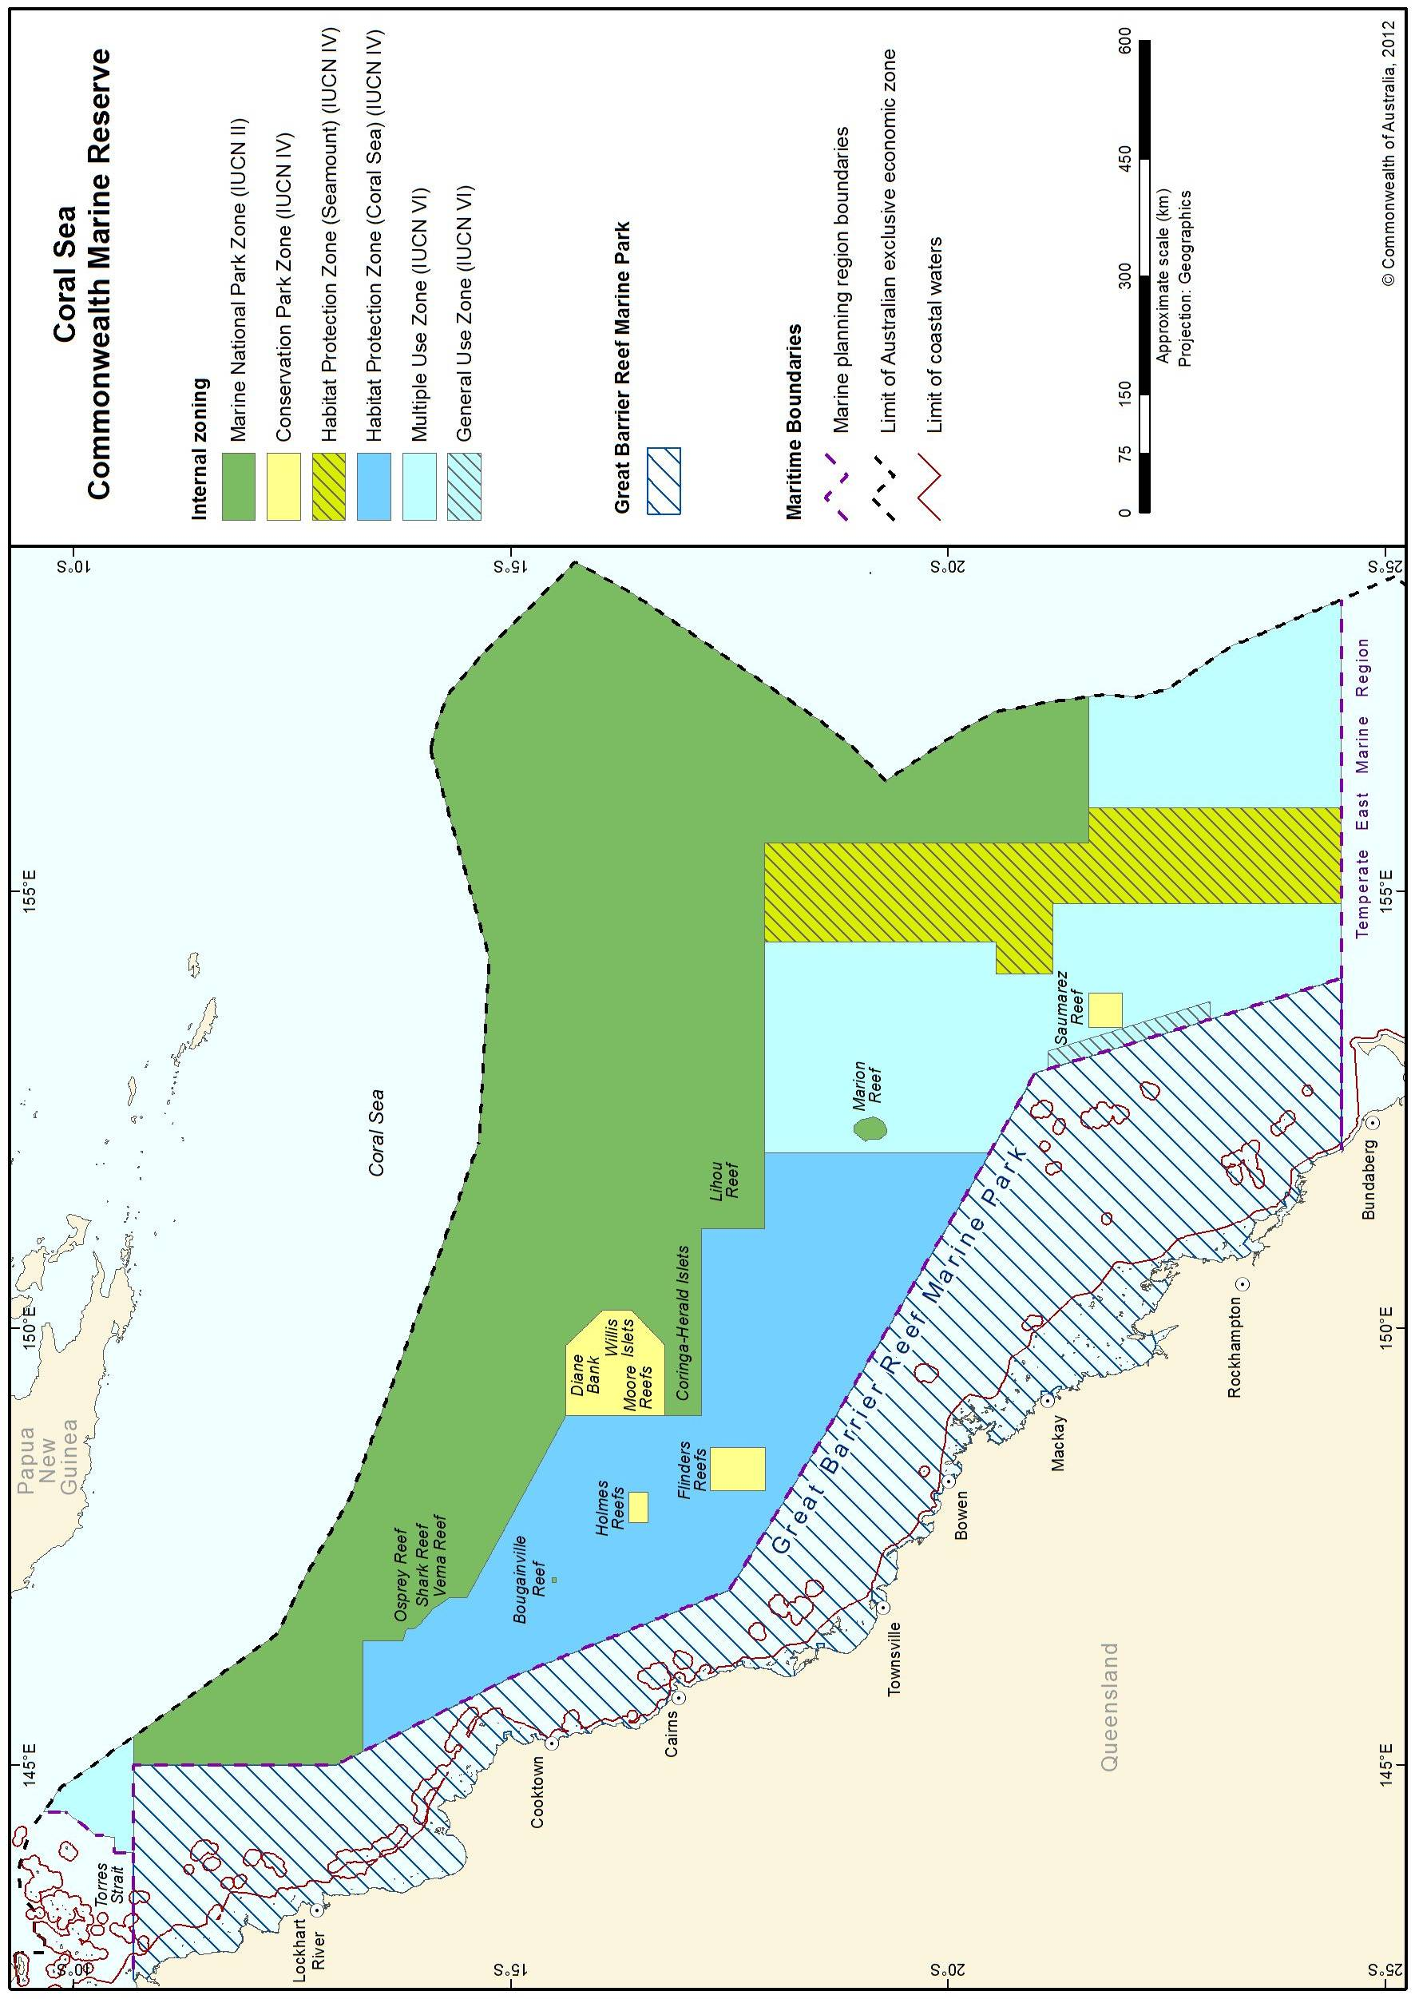

Attachment I
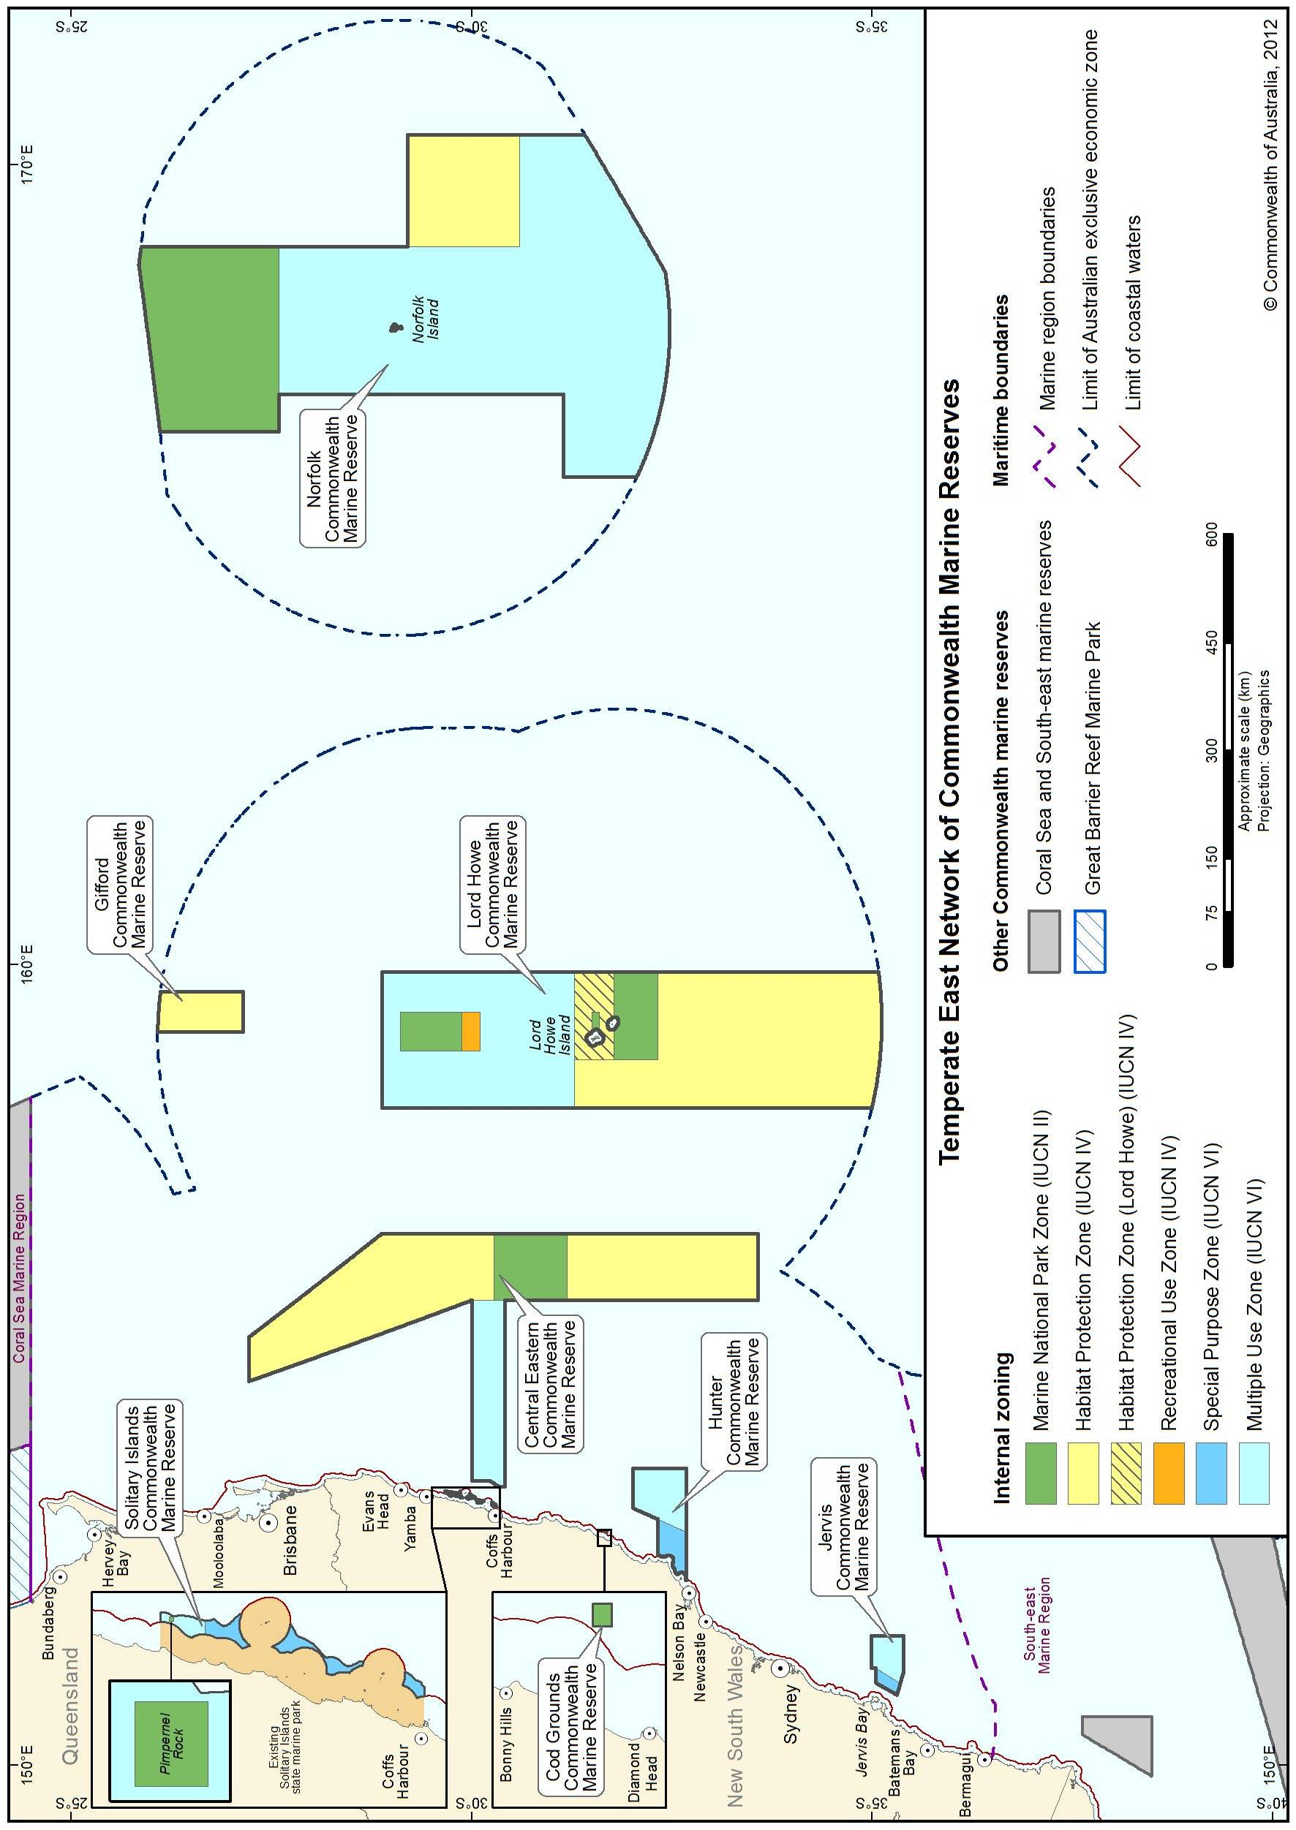
Map showing the location of the Commonwealth reserves in the Temperate East Network

IUCN categories are an internationally defined set of management categories used for consistency in comparing protected areas across Australia. IUCN categories are incorporated into the EPBC Act and Regulations. The six IUCN protected area categories: - Category Ia Sanctuary zone: protected area managed mainly for science - Category Ib Wilderness area: protected area managed mainly for wilderness protection - Category II National park: protected area managed mainly for ecosystem conservation and recreation - Category III Natural monument or feature: protected area managed for conservation of specific natural features - Category IV Habitat/species management area: protected area managed mainly for conservation through management intervention - Category V Protected landscape/seascape: protected area managed mainly for landscape/seascape conservation and recreation - Category VI Protected area with sustainable use of natural resources: protected area managed mainly for the sustainable use of natural ecosystems

