Tobacco Advertising Prohibition Amendment Regulation 2012 (No. 1)¹
Select Legislative Instrument 2012 No. 199
I, QUENTIN BRYCE, Governor-General of the Commonwealth of Australia, acting with the advice of the Federal Executive Council, make the following regulation under the Tobacco Advertising Prohibition Act 1992.
Dated 16 August 2012
QUENTIN BRYCE
Governor-General
By Her Excellency’s Command
TANYA PLIBERSEK
Minister for Health

1 Name of regulation
This regulation is the Tobacco Advertising Prohibition Amendment Regulation 2012 (No. 1).
2 Commencement
This regulation commences on the commencement of Schedule 1 to the Tobacco Advertising Prohibition Amendment Act 2012.
3 Amendment of Tobacco Advertising Prohibition Regulations
Schedule 1 amends the Tobacco Advertising Prohibition Regulations.

Schedule 1 Amendments
(section 3)

[1] Regulation 1
substitute
1 Name of regulation
This regulation is the Tobacco Advertising Prohibition Regulation 1993.
[2] Subregulation 3 (1)
insert
corresponding graphic, for a health warning message, means the graphic that appears in the same item as the health warning message in Schedule 1.
[3] Subregulation 3 (1)
insert
health warning message means a message set out in column 2 of Schedule 1.
pop-up means a window that appears automatically when a tobacco advertisement is accessed.
purchase facility, in relation to a tobacco advertisement, means a facility provided by the advertisement for a person accessing the advertisement to purchase a tobacco product.
Note Subsection 16A (3) of the Act explains what it means for a tobacco advertisement to provide a facility.
[4] Regulations 6, 7 and 8
substitute
6 Point of sale advertising generally
For subsection 16 (2) of the Act, a tobacco advertisement may be displayed:
(a) if the display of the advertisement complies with regulation 7—at a shop where tobacco products are offered for sale to the public; and
(b) if the display of the advertisement complies with regulation 8—on a vending machine that contains tobacco products.
7 Point of sale advertising—shops
(1) A tobacco advertisement displayed at a shop where tobacco products are offered for sale to the public must:
(a) be wholly within the boundaries of the shop; and
(b) be visible from the place within the shop where tobacco products are displayed for sale; and
(c) if placed on a window, face the inside of the shop; and
(d) not be attached to the outer side of:
(i) an outside wall of the shop; or
(ii) an outer window or door of the shop.
(2) However, a tobacco advertisement may be attached to a wall, window or door mentioned in paragraph (1) (d) if:
(a) the advertisement is a statement that:
(i) the shop is a tobacconist; or
(ii) the shop sells tobacco products; and
(b) the advertisement does not include a trade mark, logo or any other information by which a brand of tobacco product may be identified.
(3) In this regulation:
shop includes:
(a) a place that has fixed boundaries, whether or not those boundaries have walls; and
(b) a kiosk.
8 Point of sale advertising—vending machines
A tobacco advertisement displayed on a vending machine that contains tobacco products must not extend beyond any of the extremities of the machine.
8A Point of sale advertising—internet sales
(1) For subsection 16A (2) of the Act, a tobacco advertisement published on the internet must comply with this regulation.
(2) The tobacco advertisement, other than the purchase facility for the advertisement, must:
(a) use black text on a white background, other than hyperlinks to information about tobacco products (which may change from black to blue text after use); and
(b) include the statement “Product prices include all taxes”; and
(c) display tobacco product information in a standardised layout and format using the same font and font size so that no tobacco product is displayed more prominently than any other tobacco product.
(3) The tobacco advertisement, including the purchase facility for the advertisement, must:
(a) if the advertisement is designed to be accessed only from a mobile phone—use a prominent pop-up that includes:
(i) a health warning message and corresponding graphic in a legible and undistorted form; and
(ii) a warning, in a legible form in English, indicating that:
(A) it is illegal to sell tobacco products to a person under 18; and
(B) it is illegal to purchase a tobacco product for use by a person under 18; and
(b) if the advertisement is designed to be accessed from a device other than a mobile phone—include in a prominent position at the top and bottom of each page of the advertisement:
(i) a health warning message and corresponding graphic in a legible and undistorted form; and
(ii) a warning, in a legible form in English, indicating that:
(A) it is illegal to sell tobacco products to a person under 18; and
(B) it is illegal to purchase a tobacco product for use by a person under 18; and
(c) include a system that limits access to the advertisement, including the purchase facility for the advertisement, to a person who is at least 18.
Examples for paragraph (c)
1 A system that stops a person accessing the advertisement, including the purchase facility for the advertisement, unless the person declares that he or she is at least 18.
2 A system that stops a person accessing the advertisement, including the purchase facility for the advertisement, unless the person specifies his or her date of birth and the date specified indicates that the person is at least 18.
(4) The tobacco advertisement may include the country of origin for each tobacco product in one sentence stating any of the following:
(a) the product’s country of origin;
(b) the country of origin for components of the product;
(c) that components of the product are imported;
but must not otherwise describe the product or the components of the product.
Examples
1 “Made in Australia from imported tobacco”, not “Made in Australia from imported premium tobacco”.
2 “Product of Cuba”, not “Made from premium Cuban tobacco”.
(5) The tobacco advertisement may include the following information for each tobacco product being advertised:
(a) the product name;
(b) the price of the product (inclusive of all taxes);
(c) the package size or weight of the product;
(d) an item number or code for the product;
(e) information about any other charges payable;
but must not contain any other information not required or permitted under the Act or these regulations.
(6) To avoid doubt, the tobacco advertisement, including the purchase facility for the advertisement, must not include the following:
(a) words that make claims about or describe the appeal of the tobacco product;
(b) words or images that entice, or are intended to entice, a person to purchase the tobacco product;
(c) words that directly or by implication contradict, qualify or modify a health warning marked, or that is required to be marked, on the tobacco product being advertised;
(d) images of tobacco products;
(e) more than one price for each tobacco product;
(f) content that promotes another internet site that:
(i) contains a tobacco advertisement; or
(ii) solicits internet traffic to a tobacco advertisement.
Example for paragraph (a)
Words that make claims about or describe the appeal of tobacco products include, but are not limited to:
- lite
- low-tar.
Example for paragraph (b)
Words that entice a person to purchase the tobacco product include, but are not limited to:
- cheap
- discount
- lite
- low-tar
- bulk savings
- buy one get one free
- tax free.
[5] Regulation 10
omit
[6] After Regulation 10
insert
Schedule 1 Health warning messages and corresponding graphics
(subregulation 3 (1))

Item | Health warning message | Corresponding graphic
1 | SMOKING HARMS UNBORN BABIES | 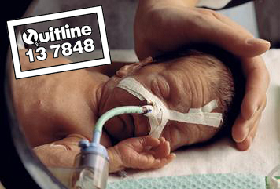
2 | SMOKING CAUSES BLINDNESS | 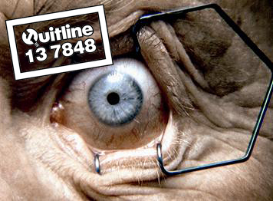
3 | SMOKING CAUSES PERIPHERAL VASCULAR DISEASE | 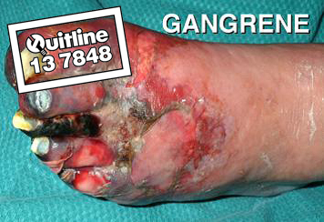
4 | QUITTING WILL IMPROVE YOUR HEALTH | 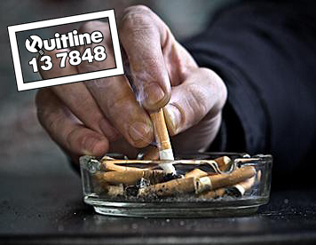
5 | CIGAR SMOKING CAUSES LUNG CANCER | 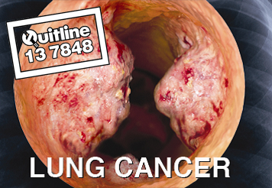

Note
1. All legislative instruments and compilations are registered on the Federal Register of Legislative Instruments kept under the Legislative Instruments Act 2003. See www.comlaw.gov.au.

