|  |  |
| --- | --- |
|  | (July 2012) |

Auditing Standard ASA 2012-1  
Amending Standard to   
ASA 570 Going Concern

Issued by the **Auditing and Assurance Standards Board**



##### Obtaining a Copy of this

This is available on the Auditing and Assurance Standards Board (AUASB) website: www.auasb.gov.au

##### Contact Details

|  |  |
| --- | --- |
| Auditing and Assurance Standards Board  Level 7, 600 Bourke Street  Melbourne Victoria 3000  AUSTRALIA | Phone: (03) 8080 7400  Fax: (03) 8080 7450  E-mail: enquiries@auasb.gov.au  **Postal Address:**  PO Box 204  Collins Street West  Melbourne Victoria 8007  AUSTRALIA |

##### COPYRIGHT

© 2012 Commonwealth of Australia. The text, graphics and layout of this are protected by Australian copyright law and the comparable law of other countries. Reproduction within Australia in unaltered form (retaining this notice) is permitted for personal and non‑commercial use subject to the inclusion of an acknowledgment of the source. Requests and enquiries concerning reproduction and rights for commercial purposes within Australia should be addressed to the Executive Director, Auditing and Assurance Standards Board, PO Box 204, Collins Street West, Melbourne Victoria 8007. Otherwise, no part of the may be reproduced, stored or transmitted in any form or by any means without the prior written permission of the AUASB except as permitted by law.

ISSN 1833-4393

# CONTENTS

PREFACE

AUTHORITY STATEMENT

*Paragraphs*

**Application** Aus 0.1-Aus 0.2

**Operative Date** Aus 0.3

**Introduction**

Scope of this Auditing Standard 1

**Objective** 2

**Definition** 3

**Amendments to Auditing Standard**

Amendments to ASA 570 4

# preface

#### Reasons for Issuing 2012-1

The Auditing and Assurance Standards Board (AUASB) issues *Amending Standard to ASA 570 Going Concern,* pursuant to the requirements of the legislative provisions and the Strategic Direction explained below.

The AUASB is an independent statutory committee of the Australian Government established under section 227A of the *Australian Securities and Investments Commission Act 2001*, as amended (ASIC Act). Under section 336 of the *Corporations Act 2001*, the AUASB may make Auditing Standards for the purposes of the corporations legislation. These Auditing Standards are legislative instruments under the *Legislative Instruments Act 2003*.

Under the Strategic Direction given to the AUASB by the Financial Reporting Council (FRC), the AUASB is required, inter alia, to develop auditing standards that have a clear public interest focus and are of the highest quality.

#### Amended by

This makes amendments to Auditing Standard ASA 570 *Going Concern.*

#### Main Features

This makes amendments to ASA 570 *Going Concern* comprising [Aus] Appendix 1 *Linking Going Concern Considerations and Types of Audit Opinions.*

The amendments are editorial improvements in nature and do not have an impact on the requirements of the Auditing Standard.

## AUTHORITY STATEMENT

The Auditing and Assurance Standards Board (AUASB) makes this   *Amending Standard to ASA 570 Going Concern,* pursuant to section 227B of the *Australian Securities and Investments Commission Act 2001* and section 336 of the *Corporations Act 2001*.

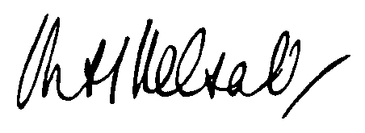

Dated: 31 July 2012 M H Kelsall  
 Chairman - AUASB

## Auditing Standard

##### Application

Aus 0.1 This Auditing Standard applies to:

(a) an audit of a financial report for a financial year, or an audit of a financial report for a half-year, in accordance with the *Corporations Act 2001*; and

(b) an audit of a financial report, or a complete set of financial statements, for any other purpose.

Aus 0.2 This Auditing Standard also applies, as appropriate, to an audit of other historical financial information.

##### Operative Date

Aus 0.3 This Auditing Standard is operative for financial reporting periods commencing on or after 1 July 2012.

##### Introduction

###### Scope of this Auditing Standard

1. This Auditing Standard makes amendments to [Aus] Appendix 1 of Australian Auditing Standard, ASA 570 *Going Concern*. The amendments arise from an AUASB decision to improve the content and layout of the diagram in [Aus] Appendix 1 *Linking Going Concern Considerations and Types of Audit Opinions* and have no impact on the requirements of   
   ASA 570.

##### Objective

1. The objective of this is to make amendments to ASA 570 *Going Concern*.

##### Definition

1. For the purposes of this , the meanings of terms are set out in each Auditing Standard and in the *AUASB Glossary*. This does not introduce new definitions.

##### Amendments to

###### Amendments to ASA 570

1. The diagram contained in [Aus] Appendix 1 *Linking Going Concern Considerations and Types of Audit Opinions* is withdrawn and replaced with a new diagram as follows:

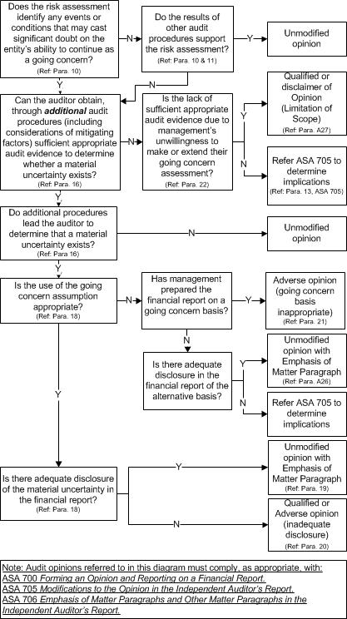

##### Conformity with International Standards on Auditing

This has been made for Australian legislative purposes and there is no equivalent International Standards on Auditing issued by the International Auditing and Assurance Standards Board (IAASB), an independent standard-setting board of the International Federation of Accountants (IFAC).