

Telecommunications Numbering Plan Variation (No. 1) 1

*Telecommunications Act 1997*

The Australian Communications And Media Authority makes the following variation under subsection 455 (1) of the *Telecommunications Act 1997*.

Dated *9 July* 2012

*Chris Chapman*   
[signed]   
Member

*Richard Bean*   
[signed]   
Member/~~General Manager~~

Australian Communications and Media Authority

1 Name of variation

This variation is the *Telecommunications Numbering Plan Variation 2012 (No. 1)*.

2 Commencement

This variation commences on the day after it is registered.

3 Variation of *Telecommunications Numbering Plan 1997*

Schedule 1 varies the *Telecommunications Numbering Plan 1997*.

Schedule 1 Variations

(section 3)

[] Paragraphs 3.5 (2) (a) and (b), (3) (a) and (4) (c)

omit

geographic sector or

[] Subparagraph 3.5 (5) (a) (i)

omit each mention of

geographic sector or

[] Paragraph 3.5 (6) (a)

omit

geographic sector or

[] Chapter 5, boxed note

omit

geographic

[] Subsections 6.25 (3) and (4)

substitute

(3) ACMA must allocate numbers for a standard zone unit as follows:

(a) if, in an available prefix for the standard zone unit, there is available a contiguous block of numbers that is greater than or equal to the request in size, ACMA must allocate the numbers from the available prefix;

(b) if there is no available prefix for the standard zone unit containing a contiguous block of numbers that is greater than or equal to the request in size, ACMA must allocate the numbers from an unavailable prefix for the standard zone unit.

(4) ACMA must allocate numbers for digital mobile services as follows:

(a) if, in an available prefix for digital mobile services, there is available a contiguous block of numbers that is greater than or equal to the request in size, ACMA must allocate the numbers from the available prefix;

(b) if there is no available prefix for digital mobile services containing a contiguous block of numbers that is greater than or equal to the request in size, ACMA must allocate the numbers from an unavailable prefix for digital mobile services.

(5) In this section:

***available prefix*** means a prefix from which a number has previously been allocated.

***unavailable prefix*** means a prefix from which a number has not previously been allocated.

[] Chapter 6, Part 3, boxed note

omit

or geographic sector

[] Paragraph 6.31 (b)

omit

a geographic sector or area

insert

an area

[] Paragraph 6.32 (4) (a)

omit

or geographic sector

[] Paragraph 6.32 (4) (b)

omit

unit or geographic sector.

insert

unit.

[] Paragraph 6.33 (1) (aa)

omit

unit or geographic sector;

insert

unit;

[] Paragraph 7A.6 (2) (b)

omit

[] Paragraphs 7A.6 (3) (a), (b) and (d)

omit

area, sector

insert

area

[] Subsection 11.17 (5)

omit

geographic

[] Schedule 2, table headed *Central East Region*, after area code (02) 33

insert

|  |  |  |  |
| --- | --- | --- | --- |
| (02) 37 | Armidale Barraba Glen Innes  Gunnedah Inverell Moree (*except Berkley Downs, Bonnay, Boorooma, Borah Tank, Cumborah, Goodooga, Grawin, Lightning Ridge and Walgett charging zones*) Narrabri Tamworth | (02) area code followed by 8 digit local number starting with 37 |  |

[] Schedule 2, table headed *Central East Region*, after area code (02) 38

insert

|  |  |  |  |
| --- | --- | --- | --- |
| (02) 39 | Adelong Griffith Hay Narrandera Temora Wagga Wagga West Wyalong | (02) area code followed by 8 digit local number starting with 39 |  |

[] Schedule 2, table headed *Central East Region*, after area code (02) 53

insert

|  |  |  |  |
| --- | --- | --- | --- |
| (02) 54 | Bega Cooma | (02) area code followed by 8 digit local number starting with 54 |  |

[] Schedule 2, table headed *South East Region*, before area code (03) 40

insert

|  |  |  |  |
| --- | --- | --- | --- |
| (03) 32 | Colac Geelong | (03) area code followed by 8 digit local number starting with 32 |  |
| (03) 33 | Ararat Ballarat Horsham Kyneton (*except Gisborne, Kyneton, Redesdale, Romsey, Trentham and Woodend charging zones*) Nhill | (03) area code followed by 8 digit local number starting with 33 |  |
| (03) 34 | Bendigo Charlton Echuca Kerang Kyneton (*except Bacchus Marsh, Ballan, Balliang and Mount Wallace charging zones*) Maryborough | (03) area code followed by 8 digit local number starting with 34 |  |

[] Schedule 2, table headed *North East Region*, after area code (07) 57

insert

|  |  |  |  |
| --- | --- | --- | --- |
| (07) 70 | Cairns | (07) area code followed by 8 digit local number starting with 70 |  |
| (07) 75 | Charleville Dalby Dirranbandi Goondiwindi Inglewood Longreach Miles Roma Stanthorpe Toowoomba Warwick | (07) area code followed by 8 digit local number starting with 75 |  |

[] Schedule 2, table headed *North East Region*, after area code (07) 76

insert

|  |  |  |  |
| --- | --- | --- | --- |
| (07) 77 | Cloncurry Hughenden Townsville | (07) area code followed by 8 digit local number starting with 77 |  |
| (07) 79 | Biloela Emerald Gladstone Mackay Rockhampton | (07) area code followed by 8 digit local number starting with 79 |  |

[] Schedule 2, table headed *Central and West Region*, before area code (08) 51

insert

|  |  |  |  |
| --- | --- | --- | --- |
| (08) 25 | Berri Gawler Kangaroo Island Malalla Murray Bridge Nurioopta Tailem Bend Victor Harbour Waikerie | (08) area code followed by 8 digit local number starting with 25 |  |
| (08) 26 | Ceduna Port Augusta Port Lincoln (*except Thistle and Wedge charging zones*)  Port Pirie | (08) area code followed by 8 digit local number starting with 26 |  |
|  | Cook  Gladstone Peterborough Woomera |  |  |

[] Schedule 2, table headed *Central and West Region*, after area code (08) 54

insert

|  |  |  |  |
| --- | --- | --- | --- |
| (08) 55 | Bullsbrook East Northam (*except Bolgart, Calingiri, Cunderdin, Cunderdin North, Dowerin, Ejanding, Goomalling, Jennacubbine, Konnongorring, Meckering, Northam, Studleigh, Tammin and Yorkrakine charging zones*) Pinjarra | (08) area code followed by 8 digit local number starting with 55 |  |
| (08) 58 | Albany Katanning Kondinin Narrogin Wagin | (08) area code followed by 8 digit local number starting with 58 |  |

[] Schedule 2, table headed *Central and West Region*, after area code (08) 68

insert

|  |  |  |  |
| --- | --- | --- | --- |
| (08) 69 | Carnamah Carnarvon Geraldton Meekatharra Morawa Mullewa | (08) area code followed by 8 digit local number starting with 69 |  |
|  | Wongan Hills (*except Ballidu, Burakin, Cadoux, Dalwallinu, Dalwallinu West, Goodlands, Kalannie, Kalannie East, Wongan Hills, Wubin and Wubin West charging zones*) |  |  |

[] Schedule 3

substitute

Schedule 3 Numbers of geographic significance

(sections 3.5 and 3.7)

Part 1 Numbers of local geographic significance

Numbers of local geographic significance are to be allocated in the areas mentioned in the following tables. A map showing the approximate boundaries of standard zone units for a metropolitan area is included after each table, for illustrative purposes only.

Sydney area

| Area | Numbers in area |
| --- | --- |
| Area that is the Sydney standard zone unit | Numbers starting with (02) 72, (02) 73, (02) 74, (02) 76, (02) 77, (02) 80, (02) 82, (02) 83, (02) 85, (02) 88, (02) 90, (02) 91, (02) 92, (02) 93, (02) 94, (02) 95, (02) 96, (02) 97, (02) 98 or (02) 99 |
| Area that is the Sutherland standard zone unit | Numbers starting with (02) 75, (02) 85 or (02) 95 |
| Area that is the Bankstown standard zone unit | Numbers starting with (02) 81, (02) 87 or (02) 97 |
| Area that is the Parramatta standard zone unit | Numbers starting with (02) 78, (02) 88 or (02) 98 |
| Area that is the Terrey Hills standard zone unit | Numbers starting with (02) 84, (02) 89, (02) 94 or (02) 99 |
| Area that is the Avalon Beach standard zone unit | Numbers starting with (02) 84, (02) 89, (02) 94 or (02) 99 |
| Area that is the Dural standard zone unit | Numbers starting with (02) 84, (02) 89, (02) 94 or (02) 99 |
| Area that is the Blacktown standard zone unit | Numbers starting with (02) 86, (02) 88 or (02) 98 |
| Area that is the Liverpool standard zone unit | Numbers starting with (02) 81, (02) 87 or (02) 97 |
| Area that is the Engadine standard zone unit | Numbers starting with (02) 75, (02) 85 or (02) 95 |

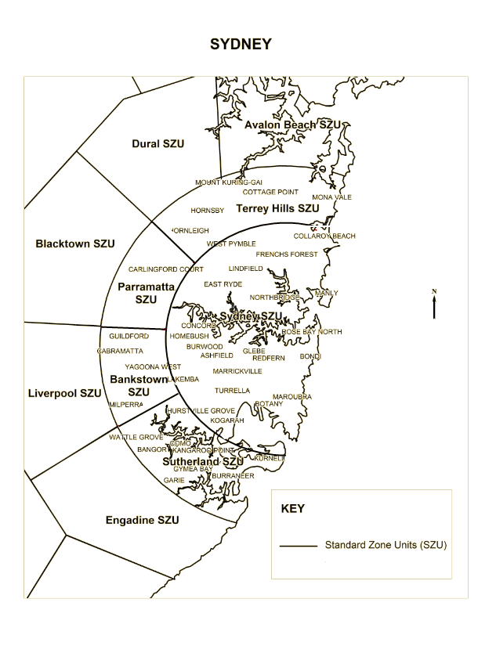

Melbourne area

| Area | Numbers in area |
| --- | --- |
| Area that is the Melbourne standard zone unit | Numbers starting with (03) 70, (03) 71, (03) 77, (03) 78, (03) 79, (03) 83, (03) 85, (03) 86, (03) 90, (03) 91, (03) 93, (03) 94, (03) 95, (03) 96 or (03) 98 |
| Area that is the Point Cook standard zone unit | Numbers starting with (03) 73, (03) 83 or (03) 93 |
| Area that is the Sydenham standard zone unit | Numbers starting with (03) 73, (03) 83 or (03) 93 |
| Area that is the Craigieburn standard zone unit | Numbers starting with (03) 73, (03) 83 or (03) 93 |
| Area that is the Eltham standard zone unit | Numbers starting with (03) 84 or (03) 94 |
| Area that is the Ringwood standard zone unit | Numbers starting with (03) 88 or (03) 98 |
| Area that is the Clayton standard zone unit | Numbers starting with (03) 75, (03) 85 or (03) 95 |
| Area that is the Werribee standard zone unit | Numbers starting with (03) 80, (03) 87 or (03) 97 |
| Area that is the Sunbury standard zone unit | Numbers starting with (03) 80, (03) 87 or (03) 97 |
| Area that is the Kalkallo standard zone unit | Numbers starting with (03) 81, (03) 87 or (03) 97 |
| Area that is the Whittlesea standard zone unit | Numbers starting with (03) 81, (03) 87 or (03) 97 |
| Area that is the Croydon standard zone unit | Numbers starting with (03) 82, (03) 87 or (03) 97 |
| Area that is the Dandenong standard zone unit | Numbers starting with (03) 87, (03) 89 or (03) 97 |

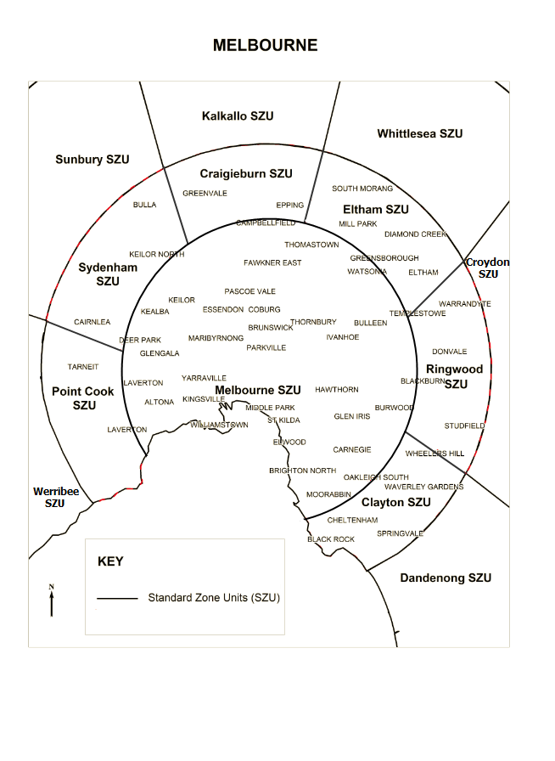

Brisbane area

| Area | Numbers in area |
| --- | --- |
| Area that is the Brisbane standard zone unit | Numbers starting with (07) 21, (07) 30, (07) 321, (07) 322, (07) 323, (07) 324, (07) 325, (07) 326, (07) 327, (07) 329, (07) 330, (07) 331, (07) 332, (07) 333, (07) 334, (07) 335, (07) 336, (07) 337, (07) 339, (07) 34, (07) 35, (07) 37, (07) 382, (07) 383, (07) 384, (07) 385, (07) 386, (07) 387, (07) 389 or (07) 39 |
| Area that is the Sandgate standard zone unit | Numbers starting with (07) 326, (07) 36, (07) 386 |
| Area that is the Redcliffe standard zone unit | Numbers starting with (07) 20, (07) 30, (07) 320, (07) 328, (07) 338, (07) 34 or (07) 388 |
| Area that is the Samford standard zone unit | Numbers starting with (07) 20, (07) 30, (07) 320, (07) 328, (07) 338, (07) 34 or (07) 388 |
| Area that is the Ipswich standard zone unit | Numbers starting with (07) 28, (07) 30, (07) 320, (07) 328, (07) 338, (07) 34 or (07) 388 |
| Area that is the Beenleigh standard zone unit | Numbers starting with (07) 28, (07) 30, (07) 320, (07) 328, (07) 338, (07) 34, (07) 380 or (07) 388 |
| Area that is the Cleveland standard zone unit | Numbers starting with (07) 28, (07) 30, (07) 320, (07) 328, (07) 338, (07) 34 or (07) 388 |

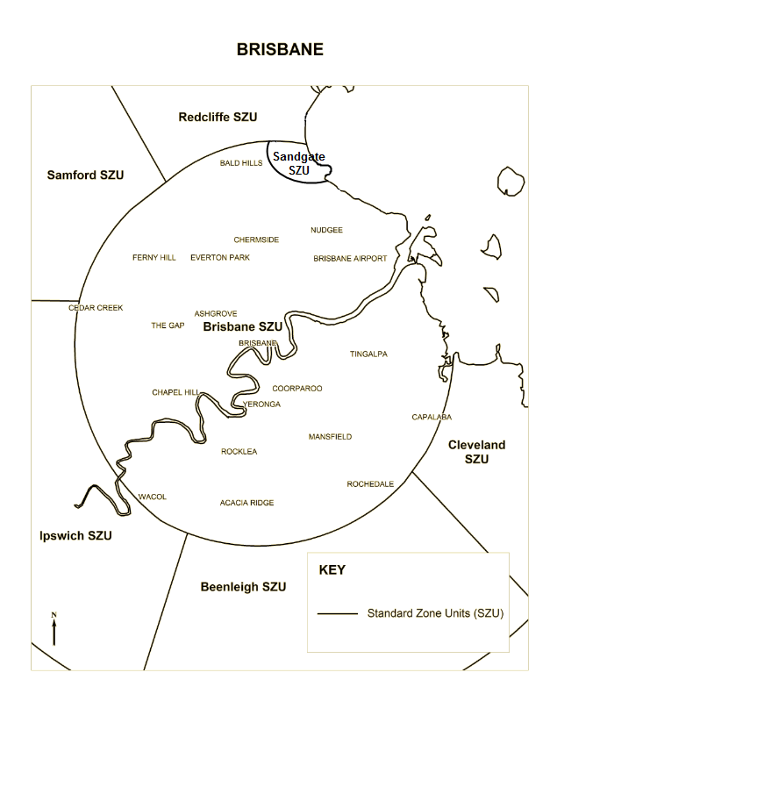

Adelaide area

| Area | Numbers in area |
| --- | --- |
| Area that is the Adelaide standard zone unit | Numbers starting with (08) 700, (08) 707, (08) 708, (08) 710, (08) 711, (08) 713, (08) 714, (08) 715, (08) 716, (08) 717, (08) 720, (08) 721, (08) 733, (08) 742, (08) 744, (08) 747, (08) 810, (08) 811, (08) 812, (08) 813, (08) 814 (08) 815, (08) 816, (08) 817, (08) 819, (08) 820, (08) 821, (08) 822, (08) 823, (08) 824, (08) 825, (08) 826, (08) 827, (08) 829, (08) 830, (08) 831, (08) 833, (08) 834, (08) 835, (08) 836, (08) 837, (08) 839, (08) 840, (08) 841, (08) 842, (08) 843, (08) 844, (08) 845, (08) 846, (08) 847 or (08) 849 |
| Area that is the Salisbury standard zone unit | Numbers starting with (08) 718, (08) 728, (08) 737, (08) 738, (08) 739, (08) 818, (08) 828, (08) 838 or (08) 848 |
| Area that is the Woodside standard zone unit | Numbers starting with (08) 718, (08) 728, (08) 748, (08) 749, (08) 818, (08) 838 or (08) 848 |
| Area that is the Mt Barker standard zone unit | Numbers starting with (08) 718, (08) 719, (08) 728, (08) 729, (08) 818, (08) 838 or (08) 848 |
| Area that is the McLaren Vale standard zone unit | Numbers starting with (08) 718, (08) 726, (08) 727, (08) 728, (08) 818, (08) 838 or (08) 848 |

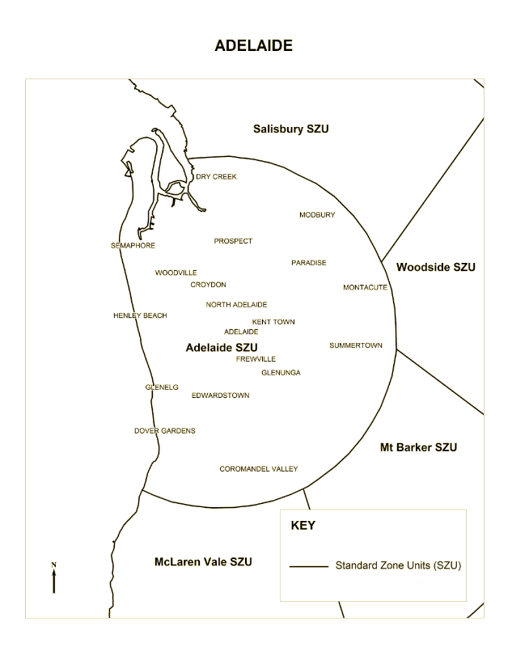

Perth area

| Area | Numbers in area |
| --- | --- |
| Area that is the Perth standard zone unit | Numbers starting with (08) 52, (08) 614, (08) 615, (08) 616, (08) 618, (08) 621, (08) 622, (08) 623, (08) 624, (08) 625, (08) 626, (08) 627, (08) 628, (08) 631, (08) 632, (08) 633, (08) 635, (08) 637, (08) 638, (08) 640, (08) 642, (08) 643, (08) 644, (08) 645, (08) 647, (08) 648, (08) 650, (08) 654, (08) 655 (08) 920, (08) 921, (08) 922, (08) 923, (08) 924, (08) 925, (08) 926, (08) 927, (08) 928, (08) 931, (08) 932, (08) 933, (08) 934, (08) 935, (08) 936, (08) 937, (08) 938, (08) 941, (08) 942, (08) 943, (08) 944, (08) 945, (08) 946, (08) 947 or (08) 948 |
| Area that is the Fremantle standard zone unit | Numbers starting (08) 621, (08) 622, (08) 623, (08) 631, (08) 633, (08) 641, (08) 642, (08) 651, (08) 923, (08) 933 or (08) 943 |
| Area that is the Wanneroo standard zone unit | Numbers starting with (08) 620, (08) 630, (08) 634, (08) 640, (08) 920, (08) 930 or (08) 940 |
| Area that is the Herne Hill standard zone unit | Numbers starting with (08) 619, (08) 629, (08) 639, (08) 649, (08) 652, (08) 653, (08) 929, (08) 939 or (08) 949 |
| Area that is the Kalamunda standard zone unit | Numbers starting with (08) 619, (08) 629, (08) 639, (08) 649, (08) 656, (08) 657, (08) 929, (08) 939 or (08) 949 |
| Area that is the Armadale standard zone unit | Numbers starting with (08) 619, (08) 629, (08) 639, (08) 649, (08) 658, (08) 659, (08) 929, (08) 939 or (08) 949 |
| Area that is the Spearwood standard zone unit | Numbers starting with (08) 613, (08) 617, (08) 619, (08) 629, (08) 639, (08) 649, (08) 929, (08) 939 or (08) 949 |
| Area that is the Rottnest Island standard zone unit | Numbers starting with (08) 613, (08) 617, (08) 619, (08) 629, (08) 639, (08) 649, (08) 929, (08) 939 or (08) 949 |

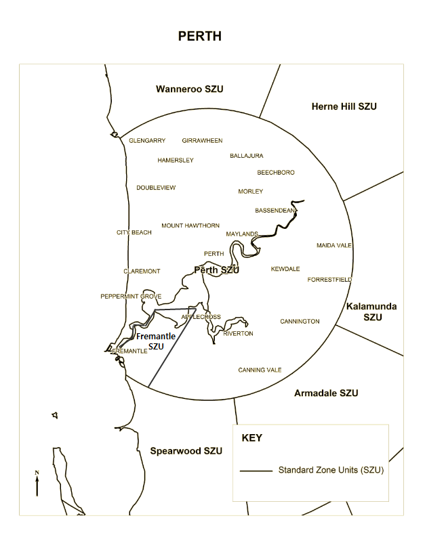

Part 2 Numbers of broad geographic significance

Numbers of broad geographic significance are to be allocated in the charging districts mentioned in the following table.

| Charging district | Numbers in charging district |
| --- | --- |
| Sydney | Numbers starting with (02) 79, (02) 96 or (02) 99 |
| Melbourne | Numbers starting with (03) 92 or (03) 99 |
| Brisbane | Numbers starting with (07) 31 or (07) 381 |
| Adelaide | Numbers starting with (08) 712, (08) 722, (08) 723, (08) 731, (08) 732 or (08) 832 |
| Perth | Numbers starting with (08) 610, (08) 611, (08) 636 or (08) 646 |

[] Schedule 4, Part 1, after number prefix 0550

insert

|  |  |  |  |
| --- | --- | --- | --- |
| **05**  (except 0550) | Digital mobile service | 10 digit number | Yes  *Not shared* |

[] Schedule 7, clause 2.5

omit

[] Schedule 8

omit

|  |  |  |
| --- | --- | --- |
| Digital mobile service | 04 | 100,000 numbers |

insert

|  |  |  |
| --- | --- | --- |
| Digital mobile service | 04 or 05 | 100,000 numbers |

**Note**

1. All legislative instruments and compilations are registered on the Federal Register of Legislative Instruments kept under the *Legislative Instruments Act 2003.* See www.comlaw.gov.au.