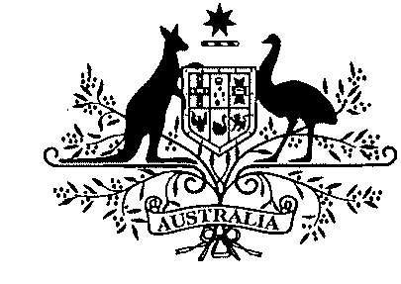 | Australian Government
 | Civil Aviation Safety Authority
Tabling Officer
Department of the House of Representatives
Parliament House
CANBERRA ACT 2600
Dear Tabling Officer
Substitution of Explanatory Statements tabled on 21 May 2012 with:
- Civil Aviation Order 40.1.0 Amendment Instrument 2012 (No. 2) - F2012L01042
- Civil Aviation Order 40.3.0 Amendment Instrument 2012 (No. 1) - F2012L01043
- Civil Aviation Order 82.0 Amendment Instrument 2012 (No. 1) - F2012L01044
I am writing to request the substitution of the Explanatory Statements tabled with the Civil Aviation Orders mentioned above.
The Explanatory Statements for these Civil Aviation Orders did not include the Regulation Impact Statement (RIS) that was prepared by CASA and assessed by the Office of Best Practice Regulation as meeting the Australian Government’s Best Practice Regulation requirements (OBPR ID: 13510). The RIS is now attached at Appendix 2. The Attorney- General’s Department has been notified of the error and a new electronic copy of the Explanatory Statement, identical to the attached hard copy, has been emailed to them.
I have attached one copy of each of the revised Explanatory Statements and would be grateful if they could be substituted for the ones tabled with the abovementioned Civil Aviation Orders on 21 May 2012.
Yours sincerely,
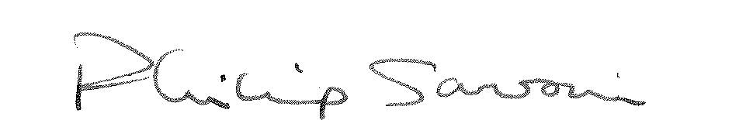
Philip Sansoni
for Manager, Legislative Drafting Branch
Legal Services Division
25 May 2012
GPO Box 2005 Canberra ACT 2601 Telephone 131 757
Canberra, Brisbane, Darwin, Cairns, Townsville, Tamworth, Bankstown, Mascot, Melbourne, Adelaide, Perth

