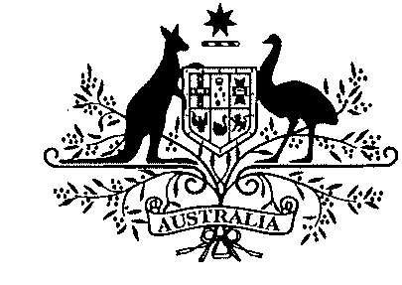 | Australian Government
 | Civil Aviation Safety Authority
Tabling Officer
Department of the Senate
Parliament House
CANBERRA ACT 2600
Dear Tabling Officer
Substitution of Explanatory Statements:
Civil Aviation Order 40.1.0 Amendment Instrument 2012 (No. 2) - F2012L01042
Civil Aviation Order 40.3.0 Amendment Instrument 2012 (No. 1) - F2012L01043
Civil Aviation Order 82.0 Amendment Instrument 2012 (No. 1) - F2012L01044
I am writing to request the substitution of the Explanatory Statements that accompanied the Civil Aviation Orders mentioned above.
The Explanatory Statements for these Civil Aviation Orders did not include the Regulation Impact Statement (RIS) that was prepared by CASA and assessed by the Office of Best Practice Regulation as meeting the Australian Government’s Best Practice Regulation requirements (OBPR ID: 13510). The RIS is now attached at Appendix 2. The Attorney-General’s Department has been notified of the error and a new electronic copy of the Explanatory Statement, identical to the attached hard copy, has been emailed to them.
Two copies of each of the revised Explanatory Statements are attached. I would be grateful if they could be substituted for the Explanatory Statements that accompanied the Civil Aviation Orders mentioned above.
Yours sincerely
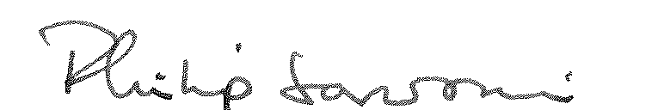
Philip Sansoni
for Ebenezer Banful
Manager, Legislative Drafting Branch
Legal Services Division
25 May 2012
GPO Box 2005 Canberra ACT 2601 Telephone 131 757
Canberra, Brisbane, Darwin, Cairns, Townsville, Tamworth, Bankstown, Mascot, Melbourne, Adelaide, Perth

