**EXPLANATORY STATEMENT**

***Radiocommunications Act 1992***

**RADIOCOMMUNICATIONS (SPECTRUM RE-ALLOCATION) DECLARATION NO. 2 OF 2011**

Issued by the authority of the Minister for Broadband, Communications and the Digital Economy

**Background**

Part 3.6 of the *Radiocommunications Act 1992* (‘the Act’) deals with the re-allocation of encumbered spectrum. Under section 153B of the Act, the Minister may make a declaration (a disallowable legislative instrument) that one or more parts of the spectrum are subject to re-allocation. The spectrum can be re-allocated by issuing either spectrum or apparatus licences.

Incumbent apparatus licensees in subject parts of the spectrum have a period (which is described in the declaration as the ‘re-allocation period’) to vacate the spectrum. This avoids delays to the re-allocation process which may be incurred if spectrum is required to be cleared prior to re-allocation. It also mitigates the risk of clearing spectrum unnecessarily or too early in relation to the demand for its use.

Certain apparatus licences that are affected by a spectrum re-allocation declaration will be cancelled at the end of the period specified in the declaration.

The re-allocation period must begin within 28 days after the declaration is made, and run for at least 2 years.

Before making a declaration about any part(s) of the spectrum, the Minister must have received, and had regard to, a recommendation from the Australian Communications and Media Authority (ACMA) about the same part(s) of the spectrum (section 153E of the Act). The ACMA’s recommendation must be developed and made in accordance with sections 153F and 153G of the Act.

Only spectrum currently occupied by apparatus licences, or unoccupied spectrum, may be covered by a re-allocation declaration. The reason for allowing unoccupied spectrum to be covered is to facilitate the re‑allocation of contiguous blocks of spectrum, rather than fragmented parts that are separated by intervals of unoccupied spectrum.

**Purpose**

The Government has committed to auctioning the 2.5 GHz band during 2012-13.

An auction is being planned to sell spectrum from the 2.5GHz band and the digital dividend band (which is subject to a separate spectrum re-allocation declaration) through a single process at the end of 2012. This declaration formally initiates the re-allocation process for the 2.5 GHz band, paving the way for the auction of the spectrum.

The 2.5 GHz band is currently almost exclusively licensed to the three commercial free-to-air television broadcasters and the Australian Broadcasting Corporation (ABC) to facilitate television broadcasting coverage of an event remotely located from a broadcasting studio (also known as outside broadcasting). This includes electronic news gathering (ENG). The parts of the spectrum specified in this declaration are to be re-allocated to allow for new uses, such as Wireless Access Services (WAS). The demand for WAS is growing, both nationally and globally, in response to technological advancements and consumer expectations.

The Government’s goal in re-allocating the spectrum is to maximise the overall public benefit derived from the use of that spectrum. The re-allocation of this spectrum promises benefits to business, consumers and the broader Australian community and economy in the form of service improvements, greater connectivity and productivity gains.

In relation to this declaration affecting spectrum in relation to 2.5 GHz band, the ACMA made a recommendation to the Minister on 19 August 2011. The ACMA recommended the following:

* two 70 MHz blocks of spectrum, with frequency boundaries 2500-2570 MHz and 2620-2690 MHz, should be re-allocated nationally, excluding the Mid West Radio Quiet Zone;
* the re-allocation period should start on 2 November 2011 and should end on:

(a) 31 January 2016 for the Perth area; and

(b) 30 September 2014 for all other parts of Australia;

* the re-allocation deadline should be 30 September 2013; and
* Spectrum licensing should apply.

Spectrum licensing will apply to the spectrum being re-allocated. Spectrum licensing is considered to be the option most likely to ensure the efficient allocation and use of the spectrum and to provide licensees with the flexibility and security of tenure needed to encourage investment in infrastructure.

The ACMA undertook a review of the 2.5 GHz band during 2010. It released the discussion paper titled *Review of the 2.5GHz band and long term arrangements for ENG* seeking public comment on a range of options for future licensing arrangements, planning and pricing for the 2.5 GHz band. The purpose of this review was to align the use of the band with its highest value use and identify long-term arrangements for existing ENG services. This paper generated 42 submissions during the consultation period which closed on 12 March 2010. The ACMA released a Response to Submissions paper on 21 October 2010. Both papers have been published on the ACMA website at www.acma.gov.au.

The ACMA undertook consultation with affected apparatus licensees and the public as required under section 153G of the Act from 28 May 2011 to 15 July 2011. Nine submissions were received. These have been published on the ACMA website at www.acma.gov.au. The ACMA had regard to the comments made when developing its final recommendation to the Minister.

A regulation impact statement (RIS) titled *Regulation Impact Statement: Future arrangements for the 2.5 GHz radiofrequency spectrum band and long-term arrangements for ENG* was prepared by the ACMA to inform its decision-making when making the recommendation to the Minister. The RIS has been published on the Office of Best Practice Regulation website at www.obpr.gov.au.

**Notes on Clauses**

**Clause 1**

Clause 1 provides for the citation of the Declaration as the *Radiocommunications (Spectrum Re-allocation) Declaration No. 2 of 2011*.

**Clause 2**

Clause 2 provides that the Declaration will commence on the day after it is registered on the Federal Register of Legislative Instruments.

**Clause 3**

Clause 3 sets out a number of definitions for the purpose of the Declaration.

‘Act’ is defined to mean the *Radiocommunications Act 1992*.

‘Mid West Radio Quiet Zone’ (RQZ) is defined by reference to the geographic coordinates set out in Table B of the Schedule.

‘National Area’ is defined by reference to the geographic coordinates set out in Table A of the Schedule. The area bounded by the given coordinates encompasses most of Australia, excluding the external territories.

‘Perth Area’ is defined by reference to the geographic coordinates set out in Table B of the Schedule.

The terms ‘re-allocation period’ and ‘re-allocation deadline’ both have the same meaning as in section 153B of the Act.

**Clause 4**

Clause 4 sets out the parts of the spectrum that are subject to re-allocation under the Declaration, the specific areas to which the Declaration applies and a number of other relevant matters in accordance with section 153B of the Act.

Subclause 4(1) sets out the parts of the spectrum that are subject to re-allocation in relation to the re-allocation period under Part 3.6 of the Act, in accordance with subsection 153B(1) of the Act.

Two separate parts of the spectrum are specified in subclause 4(1). The parts of the spectrum specified in paragraphs 4(1)(a) and (b) form part of the 2.5GHz frequency band. The 2.5 GHz band is currently used by apparatus licensees – mainly the commercial free‑to-air television broadcasters and the ABC – for outside broadcasting including ENG.

Subclause 4(2) specifies the areas to which the Declaration is to apply, for each part of the spectrum specified in the Declaration, as required by subsection 153B(3) of the Act. There are two separate areas specified under subclause 4(2). The first area, set out in paragraph 4(2)(a), is the ‘National Area’, but excluding firstly the ‘Perth Area’, and secondly an area referred to as the ‘Mid West Radio Quiet Zone’ (RQZ). Definitions for the ‘National Area, the ‘Perth Area’ and the RQZ are provided in clause 3.

The specified area identified as the ‘National Area’ refers to the area bounded by the geographic coordinates set out in Table A to the Schedule.  This area encompasses most of Australia, excluding the external territories.  A pictorial representation of the ‘National Area’, ‘Perth Area’ (in bright green) and RQZ (in pink) based on the coordinates contained in Tables A, B and C of the Schedule is provided as Figure 1 below.

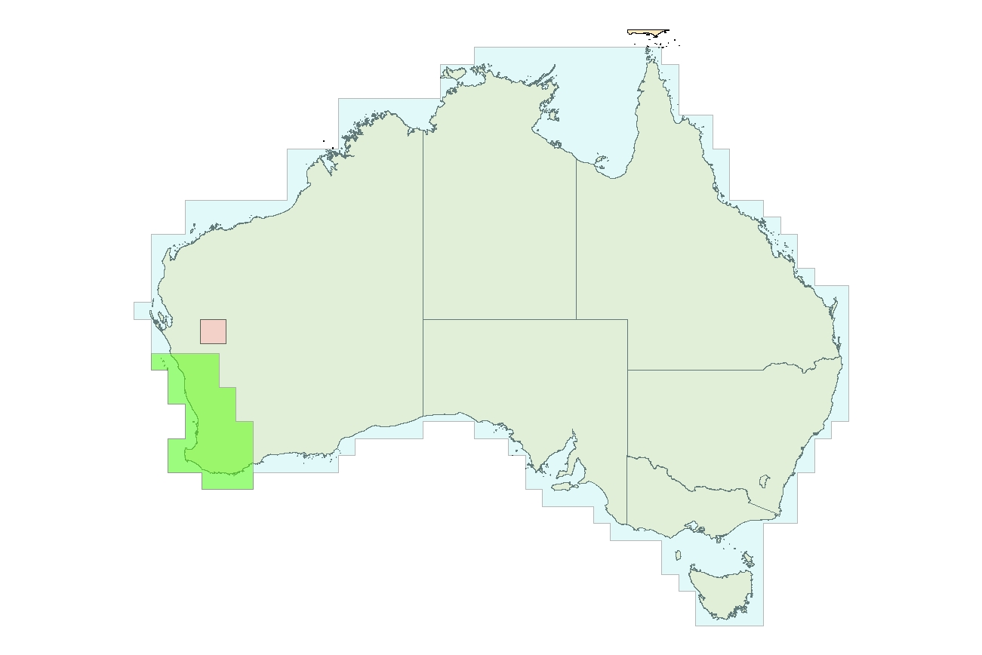

Figure 1

The Perth Area is excluded from the area specified under paragraph 4(2)(a) because it is specified as a separate area under paragraph 4(2)(b). It is necessary to specify the Perth Area separately in order to accommodate the longer re-allocation period for the Perth Area in respect of the spectrum specified in subclause 4(1) (see subclause 4(4)) for the re-allocation periods for those parts of the spectrum).

The RQZ is an area approximately 300 kilometres north-east of Geraldton, Western Australia. The ACMA endeavours to maintain low levels of radiofrequency for this area in order to facilitate the development and use of new radio astronomy technologies at that location, and support Australia's bid to host the Square Kilometre Array (SKA). When built, the SKA will be the largest and most sensitive radio telescope. Australia and South Africa are currently shortlisted as potential locations for the SKA.

The ACMA has excluded the RQZ from the area designated for allocation in order to preserve licensing options for the Murchison Radioastronomy Observatory at the centre of the RQZ, and for other services in the areas around the centre of the RQZ, subject to their compliance with conditions contained in the *Radiocommunications (Mid West Radio Quiet Zone) Frequency Band Plan 2011* to protect radioastronomy.

Subclause 4(3) sets out the re-allocation periods in relation to the parts of the spectrum mentioned in subclause (4)(1). The most significant feature of the re-allocation period under the Act is that, at the end of the period, most apparatus licences will automatically be cancelled if they are in a part of the spectrum covered by the declaration (section 153H of the Act). Particular kinds of broadcasting apparatus licence are not automatically cancelled by operation of section 153H (paragraph 153H(3)(c) refers). However none of these kinds of ‘protected’ apparatus licences are in the parts of the spectrum covered by this declaration.

Two different re-allocation periods are specified under subclause 4(3). The first re-allocation period is specified to begin in 2 November 2011 and end on 30 September 2014. This re allocation period applies in respect of the area specified in paragraph 4(2)(a), which is the National Area, excluding the Perth Area and the RQZ. The second re-allocation period is specified to also begin on 2 November 2011, but it has a different end date of 31 January 2016. This re-allocation period applies in respect of the Perth Area.

The timing of the re-allocation period for the 2.5 GHz band is affected by the need to relocate incumbent ENG services to alternative bands before prospective new licensees can obtain access to the spectrum. In the Perth area, the identified alternative bands for ENG are unlikely to be available until January 2016. A longer re-allocation period has been set for the Perth area reflecting this relocation timing. Specifying two different re-allocation periods means that spectrum in the majority of Australia can be made available to the new licensees as soon as it is cleared, rather than having this spectrum remain unused until such time as the spectrum in the Perth area is able to be cleared.

Subclause 4(4) specifies the re-allocation deadline for the parts of the spectrum specified in subclause 4(1), as required by subsection 153B(5) of the Act. In accordance with subsection 153B(5) of the Act the re-allocation deadline must be at least 12 months before the end of the re-allocation period. Subclause 4(4) specifies as re-allocation deadline of 30 September 2013. If no spectrum licences are allocated in respect of the declared parts of the spectrum on or before 30 September 2013, section 153K of the Act will operate to revoke the Declaration immediately after the re‑allocation deadline.

Subclause 4(5) provides that each part of the spectrum specified in subclause 4(1) of the Declaration may only be re-allocated by issuing spectrum licences under Division 1 of Part 3.2 of the Act. This provision is included in accordance with subsection 153B(6) of the Act, which states that for each part of the spectrum mentioned in the Declaration, the Declaration must state whether the part of the spectrum should be re-allocated by issuing spectrum licences under Division 1 of Part 3.2 of the Act, or apparatus licences under Division 2 of Part 3.3 of the Act.

Subclause 4(6) contains a provision which clarifies the end-points of the frequency ranges specified for each frequency band identified in subclause 4(1). Subclause 4(6) confirms that each frequency band includes all frequencies that are greater than the lower frequency, up to and including the higher frequency. The practice of including the higher, but not the lower number, when identifying a range of frequencies is used to prevent cases of frequency band overlap.