

Food Standards (Application A1042 – Food derived from Herbicide-tolerant Corn Line DAS-40278-9) Variation

The Board of Food Standards Australia New Zealand gives notice of the making of this variation under section 92 of the Food Standards Australia New Zealand Act 1991. The Standard commences on the date specified in clause 3 of this variation.

Dated 7 October 2011
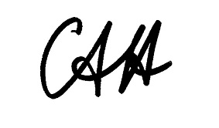
Standards Management Officer
Delegate of the Board of Food Standards Australia New Zealand

1 Name

This instrument is the Food Standards (Application A1042 – Food derived from Herbicide-tolerant Corn Line DAS-40278-9) Variation.

2 Variation to Standards in the Australia New Zealand Food Standards Code

The Schedule varies the Standards in the Australia New Zealand Food Standards Code.

3 Commencement

This variation commences on 13 October 2011.

SCHEDULE

[1] Standard 1.5.2 is varied by inserting in numerical order in the Schedule –

 | 2.19 | Food derived from herbicide-tolerant corn line DAS-40278-9

