

**Australian Government**

**Attorney-General's Department**

**Civil Law Division**

AG-MC11/12487

22 November 2011

Richard Selth

Director of Legislation and Records

House of Representatives Table Office

RG 89

Parliament House

Canberra ACT 2600

Australia

Dear Richard

**Replacement explanatory statement for the *Personal Property Securities Amendment Regulations 2011 (No. 1)* Select Legislative Instrument 2011 No. 176 (F2011L02030)**

I refer to our letter of 18 November regarding the explanatory statement accompanying the *Personal Property Securities Amendment Regulations 2011 (No. 1)* (the amending Regulations). The Senate Table Office has advised that the explanatory statement provide to your offices omitted the Select Legislative Instrument (SLI) number. Please find **attached** the replacement explanatory statement containing a description of the consultation undertaken and including the SLI number. This explanatory statement has also been provided to the Senate Table Office.

The action officer for this matter is Peter Horobin who can be contacted on (02) 6141 3626.

Yours sincerely

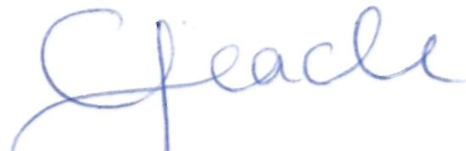

Chris Jeacle

Acting Assistant Secretary

Personal Property Securities Branch

Telephone: (02) 6141 4125

Facsimile: (02) 6141 3674

E-mail: [chris.jeacle@ag.gov.au](mailto:chris.jeacle@ag.gov.au)

Robert Garran Offices, National Circuit, Barton ACT 2600 Telephone (02) 6141 6666 [www.ag.gov.au](http://www.ag.gov.au) ABN 92 661 124436