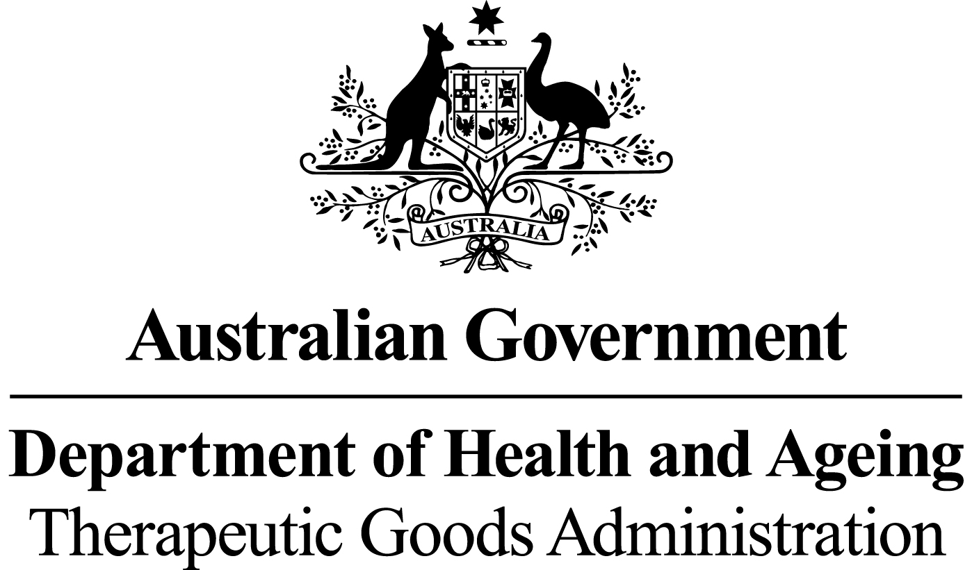

# *THERAPEUTIC GOODS ACT 1989*

### Section 10

# THERAPEUTIC GOODS ORDER NO. 86

# *Standards for human skin*

I, Jenny Hefford, delegate of the Minister for Health and Ageing for the purposes of section 10 of the *Therapeutic Goods Act 1989* (the Act) and acting under that section, having consulted with the Therapeutic Goods Committee in accordance with subsection 10(4) of the Act, HEREBY:

DETERMINE that the matters specified in this Order shall constitute a standard for biologicals that are human skin.

Dated this 8 day of July 2011

*(signed by)*

Jenny Hefford

Delegate of the Minister for Health and Ageing

### Name of Order

This Order may be cited as Therapeutic Goods Order No. 86 Standards for human skin.

### Commencement

This Order commences on 31 May 2012.

### Purpose of this Order

The purpose of this Order is to specify minimum technical requirements with which a biological that is human skin must comply.

### Interpretation

1. In this Order:

***Act*** means the*Therapeutic Goods Act 1989.*

***allogeneic use*** means use of a biological that is removed from one person and applied to another.

***antimicrobial*** means the ability of a substance to kill or inhibit growth of microorganisms.

***aseptic technique*** means the technique that consists of measures used to prevent contamination by microorganisms.

***autologous use*** means use of a biological that is removed from and applied to the same person.

***bioburden*** has the same meaning as in the Act.

***biological*** has the same meaning as in the Act.

***cell(s)*** means individual cells or a collection of cells when not bound by any form of connective tissue.

***collection*** means removing a biological or a source of a biological from a donor.

***container*** has the same meaning as in the Act.

***critical material*** means all materials or supplies used in the manufacture of therapeutic goods which could have a direct impact on the quality, safety or function of the final goods.

***donor*** means any source, whether living or deceased, of blood, blood components, cells or tissues.

***manufacture*** has the same meaning as in the Act.

***microbial*** means microorganisms including, but not limited to, bacteria, fungi, Mycoplasma and Rickettsia but does not include viruses or prions.

***minimal manipulation***the same meaning as in the Regulations.

***processing*** means any activity involved in the preparation, manipulation, preservation for storage, and packaging of a biological.

***recipient*** means a person who receives blood, blood components, cells or tissues by infusion or implantation.

***Regulations*** means the Therapeutic Goods Regulations 1990.

***skin*** is the outer integument or covering of the body, consisting of the dermis and the epidermis and resting upon the subcutaneous tissues.

***specified microorganism*** means a microorganism of clinical significance which, if isolated from the tissue, necessitates rejection of the tissue for therapeutic use.

***storage*** means maintaining a substance, material or product under appropriate controlled conditions.

***tissue*** means all constituent parts of the body formed by cells.

***transport*** means the transfer within or between premises of a substance, material or product under appropriate controlled conditions.

### Application of this Order

* 1. Subject to section 6, the requirements of this Order apply to biologicals that are human skin collected from:
     1. living human donors for autologous or allogeneic use; or
     2. deceased human donors for allogeneic use.

### Exemptions

* 1. The following biologicals that are human skin are exempt from the requirements set out under this Order:
  2. human skin cells and tissue biopsied for the purpose of an *in vitro* diagnosis and that are not for manufacture and/or reintroduction or transplant to a recipient; and
  3. human skin that is processed beyond minimal manipulation.

### General Requirements

1. In relation to manufacturing procedures relating to human skin, any critical materials used in the collection and manufacture of human skin must be of a design and quality that will not adversely affect the quality and condition of the human skin.
2. Collected human skin must be sampled for bioburden, using a validated sampling technique prior to being packaged and, when packaged, must be packaged within at least one moisture impermeable barrier using an aseptic technique.
3. Human skin must be manufactured in accordance with a defined and documented microbial contamination reduction procedure.
4. Written specifications for human skin must include a list of specified microorganisms, developed using a risk assessment process, listing microorganisms which, if tested and found to be present on sampled tissue specimens of human skin, must result in rejection of the skin for therapeutic use.
5. Any microbial growth detected when samples/specimens are cultured must be reported by the manufacturer to the medical practitioner who is treating the recipient of the human skin.
6. If the skin has been subjected to terminal sterilisation, the sterilisation process must be qualified to ensure that a sterility assurance level of 10-6 is achieved for the tissue.
7. After processing, human skin must be sealed within a sterile container and at least double packaged so as to:
8. prevent ingress/egress of material (other than gas sterilant if applicable); and
9. ensure that any breach of integrity will be evident.
10. After processing, human skin must be stored as follows:
11. either:
12. less than minus 40°C for a maximum period of 5 years; or
13. 2°C to 8°C for no more than 14 days; or
14. 2°C to 8°C for no more than 2 years if stored in greater than 75% glycerol; or
15. in accordance with conditions and duration specified and justified by validation data or documented evidence from the relevant scientific literature; and
16. when transported, in a manner that ensures that whichever of the conditions set out at (i), (ii), (iii) or (iv) applies is maintained during transport.