Food Standards (Application A1030 – Calcium Lignosulphonate (40-65) as a Food Additive) Variation

The Board of Food Standards Australia New Zealand gives notice of the making of this variation under section 92 of the Food Standards Australia New Zealand Act 1991. The Standard commences on the date specified in clause 3 of this variation.

Dated 27 June 2011

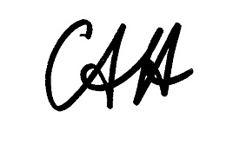

Standards Management Officer
Delegate of the Board of Food Standards Australia New Zealand

1 Name

This instrument is the Food Standards (Application A1030 – Calcium Lignosulphonate (40-65) as a Food Additive) Variation.

2 Variation to Standards in the Australia New Zealand Food Standards Code

The Schedule varies the Standards in the Australia New Zealand Food Standards Code.

3 Commencement

These variations commence on 11 July 2011.

SCHEDULE

[1] Standard 1.2.4 is varied by –

[1.1] inserting the following entry in alphabetical order into Part 1 of Schedule 2 –

Calcium lignosulphonate (40-65) | 1522

[1.2] inserting the following entry in numerical order into Part 2 of Schedule 2 –

Calcium lignosulphonate (40-65) | 1522

[2] Standard 1.3.1 is varied by inserting in column 1 and 2 respectively in each of the listings in Schedule 2 (Alphabetical Order and Numeric Order) –

1522 | Calcium lignosulphonate (40-65)

