AASB Standard | AASB 2011-2  May 2011

Amendments to Australian Accounting Standards arising from the Trans-Tasman Convergence Project – Reduced Disclosure Requirements

[AASB 101 & AASB 1054]

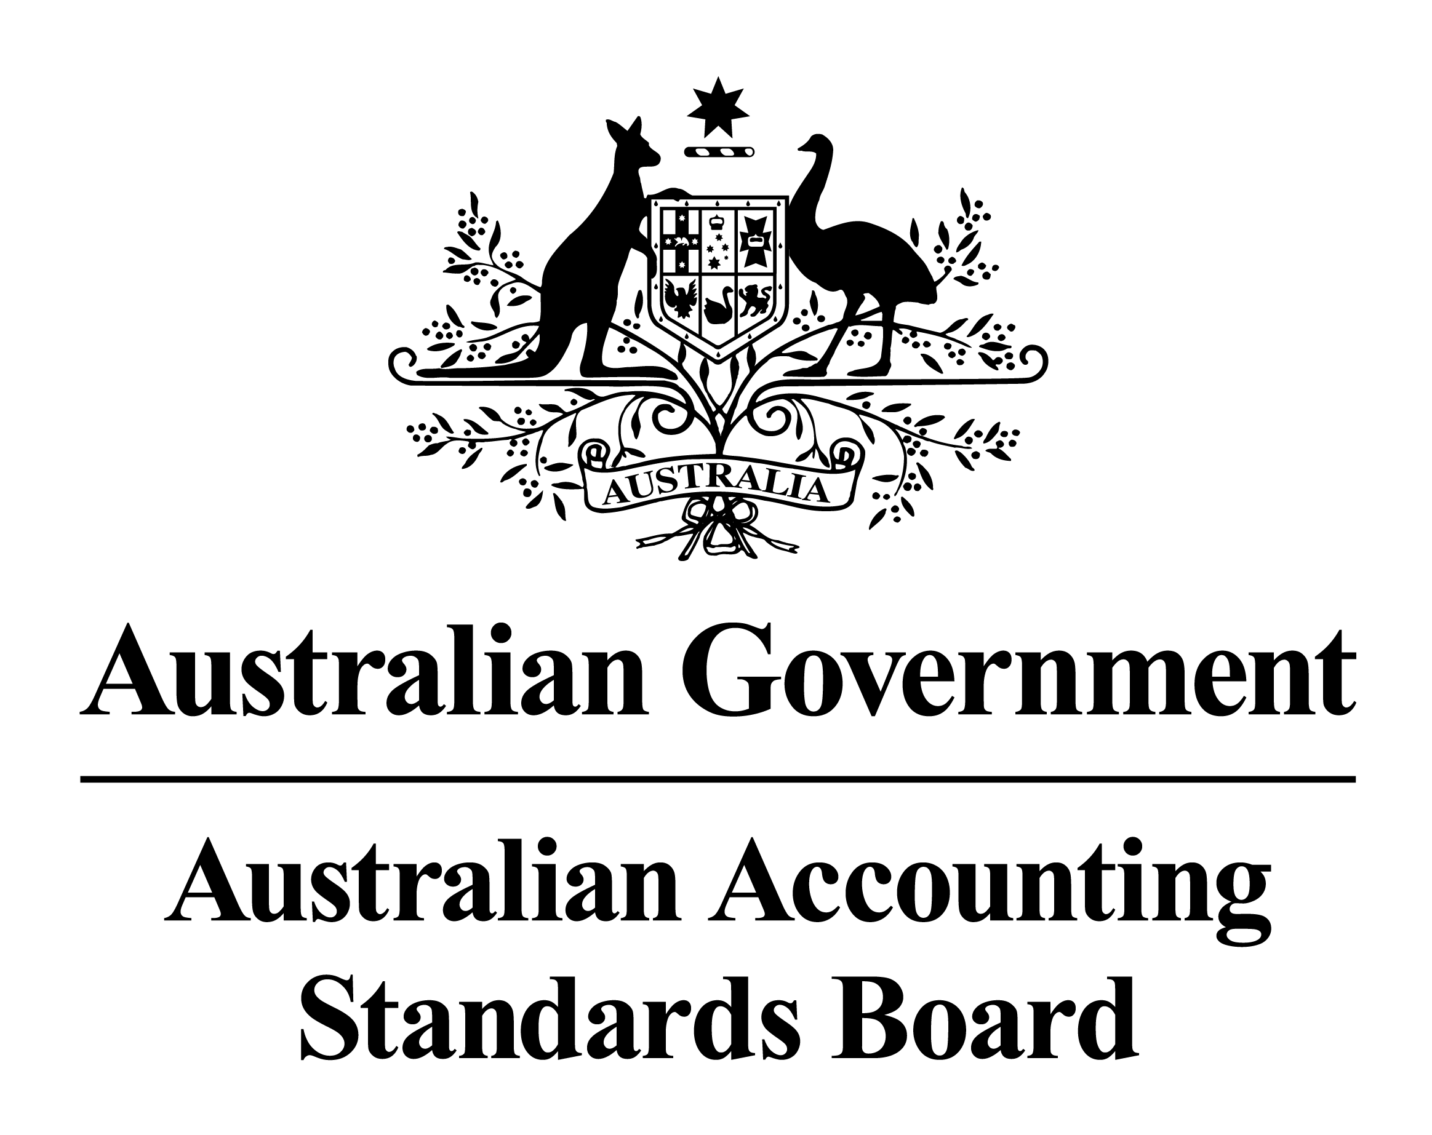

Obtaining a Copy of this Accounting Standard
This Standard is available on the AASB website: www.aasb.gov.au.
Alternatively, printed copies of this Standard are available for purchase by contacting:

The Customer Service Officer  Australian Accounting Standards Board  Level 7  600 Bourke Street  Melbourne Victoria  AUSTRALIA | Postal address:  PO Box 204  Collins Street West  Victoria 8007  AUSTRALIA
Phone: (03) 9617 7637
Fax: (03) 9617 7608
E-mail: publications@aasb.gov.au
Website: www.aasb.gov.au

Other Enquiries
COPYRIGHT

© Commonwealth of Australia 2011

This work is copyright. Apart from any use as permitted under the Copyright Act 1968, no part may be reproduced by any process without prior written permission. Requests and enquiries concerning reproduction and rights should be addressed to The Director of Finance and Administration, Australian Accounting Standards Board, PO Box 204, Collins Street West, Victoria 8007.

ISSN 1036-4803
Phone: (03) 9617 7600
Fax: (03) 9617 7608
E-mail: standard@aasb.gov.au

CONTENTS
Preface
Accounting Standard
AASB 2011-2 AmenDMENTS TO aUSTRALIAN aCCOUNTING sTANDARDS aRISING FROM the trans-tasman convergence project – reduced disclosure requirements

Paragraphs
Objective 1
Application 2 – 5
Amendments to AASB 101 6 – 7
Amendments to AASB 1054 8

Australian Accounting Standard AASB 2011-2 Amendments to Australian Accounting Standards arising from the Trans-Tasman Convergence Project – Reduced Disclosure Requirements is set out in paragraphs 1 – 8. All the paragraphs have equal authority.

Preface

Standards Amended by AASB 2011-2
This Standard makes amendments to the following Australian Accounting Standards:
- AASB 101 Presentation of Financial Statements
- AASB 1054 Australian Additional Disclosures,
to establish reduced disclosure requirements for entities preparing general purpose financial statements under Australian Accounting Standards – Reduced Disclosure Requirements in relation to the Australian additional disclosures arising from the Trans-Tasman Convergence Project.

Main Features of this Standard

Amendments to AASB 101
In June 2010, the AASB issued AASB 2010-2 Amendments to Australian Accounting Standards arising from Reduced Disclosure Requirements that introduced reduced disclosure requirements (RDR) to many Australian Accounting Standards, including AASB 101.
In May 2011, the AASB issued AASB 2011-1 Amendments to Australian Accounting Standards arising from the Trans-Tasman Convergence Project and AASB 1054 as outcomes of the Trans-Tasman Convergence project. AASB 1054 contains the Australian-specific disclosures that are in addition to International Financial Reporting Standards. AASB 2011-1 contains the related amendments to other Australian Accounting Standards. For example, some of the disclosure requirements previously in paragraphs Aus15.1-Aus15.3 and other paragraphs of AASB 101 are now included in AASB 1054 instead.
This Standard revises the RDR amendments originally specified in AASB 2010-2 for AASB 101 to reflect the deletion of certain disclosure requirements from AASB 101.

Amendments to AASB 1054
This Standard makes amendments to AASB 1054 to introduce reduced disclosure requirements to that Standard for entities preparing general purpose financial statements under Australian Accounting Standards – Reduced Disclosure Requirements. These reflect the reduced disclosure requirements originally specified in AASB 2010-2 for AASB 101 disclosures that are now in AASB 1054.

Application Date
This Standard is applicable to annual reporting periods beginning on or after 1 July 2013. Early adoption is permitted for annual reporting periods beginning on or after 1 July 2009 but before 1 July 2013, provided that the following are also adopted for the same period:
- AASB 1053 Application of Tiers of Australian Accounting Standards;
- AASB 1054; and
- AASB 2011-1.

aCCOUNTING STANDARD AASB 2011-2
The Australian Accounting Standards Board makes Accounting Standard AASB 2011-2 Amendments to Australian Accounting Standards arising from the Trans-Tasman Convergence Project – Reduced Disclosure Requirements under section 334 of the Corporations Act 2001.

 | Kevin M. Stevenson
Dated 11 May 2011 | Chair – AASB

aCCOUNTING STANDARD AASB 2011-2
AMENDMENTS TO AUSTRALIAN ACCOUNTING STANDARDS ARISING FROM the trans-Tasman Convergence project – reduced disclosure requirements

Objective
- The objective of this Standard is to make amendments to:
  - AASB 101 Presentation of Financial Statements; and
  - AASB 1054 Australian Additional Disclosures;
to establish reduced disclosure requirements for entities preparing general purpose financial statements under Australian Accounting Standards – Reduced Disclosure Requirements for the Australian additional disclosures arising from the Trans-Tasman Convergence Project.

Application
- This Standard applies to:
- each entity that is required to prepare financial reports in accordance with Part 2M.3 of the Corporations Act;
- general purpose financial statements of each reporting entity; and
- financial statements that are, or are held out to be, general purpose financial statements.
- This Standard applies to annual reporting periods beginning on or after 1 July 2013.
- This Standard shall be applied when AASB 1053 Application of Tiers of Australian Accounting Standards is applied. This Standard may be applied to annual reporting periods beginning on or after 1 July 2009 but before 1 July 2013 provided the following are also adopted for the same period:
- AASB 1053;
- AASB 1054; and
- AASB 2011-1 Amendments to Australian Accounting Standards arising from the Trans-Tasman Convergence Project.
When an entity applies this Standard to such an annual reporting period, it shall disclose that fact.
- This Standard uses underlining, striking out and other typographical material to identify some of the amendments to a Standard, in order to make the amendments more understandable. However, the amendments made by this Standard do not include that underlining, striking out or other typographical material.

Amendments to AASB 101
- Paragraph Aus1.8 is amended as follows (new text is underlined and deleted text is struck through):
Aus1.8 The following do not apply to entities preparing general purpose financial statements under Australian Accounting Standards – Reduced Disclosure Requirements:
      - paragraphs 10(f), 15, 16, Aus16.1, Aus16.3, 39(c), 42(b), 61, 65, 80A, 90-92, 94, 104, 131 and 134-138 Aus138.6;
      - the second sentence in paragraph 39; and
      - in paragraph 107, the text “, and the related amount of dividends per share”.
Entities applying Australian Accounting Standards – Reduced Disclosure Requirements may elect to comply with some or all of these excluded requirements.
- Paragraph RDR16.1 is amended as follows (deleted text is struck through):
RDR16.1 An entity whose financial statements comply with Australian Accounting Standards – Reduced Disclosure Requirements shall make an explicit and unreserved statement of such compliance in the notes. An entity shall not describe financial statements as complying with Australian Accounting Standards – Reduced Disclosure Requirements unless they comply with all the requirements of Australian Accounting Standards – Reduced Disclosure Requirements. Entities applying Australian Accounting Standards – Reduced Disclosure Requirements would not be able to state compliance with IFRSs.

Amendments to AASB 1054
- The following subheading and paragraphs are added to AASB 1054:
Reduced Disclosure Requirements
5A Paragraphs 10-16 of this Standard do not apply to entities preparing general purpose financial statements under Australian Accounting Standards – Reduced Disclosure Requirements. Entities applying Australian Accounting Standards – Reduced Disclosure Requirements may elect to comply with some or all of these excluded requirements.
5B The requirements that do not apply to entities preparing general purpose financial statements under Australian Accounting Standards – Reduced Disclosure Requirements are identified in this Standard by shading of the relevant text.
5C RDR paragraphs in this Standard apply only to entities preparing general purpose financial statements under Australian Accounting Standards – Reduced Disclosure Requirements.
RDR7.1 An entity whose financial statements comply with Australian Accounting Standards – Reduced Disclosure Requirements shall make an explicit and unreserved statement of such compliance in the notes. An entity shall not describe financial statements as complying with Australian Accounting Standards – Reduced Disclosure Requirements unless they comply with all the requirements of Australian Accounting Standards – Reduced Disclosure Requirements.

