Supplementary Information regarding Public Consultation for the Cockatoo Island Management Plan

# Introduction

The following information is being provided by the Sydney Harbour Federation Trust to the Attorney-General's Department to supplement the Explanatory Statement for the Cockatoo Island Management Plan, which was registered on the Federal Register of Legislative Instruments on 2 September 2010 for the purposes of sections 324S and 341S of the *Environment Protection and Biodiversity Conservation Act 1999.*

# Public Consultation

The Draft Cockatoo Island Management Plan was placed on public exhibition as required under the EPBC Act, and the Trust Comprehensive Plan.

This exhibition took place between 8 September and 3 October 2008. Advertisements were placed in the Australian newspaper and various local papers distributed to the suburbs immediately surrounding the Island. The draft Plan was made available for public viewing at five separate locations and online via the Harbour Trust website. Letters advising of the exhibition were also sent to various stakeholders with an interest in the Island including Commonwealth and State agencies and the local government representatives.

At the conclusion of the exhibition period the Trust received one submission from Sydney Ferries. In summary, Sydney Ferries raised no objections or issues in relation to the draft Plan. No changes were made to the Plan as a result of the exhibition.

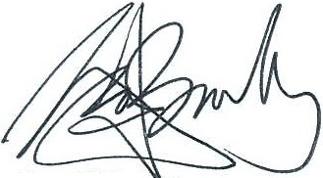

Geoff Bailey Executive Director

Sydney Harbour Federation Trust 10 March 2011