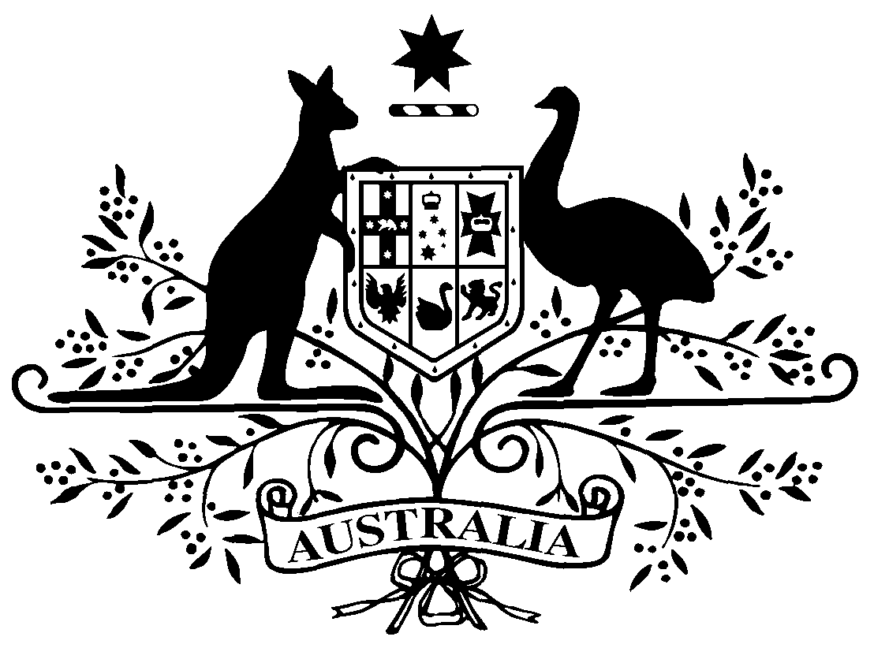

COMMONWEALTH OF AUSTRALIA

Instrument number PB 52 of 2010

Special arrangements (Variation) made under subsection 100(2) of the National Health Act 1953

I, Linda Jackson, delegate of the Minister for Health and Ageing, make this instrument under subsection 100(2) of the National Health Act 1953.

Dated 19 May 2010

Signed

LINDA JACKSON
Assistant Secretary
Access and Systems Branch
Pharmaceutical Benefits Division
Department of Health and Ageing

Special Arrangements (Variation)— IVF/GIFT Program

- Commencement
This instrument commences on 1 June 2010.
- Amendment of PB 26 of 2007
Schedule 1 varies PB 26 of 2007.

Schedule 1 Variations

[1] The Schedule, Part 1
omit from the table in the order indicated:
Follitropin Alfa | Injection set containing 1 vial powder for injection 75 I.U and 1 pre-filled syringe solvent 1 mL | Gonal-f 75 | Merck Serono Australia Pty Ltd (SG)
Follitropin Alfa | Injection set containing 10 vials powder for injection 75 I.U and 10 pre-filled syringes solvent 1 mL | Gonal-f 75 | Merck Serono Australia Pty Ltd (SG)
Follitropin Alfa | Injection set containing 1 vial powder for injection 450 I.U and 1 pre-filled syringe solvent 1 mL | Gonal-f | Merck Serono Australia Pty Ltd (SG)
Follitropin Alfa | Injection set containing 1 vial powder for injection 1,050 I.U and 1 pre-filled syringe solvent 2 mL | Gonal-f | Merck Serono Australia Pty Ltd (SG)

Note

1. All legislative instruments and compilations are registered on the Federal Register of Legislative Instruments kept under the Legislative Instruments Act 2003. See http://www.frli.gov.au.

