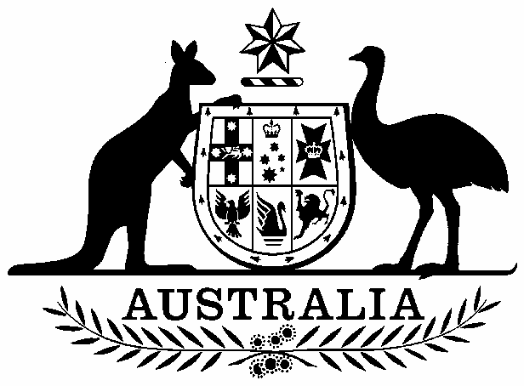

Commonwealth of Australia

Inclusion of ecological communities in the list of threatened ecological communities under section 181 of the Environment Protection and Biodiversity Conservation Act 1999

I, PETER ROBERT GARRETT, Minister for Environment Protection, Heritage and the Arts, pursuant to paragraph 184(1)(a) of the Environment Protection and Biodiversity Conservation Act 1999, hereby amend the list referred to in section 181 of that Act by:

including in the list in the endangered category
Grey Box (Eucalyptus microcarpa) Grassy Woodlands and Derived Native Grasslands of South-eastern Australia
as described in the Schedule to this instrument.

Dated this….......Nineteenth...................day of….................March..............................2010

Signed by Peter Garrett

Minister for Environment Protection, Heritage and the Arts

SCHEDULE

Grey Box (Eucalyptus microcarpa) Grassy Woodlands and Derived Native Grasslands of South-eastern Australia

The Grey Box (Eucalyptus microcarpa) Grassy Woodlands and Derived Native Grasslands of South-Eastern Australia is a broad-scale ecological community that ranges from central New South Wales through southern NSW, northern and central Victoria into eastern South Australia. Disjunct patches are also known to occur in the Victorian Volcanic Plain to the west of Melbourne, and in the Flinders and Mount Lofty Ranges of South Australia.
The ecological community typically occurs in landscapes of low-relief such as flat to undulating plains, low slopes and rises and, to a lesser extent, drainage depressions and flats. Patches may extend to more elevated hillslopes on the fringes of its range where it intergrades with other woodland or forest communities.

The typical structure of the Grey Box (E. microcarpa) Grassy Woodlands and Derived Native Grasslands of South-Eastern Australia is a woodland to open forest with a tree canopy layer dominated by eucalypts, a moderately dense to sparse mid (or shrub) layer and a variable ground layer. Patches of the ecological community may occur as derived grassland, where the tree canopy and shrub layers have been removed but the native ground layer remains largely intact. There should be evidence to indicate that the tree canopy and shrub layers removed were consistent with the description of the ecological community and that sufficient native ground layer species remain to be consistent with the ground layer for the woodland state of the ecological community.

The tree canopy, where present, is dominated by Eucalyptus microcarpa (Grey Box). Other tree species may be present to co-dominant with Grey Box at some sites. The tree species associated with Grey Box varies across the range of the ecological community. The more widespread associated tree species include: Allocasuarina luehmannii (Buloke), Brachychiton populneus (Kurrajong), Callitris columellaris (White Cypress Pine), Eucalyptus albens (White Box), E. camaldulensis (River Red Gum), E. conica (Fuzzy Box), E. leucoxylon (Yellow Gum, SA Blue Gum), E. melliodora (Yellow Box) and E. populnea (Bimble Box, Poplar Box).

The mid layer is variable, ranging from absent, where it has been removed, to moderately dense cover. Shrub composition also is variable. Widespread shrubs that may be present include species in the genera Acacia, Bursaria, Cassinia, Dodonaea, Eremophila and Maireana. Regrowth of young canopy trees also may be present in the mid layer.

The ground layer is variable and ranges from largely absent to mostly grassy to forb-rich. The species composition also is variable and includes a range of tussock grasses, other grass-like plants, forbs and chenopods. Common graminoid genera present include Austrodanthonia (Wallaby Grasses), Austrostipa (Spear Grasses), Elymus (Wheat-grass), Enteropogon (Windmill Grasses), Dianella (Flax-lilies) and Lomandra (Mat-rushes). Chenopod genera commonly present include Atriplex, Chenopodium, Einadia, Enchylaena, Maireana, Salsola and Sclerolaena.

The key diagnostic characteristics for the Grey Box (E. microcarpa) Grassy Woodlands and Derived Native Grasslands of South-Eastern Australia are:
- The ecological community occupies a landscape zone transitional between semi-arid communities and the temperate woodlands and forests of the lower slopes and ranges.
- The ecological community occurs on low slopes and plains from central NSW, through northern and central Victoria into South Australia. Disjunct occurrences are known from near Melbourne and in the Flinders-Lofty Block Bioregion of South Australia.
- The vegetation structure of the ecological community is typically a woodland to open forest.
- The tree canopy is dominated (≥ 50% canopy crown cover) by Eucalyptus microcarpa (Grey Box). Other tree species may be present in the canopy and, in certain circumstances, may be co-dominant with Grey Box but are never dominant on their own.
- The mid layer comprises shrubs of variable composition and cover, from absent to moderately dense. The mid layer usually has a crown cover of less than 30% with local patches up to 40% crown cover.
- The ground layer also is highly variable in development and composition, ranging from almost absent to mostly grassy to forb-rich. Ground layer flora commonly present include one or more of the graminoid genera: Austrodanthonia, Austrostipa, Elymus, Enteropogon, Dianella and Lomandra; and one or more of the chenopod genera: Atriplex, Chenopodium, Einadia, Enchylaena, Maireana, Salsola and Sclerolaena.
- Derived grasslands are a state of the ecological community, whereby the canopy and mid layers have been mostly removed to <10% crown cover but the native ground layer remains largely intact, with 50% or more of the total vegetation cover being native.

