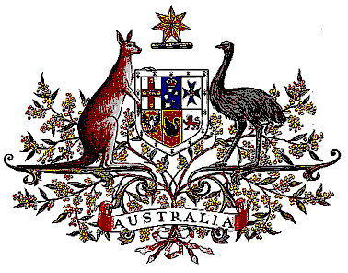Veterans’ Entitlements Act 1986

Determination of Warlike Service
OPERATION CATALYST

I, Greg Combet, Minister for Defence Personnel, Materiel and Science for the Minister for Defence:
  - revoke the determination made under subsection 5C(1) of the Veterans’ Entitlements Act 1986 (the Act) on 16 July 2003 in relation to Operation CATALYST; and
  - determine that service rendered as a member of the Australian Defence Force allotted for service on Operation CATALYST during the period 16 July 2003 to 31 July 2009 in the Specified Area defined below is warlike service for the purposes of the definition of “warlike service” in subsection 5C(1) of the Act.
- The Specified Area comprises the total land areas, territorial waters, internal waterways and superjacent airspace boundaries of Iraq, Kuwait, Bahrain, Qatar, United Arab Emirates, Saudi Arabia north of 23 degrees North latitude, the Persian Gulf and the Strait of Hormuz.

Dated 12 February, 2010

GREG COMBET
Minister for Defence Personnel, Materiel and Science
for the Minister for Defence

