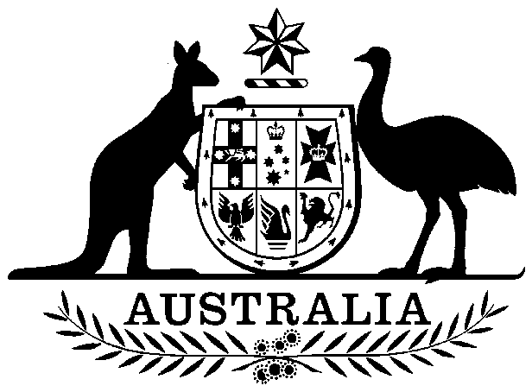
COMMONWEALTH OF AUSTRALIA

Environment Protection and Biodiversity Conservation Act 1999

Amendment of List of Exempt Native Specimens

I, NIGEL ROUTH, Assistant Secretary, Marine Biodiversity Policy Branch, as Delegate of the Minister for the Environment, Heritage and the Arts pursuant to subsection 303DC(1) of the Environment Protection and Biodiversity Conservation Act 1999 (EPBC Act), hereby amend the list of exempt native specimens established under section 303DB of the EPBC Act by deleting from the list the following item that was included on the list on 24 November 2004 and any associated notations:

- Specimens that are or are derived from fish or invertebrates, other than specimens that belong to species listed under Part 13 of the Act, taken in the Southern Squid Jig Fishery, as defined in the Southern Squid Jig Fishery Management Plan 2004, made under the Fisheries Management Act 1991.

Dated this 24th day of November 2009

[signed]

……………Nigel Routh……………
Delegate of the Minister for the Environment, Heritage and the Arts

