National Transport Commission (Model Amendments Regulations: Australian Road Rules — Package No. 5 — General) Regulations 2009¹
Select Legislative Instrument 2009 No. 241
I, QUENTIN BRYCE, Governor-General of the Commonwealth of Australia, acting with the advice of the Federal Executive Council, make the following Regulations under the National Transport Commission Act 2003.
Dated 17 September 2009
QUENTIN BRYCE
Governor-General
By Her Excellency’s Command
ANTHONY ALBANESE
Minister for Infrastructure, Transport, Regional Development and Local Government

1 Name of Regulations
These Regulations are the National Transport Commission (Model Amendments Regulations: Australian Road Rules — Package No. 5 — General) Regulations .
2 Commencement
These Regulations commence on the day after they are registered.
3 Model legislation — Australian Road Rules
For section 7 of the National Transport Commission Act 2003 (the NTC Act), Schedule 1 sets out model legislation, in the form of amending Regulations, about the rules to be followed by all road users.
Note 1 The model legislation set out in Schedule 1 does not have the force of law (see paragraph 7 (2) (a) of the NTC Act).
Note 2 These Regulations are not subject to disallowance — see the Legislative Instruments Act 2003, subsection 44 (2) (table, item 44) and the Legislative Instruments Regulations 2004, regulation 8 and Schedule 2 item 7.
Note 3 These Regulations are not subject to sunsetting — see the Legislative Instruments Act 2003, subsection 54 (2) (table, item 51) and the Legislative Instruments Regulations 2004, regulation 9 and Schedule 3 item 4.
Note 4 The amendments set out in Schedule 1 were approved by the Australian Transport Council on 29 September 2006. An earlier version of these amendments was set out in the National Transport Commission (Road Transport Legislation — Australian Road Rules) Amendment Regulations 2008 (No. 2). Contrary to what was stated in note 5 to regulation 3 of those Regulations, the amendments set out in those Regulations were not approved by the Australian Transport Council. These Regulations revoke the 2008 Regulations (regulation 5) and set out the amendments concerning general provisions that were approved by the Council on 29 September 2006.
4 Amendment of the National Transport Commission (Road Transport Legislation — Australian Road Rules) Regulations 2006
Schedule 1 amends the text set out in Schedule 1 to the National Transport Commission (Road Transport Legislation — Australian Road Rules) Regulations 2006 as if a reference in Schedule 1 to a provision of the Australian Road Rules were a reference to the corresponding provision in that text.
5 Revocation of the National Transport Commission (Road Transport Legislation — Australian Road Rules) Amendment Regulations 2008 (No. 2)
The National Transport Commission (Road Transport Legislation — Australian Road Rules) Amendment Regulations 2008 (No. 2) are revoked.

Schedule 1 Amendments
(regulation 3)

- Part 4, Division 1, heading
substitute
Division 1 Left turns
[2] Rule 26
substitute
26 Application of Division to roundabouts, road-related areas and adjacent land
(1) This Division does not apply to a driver entering or leaving a roundabout.
Note 1 Roundabout is defined in rule 109.
Note 2 Part 9 deals with entering and leaving a roundabout.
(2) This Division applies to a driver turning left from a road into a road-related area or adjacent land, or from a road-related area into a road, as if the driver were turning left at an intersection.
Note 1 Adjacent land and intersection are defined in the dictionary and road-related area is defined in rule 13. Adjacent land or a road-related area can include a driveway, service station or shopping centre — see the definitions.
Note 2 Rule 74 deals with the give way rules applying to a driver entering a road from a road-related area or adjacent land, and rule 75 deals with the give way rules applying to a driver entering a road-related area or adjacent land from a road. Rule 212 deals with a driver entering and leaving a median strip parking area.
Note 3 For the meaning of left, see rule 351 (1).
(3) In this rule:
road does not include a road-related area.
Note A road-related area includes the shoulder of a road — see rule 13.
[3] Paragraph 28 (1) (c)
omit
subrule (2)
insert
subrule (1A) or (2)
[4] After subrule 28 (1), including the notes and example
insert
(1A) A driver turning left at an intersection from a multi-lane road that has a slip lane must approach and enter the intersection:
(a) from within the slip lane; or
(b) if there is an obstruction that prevents the driver from entering the intersection from within the slip lane — from within the left lane.
Offence provision.
Note Obstruction and slip lane are defined in the dictionary.
[5] Subrule 28 (3), note 1
substitute
Note 1 Special purpose lane is defined in the dictionary.
[6] Rule 29
substitute
29 Making a left turn as indicated by a turn line
(1) If a driver is turning left at an intersection and there is a turn line indicating how the turn is required to be made, the driver must make the turn as indicated by the turn line unless:
(a) the driver is turning, at B lights or traffic arrows, in accordance with Division 2 of Part 17; or
(b) subrule (2) applies to the driver.
Offence provision.
Note B lights, intersection, traffic arrows and turn line are defined in the dictionary.
Example
Making a left turn as indicated by a turn line
(2) A driver may turn left at an intersection other than as indicated by a turn line if:
(a) the driver’s vehicle, together with any load or projection, is 7.5 metres long, or longer; and
(b) the vehicle displays a do not overtake turning vehicle sign; and
(c) it is not practicable for the driver to turn left as indicated by the turn line; and
(d) the driver can safely turn left other than as indicated by the turn line.
Note 1 Driver’s vehicle is defined in the dictionary.
Note 2 Vehicle includes a combination — see rule 15 (d).
Note 3 Under the law of this jurisdiction, only certain long vehicles may display a do not overtake turning vehicle sign.
Do not overtake turning vehicle signs

Note for diagrams These signs are displayed on certain long vehicles.
[7] Part 4, Division 2, heading
substitute
Division 2 Right turns
[8] Rule 30
substitute
30 Application of Division to certain right turns
(1) This Division does not apply to:
(a) a driver turning right at an intersection where there is a hook turn only sign; or
(b) the rider of a bicycle making a hook turn under Division 3; or
(c) a driver making a U-turn; or
(d) a driver entering or leaving a roundabout.
Note 1 Bicycle, intersection and U-turn are defined in the dictionary and roundabout is defined in rule 109.
Note 2 Division 3 of this Part deals with hook turns, Division 4 deals with U-turns and Part 9 deals with entering and leaving a roundabout.
Note 3 For the meaning of right, see rule 351 (2).
(2) This Division applies to a driver turning right from a road into a road-related area or adjacent land, or from a road-related area into a road, as if the driver were turning right at an intersection.
Note 1 Adjacent land is defined in the dictionary and road-related area is defined in rule 13. Adjacent land or a road-related area can include a driveway, service station or shopping centre — see the definitions.
Note 2 Rule 74 deals with the give way rules applying to a driver entering a road from a road-related area or adjacent land, and rule 75 deals with the give way rules applying to a driver entering a road-related area or adjacent land from a road. Rule 212 deals with a driver entering and leaving a median strip parking area.
(3) In this rule:
road does not include a road-related area.
Note A road-related area includes the shoulder of a road — see rule 13.
[9] Rule 33
substitute
33 Making a right turn
(1) A driver turning right at an intersection must make the turn in accordance with this rule unless:
(a) the driver is turning, at B lights or traffic arrows, in accordance with Division 2 of Part 17; or
(b) subrule (4) applies to the driver.
Offence provision.
Note B lights, intersection and traffic arrows are defined in the dictionary.
(2) If there is a turn line indicating how the turn is required to be made, the driver must make the turn as indicated by the turn line.
Note Turn line is defined in the dictionary.
(3) If there is no turn line indicating how the turn is required to be made, the driver must make the turn so the driver:
(a) passes as near as practicable to the right of the centre of the intersection; and
(b) turns into the left of the centre of the road the driver is entering, unless the driver is entering a one-way road.
Note Centre of the road is defined in the dictionary.
Examples
Example 1  Making a right turn as indicated by turn lines | Example 2  Making a right turn from a road with no turn lines indicating how to make the turn
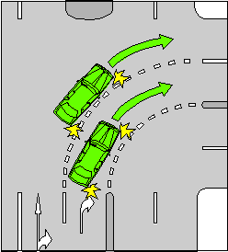 | 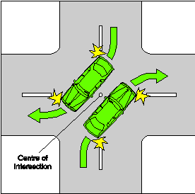
(4) A driver may turn right other than as indicated by a turn line if:
(a) the driver’s vehicle, together with any load or projection, is 7.5 metres long, or longer; and
(b) the vehicle displays a do not overtake turning vehicle sign; and
(c) it is not practicable for the driver to turn right as indicated by the turn line; and
(d) the driver can safely make the turn other than as indicated by the turn line.
Note 1 Driver’s vehicle is defined in the dictionary.
Note 2 Vehicle includes a combination — see rule 15 (d).
Note 3 Under the law of this jurisdiction, only certain long vehicles may display a do not overtake turning vehicle sign.
Do not overtake turning vehicle signs
Note for diagrams These signs are displayed on certain long vehicles.

[10 to 14 have been deleted – renumber]

[10] Part 4, Division 5
omit
[11] Part 6, heading
substitute
Part 6 Traffic lights, traffic arrows and twin red lights
[12] Part 6, Division 1, heading, except the notes
substitute
Division 1 Obeying traffic lights and traffic arrows
[13] Part 6, Division 1, heading, note 1
omit
installed with traffic lights that are
[14] Subrule 56 (1), example
substitute
Example for subrule (1) (b)
Stopping at a stop here on red signal sign on a road the driver is entering
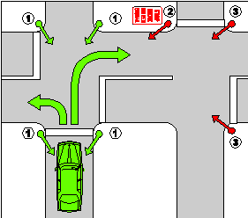
[15] Rule 60
omit
an intersection
insert
an intersection or marked foot crossing
[16] Rule 60
omit
the intersection.
insert
the intersection or marked foot crossing.
[17] Rule 60, note 1
substitute
Note 1 Enter, intersection, marked foot crossing and red traffic arrow are defined in the dictionary.
[18] Part 6, Division 2, heading, except the note
substitute
Division 2 Giving way at traffic lights and traffic arrows
[19] Rule 62
omit
A driver
insert
(1) A driver
[20] Rule 62, after note 4
insert
(2) However, a driver who is turning at an intersection with traffic arrows showing a green traffic arrow need not give way to an oncoming vehicle if the driver is turning in the direction indicated by the green traffic arrow.
Note Green traffic arrow is defined in the dictionary.
[21] Subrule 67 (2), including the note
substitute
(2) The driver must stop as near as practicable to, but before reaching:
(a) the stop line; or
(b) if there is no stop line — the intersection.
[22] Subrule 67 (3), note
substitute
Note Enter, give way line, oncoming vehicle, slip lane and U-turn are defined in the dictionary.
[23] Subrule 68 (1)
omit
(except an intersection, children’s crossing, level crossing, or a place with twin red lights)
[24] Subrule 68 (1)
omit
rule.
insert
rule, unless the place is:
(a) an intersection; or
(b) a children’s crossing; or
(c) an area of a road that is not a children’s crossing only because it does not have:
(i) children crossing flags; or
(ii) children’s crossing signs and twin yellow lights; or
(d) a level crossing; or
(e) a place with twin red lights.
[25] Subrule 68 (2)
substitute
(2) The driver must stop as near as practicable to, but before reaching:
(a) the stop line; or
(b) if there is no stop line — the stop sign.
[26] Subrule 68 (3)
before
stop sign.
insert
stop line or
[27] Paragraph 73 (2) (a)
omit
road; and
insert
road (except a vehicle making a U-turn on the continuing road at the T-intersection); and
- Paragraph 73 (3) (a)
omit
road; and
insert
road (except a vehicle making a U-turn on the continuing road at the T-intersection); and
- Paragraph 73 (5) (a)
omit
right; and
insert
right (except a vehicle making a U-turn from the terminating road at the T-intersection); and
- Subrule 80 (2)
omit
must stop at
insert
must stop as near as practicable to, but before reaching,
- Subrule 80 (3)
after
until
insert
there is no pedestrian on or entering the crossing and
- Subrule 81 (3), except the notes, diagram and examples
substitute
(3) A pedestrian crossing is an area of a road:
(a) at a place with white stripes on the road surface that:
(i) run lengthwise along the road; and
(ii) are of approximately the same length; and
(iii) are approximately parallel to each other; and
(iv) are in a row that extends completely, or partly, across the road; and
(b) with or without either or both of the following:
(i) a pedestrian crossing sign;
(ii) alternating flashing twin yellow lights.
- Rule 85
substitute
85 Giving way on a painted island
A driver entering a turning lane from a painted island must give way to:
(a) any vehicle in the turning lane; or
(b) if the turning lane and painted island are nearest to the far left side of the road — any vehicle entering the turning lane from the marked lane, or line of traffic, immediately to the right of the turning lane; or
(c) if the turning lane and painted island are nearest to the dividing line or median strip on the road or the far right side of the road — any vehicle entering the turning lane from the marked lane, or line of traffic, immediately to the left of the turning lane.
Offence provision.
Note 1 Line of traffic, marked lane, painted island and turning lane are defined in the dictionary.
Note 2 Rules 138 and 139 (4) allow a driver to drive on a painted island in certain circumstances.
Note 3 For this rule, give way means the driver must slow down and, if necessary, stop to avoid a collision — see the definition in the dictionary.
Examples
Example 1  Driver entering a turning lane from a painted island giving way to a vehicle entering the turning lane from the marked lane immediately to the right of the turning lane. | Example 2  Driver entering a turning lane from a painted island giving way to a vehicle entering the turning lane from the marked lane immediately to the left of the turning lane.
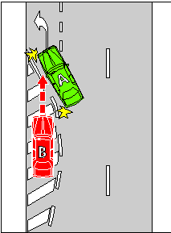 | 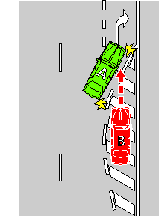
In the examples, vehicle B must give way to vehicle A.
- Rule 87, heading
substitute
87 Giving way when moving from a side of a road or a median strip parking area
- Subrule 87 (1)
omit
road, or from a shoulder of a road,
insert
road
- Subrule 87 (1), note 1
substitute
Note 1 Line of traffic and marked lane are defined in the dictionary.
- After subrule 87 (3), including the notes
insert
(4) In this rule:
road does not include a road-related area, but includes any shoulder of the road.
Note Road-related area is defined in rule 13 and shoulder is defined in rule 12.
- Part 8, Division 1, heading
substitute
Division 1 Traffic signs and road markings at intersections and other places
Note Intersection, road marking and traffic sign are defined in the dictionary.
- Subrules 91 (1) and (2), except the diagrams and the note for diagrams
substitute
(1) If there is a no left turn sign at an intersection, or another place on a road, a driver must not turn left at the intersection or place.
Offence provision.
(2) If there is a no right turn sign at an intersection, or another place on a road, a driver must not turn right or make a U-turn at the intersection or place.
Offence provision.
- Subrule 91 (3)substitute
(3) However, a driver may make a U-turn at the intersection or place if there is a U-turn permitted sign at the intersection or place.
- Subrule 92 (2), including the note and the examples
substitute
(2) However, this rule does not apply to a driver if:
(a) the arrows indicate a direction to the right (whether or not they also indicate another direction) at an intersection and the driver is making a U-turn at the intersection; or
(b) a traffic sign indicates that the driver may drive in a direction different to that indicated by the traffic lane arrows; or
(c) the driver is driving in the direction indicated by traffic lane arrows that apply to 1 or more marked lanes and there is an obstruction in each of those lanes; or
(d) the driver is turning at an intersection in accordance with subrule 28 (2) or 32 (2).
Note 1 Obstruction and U-turn are defined in the dictionary.
Note 2 Rules 40 and 41 deal with making a U-turn at an intersection. If there are traffic lights at the intersection, the driver may make a U-turn only if there is a U-turn permitted sign at the intersection. If there are no traffic lights at the intersection, the driver may make a U-turn unless there is a no U-turn sign at the intersection.
Note 3 Subrule 28 (2) deals with vehicles 7.5 metres long or longer turning left at an intersection from within the marked lane next to the left lane as well as, or instead of, the left lane on a multi-lane road. Rule 32 (2) deals with vehicles 7.5 metres long or longer turning right at an intersection from within the marked lane next to the right lane as well as, or instead of, the right lane on a multi-lane road.
Examples
Example 1  Traffic lane arrows on the surface of marked lanes | Example 2  Traffic lane arrows on a traffic sign
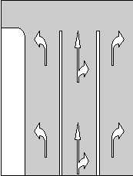 | 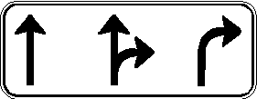
- Subrule 98 (2), after note 2
insert
(3) This rule does not apply to the rider of a motor bike that is a postal vehicle, the rider of a bicycle or the rider of an animal if the rider:
(a) is riding on a footpath, nature strip or shared path adjacent to the length of road; and
(b) is permitted to ride on the footpath, nature strip or shared path under the Australian Road Rules or another law of this jurisdiction.
Note Bicycle, footpath, motor bike, nature strip and postal vehicle are defined in the dictionary and shared path is defined in rule 242.
- Subrule 99 (2), before the diagrams
insert
(3) This rule does not apply to the rider of a motor bike that is a postal vehicle, the rider of a bicycle or the rider of an animal if the rider:
(a) is riding on a footpath, nature strip or shared path; and
(b) is permitted to ride on the footpath, nature strip or shared path under the Australian Road Rules or another law of this jurisdiction.
Note Bicycle, footpath, motor bike, nature strip and postal vehicle are defined in the dictionary and shared path is defined in rule 242.
- After rule 101
insert in Division 2
101A Safety ramp and arrester bed signs
(1) A driver must not drive on a safety ramp or arrester bed unless:
(a) it is necessary for the driver to do so in the interests of safety; or
(b) the driver is permitted to do so under another law of this jurisdiction.
Offence provision.
(2) In this rule:
arrester bed means an area to which an arrester bed sign applies.
safety ramp means an area to which a safety ramp sign applies.
Arrester bed sign | Safety ramp sign
 | 
Note for diagrams There are a number of other permitted versions of each of these signs — see the diagrams in Schedule 3.
- Subrule 104 (4), except the diagram
substitute
(4) This rule does not apply to a driver if the destination of the driver lies beyond a no trucks sign and:
(a) there is no other route by which the driver’s vehicle could reach that destination; or
(b) any other route by which the driver’s vehicle could reach that destination would require the vehicle to pass another no trucks sign.
- Rule 109
omit
intersection with:
insert
intersection:
- Paragraph 109 (a)
omit
either:
insert
with either:
- Paragraph 109 (b)
substitute
(b) with or without a roundabout sign at each entrance.
- Subrule 111 (2), example 1, diagram
substitute
- Subrule 111 (3), example 2, diagram
substitute
- Subrule 111 (4), example 3, diagram
substitute
- Subrule 111 (5), example 4, diagram
substitute
- Subrule 115 (1), except the note
substitute
(1) A driver driving in a roundabout must drive:
(a) to the left of the central traffic island in the roundabout; or
(b) if subrule (2) applies to the driver — on the edge of the central traffic island, to the left of the centre of the island; or
(c) if subrule (3) applies to the driver — over the central traffic island, to the left of the centre of the island.
Offence provision.
- Paragraph 121 (a)
substitute
(a) stop as near as practicable to, but before reaching, the stop line or, if there is no stop line, as near as practicable to, but before reaching, the stop sign; and
- Paragraph 130 (2) (g)
omit
congested.
insert
congested; or
- After paragraph 130 (2) (g)
insert
(h) the right lane is a special purpose lane in which the driver, under another provision of the Australian Road Rules, is permitted to drive; or
(i) there are only 2 marked lanes and the left lane is a slow vehicle turn out lane.
- Subrule 130 (2), note 1
substitute
Note 1 Centre of the road, left traffic lane arrows, obstruction, overtake, right change of direction signal, special purpose lane, traffic, and U-turn are defined in the dictionary.
- Subrule 130 (4), after definition of lane, including the notes
insert
slow vehicle turn out lane means a marked lane, or the part of a marked lane, to which a slow vehicle turn out lane sign applies.
Note A slow vehicle turn out lane is designed for slow-moving vehicles to move into to allow faster vehicles to pass in an adjacent marked lane.
- Rule 130, diagram of End keep left unless overtaking sign
substitute
End keep left unless overtaking sign | Slow vehicle turn out lane sign
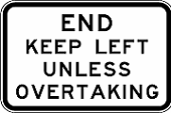 | 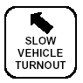
- Rule 130, after the diagrams
insert
Note for diagrams There is another permitted version of the End keep left unless overtaking sign — see the diagram in Schedule 3.
- Rule 131
omit
A driver
insert
(1) A driver
- Rule 131
after note 2, insert
(2) This rule does not apply to the rider of a motor bike that is a postal vehicle, the rider of a bicycle or the rider of an animal if:
(a) the rider is riding on a footpath, nature strip or shared path; and
(b) the rider is permitted to ride on the footpath, nature strip or shared path under the Australian Road Rules or another law of this jurisdiction; and
(c) either:
(i) the oncoming vehicle is not on the footpath, nature strip or shared path; or
(ii) the oncoming vehicle is not permitted, under the Australian Road Rules or under another law of this jurisdiction, to be on the footpath, nature strip or shared path.
Note Bicycle, footpath, motor bike, nature strip and postal vehicle are defined in the dictionary and shared path is defined in rule 242.
- After subrule 132 (2), including the note
insert
(2A) A driver on a road with a single continuous dividing line, a single continuous dividing line to the left of a broken dividing line or 2 parallel continuous dividing lines must not drive across the dividing lines to perform a U-turn.
Offence provision.
- Subrule 132 (3), after note 2
insert
(4) In this rule:
road does not include a footpath, nature strip, bicycle path, separated footpath or shared path.
Note Footpath and nature strip are defined in the dictionary, bicycle path and separated footpath are defined in rule 239 and shared path is defined in rule 242.
- Rule 134, examples 3, 4 and 5
substitute
Example 3  Driving to the right of the centre of the road not permitted — overtaking on a road with a single continuous dividing line only | Example 4  Driving to the right of the centre of the road not permitted — overtaking on a road with a single continuous dividing line to the left of a broken dividing line
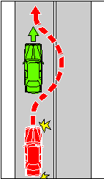 | 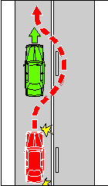
Example 5
Driving to the right of the centre of the road not permitted — overtaking on a road with 2 parallel continuous dividing lines
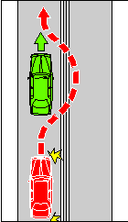
- Subrule 138 (2), note 2
omit
island.
insert
island and rule 197 deals with stopping on painted islands.
- Paragraph 141 (1) (b)
omit
signal; or
insert
signal and it is safe to overtake to the left of the vehicle; or
- Subrule 141 (1), note
substitute
Note 1 Bicycle, centre of the road, marked lane, multi-lane road, overtake, right change of direction signal and U-turn are defined in the dictionary.
- Paragraph 146 (1) (a)
omit
service road, a shoulder of the road or emergency stopping lane); or
insert
service road or a shoulder of the road); or
- Subrule 146 (1), note 1
omit
the dictionary, shoulder is defined in rule 12, and emergency stopping lane is defined in rule 95.
insert
the dictionary and shoulder is defined in rule 12.
- Paragraph 146 (2) (b)
omit
service road, a shoulder of the road or an emergency stopping lane); or
insert
service road or a shoulder of the road); or
- Subrule 148 (1)
omit
on a multi-lane road
- Subrule 148 (1), example 1
substitute
Example 1
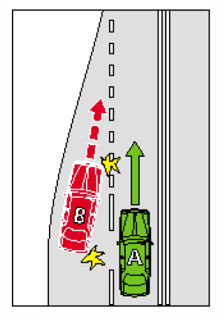
- After rule 148
insert
148A Giving way when moving within a single marked lane
If a driver diverges to the left or right within a marked lane, the driver must give way to any vehicle that is in the lane.
Offence provision.
Note Marked lane is defined in the dictionary.
- Subrule 150 (1), including the notes
substitute
(1) A driver must not drive on or over a continuous white edge line on a road unless subrule (1A) or (1B) applies to the driver.
Offence provision.
Note 1 Edge line is defined in the dictionary.
Note 2 A driver must not stop at the side of a road marked with a continuous yellow edge line — see rule 169.
(1A) A driver may drive on or over a continuous white edge line on a road if the driver is:
(a) overtaking a vehicle that is turning right, or making a U-turn from the centre of the road, and is giving a right change of direction signal; or
(b) driving a slow-moving vehicle, and it is necessary for the driver to drive on or over the edge line to allow the vehicle to be overtaken or passed by another vehicle; or
(c) driving a vehicle that is too wide, or too long, to drive on the road without driving on or over the edge line; or
(d) permitted to drive on or over the edge line under another law of this jurisdiction; or
(e) avoiding an obstruction.
Note Centre of the road, obstruction, overtake, right change of direction signal and U-turn are defined in the dictionary.
(1B) A driver may drive on or over a continuous white edge line on a road for up to 100 metres if the driver is:
(a) turning at an intersection; or
(b) entering or leaving the road; or
(c) entering a part of the road of one kind from a part of the road of another kind (for example, moving to or from a service road, a shoulder of the road or an emergency stopping lane); or
(d) stopping at the side of the road (including any shoulder of the road).
Note Intersection and service road are defined in the dictionary, emergency stopping lane is defined in rule 95, and shoulder is defined in rule 12.
- Subrule 154 (2), except the diagrams and the note for diagrams
substitute
(2) A bus lane is a marked lane, or the part of a marked lane:
(a) beginning at a bus lane sign (whether or not there is also a bus lane road marking) and ending at the nearest of the following:
(i) an end bus lane sign;
(ii) a traffic sign that indicates the beginning of another special purpose lane; or
(b) beginning at a bus lane road marking (if there is no bus lane sign) and ending at the next intersection.
Note Intersection, marked lane, special purpose lane and traffic sign are defined in the dictionary.
(3) In this rule:
bus lane road marking means a road marking consisting of:
(a) the letters ‘BL’; or
(b) the words ‘bus lane’; or
(c) the words ‘bus only’.
Note Road marking is defined in the dictionary.
- Subrule 155 (1)
omit
tram or public bus)
insert
tram, tram recovery vehicle or public bus)
- Subrule 155 (1), note 1
substitute
Note 1 Public bus, tram and tram recovery vehicle are defined in the dictionary.
- Subrule 155 (3), including the notes
substitute
(3) A tram lane is a part of a road with tram tracks that:
(a) is between a tram lane sign and an end tram lane sign; and
(b) is marked along the left side of the tracks (when facing the direction of travel of a tram on the tracks) by a continuous yellow line parallel to the tracks.
Note Tram tracks is defined in the dictionary.
- After rule 155
insert
155A Tramways
(1) A driver (except the driver of a tram, tram recovery vehicle or public bus) must not drive in a tramway, unless the driver is permitted to drive in the tramway under subrule (2).
Offence provision.
Note 1 Public bus, tram and tram recovery vehicle are defined in the dictionary.
Note 2 The exceptions and defence provided in rule 158 do not apply to tramways.
(2) A driver may drive in a tramway if:
(a) it is necessary for the driver to drive in the tramway to avoid an obstruction; and
(b) when driving in the tramway, the driver does not move into the path of an approaching tram or public bus travelling in the tramway.
Note Obstruction is defined in the dictionary.
(3) A tramway is a part of a road with tram tracks that :
(a) is between a tramway sign and an end tramway sign; and
(b) is marked along the left side of the tracks (when facing the direction of travel of a tram on the tracks) by either:
(i) 2 continuous yellow lines parallel to the tracks; or
(ii) a structure (for example, a dividing strip, pedestrian refuge, traffic island, row of bollards or separation kerb), whether or not the structure is also being used to indicate a safety zone;
but does include any part of the road where vehicles are permitted to cross the tramway.
- For the purposes of subparagraph (3)(b)(i), a line is to be considered to be continuous despite any break in it that is designed to permit vehicles to cross the tramway
Note Dividing strip, traffic island and tram tracks are defined in the dictionary and safety zone is defined in rule 162.
Tramway sign | End tramway sign
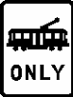 | 
Examples
Tramway with double yellow line | Tramway with separation kerb
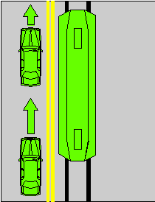 | 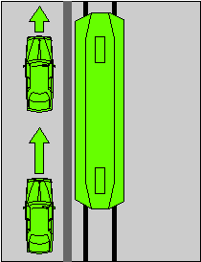
- Subrule 168 (3), except the diagrams and the notes for diagrams
substitute
(3) In this rule:
required time means:
(a) if information on or with the sign indicates a time — the indicated time; or
(b) if there is no indicated time — 2 minutes; or
(c) if there is no indicated time, or the indicated time is less than 5 minutes, and rule 206 applies to the driver — 5 minutes.
Note 1 With is defined in the dictionary.
Note 2 Rule 206 applies to a driver if the driver’s vehicle displays a current parking permit for people with disabilities and the driver complies with the conditions of use of the permit — see rule 206 (1).
- Subrule 170 (1), before the note
insert
Offence provision.
- Rule 171, example 1, diagram
substitute
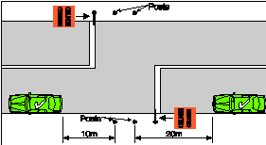
- Subrules 176 (4) and (5), except the diagrams and the note for diagrams
substitute
(4) A clearway sign applies, for the days or times indicated on the sign, to a length of road beginning at the sign and ending at the nearest of the following:
(a) a clearway sign on the road that indicates different days or times;
(b) an end clearway sign on the road;
(c) the end of the road.
- Rule 187, heading
substitute
187 Stopping in a bicycle lane, bus lane, tram lane, tramway, transit lane, truck lane or on tram tracks
- Subrule 187(3), including the notes
substitute
(3) A driver (except the driver of a tram, a tram recovery vehicle or a public bus) must not stop in a tram lane, a tramway or on tram tracks.
Offence provision.
Note 1 Bicycle lane is defined in rule 153, bus lane is defined in rule 154, tram lane is defined in rule 155, tramway is defined in rule 155A, transit lane is defined in rule 156, truck lane is defined in rule 157, and public bus, public minibus, taxi, tram and tram tracks are defined in the dictionary.
Note 2 Rule 76 deals with drivers keeping clear of trams travelling in tram lanes or on tram tracks marked on each side by a yellow line.
Note 3 Part 11, Division 6 deals with driving in bicycle lanes, bus lanes, tram lanes, tramways, transit lanes and truck lanes.
- Subrule 196 (1), except the notes
substitute
(1) A driver (except the driver of a tram, a tram recovery vehicle or a public bus travelling along tram tracks) must not stop at a tram stop or on the road within 20 metres before a sign that indicates a tram stop, unless:
(a) the driver stops at a place on a length of road, or in an area, to which a parking control sign applies; and
(b) the driver is permitted to stop at that place under the Australian Road Rules.
Offence provision.
- Subrule 196 (1), note 1
substitute
Note 1 Parking control sign, public bus, tram and travelling along tram tracks are defined in the dictionary.
- Rule 197, heading
substitute
197 Stopping on a path, dividing strip, nature strip or painted island
- After subrule 197 (1), including the notes
insert
(1A) A driver must not stop on a painted island.
Offence provision.
Note 1 Painted island is defined in the dictionary.
Note 2 Rule 85 deals with the give way rules applying to a driver entering a turning lane from a painted island and rule 138 deals with keeping off painted islands.
- Subrule 197 (2)
omit
This rule
insert
Subrule (1)
- After subrule 205 (1), including the note
insert
(1A) If a permissive parking sign does not indicate a period and does not indicate that it applies at particular times, or at particular times on particular days, a driver may, at any time, park continuously on a length of road, or in an area, to which the sign applies, unless:
(a) another parking control sign applies to the length of road or area; and
(b) the driver is prohibited from parking on the length of road, or in the area, under the Australia Road Rules.
Note Parking control sign is defined in the dictionary.
- After rule 205
insert
205A Parking outside times indicated
If a permissive parking sign indicates that it applies at particular times, or at particular times on particular days, a driver may park on the length of road, or in an area, to which the sign applies at a time, or at a time on a day, when the sign does not apply, unless:
(a) another parking control sign applies to the length of road or area; and
(b) the driver is prohibited from parking on the length of road, or in the area, at that time, or at that time on that day, under the Australia Road Rules.
Note 1 Parking control sign is defined in the dictionary.
Note 2 Rules 318 (1) and (2) deal with the effect of information on or with a traffic control device (including a permissive parking sign) that limits the application of the device to particular times or days. Under rule 318 (3), if the information indicates that the device applies on a particular day, for example Friday, the sign does not have effect on a Friday that is a public holiday at the place where the device is located, unless otherwise stated.
- Subrule 208 (6)
omit
any dividing line
insert
the continuous dividing line
- After rule 208
insert
208A Parallel parking in a road-related area (except in a median strip parking area)
(1) A driver who parks in a road-related area (except in a median strip parking area) must position the driver’s vehicle to face:
(a) in the direction of travel of vehicles in the marked lane or line of traffic next to the part of the road-related area where the driver parks; or
(b) if there is no traffic next to that part of the road-related area — in the direction in which vehicles could lawfully travel in the road-related area; or
(c) if the road-related area is an area that divides a road — either:
(i) in the direction of travel of vehicles in the marked lane or line of traffic to the left of the driver; or
(ii) if there is no traffic to the left of the driver — in the direction in which vehicles could lawfully travel on that part of the road.
Offence provision.
Note Driver’s vehicle, line of traffic, marked lane and median strip parking area are defined in the dictionary and road-related area is defined in rule 13.
Subrule (1) does not apply if:
(a) another law of this jurisdiction permits the driver to park in another manner in the road-related area; or
(b) signs or road markings indicate that angle parking is required in the road-related area.
- Subrule 210 (2A), examples
substitute
Examples
Example 1  Parking at 45°  at the side of a two-way road | Example 2  Parking at 45°  at the right side of a one-way road
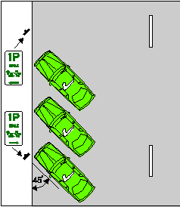 | 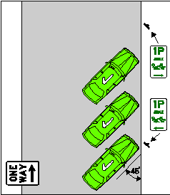
- Subrule 210 (4A), examples
substitute
Examples for subrule (4)
Example 5  Parking ‘rear in’ at 30° at the side of a road | Example 6  Parking ‘rear in’ at 30° in a median strip parking area
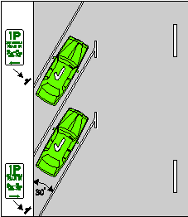 | 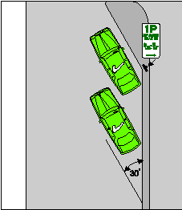
Example 7  Parking ‘rear in’ at 45° at the side of a road | Example 8  Parking ‘rear in’ at 45° in a median strip parking area
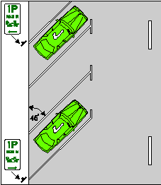 | 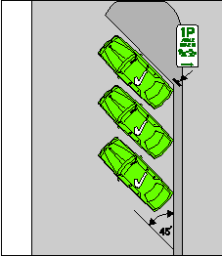
Example 9  Parking ‘rear in’ at 60° at the side of a road | Example 10  Parking ‘rear in’ at 60° in a median strip parking area
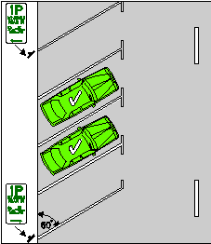 | 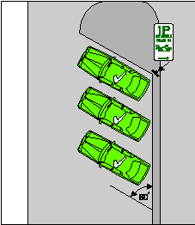
- Subrules 211 (1) and (2)
substitute
(1) This rule applies to a driver who parks on a length of road, or in an area, that has parking bays (whether or not a park in bays only sign applies to the length of road or area).
Note Parking bay is defined in the dictionary.
Park in bays only sign
(2) The driver must position the driver’s vehicle completely within a single parking bay, unless the vehicle is too wide or long to fit completely within the bay.
Offence provision.
Note 1 Driver’s vehicle is defined in the dictionary.
Note 2 Vehicle includes a combination — see rule 15 (d).
- Subrule 211 (3), diagram
omit
- Subrule 213 (5)
substitute
(5) If the driver will be over 3 metres from the closest part of the vehicle and there is no-one left in the vehicle, the driver must:
(a) if the windows of the vehicle can be secured — secure the windows immediately before leaving the vehicle; and
(b) if the doors of the vehicle can be locked — lock the doors immediately after leaving the vehicle.
Offence provision.
Note 1 Window is defined in the dictionary.
(6) For the purposes of subrule (5), a window is secure even if it is open by up to 2 centimetres.
- Rule 217, heading
substitute
217 Using fog lights
- Subrule 217 (1)
omit
a rear fog light must not operate the fog light
insert
front fog lights or rear fog lights must not operate the fog lights
- Subrule 217 (2)
substitute
(2) In this rule:
front fog light means a light (other than a headlight) fitted to the front of a vehicle to improve illumination of the road in fog, snowfall, heavy rain or dust clouds.
rear fog light means a light (other than a brake light, a tail light, a number plate light or a reversing light) fitted to the rear of a vehicle to make the vehicle more easily visible from the rear in fog, snowfall, heavy rain or dust clouds.
- Rule 221
omit
The driver
Insert
- The driver
- Rule 221 (g)
omit
device
insert
device, or an alcohol interlock device,
- Rule 221 , after Note 3
insert
In this rule:
alcohol interlock device means a device in a vehicle that is designed to prevent the vehicle from being started or driven unless the device is supplied with a breath sample that contains either no alcohol, or less than a certain concentration of alcohol.
- Paragraph 224 (b)
omit
anti-theft device
insert
anti-theft device, or an alcohol interlock device,
- Rule 224 , note 1
Substitute
Note 1 Driver’s vehicle is defined in the dictionary, road user is defined in rule 14 and alcohol interlock device is defined in rule 221.
- Subrule 225 (1)
omit
the vehicle
insert
the vehicle, or a trailer being towed by the vehicle,
- Subrule 225 (2), including the note
substitute
(2) A person who is travelling in or on a vehicle or trailer must not have in his or her possession a device for preventing the effective use of a speed measuring device, or a device for detecting the use of a speed measuring device, unless the person is exempt from this rule under another law of this jurisdiction.
Offence provision.
(3) Subrules (1) and (2) apply whether or not the device is operating or in working order.
Note Under the law of this jurisdiction, radar detectors and similar devices may be subject to confiscation.
- Subrule 236 (5)
omit
A person in
insert
A driver, or a passenger, in or on
- After paragraph 238 (2) (a)
insert
(ab) must, when moving forward, face approaching traffic that is moving in the direction opposite to which the pedestrian is travelling, unless it is impracticable to do so; and
- Before rule 240
insert in Part 14, Division 2
240A No wheeled recreational devices or toys sign
A person on a road who is travelling in or on a wheeled recreational device or wheeled toy must not travel past a no wheeled recreational devices or toys sign.
Offence provision.
No wheeled recreational devices or toys sign
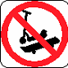 | 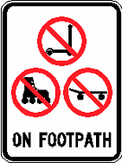
- Paragraph 240 (1) (b)
omit
60
insert
50
- Paragraph 240 (2) (b)
substitute
(b) on a road at night; or
(c) on a road at any other time if another law of this jurisdiction prohibits wheeled recreational devices from being on all roads, or that road, at that time.
- Subrule 240(2), example
omit
- Subrule 240 (2), after the penalty
insert
Note Night is defined in the dictionary.
- After subrule 240 (3)
insert
(3A) Subrules (1) and (2) do not apply to a person who is crossing a road in or on a wheeled recreational device or wheeled toy, if the person:
(a) crosses the road by the shortest safe route; and
(b) does not stay on the road longer than necessary to cross the road safely; and
(c) is not prohibited, under another law of this jurisdiction, from crossing the road in or on the wheeled recreational device or wheeled toy.
- Subrule 240 (4)
omit
In subrule (1),
insert
In subrules (1) and (2) (b),
- Rule 246
omit
The rider
insert
(1) The rider
- Rule 246
after the example, insert
(2) A passenger on a bicycle that is moving, or is stationary but not parked, must sit in the seat designed for the passenger.
Offence provision.
(3) The rider of a bicycle must not ride with a passenger unless the passenger complies with subrule (2).
Offence provision.
- Subrules 256 (2) and (3)
substitute
(2) A passenger on a bicycle that is moving, or is stationary but not parked, must wear an approved bicycle helmet securely fitted and fastened on the passenger’s head, unless the passenger is:
(a) a paying passenger on a three or four-wheeled bicycle; or
(b) exempt from wearing a bicycle helmet under another law of this jurisdiction.
Offence provision.
(3) The rider of a bicycle must not ride with a passenger on the bicycle unless the passenger complies with subrule (2).
Offence provision.
- Subrule 260 (1), note
substitute
Note 1 Bicycle crossing lights is defined in the dictionary.
Note 2 Red bicycle crossing light includes a flashing red bicycle crossing light — see the definition in the dictionary.
- Subrule 261 (1), note
substitute
Note 1 Bicycle crossing lights is defined in the dictionary.
Note 2 Yellow bicycle crossing light includes a flashing yellow bicycle crossing light — see the definition in the dictionary.
- Rule 262
substitute
262 Proceeding when bicycle crossing lights change to yellow or red
(1) The rider of a bicycle who is crossing at an intersection, or another place on a road, with bicycle crossing lights and traffic lights must comply with this rule.
Offence provision.
Note Bicycle crossing lights, intersection and traffic lights are defined in the dictionary.
(2) If the bicycle crossing lights change from green to yellow, flashing yellow, red or flashing red while the rider is crossing the road, the rider must not stay on the road for longer than necessary to cross safely to the nearer (in the direction of travel of the rider) of the following:
(a) a dividing strip, safety zone, or traffic island, forming part of the area set aside or used by riders of bicycles to cross the road at the intersection or place (the safety area);
(b) the nearest side of the road.
Note Dividing strip and traffic island are defined in the dictionary, and safety zone is defined in rule 162.
(3) If, under subrule (2), the rider crosses to the safety area, the rider must remain in the safety area until the bicycle crossing lights change to green.
(4) However, if the rider cannot operate the bicycle crossing lights from the safety area, the rider may cross to the far side of the road when:
(a) the traffic lights change to green or flashing yellow, or there is no red traffic light showing; and
(b) it is safe to do so.
Note Red traffic light is defined in the dictionary.
(5) In this rule:
road does not include a road-related area, but includes any shoulder of the road.
Note Road-related area is defined in rule 13 and shoulder is defined in rule 12.
- Paragraph 267 (5) (b)
substitute
(b) either:
(i) if the vehicle has 2 or more rows of seats — the person is not in the front row of seats or there is not a seating position available for the person in another row of seats; or
(ii) if the vehicle is a police vehicle and has a caged, or other secured, area designed for the carriage of passengers — the person occupies a seating position in that area.
- Subrule 268 (3), after the penalty
insert
Note Window is defined in the dictionary.
- Subrules 268 (4A) and (4B)
omit
who is under 16 years old
- Subrule 271 (1)
omit
that is moving, or
insert
that is moving (other than a rider who is walking beside and pushing a motor bike), or the rider of a motor bike that
- After subrule 271 (5)
insert
(5A) The rider of a motor bike must not ride with a passenger who is under 8 years old unless the passenger is in a sidecar.
Offence provision.
(5B) A passenger must not ride in a sidecar of a motorbike unless the passenger is seated safely.
Offence provision.
(5C) The rider of a motor bike must not ride with a passenger in a sidecar unless the passenger complies with subrule (5B).
Offence provision.
- Part 17, heading, except the notes
substitute
Part 17 Additional rules for drivers of trams, tram recovery vehicles and public buses
- Part 17, heading, note 1
after
trams,
insert
tram recovery vehicles,
- Part 17, heading, note 2
omit
trams and public buses
insert
trams, tram recovery vehicles and public buses
- Part 17, Division 1, heading, note
substitute
Note Public bus, T lights, tram, tram recovery vehicle and travelling along tram tracks are defined in the dictionary.
- Rule 273
substitute
273 Division also applies to tram recovery vehicles and public buses travelling along tram tracks
(1) This Division applies to the driver of a tram recovery vehicle as if a reference in the Division to a tram included a reference to a tram recovery vehicle.
(2) This Division applies to the driver of a public bus travelling along tram tracks as if a reference in the Division to a tram included a reference to a public bus travelling along tram tracks.
- Rule 280, heading
substitute
280 Application of Division
- Subrule 280 (1), except the note
substitute
(1) This Division applies to the driver of a public bus who is driving in a bus lane.
- After subrule 297 (1)
insert
(1A) A driver must not drive a vehicle if a person or an animal is in the driver’s lap.
Offence provision.
- After subrule 297 (2), including the note
insert
(3) The rider of a motor bike must not ride with an animal on the petrol tank of the motor bike.
Offence provision.
Note Motor bike is defined in the dictionary.
(4) Subrule (3) does not apply to a person who rides with an animal on the petrol tank of a motor bike for a distance of not more 500 metres on a road for the purposes of a farming activity that the person is carrying out.
- Rule 300, heading
substitute
300 Use of mobile phones
- Subrule 300 (1)
omit
hand-held mobile phone
insert
mobile phone that the driver is holding in his or her hand
- Subrule 300 (2), after definition of mobile phone
insert
use, in relation to a mobile phone, includes the following:
(a) holding the phone to, or near, the ear (whether or not engaged in a phone call);
(b) writing, sending or reading a text message on the phone;
(c) turning the phone on or off;
(d) operating any other function of the phone.
- Rule 301
substitute
301 Leading an animal while driving a vehicle
(1) The driver of a motor vehicle must not lead an animal, including by tethering the animal to the motor vehicle, unless the driver is permitted to do so under another law of this jurisdiction.
Offence provision.
Note Motor vehicle is defined in the dictionary.
(2) A person who is a passenger in, or on any part of, a motor vehicle must not lead an animal while the motor vehicle is moving unless the passenger is permitted to do so under another law of this jurisdiction.
Offence provision.
(3) The rider of a bicycle must not lead an animal, including by tethering the animal to the bicycle, unless the rider is permitted to do so under another law of this jurisdiction.
Offence provision.
Note Bicycle is defined in the dictionary.
- Rule 309
omit
tram, or
insert
tram, the driver of a tram recovery vehicle engaged in accessing or recovering a disabled tram, or the driver of
- Rule 309, note
substitute
Note Public bus, tram, tram recovery vehicle and travelling along tram tracks are defined in the dictionary.
- Subrule 313 (2)
omit
• rule 288 (Driving on a path).
insert
• rule 288 (Driving on a path)
• rule 289 (Driving on a nature strip).
- After rule 313A
insert in Part 19
313B Exemption for breakdown vehicles
(1) Another law of this jurisdiction may provide that a provision mentioned in subrule (2) does not apply to the driver of a breakdown vehicle while:
(a) the driver is engaged in repairing a disabled vehicle; and
(b) the driver is unable to comply with the provision; and
(c) the breakdown vehicle is displaying a flashing light; and
(d) the driver is acting safely.
(2) For subrule (1), the provisions are as follows:
- rule 137 (Keeping off dividing strips)
- rule 138 (Keeping off a painted island)
- rule 147 (Moving from one marked lane to another marked lane across a continuous line separating the lanes)
- rule 289 (Driving on a nature strip)
- rule 290 (Driving on a traffic island).
(3) In this rule:
breakdown vehicle means any vehicle driven by a person who is:
(a) a breakdown worker; and
(b) driving the vehicle in the course of his or her duties as a breakdown worker.
Note 1 Vehicle is defined in rule 15.
Note 2 Drive includes be in control of — see the definition in the dictionary.
breakdown worker means a person who is a breakdown worker for this rule under another law of this jurisdiction.
- After rule 323
insert in Division 1
323A Audible lines
(1) An audible line is a line on a road that is made up of a series of closely spaced raised pieces of material designed to create a continuous noise or vibration if driven on by a motor vehicle.
Note Motor vehicle is defined in the dictionary.
(2) A reference in the Australian Road Rules to a line is to be taken to include a reference to an audible line, unless otherwise expressly stated.
(3) For the purposes of the Australian Road Rules:
(a) an audible line is to be taken to be continuous even if there is no physical link between the pieces of material that make up the line;
(b) if there is no physical link between those pieces, the colour of the audible line is to be taken to be the visible colour of those pieces.
- Subrule 334 (2), except the examples
substitute
(2) If a parking control sign applies to a length of road, the sign is at the side of the road, and there are no parking bays to which the sign applies, then, unless information on or with the sign indicates otherwise, the sign applies to:
(a) any shoulder of the road on that side of the road; and
(b) the part of the road on the length of road that extends from the far side of the road (excluding any road-related area) on that side of the road for:
(i) if the sign, or information on or with the sign, includes the words ‘angle parking’ or ‘angle’ — 6 metres; or
(ii) in any other case — 3 metres.
Note Road-related area is defined in rule 13 and shoulder is defined in rule 12.
- Subrule 335 (2), after example 4
insert
5 An end no parking area sign.
6 An end no stopping area sign.
7 An end parking area sign.
- Subrule 340 (2), example 2
substitute
2 If a driver is turning left using a slip lane at an intersection, a traffic light on the right side of the painted island or traffic island that separates the slip lane from other parts of the road does not apply to the driver.
- Rule 341, note
substitute
Note 1 Road marking is defined in the dictionary.
Note 2 A person may, under another rule, be exempt from complying with particular road markings — see, for example, rules 134, 138, 139, 147 and 150.
- After rule 351
insert in Part 21
352 References to stopping as near as practicable to a place
A requirement in the Australian Road Rules for a driver to stop as near as practicable to a place is not complied with only because the driver stops behind a vehicle that has stopped at the place.
Example
If a driver stops behind a vehicle that has stopped at a stop sign or stop line in accordance with rule 67, 68 or 121, the driver must, after the vehicle has proceeded, stop at the stop sign or stop line in accordance with the rule.
- Schedule 2, End keep left unless overtaking sign
substitute
End keep left unless overtaking sign
(rule 130)
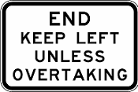
- Schedule 2, after End no overtaking or passing sign
insert
End no parking area sign  (rule 335)  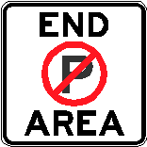 | End no stopping area sign  (rule 335)  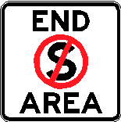
End parking area sign
(rule 335)
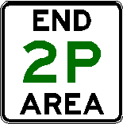
- Schedule 2, before Park in bays only sign
insert
One-way sign
(rule 98)

- Schedule 2, after Shared zone sign
insert
Slow vehicle turn out lane sign
(rule 130)
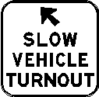
- Schedule 3, after End freeway sign, last occurring
insert
End keep left unless overtaking sign
(rule 130)
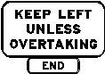
- Schedule 3, before End separated footpath sign
insert
End school zone sign
(rule 23)
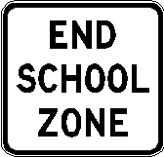
- Schedule 3, after End tram lane sign
insert
End tramway sign
(rule 155A)

- Schedule 3, after No U-turn sign (Variable illuminated message sign)
insert
No recreational devices or toys sign  (rule 240A) | No wheeled recreational devices or toys sign  (rule 240A)  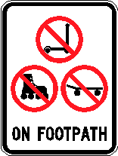
- Schedule 3, One-way sign, second occurring
omit
- Schedule 3, before Separated footpath sign
insert
School zone sign  (rule 23)  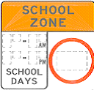 | School zone sign  (rule 23)  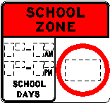
School zone sign  (rule 23)  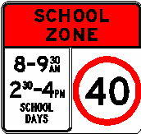 | School zone sign  (rule 23)  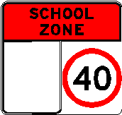
- Schedule 3, before Tram lane sign
insert
Taxi zone sign
(rule 182)
- Schedule 3, after Tram lane sign
insert
Tramway sign
(rule 155A)
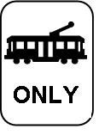
- Schedule 3, after Transit lane sign
insert
Truck arrester bed  TRUCK  ARRESTER  BED  TRUCK  ARRESTER  BED  (rule 101A) | Truck arrester bed  (rule 101A)
- Dictionary, after definition of adjacent land
insert
alcohol interlock device see rule 221.
- Dictionary, definition of built-up area
substitute
built-up area, in relation to a length of road, means an area in which either of the following is present for a distance of at least 500 metres or, if the length of road is shorter than 500 metres, for the whole road:
(a) buildings, not over 100 metres apart, on land next to the road;
(b) street lights not over 100 metres apart.
- Dictionary, after definition of freeway
insert
front fog light see rule 217.
- Dictionary, definition of traffic arrows
omit
installed with traffic lights that is
- Dictionary, after definition of tram lane
insert
tram recovery vehicle means a vehicle used by a tram operator to access and recover disabled trams for which the tram operator is responsible.
- Dictionary, definition of tram stop
substitute
tram stop means a place on a road at which there is a sign indicating that trams will stop to enable people to get on or off.
- Dictionary, after definition of tram tracks
insert
tramway see rule 155A.
- Dictionary, after definition of turning lane
insert
turn line means a road marking, at an intersection, consisting of a line (whether broken or continuous) that is designed to indicate how a turn is to be made at the intersection.
- Dictionary, after definition of white traffic arrow
insert
window, in relation to a vehicle, includes any sunroof fitted to the vehicle.

Note
1. All legislative instruments and compilations are registered on the Federal Register of Legislative Instruments kept under the Legislative Instruments Act 2003. See http//www.frli.gov.au.

