Foreign Acquisitions and Takeovers Legislation Amendment Regulations 2009 (No. 2)¹
Select Legislative Instrument 2009 No. 104
I, QUENTIN BRYCE, Governor-General of the Commonwealth of Australia, acting with the advice of the Federal Executive Council, make the following Regulations under the Foreign Acquisitions and Takeovers Act 1975.
Dated 4 June 2009
QUENTIN BRYCE
Governor-General
By Her Excellency’s Command
CHRIS BOWEN
Assistant Treasurer
Contents
1 Name of Regulations 2
2 Commencement 2
3 Amendment of Foreign Acquisitions and Takeovers Regulations 1989 2
4 Amendment of Foreign Acquisitions and Takeovers (Notices) Regulations 1975 2
Schedule 1 Amendment of Foreign Acquisitions and Takeovers Regulations 1989 3
Schedule 2 Amendments of Foreign Acquisitions and Takeovers (Notices) Regulations 1975 4

1 Name of Regulations
These Regulations are the Foreign Acquisitions and Takeovers Legislation Amendment Regulations 2009 (No. 2).
2 Commencement
These Regulations commence on the day after they are registered.
3 Amendment of Foreign Acquisitions and Takeovers Regulations 1989
Schedule 1 amends the Foreign Acquisitions and Takeovers Regulations 1989.
4 Amendment of Foreign Acquisitions and Takeovers (Notices) Regulations 1975
Schedule 2 amends the Foreign Acquisitions and Takeovers (Notices) Regulations 1975.

Schedule 1 Amendment of Foreign Acquisitions and Takeovers Regulations 1989
(regulation 3)

[1] Regulation 2, definition of spouse
substitute
spouse, in relation to a person, includes a de facto partner of the person within the meaning of the Acts Interpretation Act 1901.
Schedule 2 Amendments of Foreign Acquisitions and Takeovers (Notices) Regulations 1975
(regulation 4)

[1] Subregulation 4 (1)
omit
the Schedule
insert
Schedule 1
[2] Subregulation 4 (2)
omit
the Schedule
insert
Schedule 1
[3] Subregulation 4 (3)
substitute
(3) The prescribed form of notice for section 26A of the Act is:
(a) unless paragraph (b) or (c) applies — Form 3 in Schedule 1; and
(b) if a natural person acquires an interest in Australian residential land — Form 4 in Schedule 1; and
(c) if a company or trust estate acquires an interest in Australian residential land — Form 5 in Schedule 1.
[4] Schedule, heading
substitute
Schedule 1 Forms
(regulation 4)

[5] Schedule, Forms 3 and 4
substitute
Form 3 Notice under section 26A of the Act
(paragraph 4 (3) (a))
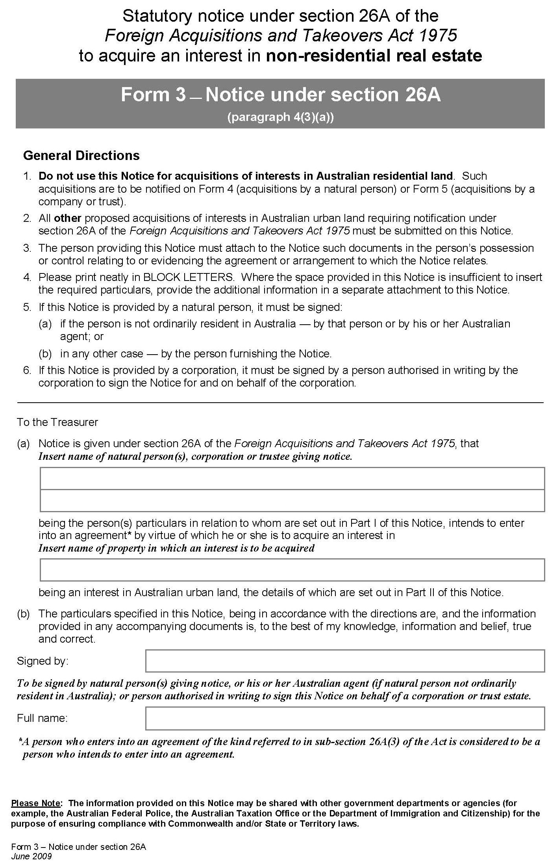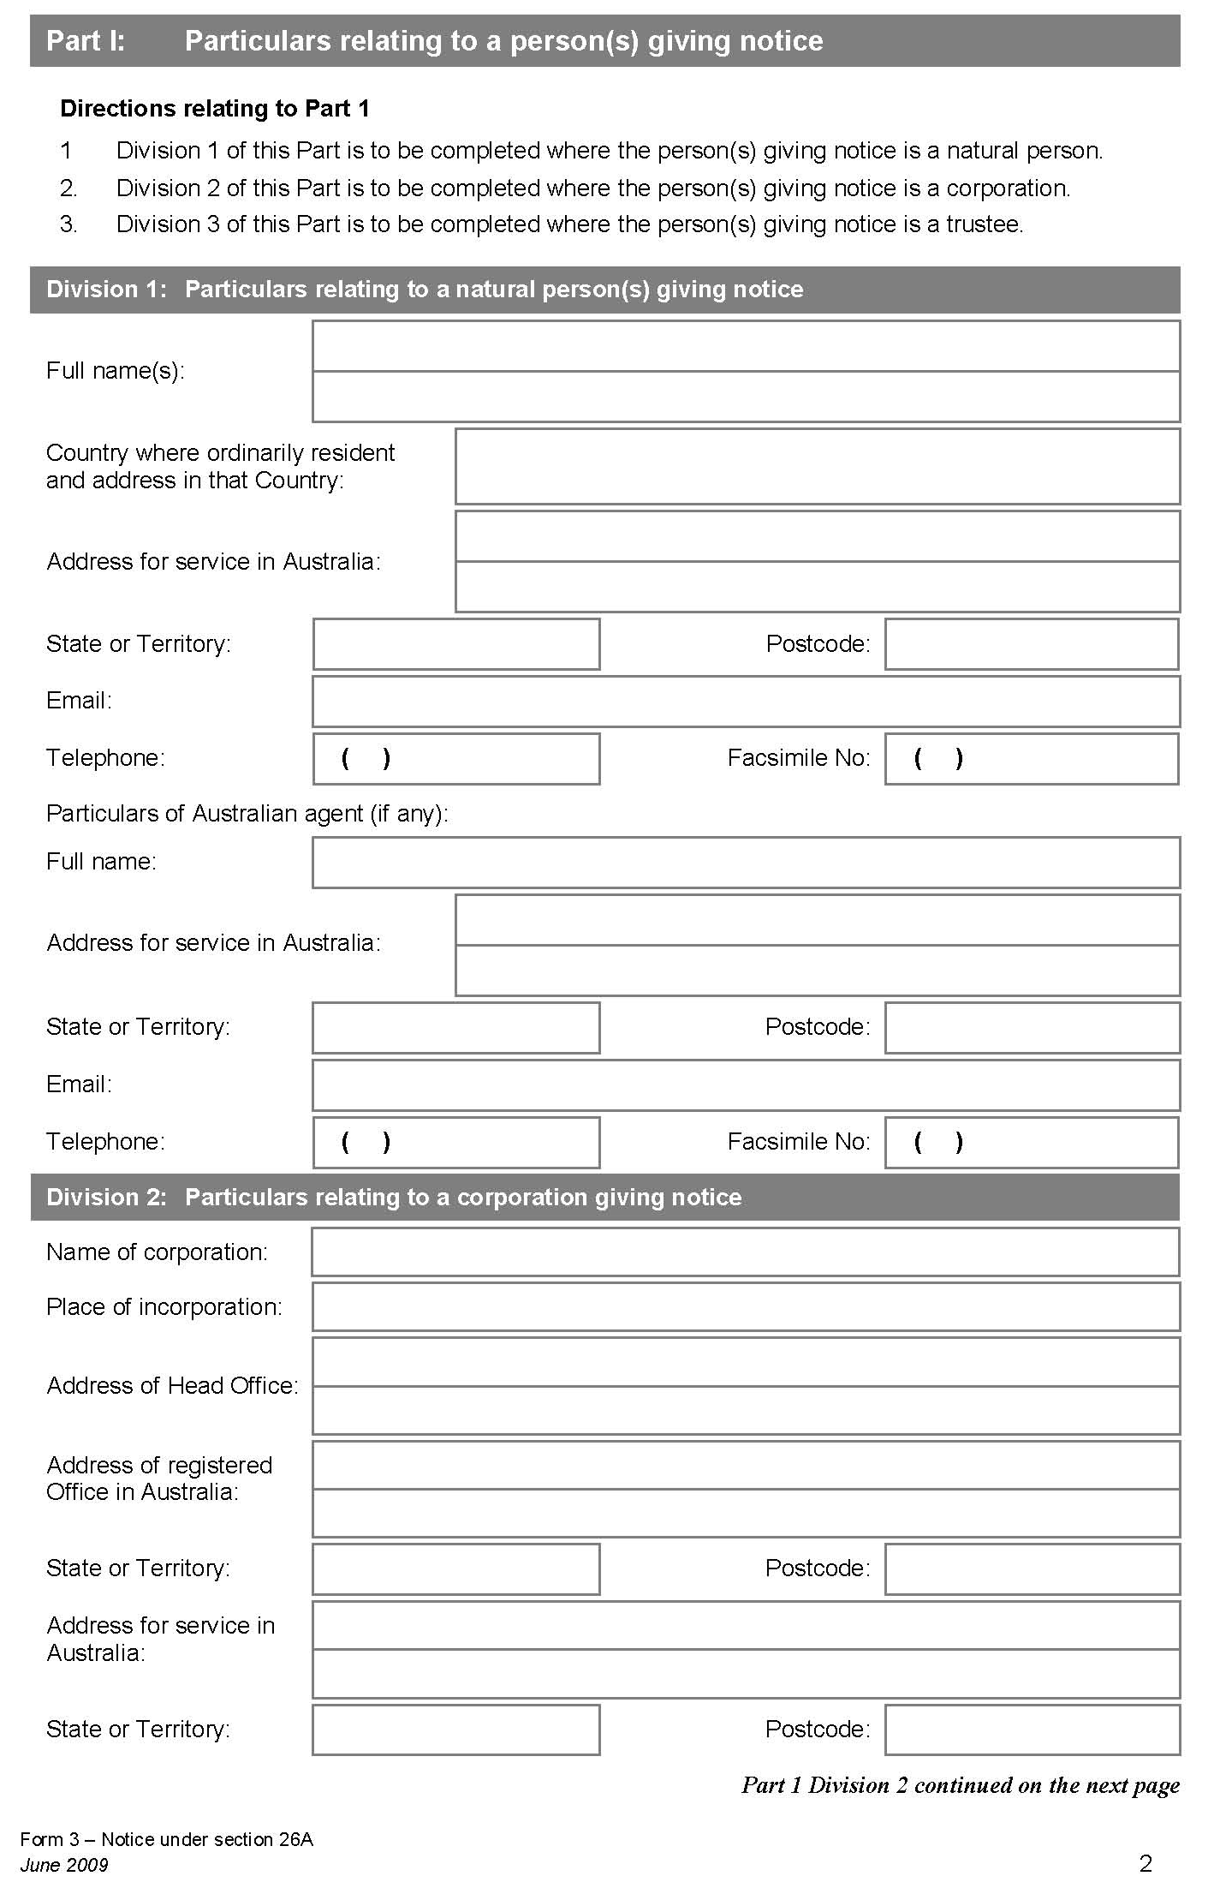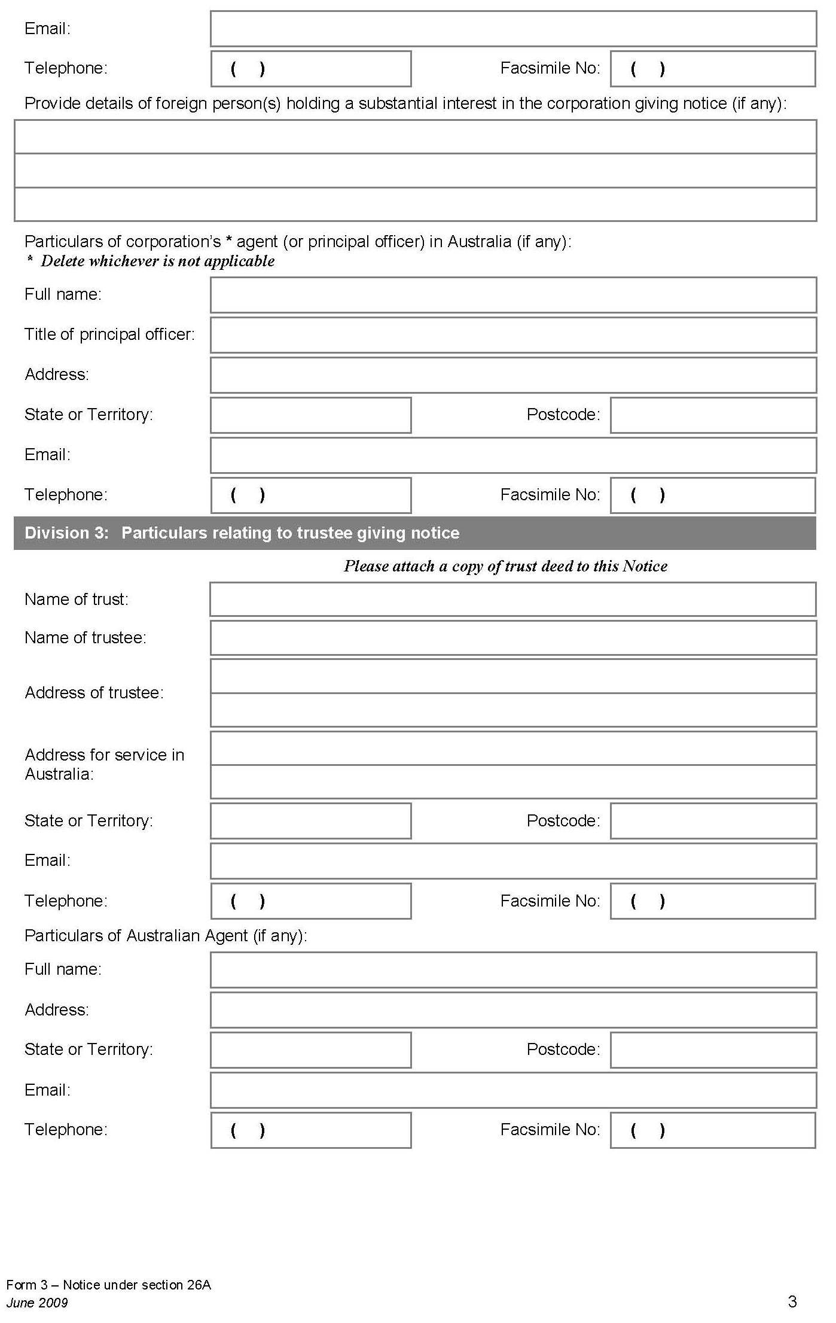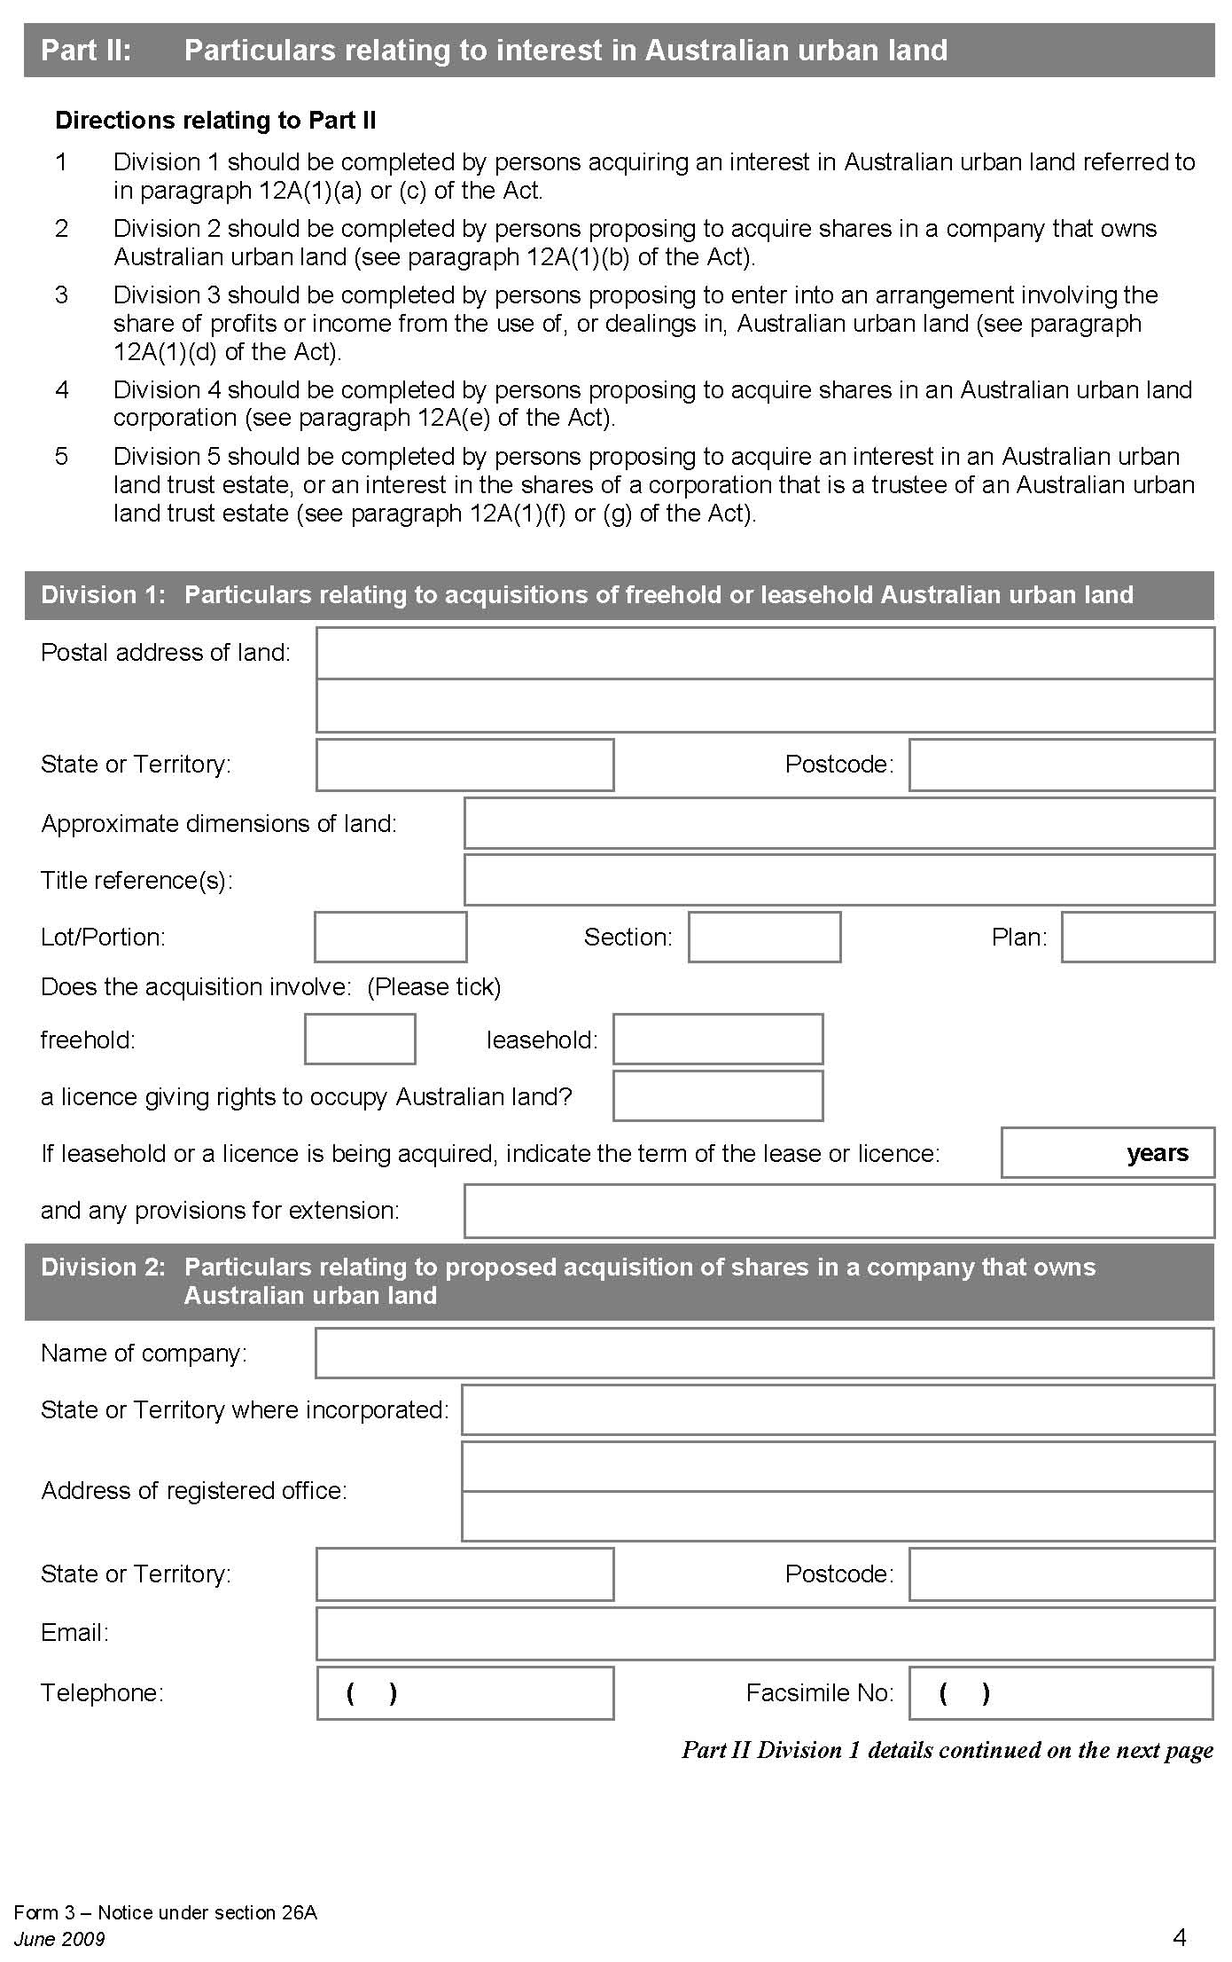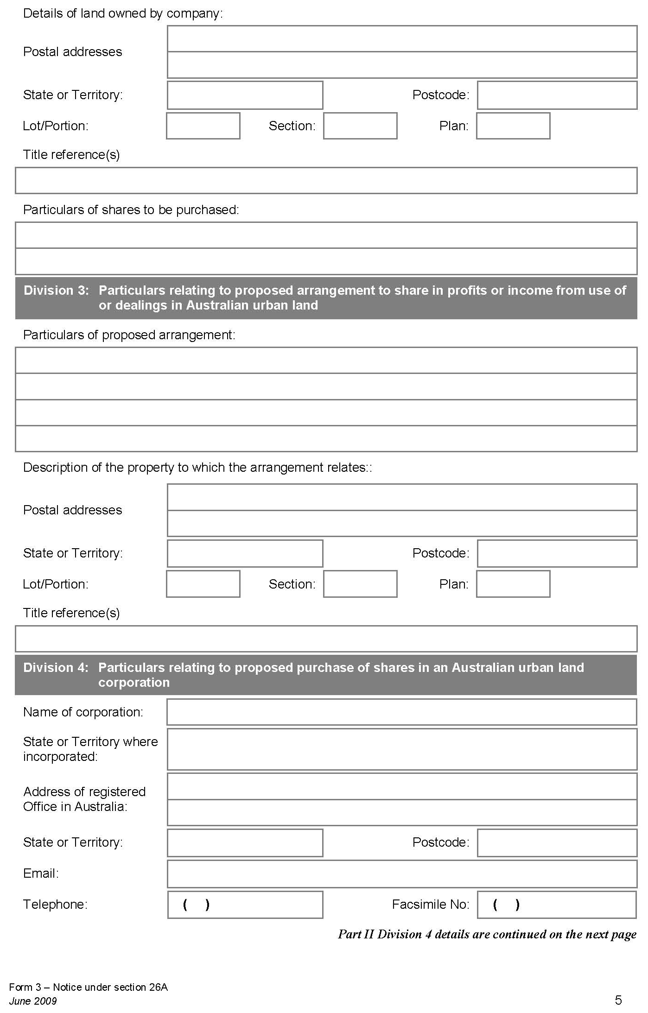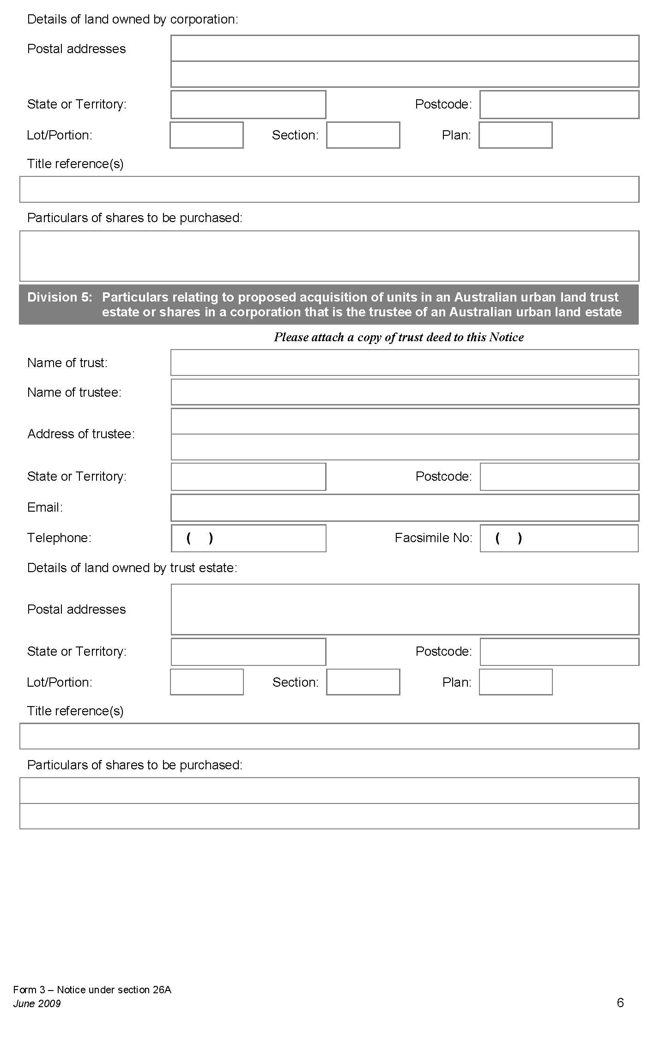
Form 4 Notice under section 26A of the Act
(paragraph 4 (3) (b))
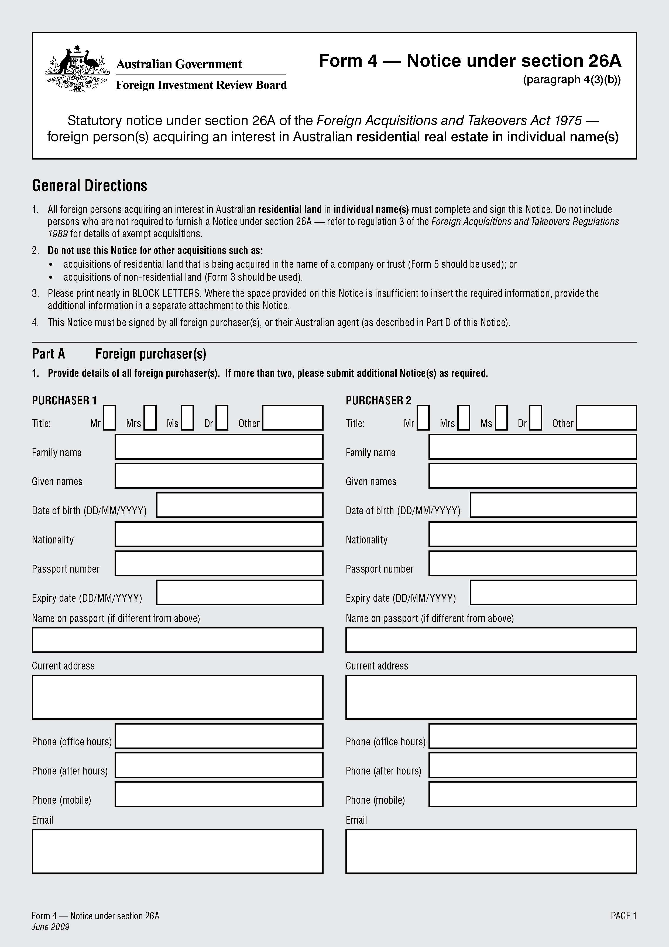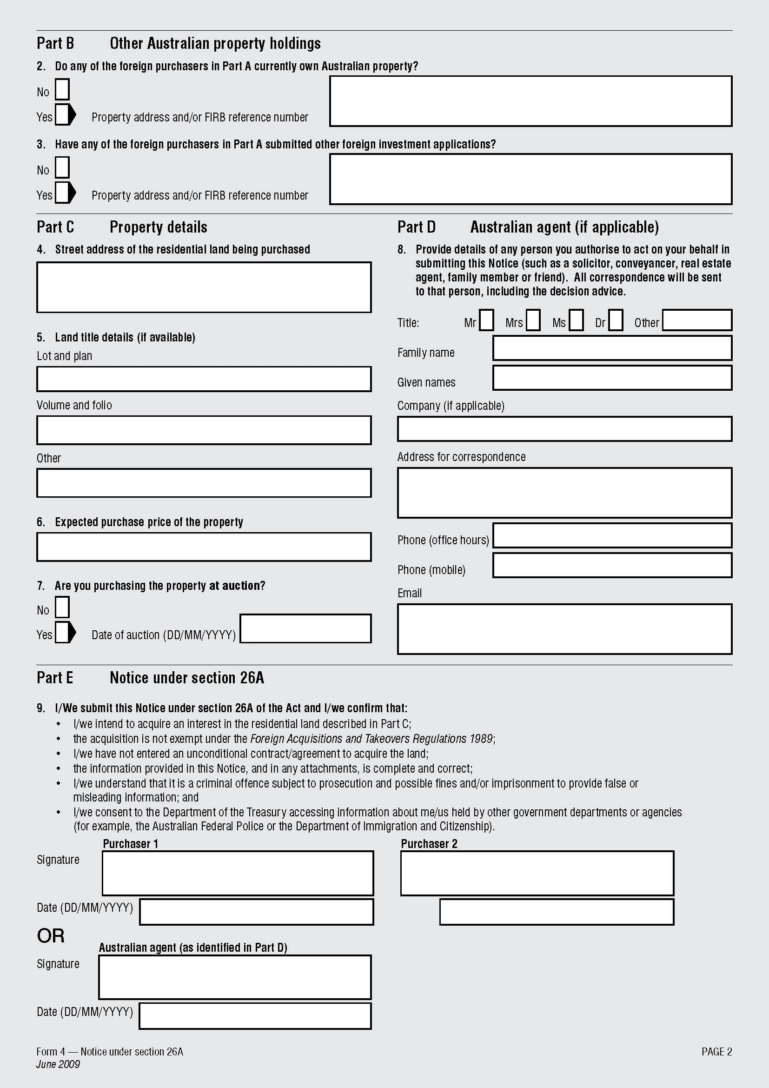
Form 5 Notice under section 26A of the Act
(paragraph 4 (3) (c))

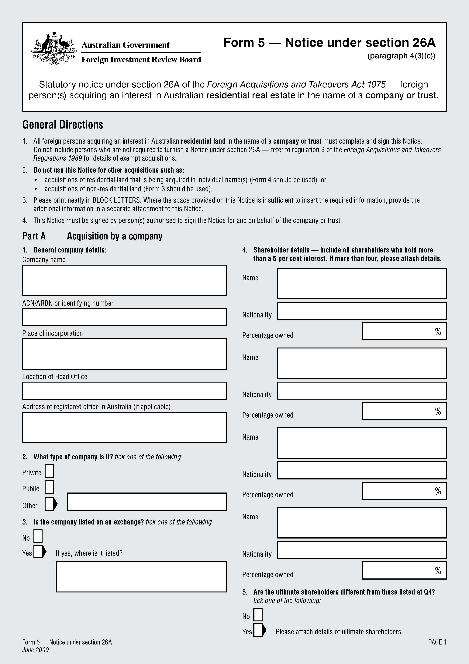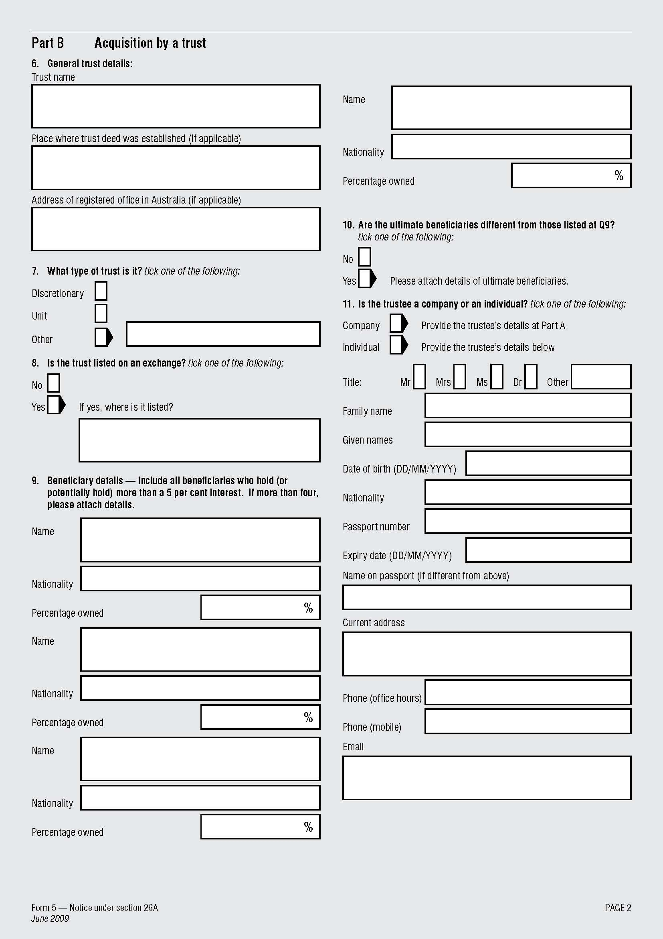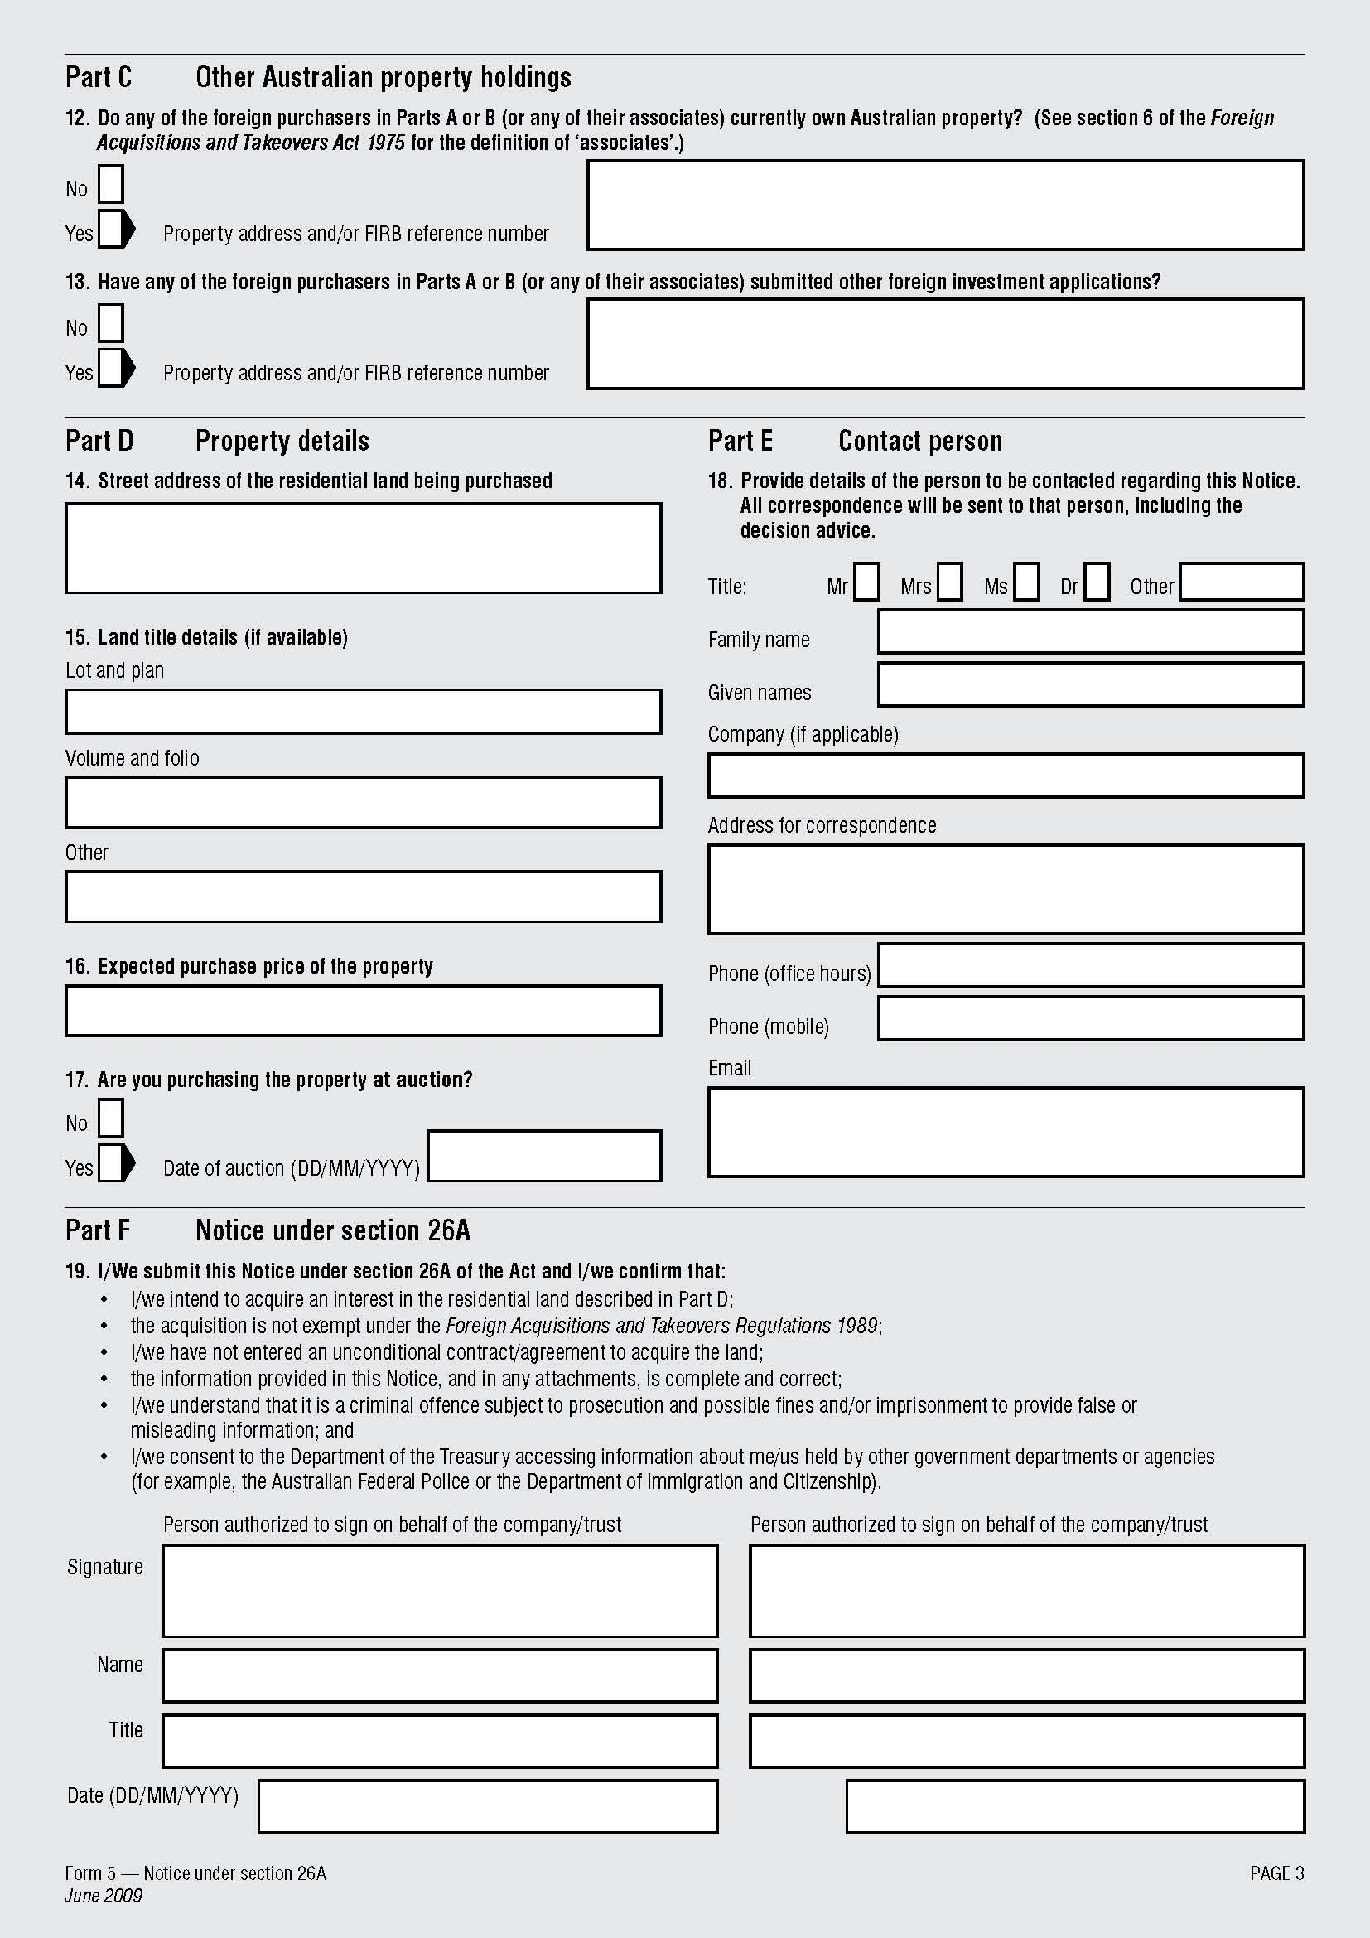

Note
1. All legislative instruments and compilations are registered on the Federal Register of Legislative Instruments kept under the Legislative Instruments Act 2003. See http://www.frli.gov.au.

