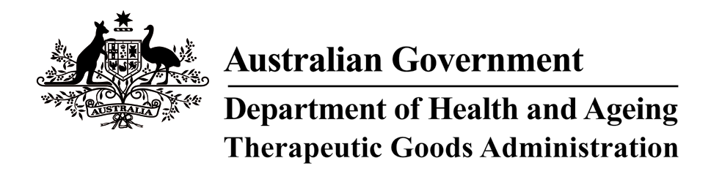

THERAPEUTIC GOODS ACT 1989

ORDER UNDER SUBSECTION 3(1) – DEFINITION OF BRITISH PHARMACOPOEIA

I, CHARLES MASKELL-KNIGHT, delegate of the Minister for Health and Ageing for the purposes of the exercise of the Minister’s power under the definition of “British Pharmacopoeia” in subsection 3(1) of the Therapeutic Goods Act 1989 (“the Act”) and acting under that provision, HEREBY SPECIFY that on and from 1 June 2009 the definition of “British Pharmacopoeia” in the Act shall be the British Pharmacopoeia 2009.

Dated this 4th day of May 2009

Signed

CHARLES MASKELL-KNIGHT
A/g National Manager
Therapeutic Goods Administration
(Delegate of the Minister for Health and Ageing)

