POISONS STANDARD AMENDMENT NO.1 OF 2009

The National Drugs and Poisons Schedule Committee, acting in accordance with its power under paragraph 52D(2)(a) of the Therapeutic Goods Act 1989 (the Act), amends the Poisons Standard 2008 in the manner set out in Schedule 1.

The amendments to the Poisons Standard 2008 as set out in Schedule 1 commence on 1 May 2009.

Signed
DR RUTH LOPERT
CHAIR
NATIONAL DRUGS AND POISONS SCHEDULE COMMITTEE

Dated this 6th day of April 2009

Schedule 1-Amendments to the Poisons Standard 2008

STANDARD
FOR THE
UNIFORM SCHEDULING
OF
DRUGS AND POISONS

No. 23

AMENDMENT No. 3

Effective Date – 1 May 2009
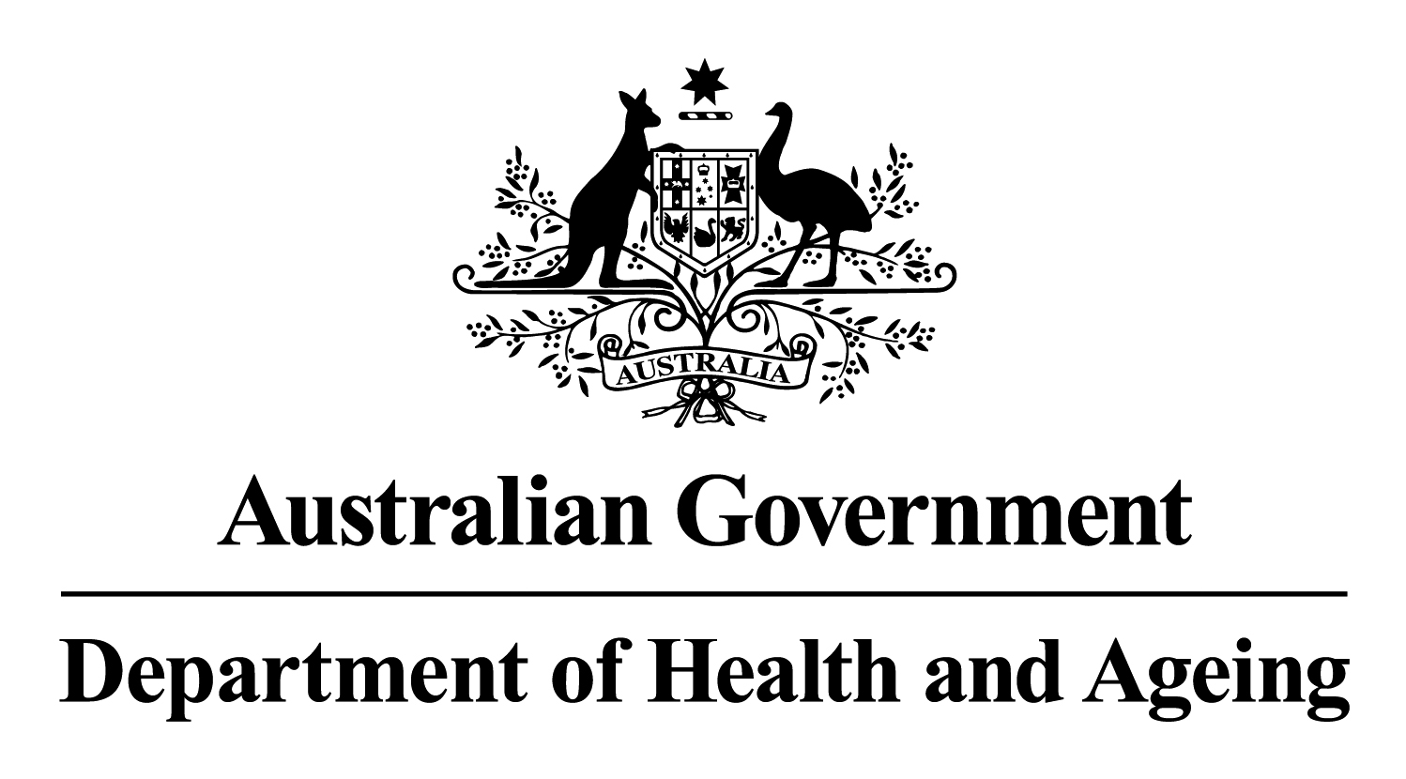

© Commonwealth of Australia 2009

ISBN 1-74186-837-8

This work is copyright. Apart from any use as permitted under the Copyright Act 1968, no part may be reproduced by any process without prior written permission from the Commonwealth. Requests and inquiries concerning reproduction and rights should be addressed to the:
Commonwealth Copyright Administration
Attorney-General’s Department
Robert Garran Offices
National Circuit
BARTON ACT 2600
or posted at http://www.ag.gov.au/cca

Published by the Australian Government under the Therapeutic Goods Act 1989.

Publication approval number: P3-4955

The amendments listed in this document were finalised at the October 2008 and February 2009 meetings of the National Drugs and Poisons Schedule Committee (NDPSC) except where separately specified. The basis of these amendments can be found in the ‘Record of the Reasons’, which can be accessed from the NDPSC website:

www.tga.gov.au/ndpsc

Further inquiries should be directed to:

The Secretary
National Drugs and Poisons Schedule Committee
GPO Box 9848
CANBERRA ACT 2601

Or by email: NDPSC@health.gov.au

Media Liaison Unit
Australian Government Department of Health and Ageing
TABLE OF CONTENTS

Part 2, Labels and Containers – amendment 1
Part 4 – The Schedules 2
Schedule 2 – New Entry 2
Schedule 2 – Amendment 2
Schedule 3 – Amendment 2
Schedule 4 – New Entries 2
Schedule 4 – Amendments 3
Schedule 5 – Amendment 3
Schedule 6 – Amendments 3
Schedule 7 – New Entry 6
PART 5 – appendices 6
Appendix C – Amendment 6
Appendix E, Part 2 – Amendment 6
Appendix F, Part 3 – New Entry 7
Appendix F, Part 3 – Amendment 7
Appendix H – Amendment 7
Appendix I – Amendment 7
Editorial Amendments and Errata 10
Part 1, Interpretation – Amendment 10
Appendix A – Amendment 10
Appendix B, Part 3 – Amendments 10

Amendments to the Standard for the Uniform Scheduling of Drugs and Poisons

The National Drugs and Poisons Schedule Committee directs that the amendments below be applied to the Standard for the Uniform Scheduling of Drugs and Poisons No. 23 and recommends that these amendments be adopted by the States and Territories with effect from 1 May 2009 unless otherwise stated. The amendments arise from decisions made by the Committee at its October 2008 meeting and confirmed at the February 2009 meeting except where separately specified.

Part 2, Labels and Containers – amendment
(The following amendment to paragraph 16 includes an editorial change identified at the February 2009 NDPSC Meeting under item 21.3)
Paragraph 16 – Amend entry to read:
Paints
16. The requirements of paragraph 7 do not apply to:
(1) paint (other than a paint for therapeutic or cosmetic use) which:
(a) contains only Schedule 5 poisons; or
(b) is a First Schedule or Second Schedule paint that is labelled with:
(i) the word “WARNING”, written in bold-face sanserif capital letters, the height of which is not less than 5 mm, on the first line of the main label with no other words written on that line; and
(ii) the expression “KEEP OUT OF REACH OF CHILDREN”, written in bold-face sanserif capital letters, the height of which is not less than 2.5 mm, on a separate line immediately below the word “WARNING”; and
(iii) the appropriate warnings specified for the paint in Appendix F, written immediately below the expression “KEEP OUT OF REACH OF CHILDREN”; and
(iv) the name and proportion of the First Schedule or Second Schedule poisons it contains, provided that where the substance is a metal or metal salt the proportion is expressed as the metallic element present “calculated on the non-volatile content” or “in the dried film” of the paint; or
(2) a tinter which contains:
(a) only Schedule 5 poisons; or
(b) a poison included in the First Schedule or Second Schedule to Appendix I, provided that it is labelled with the name and proportion of that poison, and where the poison is a metal or metal salt, the proportion is expressed as the metallic element present “calculated on the non-volatile content” or “in the dried film” of the tinter.

Part 4 – The Schedules

Schedule 2 – New Entry
KETOTIFEN for ophthalmic use in preparations containing 0.025 per cent or less of ketotifen.

Schedule 2 – Amendment
ATROPINE – Amend entry to read:
ATROPINE (excluding atropine methonitrate) for oral use:
(a) in undivided preparations containing 0.03 per cent or less of total solanaceous alkaloids when labelled with a dose of 0.3 mg or less of total solanaceous alkaloids and a recommended daily dose of 1.2 mg or less of total solanaceous alkaloids; or
(b) in divided preparations containing 0.3 mg or less of total solanaceous alkaloids per dosage unit when labelled with a recommended daily dose of 1.2 mg or less of total solanaceous alkaloids.

Schedule 3 – Amendment
KETOTIFEN – Delete entry.

Schedule 4 – New Entries
ANIDULAFUNGIN.
DESVENLAFAXINE.

ROMIPLOSTIM.

Schedule 4 – Amendments
(The following amendment to the ethylhexanediol entry includes an editorial change identified at the February 2009 NDPSC Meeting under item 21.3)
ETHYLHEXANEDIOL – Amend entry to read:
† ETHYLHEXANEDIOL for animal use.
KETOTIFEN – Amend entry to read:
KETOTIFEN except when included in Schedule 2.

Schedule 5 – Amendment
PYRITHIONE ZINC – Amend entry to read:
PYRITHIONE ZINC in paints containing 0.5 per cent or less of pyrithione zinc calculated on the non-volatile content of the paint except in paints containing 0.1 per cent or less of pyrithione zinc calculated on the non-volatile content of the paint.

Schedule 6 – Amendments
BASIC ORANGE 31 – Amend entry to read:
† BASIC ORANGE 31 (2-[(4-aminophenyl)azo]-1,3-dimethyl-1H-imidazolium chloride) except:
(a) in preparations for skin colouration and dyeing of eyelashes or eyebrows; or
(b) in hair dye preparations containing 1 per cent or less of Basic Orange 31 when the immediate container and primary pack are labelled with the following statements:
KEEP OUT OF REACH OF CHILDREN;
If in eyes wash out immediately with water; and
WARNING - This product contains ingredients which may cause skin irritation to certain individuals. A preliminary test according to the accompanying directions should be made before use. This product must not be used for dyeing eyelashes or eyebrows; to do so may be injurious to the eye.
written in letters not less than 1.5 mm in height.
BENOMYL – Delete entry.
DIDECYLDIMETHYLAMMONIUM CHLORIDE – Amend entry to read:
DIDECYLDIMETHYLAMMONIUM SALTS except in preparations containing 1 per cent or less of didecyldimethylammonium salts labelled with the statement:
Avoid contact with eyes.
(The following amendment to the formaldehyde entry includes editorial changes identified at the February 2009 NDPSC Meeting under item 21.3)
FORMALDEHYDE – Amend entry to read:
† FORMALDEHYDE (excluding its derivatives) in preparations containing 0.05 per cent or more of free formaldehyde except:
(a) for human therapeutic use;
(b) in oral hygiene preparations;
(c) in nail hardener cosmetic preparations containing 5 per cent or more of free formaldehyde;
(d) in nail hardener cosmetic preparations containing 0.2 per cent or less of free formaldehyde when labelled with the statement:
PROTECT CUTICLES WITH GREASE OR OIL;
(e) in all other cosmetic preparations; or
(f) in other preparations containing 0.2 per cent or less of free formaldehyde when labelled with the warning statement:
CONTAINS FORMALDEHYDE.
LEAD COMPOUNDS – Amend entry to read:
† LEAD COMPOUNDS except:
(a) when included in Schedule 4 or 5;
(b) in paints, tinters, inks or ink additives;
(c) in preparations for cosmetic use containing 100 mg/kg or less of lead;
(d) in pencil cores, finger colours, showcard colours, pastels, crayons, poster paints/colours or coloured chalks containing 100 mg/kg or less of lead; or
(e) in ceramic glazes when labelled with the warning statement:
CAUTION - Harmful if swallowed. Do not use on surfaces which contact food or drink.
written in letters not less than 1.5 mm in height.
METHYL METHACRYLATE – Amend entry to read:
† METHYL METHACRYLATE (excluding its derivatives) except:
(a) for cosmetic use; or
(b) in preparations containing 1 per cent or less of methyl methacrylate as residual monomer in a polymer.
(The following amendment to the paraformaldehyde entry includes editorial changes identified at the February 2009 NDPSC Meeting under item 21.3)
PARAFORMALDEHYDE – Amend entry to read:
† PARAFORMALDEHYDE (excluding its derivatives) in preparations containing 0.05 per cent or more of free formaldehyde except:
(a) for human therapeutic use;
(b) in oral hygiene preparations;
(c) in nail hardener cosmetic preparations containing 5 per cent or more of free formaldehyde;
(d) in nail hardener cosmetic preparations containing 0.2 per cent or less of free formaldehyde when labelled with the statement:
PROTECT CUTICLES WITH GREASE OR OIL;
(e) in all other cosmetic preparations; or
(f) in other preparations containing 0.2 per cent or less of free formaldehyde when labelled with the warning statement:
CONTAINS FORMALDEHYDE.

PYRITHIONE ZINC – Amend entry to read:
PYRITHIONE ZINC except:
(a) when included in Schedule 2 or 5;
(b) for human use in preparations for the treatment of the scalp containing 2 per cent or less of pyrithione zinc when compliant with the requirements of the Required Advisory Statements for Medicine Labels;
(c) in semi-solid hair preparations for animal use;
(d) in shampoos for animal use containing 2 per cent or less of pyrithione zinc when labelled with the statement “Keep out of eyes” and “If in eyes rinse well with water”;
(e) when immobilised in solid preparations containing 0.5 per cent or less of pyrithione zinc; or
(f) in paints, jointing materials or sealants containing 0.1 per cent or less of pyrithione zinc calculated on the non-volatile content.

Schedule 7 – New Entry
(The following benomyl entry includes editorial changes identified at the February 2009 NDPSC Meeting under item 21.3)
BENOMYL except in paints containing 0.5 per cent or less of benomyl.

PART 5 – appendices

Appendix C – Amendment
LEAD COMPOUNDS – Amend entry to read:
LEAD COMPOUNDS in paints, tinters, inks or ink additives except in preparations containing 0.1 per cent or less of lead calculated on the non-volatile content of the paint, tinter, ink or ink additive.

Appendix E, Part 2 – Amendment
POISON STANDARD STATEMENTS
Didecyldimethylammonium chloride – Amend entry to read:

Didecyldimethylammonium salts A,G3

Appendix F, Part 3 – New Entry
POISON WARNING SAFETY
STATEMENTS DIRECTIONS

Benomyl 46

Appendix F, Part 3 – Amendment
POISON WARNING SAFETY
STATEMENTS DIRECTIONS

Paint – Amend entry to read:
Paint
(a) First Schedule paints. 83

(b) Second Schedule paints. 84

Appendix H – Amendment
KETOTIFEN – Delete entry.

Appendix I – Amendment
(The following amendment to Appendix I includes an editorial change as identified at the February 2009 NDPSC Meeting under item 21.3)
Amend Appendix I to read:
This Appendix provides regulations for adoption by the States and Territories.
1. A person must not manufacture, sell, supply or use a First Schedule Paint for application to:
(1) a roof or any surface to be used for the collection or storage of potable water; or
(2) furniture; or
(3) any fence, wall, post, gate or building (interior or exterior) other than a building which is used exclusively for industrial purposes or mining or any oil terminal; or
(4) any premises used for the manufacture, processing, preparation, packing or serving of products intended for human or animal consumption.
2. A person must not manufacture, sell, supply or use a Third Schedule paint.
3. A person must not manufacture, sell, supply or use a paint for application to toys unless the paint complies with the specification for coating materials contained in Australian/New Zealand Standard AS/NZS ISO 8124.3:2003 entitled Safety of toys Part 3: Migration of certain elements.
4. A person must not manufacture, sell, supply, or use a paint containing a pesticide except a fungicide, algicide, bactericide or antifouling agent.
The First Schedule
The proportion of a substance for the purposes of this Schedule is calculated as a percentage of the element present in the non-volatile content of the paint.

Substance Proportion

ANTIMONY or antimony compounds
other than antimony titanate pigments more than 5 per cent

BARIUM salts except barium sulfate or
barium metaborate more than 5 per cent

CADMIUM or cadmium compounds more than 0.1 per cent

CHROMIUM as chromates of ammonia,
barium, potassium, sodium, strontium or zinc more than 5 per cent

SELENIUM or selenium compounds more than 0.1 per cent

The Second Schedule

Substance Proportion

DICHLOROMETHANE (methylene chloride) more than 5 per cent by wt

ETHYLENE GLYCOL MONOALKYL ETHERS
and their acetates more than 10 per cent by vol

TOLUENE more than 50 per cent by vol

XYLENE more than 50 per cent by vol

The Third Schedule

The proportion of a substance for the purposes of this Schedule is calculated as a percentage of the element present in the non-volatile content of the paint.

Substance Proportion

LEAD or lead compounds more than 0.1 per cent

Editorial Amendments and Errata

Part 1, Interpretation – Amendment
“Australian Code for the Transport of Dangerous Goods by Road and Rail” – Amend entry to read:
“Australian Code for the Transport of Dangerous Goods by Road and Rail” means the seventh edition of the document of that name.

Appendix A – Amendment

CHEMISTRY SETS – Amend entry to read:

CHEMISTRY SETS:

- toy, when complying with the requirements of Australian Standard AS 8124.4-2003 Safety of toys - Part 4: Experimental sets for chemistry and related activities; or

- for educational use, containing Schedule 5 or 6 poisons in containers of 3 mL or less of each liquid preparation or 5 g or less of each solid preparation in a discrete unit.

Appendix B, Part 3 – Amendments
NICABAZIN – Amend entry to read:

SUBSTANCE DATE OF REASON AREA
ENTRY FOR OF
LISTING USE

NICARBAZIN Jun 1969 d 2.3

SOMATOTROPHIN, EQUINE – Delete entry.

