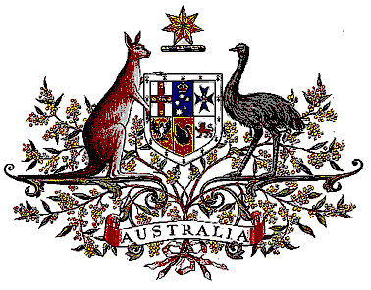

Veterans’ Entitlements Act 1986

Determination of Warlike Service
OPERATION KRUGER

I, Warren Snowdon, Minister for Defence Science and Personnel for the Minister for Defence:
  - determine that:
    - service rendered as a member of the Defence Force assigned for service with the Australian Defence Force contribution to the provision of security to the Australian Embassy in Iraq on Operation KRUGER on and from 1 January 2009 in the specified area is warlike service for the purposes of the definition of “warlike service” in subsection 5C(1) of the Veterans’ Entitlements Act 1986.
    - the specified area comprises Iraq, and
  - this Determination is taken to have commenced on 1 January 2009.

Dated Wednesday eleventh of February 2009

Signed by Warren Snowdon

WARREN SNOWDON
Minister for Defence Science and Personnel
for the Minister for Defence

