Determination under the Superannuation Act 1990
I, DAVID LINDSAY, Assistant Secretary Commonwealth Superannuation Branch, a delegate of the Minister for Finance, hereby make the following determination under subparagraph (b)(ii) of the definition of "designated employer" in subsection 15(1) of the Superannuation Act 1990
Dated 16 October 1990
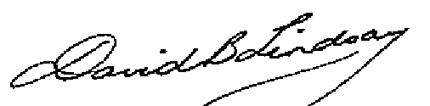
Assistant Secretary
Commonwealth Superannuation Branch
DETERMINATION UNDER SUBPARAGRAPH (b)(ii)
OF DEFINITION OF "DESIGNATED EMPLOYER"
IN SUBSECTION 15(1) OF THE SUPERANNUATION ACT 1990
Citation
1. This Declaration may be cited as "Designated Employer Determination No 2 ".
Designated Employer
2. The designated employer in relation to a productivity employee referred to in paragraph (b) (ii) of the definition of "designated employer" in subsection 15(1) of the Superannuation Act 1990 is the Department which pays the salary of that employee.

