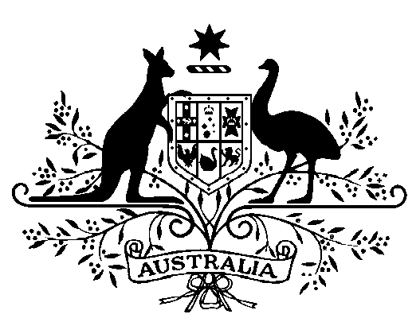

Commonwealth of Australia

Hazardous Waste (Regulation of Exports and Imports) Act 1989

Declaration Extending the Meaning of Hazardous Waste – Classification Under Foreign Laws: Thailand

I, DAVID ALISTAIR KEMP, Minister for the Environment and Heritage, noting that Thailand is a party to the Basel Convention and being satisfied that used toner is classified as Hazardous Material Type 3, Sequence No. 51 under the Chemical Wastes category according to the Notification of the Ministry of Industry, Subject: Hazardous Substance List B.E. 2546, of Hazardous Material Act B.E. 2535 of that country, and that arrangements must be made in accordance with the Basel Convention, declare, under subsection 4A(2) of the Hazardous Waste (Regulation of Exports and Imports) Act 1989, that used toner is hazardous waste for the purposes of export or proposed export to Thailand. This Declaration commences on the date of signature.

Dated 25 May 2004

DAVID KEMP
Minister for the Environment and Heritage

Under the Administrative Appeals Tribunal Act 1975, a person or persons whose
interests are affected by this decision may, within 28 days, make an application in
writing to the Department of the Environment and Heritage requesting the reasons for the decision. An application for independent review of the decision may be made to the Administrative Appeals Tribunal, on payment of the relevant fee, by or on behalf
of the person or persons whose interests are affected, either within 28 days of receipt
of the reasons for this decision, or within 28 days of this declaration if reasons for the decision are not sought. Applications should be made to the Deputy Registrar, Administrative Appeals Tribunal in your capital city, see under Commonwealth Government Section in the White Pages. Further information may be obtained from:

Manager, Hazardous Waste Section
Department of the Environment and Heritage
GPO Box 787
CANBERRA ACT 2601

Telephone 02 6274 1411, Facsimile 02 6274 1164, or
e-mail hwa@deh.gov.au

