DETERMINATION UNDER THE SUPERANNUATION ACT 1976
I, DAVID LINDSAY, Assistant Secretary, Commonwealth Employees' Superannuation Branch, a delegate of the Minister for Finance, hereby make the following determination under subparagraph (1)(a)(ii) in section 3C, "designated employers", of the Superannuation Act 1976.
Dated 15 September 1995
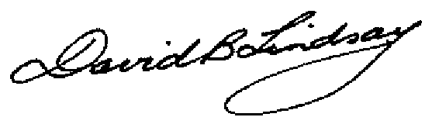
Assistant Secretary
Commonwealth Employees' Superannuation Branch
DETERMINATION UNDER SUBPARAGRAPH (1)(a)(ii) OF SECTION 3C, "DESIGNATED EMPLOYERS", OF THE SUPERANNUATION ACT 1976
Citation
1. This Declaration may be cited as "Designated Employers Determination No. 1".
Designated Employers
2. The designated employer referred to in subparagraph (1)(a)(ii) of section 3C, "designated employers", of the Superannuation Act 1976 is the Department who pays the salary of that eligible employee referred to in the definition of "eligible employee" in subsection 3(1) of that Act.

