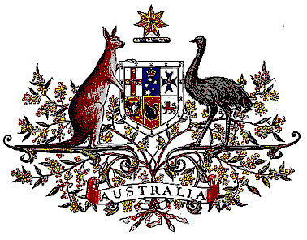

Veterans’ Entitlements Act 1986

Determination of Non-warlike Service
OPERATION HEDGEROW

I, Warren Snowdon, Minister for Defence Science and Personnel:
  - determine that:
    - the specified area comprises Sudan; and
    - service rendered as a member of the Australian Defence Force assigned for service with the Australian Defence Force mission in Sudan on Operation HEDGEROW on and from 28 July 2008 in the specified area is non-warlike service for the purposes of the definition of “non-warlike service” in subsection 5C(1) of the Veterans’ Entitlements Act 1986.
  - this Determination is taken to have commenced on 28 July 2008

Dated Thirteenth October 2008

Signed Warren Snowdon

WARREN SNOWDON
Minister for Defence Science and Personnel

