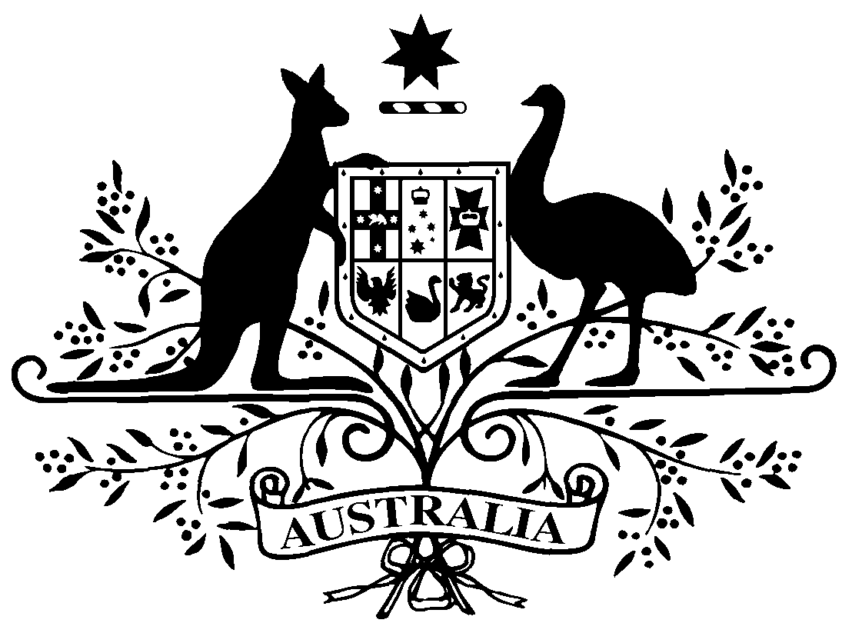

COMMONWEALTH OF AUSTRALIA

Instrument number PB 91 of 2008

Amendment special arrangements made under subparagraph100(1)(b)(i) of the National Health Act 1953

I, Declan O’Connor-Cox, Assistant Secretary, Access and Systems Branch, Department of Health and Ageing, delegate of the Minister for Health and Ageing, make this instrument under subsection 100(2) of the National Health Act 1953.

Dated 26 AUGUST 2008

DECLAN O’CONNOR-COX
Assistant Secretary
Access and Systems Branch
Department of Health and Ageing

Amendment Special Arrangements — IVF/GIFT Program

- Commencement
This instrument commences on 1 September 2008.
- Amendment of PB 26 of 2007
Schedule 1 amends PB 26 of 2007

Schedule 1 Amendments

[1] Subparagraph 3(a)
omit from the paragraph:
Health Insurance (General Medical Services Table) Regulations 2006
and substitute:
Health Insurance (General Medical Services Table) Regulations 2007
[2] Subparagraph 3(b)
omit from the paragraph:
Health Insurance (General Medical Services Table) Regulations 2006
and substitute:
Health Insurance (General Medical Services Table) Regulations 2007
[3] Subparagraph 4
omit from the paragraph:
Health Insurance (General Medical Services Table) Regulations 2006
and substitute:
Health Insurance (General Medical Services Table) Regulations 2007

[4] Paragraph 5
omit from the paragraph:
rule 26 of the Health Insurance (General Medical Services Table) Regulations 2006
and substitute:
rule 81 of the Health Insurance (General Medical Services Table) Regulations 2007
[5] The Schedule, Part 1, the reference, in the title, to the Health Insurance (General Medical Services Table) Regulations 2006
omit from the title:
Health Insurance (General Medical Services Table) Regulations 2006
and substitute:
Health Insurance (General Medical Services Table) Regulations 2007

[6] The Schedule, Part 1, item dealing with Choriogonadotropin Alfa
omit from the column headed “Form (strength, type, size, etc.)”:
Powder for injection 250 micrograms vial with solvent
and substitute:
Solution for injection 250 micrograms in 0.5 mL pre-filled syringe

