Accounting Standard | AASB 2008-4  June 2008

Amendments to Australian Accounting Standard – Key Management Personnel Disclosures by Disclosing Entities

[AASB 124]

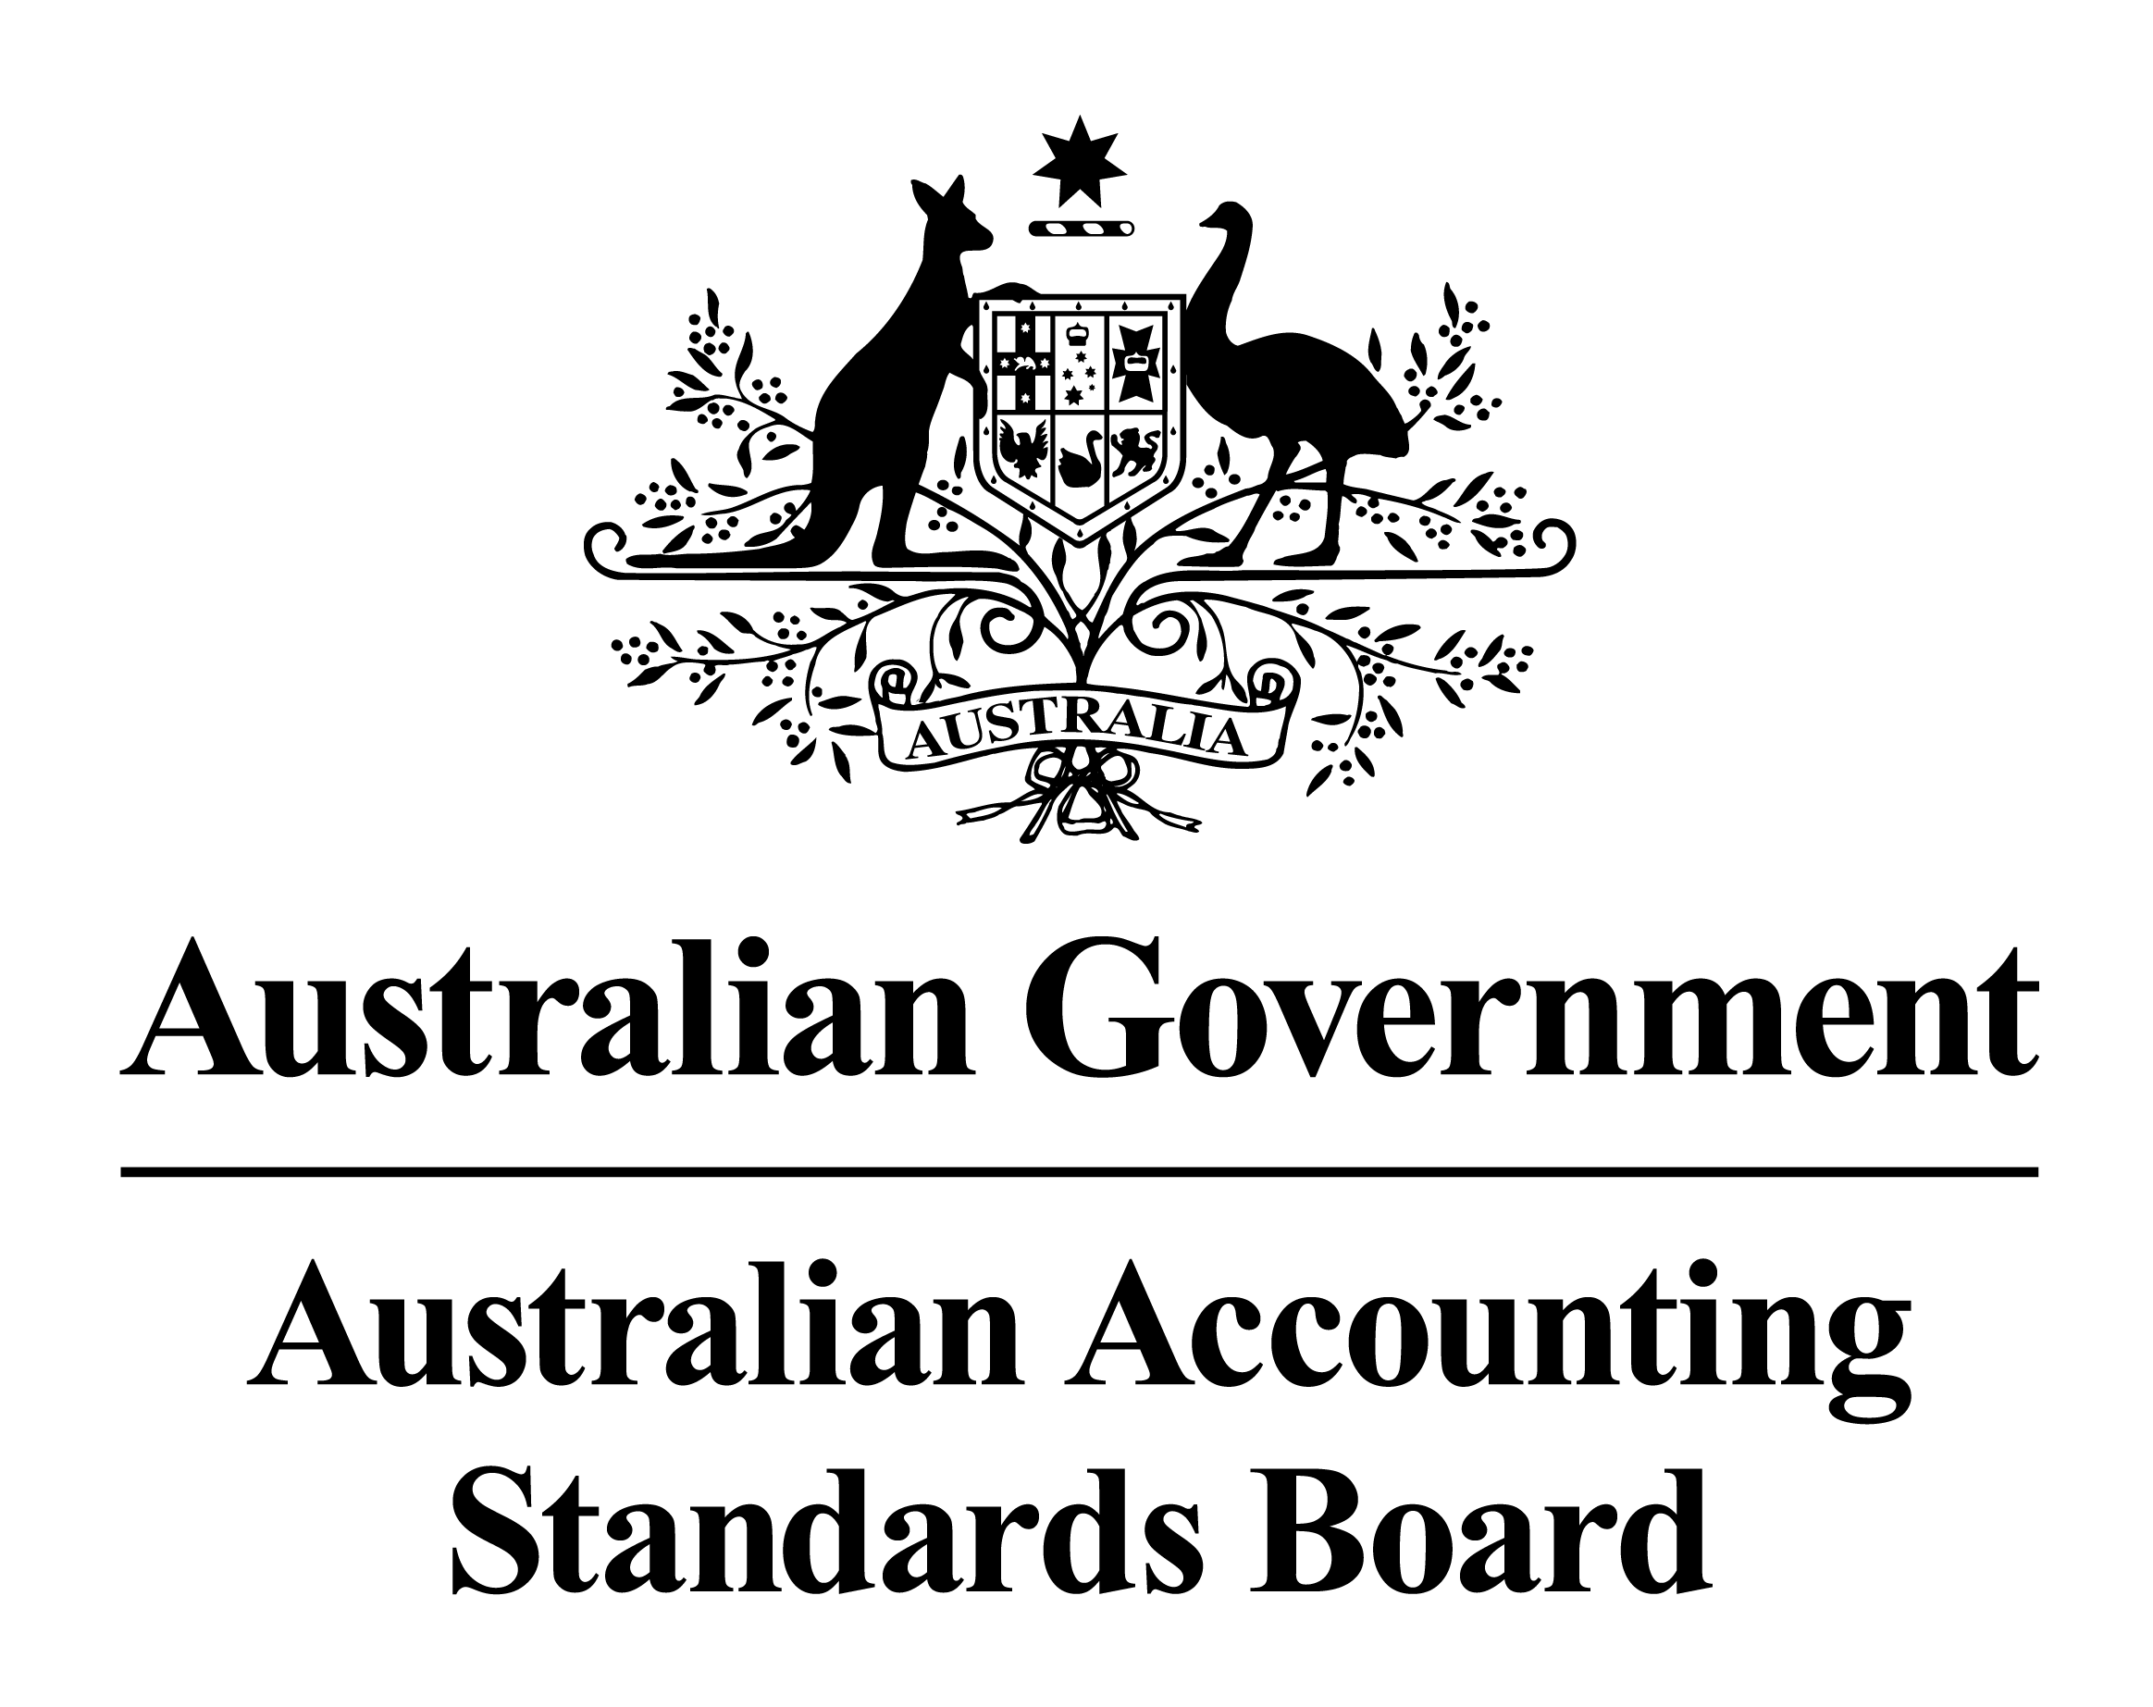

Obtaining a Copy of this Accounting Standard
This Standard is available on the AASB website: www.aasb.gov.au.
Alternatively, printed copies of this Standard are available for purchase by contacting:

The Customer Service Officer  Australian Accounting Standards Board  Level 7  600 Bourke Street  Melbourne Victoria  AUSTRALIA | Postal address:  PO Box 204  Collins Street West Victoria 8007  AUSTRALIA
Phone: (03) 9617 7637
Fax: (03) 9617 7608
E-mail: publications@aasb.gov.au
Website: www.aasb.gov.au

Other Enquiries
COPYRIGHT

© 2008 Commonwealth of Australia

This work is copyright. Reproduction in unaltered form (retaining this notice) is permitted for personal and non-commercial use subject to the inclusion of an acknowledgment of the source. Apart from any use as permitted under the Copyright Act 1968, no part may be reproduced by any process without prior written permission from the Australian Accounting Standards Board. Requests and enquiries concerning reproduction and rights for commercial purposes should be addressed to The Director of Finance and Administration, Australian Accounting Standards Board, PO Box 204, Collins Street West, Victoria 8007.

ISSN 1036-4803
Phone: (03) 9617 7600
Fax: (03) 9617 7608
E-mail: standard@aasb.gov.au

CONTENTS
Preface
Accounting Standard
AASB 2008-4 AmenDMENTS TO aUSTRALIAN aCCOUNTING sTANDARD – Key Management Personnel Disclosures by Disclosing Entities

Paragraphs
Objective 1
Application 2 – 6
Amendments to AASB 124 7 – 9

BASIS FOR CONCLUSIONS Page 7

Australian Accounting Standard AASB 2008-4 Amendments to Australian Accounting Standard – Key Management Personnel Disclosures by Disclosing Entities is set out in paragraphs 1 – 9. All the paragraphs have equal authority.

Preface

Standard Amended by AASB 2008-4
This Standard makes amendments to Australian Accounting Standard AASB 124 Related Party Disclosures.
These amendments arise from Exposure Draft ED 162 Proposed Amendments to Key Management Personnel Disclosures by Disclosing Entities.

Main Features of this Standard

Application Date
This Standard is applicable to annual reporting periods ending on or after 30 June 2008, subject to such an annual reporting period not beginning before 30 June 2007.
This Standard may be applied to annual reporting periods beginning on or after 30 June 2007 that end before 30 June 2008.

Main Requirements
This Standard excludes disclosing entities that are companies from the application of AASB 124 paragraphs Aus25.2 to Aus25.6 and Aus25.7.1 and Aus25.7.2, as the requirements for these entities are now incorporated into the Corporations law. However, AASB 124 paragraphs Aus25.7 and Aus25.7.3 to Aus25.9.3 still apply to disclosing entities that are companies.

aCCOUNTING STANDARD AASB 2008-4
The Australian Accounting Standards Board makes Accounting Standard AASB 2008-4 Amendments to Australian Accounting Standard – Key Management Personnel Disclosures by Disclosing Entities under section 334 of the Corporations Act 2001.

 | D.G. Boymal
Dated 6 June 2008 | Chair – AASB

aCCOUNTING STANDARD AASB 2008-4
AMENDMENTS TO AUSTRALIAN ACCOUNTING Standard – Key Management Personnel Disclosures by Disclosing Entities

Objective
- The objective of this Standard is to make amendments to AASB 124 Related Party Disclosures.

Application
- This Standard applies to:
- each entity that is required to prepare financial reports in accordance with Part 2M.3 of the Corporations Act 2001 and that is a reporting entity;
- general purpose financial statements of each other reporting entity; and
- financial statements that are, or are held out to be, general purpose financial statements.
- Subject to paragraph 4, this Standard applies to annual reporting periods ending on or after 30 June 2008.
- This Standard does not apply to annual reporting periods beginning before 30 June 2007.
- This Standard may be applied to annual reporting periods beginning on or after 30 June 2007 that end before 30 June 2008.
- The requirements specified in this Standard apply to the financial statements where information resulting from their application is material in accordance with AASB 1031 Materiality.

Amendments to AASB 124
- Paragraph Aus1.4 is amended to read as follows:
Aus1.4 Subject to paragraphs Aus1.4.1 and Aus1.5, paragraphs Aus25.1 to Aus25.9.3 of this Standard apply to each disclosing entity, or group of which a disclosing entity is the parent, that is required to prepare financial reports in accordance with Part 2M.3 of the Corporations Act.
- Paragraph Aus1.4.1 is added, to read as follows:
Aus1.4.1 Paragraphs Aus25.2 to Aus25.6 and Aus25.7.1 and Aus25.7.2 of this Standard do not apply to disclosing entities that are companies.
- Paragraph Aus25.1 is amended to read as follows:
Aus25.1 Paragraphs Aus25.2 to Aus25.9.3 of this Standard apply to each disclosing entity (subject to parent entity relief) that is required to prepare financial reports in accordance with Part 2M.3 of the Corporations Act. However, paragraphs Aus25.2 to Aus25.6 and Aus25.7.1 and Aus25.7.2 of this Standard do not apply to disclosing entities that are companies. The disclosures required of disclosing entities by paragraphs Aus25.2 to Aus25.9.3 are in addition to those required by paragraphs 1 to 22.

BASIS FOR CONCLUSIONS
The Basis for Conclusions accompanies, but is not part of, AASB 2008-4.

Background
- This Basis for Conclusions summarises the Australian Accounting Standards Board’s considerations in reaching the conclusions in AASB 2008-4.

Significant Issue
- As a result of the amendments to section 300A of the Corporations Act 2001 and Regulation 2M.3.03 in 2007, disclosing entities that are companies are required to report remuneration information in the directors’ report in accordance with the Corporations Act and Regulation 2M.3.03. The same remuneration information is required in the financial statements in accordance with AASB 124 Related Party Disclosures paragraphs Aus25.2 to Aus25.6 and Aus25.7.1 and Aus25.7.2.
- Corporations Act Regulation 2M.6.04 permitted listed companies to avoid making the same disclosures twice. The Corporations Amendment Regulations 2007 (No. 2) has removed that regulation.
- The Board has amended AASB 124 to relieve disclosing entities that are companies from complying with the paragraphs in AASB 124 that have been included in the Corporations Act and Regulation 2M.3.03 to avoid each disclosing entity that is a company having to disclose this information twice – in its directors’ report and in its financial statements.
- This Standard is applicable to annual reporting periods ending on or after 30 June 2008, subject to such an annual reporting period not beginning before 30 June 2007. The Board has decided to allow disclosing entities that are companies to apply this Standard to annual reporting periods beginning on or after 30 June 2007 that end before 30 June 2008.
- A number of constituents who commented on ED 162 encouraged the Board to consider removing all the key management personnel disclosures required in the Aus paragraphs of AASB 124. The Board has not yet considered all the issues relating to the Aus paragraphs, which are the subject of ongoing discussions with Treasury.

