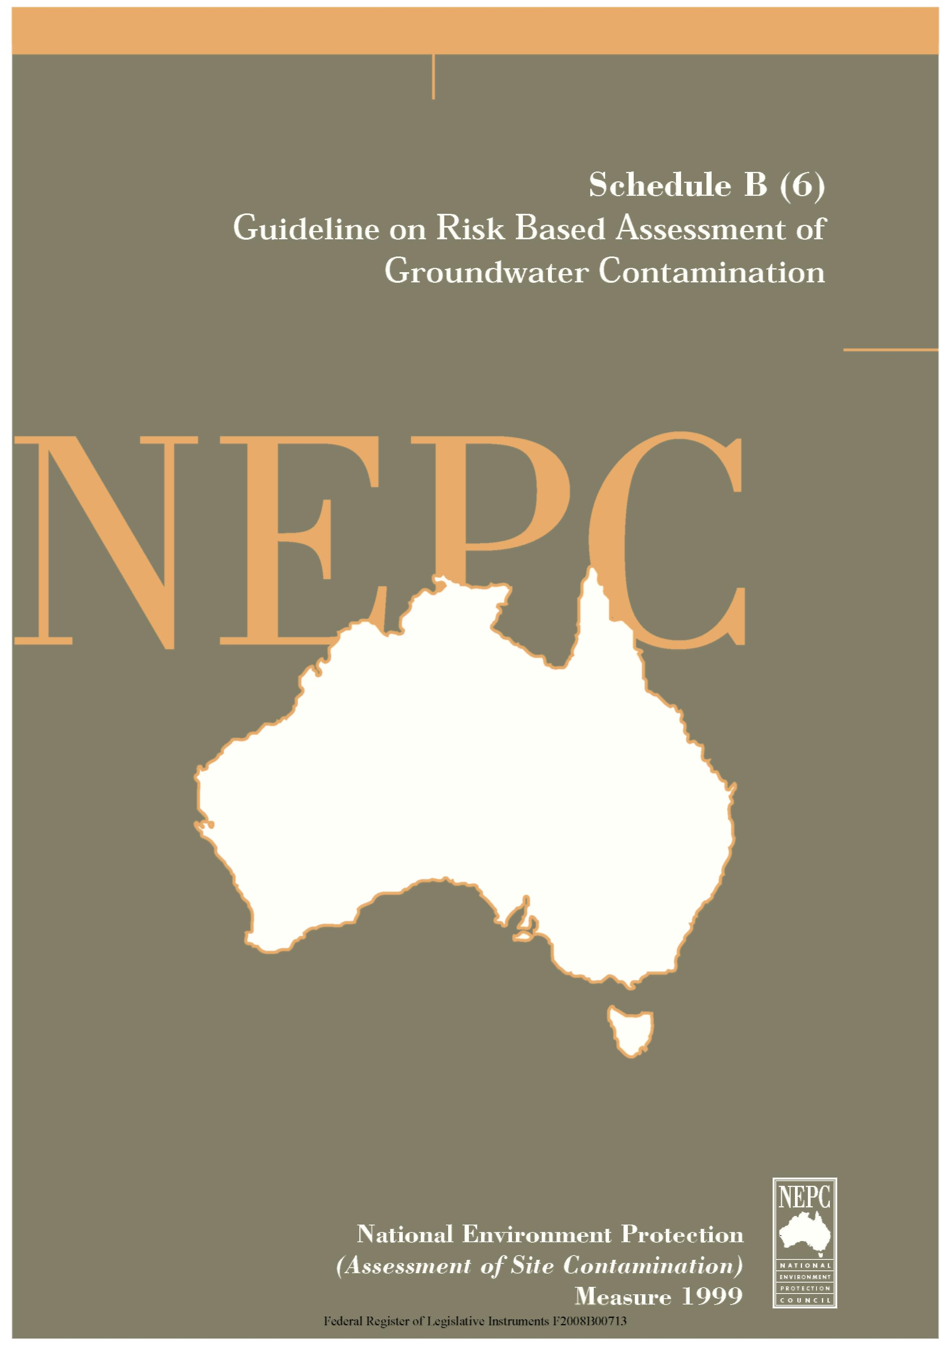

The following Guideline provides general guidance in relation to Risk Based Assessment of Groundwater Contamination in the assessment of site contamination.
This Guideline forms part of the National Environment Protection (Assessment of Site Contamination) Measure 1999 and should be read in conjunction with that document, which includes a Policy Framework and Assessment of Site Contamination flowchart.
The National Environment Protection Council acknowledges the contribution of the National Health and Medical Research Council to the development of this Measure.

Contents
Risk Based Assessment of Groundwater Contamination

 |  |  | Page
1. | Glossary |  | 1
2. | Purpose |  | 1
 | 2.1 | Scope | 2
 | 2.2 | Initiation of an Assessment of Groundwater Contamination | 2
 | 2.3 | The Basis for Risk Assessment | 3
3. | Framework for the Application of the Australian Water Quality Guidelines for Fresh and Marine Waters |  | 4
 | 3.1 | Background | 4
 | 3.2 | Framework | 5
4. | References |  | 9

1. GLOSSARY
Aquifer is a rock or sediment in a geological formation, group of formations or part of a formation which is capable of being permeated permanently or intermittently and can thereby transmit water.
Contamination means the condition of land or water where any chemical substance or waste has been added at above background level and represents, or potentially represents, an adverse health or environmental impact.
Discharge Area means an area in which there are upward components of hydraulic head in the aquifer. Groundwater flowing toward the land surface in a discharge area may escape as a spring, leading to a discharge, seep or baseflow, or by evaporation and transpiration.
Environmental Value is a value or use of the environment which is conducive to public benefit, welfare, safety or health and which requires protection from the effects of pollution, waste discharge and deposits.
Groundwater means all waters occurring below the land surface.
Groundwater Investigation Level is the concentration of a groundwater parameter at which further investigation (point of extraction) or a response (point of use) is required. Includes both Australian Water Quality Guidelines/Australian Drinking Water Guidelines criteria and site specific derived criteria.
Point Source means a source of contamination which comes from a contaminating activity at a particular site.
Receptor is the entity that may be adversely affected by contact with or exposure to a contaminant of concern.
Risk means the probability in a certain timeframe that an adverse outcome will occur in a person, a group of people, plants, animals and/or the ecology of a specified area that is exposed to a particular dose or concentration of a hazardous agent ie it depends on both the level of toxicity of hazardous agent and the level of exposure.
Risk Assessment is the process for estimating the potential impact of a chemical, biological or physical agent on humans, plants, animals and the ecology.
Well is a hole drilled into an aquifer for the purpose of monitoring or extracting groundwater. This generic term includes bores, water wells and tubewells.
2. PURPOSE
The purpose of this draft Guideline is to provide a framework for the risk based assessment of groundwater that may have been affected by site contamination. The general processes outlined for the assessment of contaminated groundwater are

compatible with the Policy Framework and the site assessment processes shown in Schedule A. The aim of this process is to minimise the risk of adverse human health and environmental impacts arising from contaminated groundwater.
2.1 Scope
The framework outlined in this Guideline is used specifically for the assessment of groundwater quality arising from point source contamination (eg leaks from fuel storage depots, sheep and cattle dips). This Guideline is not intended to address all aspects of the management of groundwater quality, or to replace the regulatory requirements of individual jurisdictions on the assessment and management of groundwater contamination. Nor is it generally applicable to other broad scale groundwater issues associated with agriculture, catchment management or salinity. These resource management issues are administered by jurisdictions through various regulatory processes.
The framework recognises existing, nationally developed approaches, policies and water quality criteria developed to protect groundwater under the National Water Quality Management Strategy and applies them to the specific issue of assessing the quality of groundwater impacted by site contamination.
When using this framework, Schedule B(2), should also be referred to. This Guideline includes information on related issues such as monitoring well establishment, groundwater sampling and the application of fate and transport modeling.
2.2 Initiation of an Assessment of Groundwater Contamination
Preliminary contaminated site investigations include a minimum of a desktop review of the geology and hydrogeology of the site. Regional information on these issues is usually available from geological maps and the relevant jurisdiction’s water resource management authority. Initial site inspections, targeted soil sampling programs and logging of soil samples and test pits will provide site-specific information. The information is used for early appraisal of the potential for groundwater contamination. The main situations that may trigger a groundwater assessment are:
- an Environmental Protection Authority may request or require an assessment of groundwater quality;
- site usage and/or site history suggests the potential for groundwater contamination; and
- assessment of soil contamination suggests the potential for groundwater contamination.
Appraisal of the groundwater issues will also rely on the professional judgement of the site assessor who should obtain specialist groundwater advice where necessary. This advice should be sought early in the assessment process to help avoid remobilisation of assessment personnel and associated additional costs. The issues which should be considered during the appraisal include:

- on-site sources (type of source);
- contaminant sources unrelated to the site;
- whether source(s) has been removed;
- permeability of the strata on the site;
- known or expected depth to the local water table;
- ambient groundwater quality;
- quantity of contaminant and its mobility characteristics;
- identification of potential receptors; and
- any other site-specific issues.
Where the appraisal indicates the likelihood of groundwater contamination, the process outlined in this document should be undertaken. Detailed groundwater investigations should only be undertaken by appropriately qualified and experienced groundwater professionals.
2.3 The Basis for Risk Assessment
Groundwater is assessed on the basis of its suitability for current or realistic future use and the risk that use may pose to human health and/or the environment. This assessment should take into account factors relevant to the environmental value of the groundwater resource such as the proposed and realistic future uses, physico-chemical and bioavailability characteristics of the particular contaminant(s) and the distribution of the contamination. In this approach the potential receptor, either human or ecological risk, determines the level of protection required.
In the case of groundwater, consideration is given to current use and realistic future uses of the groundwater. This reflects the national approach to groundwater protection which is to protect it as a resource for future use as detailed in the Guidelines for Groundwater Protection in Australia (ARMCANZ/ANZECC, 1995).
It differs from the assessment process for land contamination in that there is greater emphasis on suitability for current and realistic future uses with the groundwater assessment and emphasis on current and intended uses with soil assessment. The focus on the protection of realistic future uses (based on the inherent capacity of the aquifer to support those uses) is derived from the following considerations:
- groundwater contamination is often persistent and difficult to contain;
- some groundwater contamination may persist beyond current planning horizons, affecting future uses which today are not considered likely;
- the stress on Australia’s water resources is expected to increase, highlighting the importance of protecting groundwater resources for the future; and
- groundwater contamination may readily spread and is expensive and time consuming to remediate.

An assessment of the risk posed to human health and the environment from current and realistic future uses of the groundwater resource can be used to determine an appropriate response to groundwater contamination, and the nature and urgency of that response.
In the context of a contaminated site, groundwater can be considered to be contaminated when it is not suitable for its current or realistic future use or presents the likelihood of causing an unacceptable environmental or human health impact in the discharge environment. This differs from the National Water Quality Management Strategy definition which considers groundwater to be contaminated whenever there is a change in water quality that produces a noticeable or detectable change in its characteristics. This latter definition should be the one adopted by jurisdictions in managing and protecting groundwater resources. Therefore, if any change in groundwater is detected, relevant jurisdictional policy should also be taken into account regarding groundwater protection.
The risk assessment process must consider any impact from site contamination on groundwater quality which causes groundwater parameters to differ from ambient quality.
As with contaminated soil, this approach recognises that the appropriate level of groundwater quality will be based on its impact on the receptor. With soil assessment, landuse and the level of contact between the most sensitive human or ecological receptor and the contaminated soil primarily determine the level of protection required. In the case of groundwater, there may be several different exposure scenarios and several potential receptors, eg groundwater may be used for irrigation purposes, pass beneath a freshwater lake and then go on to discharge into the marine environment. Potential receptors will differ in each scenario and acceptable contaminant levels may well be different for each receptor. An assessment of groundwater contamination must consider the most sensitive receptor in each exposure scenario.
3. FRAMEWORK FOR THE APPLICATION OF THE AUSTRALIAN WATER QUALITY GUIDELINES FOR FRESH AND MARINE WATERS
3.1 Background
This section provides a methodology for the use of the National Water Quality Management Strategy, Australian Water Quality Guidelines for Fresh and Marine Water (AQWG) (ANZECC, 1992) and the Australian Drinking Water Guidelines (ADWG) (NHMRC/ARMCANZ, 1996) in the assessment of contaminated groundwater. The process involves building on existing criteria to provide a system that responds appropriately as knowledge about the levels of protection required becomes available.

The following assessment framework is based on identifying the receptors (human and/or ecological) for groundwater that is contaminated and determining the level of protection required by referring to the appropriate set of guidelines within the AWQG/ADWG.
This framework is intended to be consistent with the goals promoted in the Guidelines for Groundwater Protection in Australia (ANZECC, 1995). It is not intended to infer that contaminated groundwater from a contaminated site, which is transported off site, is acceptable if the AWQC criteria are not exceeded at the point of use. The process is risk-based and deals only with contamination associated with a contaminated site. Generally, any contamination of groundwater, both on site and off site, is considered unacceptable and the responsibility of the polluter. Its administration is a jurisdictional matter.
3.2 Framework
The AWQG and ADWG set out criteria for water quality relating to a number of environmental values. Environmental values are values or uses of the environment which are conducive to public benefit, welfare, safety or health and which require protection from the effects of pollution, waste discharge and deposits. Six environmental values are presented in the AWQG and ADWG:
- aquatic ecosystems;
- aquaculture and human consumers of food;
- agricultural water;
- recreation and aesthetics;
- drinking water; and
- industrial water.
For each environmental value, a set of guideline criteria is presented and these criteria form the basis, in this document, for the assessment of contaminated groundwater and associated risks. The criteria defined within the AWQG/ADWG define acceptable water quality at the point of use. In this Guideline, they are used as investigation levels at the point of extraction and as response levels at the point of use (unless a site specific risk assessment has been carried out and an alternative, more appropriate response level has been determined).
These criteria are referred to in Schedule B(1), as Groundwater Investigation Levels (GILs).
The structure of the assessment framework is outlined in Figure 3-I, which demonstrates use of the AWQG/ADWG in the assessment of groundwater contamination. In all situations the AWQG/ADWG criteria (GILs) should only be applied with reference to the policy framework which includes consideration of ambient groundwater quality. The assessment of ambient water quality should include the analysis of major ions to enable differentiation between contaminated and non-contaminated groundwater.

The assessment framework is an iterative process that has two levels of assessment. The level of assessment depends upon the point of application of the relevant criteria. A preliminary assessment is a comparison of the groundwater contaminant concentrations at the point of extraction with existing generic GILs. Detailed investigations require the assessment of contaminant concentrations over time at the point of current and realistic future use and may require the use of sophisticated modeling programs. The investigations leading to a detailed assessment should cover all relevant site-specific issues, for example, appraisal of the attenuation capacity of vadose zone soils or the removal of hydrocarbon sources. Refer to Schedule B(2) for more details on groundwater investigations. Detailed assessments compare groundwater contaminant concentrations at the point of use with existing generic GILs or can incorporate additional information such as ecosystem/ environmental variability and exposure, to derive modified, site specific response levels.

Figure 3-I
Assessment Process for Groundwater Contamination
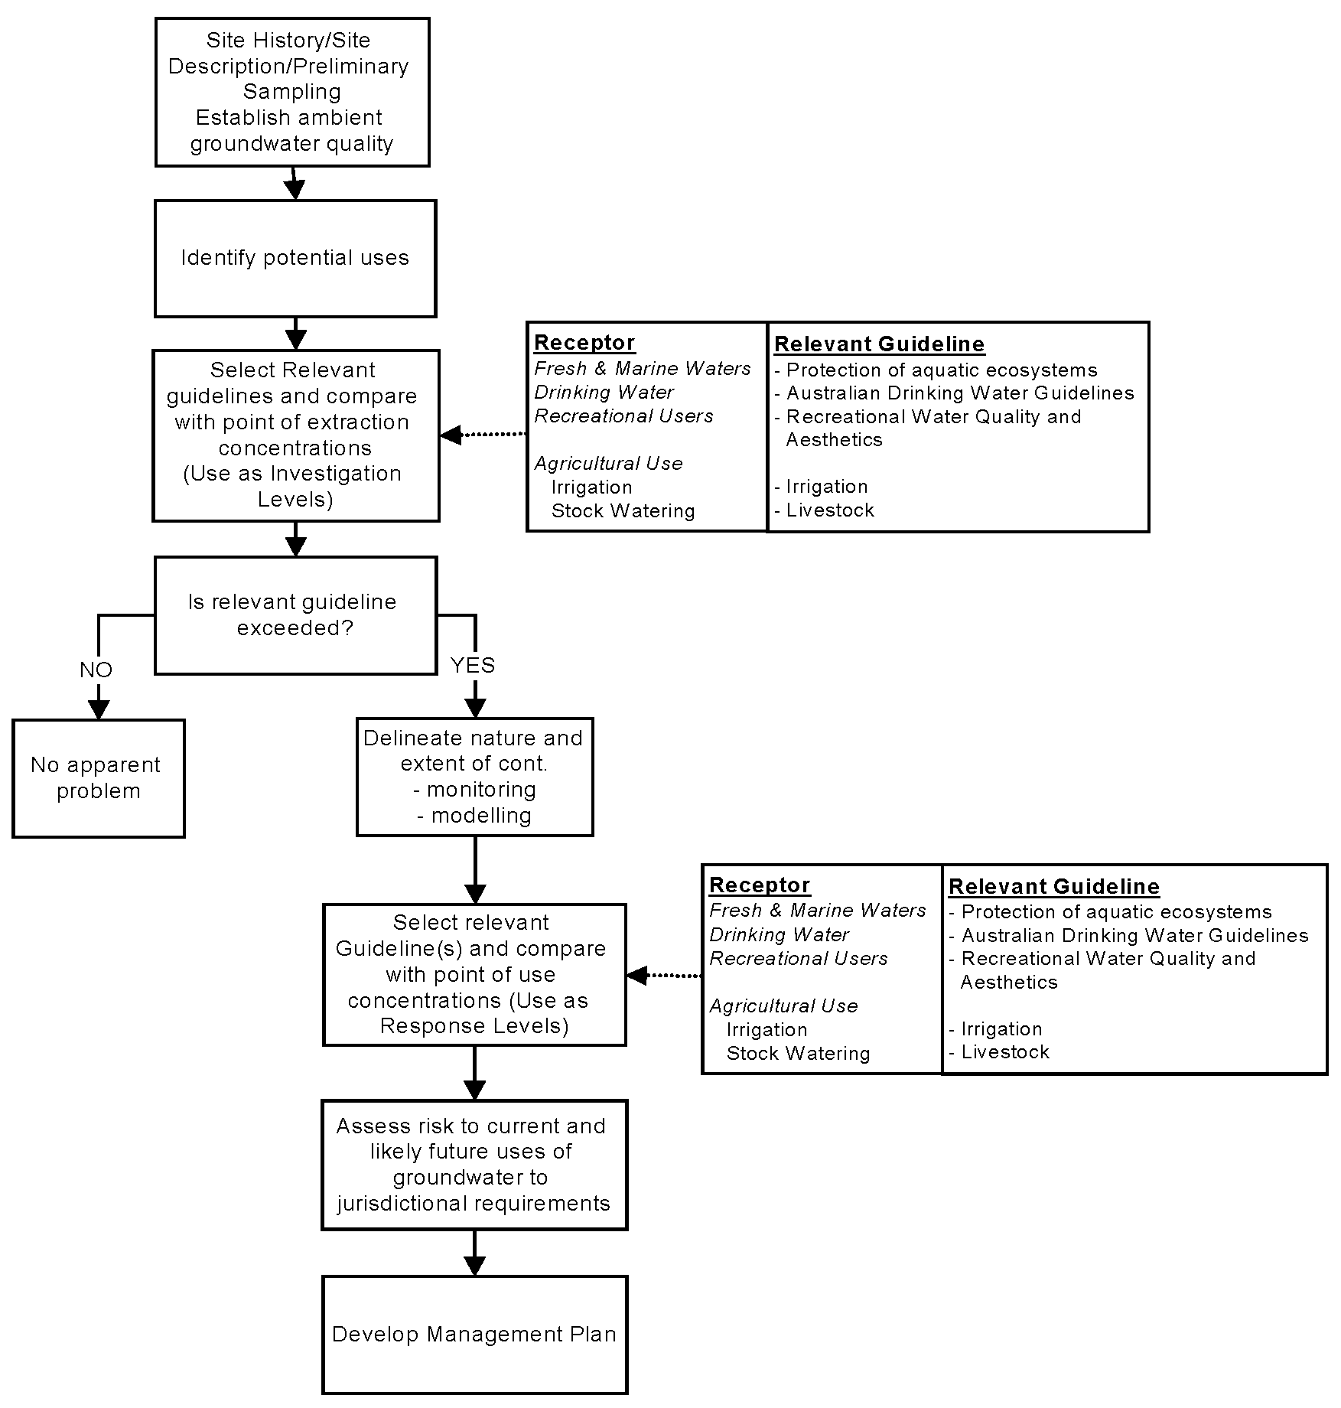
A preliminary assessment is a screening process and compares groundwater contaminant concentrations at the point of extraction with existing generic GILs. This means that a groundwater sample from a monitoring well with contaminant levels above the GILs will trigger further investigation rather than initiate action. However, site-specific consideration must be given to water quality impacts which cause variations from ambient water quality even when GILs are not exceeded. This is because individual jurisdictions may operate protective strategies for groundwater that require action at levels below the GILs or whenever levels of contaminants above ambient are detected. Such issues are the responsibility of jurisdictions.

If further investigation is required, a detailed investigation is conducted which entails devising a detailed sampling and analysis plan, in keeping with the iterative process of site contamination assessment outlined in Schedule A of the Measure. Investigation should involve determination of sources and receptors, as well as further delineation of the groundwater plume, if appropriate.
If receptors are identified, then a complete analysis of the potential impact of the plume should be undertaken considering a realistic range of aquifer conditions. With groundwater issues, this should involve the collection of sufficient data to determine the direction of groundwater flow, and to determine the vertical and lateral extent of contamination and its nature and severity. In many assessments, particularly of sites which are small in area, off site wells will need to be established in the delineation process. Identification of contaminant sources should also be completed by this time.
This more detailed investigation and analysis should result in an estimation of the current and projected contaminant concentrations in the receiving environment at the points of existing and realistic future use. Fate and transport modeling may be required to estimate the contaminant concentrations at these points. The investigation process should consider the:
- exposure pathway;
- persistence of the contaminant; and
- the physical-chemical and biochemical transformations which occur as the contaminants pass from the ground source to the point of current or future realistic use.
For further details on modeling, refer to Schedule B(2).
The GILs may then be used as response levels at the point of use, taking into account the following factors:
- economic, social and jurisdictional factors; and
- Jurisdictional policy regarding protection of the groundwater resource.
Jurisdictional policy may allow for modification of GILs on a site specific basis. For example, when determining criteria for groundwater discharging to a surface water, these should be determined on a site specific basis as some jurisdictions allow for a mixing zone or treatment, whereas others apply the GILs at the point of discharge without mixing in order to protect benthic organisms.
A management plan for unacceptable levels of contamination may include one or more of the following:
- work plan;
- determination of site specific clean-up criteria;
- development of site management options;
- determination of clean-up methods;
- implementation of remedial actions;

- water treatment at the point of use;
- restriction on the use of the aquifer; and/or
- future monitoring and information provision.
These steps are comparable to those employed for contaminated soil assessment and remediation, the major exception being that the GILs may also be used as response levels. These management issues are beyond the scope of the Measure and are matters administered by jurisdictions.
4. REFERENCES
ANZECC (1992) Australian Water Quality Guidelines for Fresh and Marine Waters, Australian and New Zealand Environment and Conservation Council, November 1992.
ARMCANZ/ANZECC (1995) Guidelines for Groundwater Protection in Australia. Agriculture and Resource Management Council of Australia and New Zealand/ Australian and New Zealand Environment and Conservation Council, September 1995.
NHMRC/ARMCANZ (1996) Australian Drinking Water Guidelines. National Health and Medical Research Council/ Agriculture and Resource Management Council of Australia and New Zealand, 1996.

