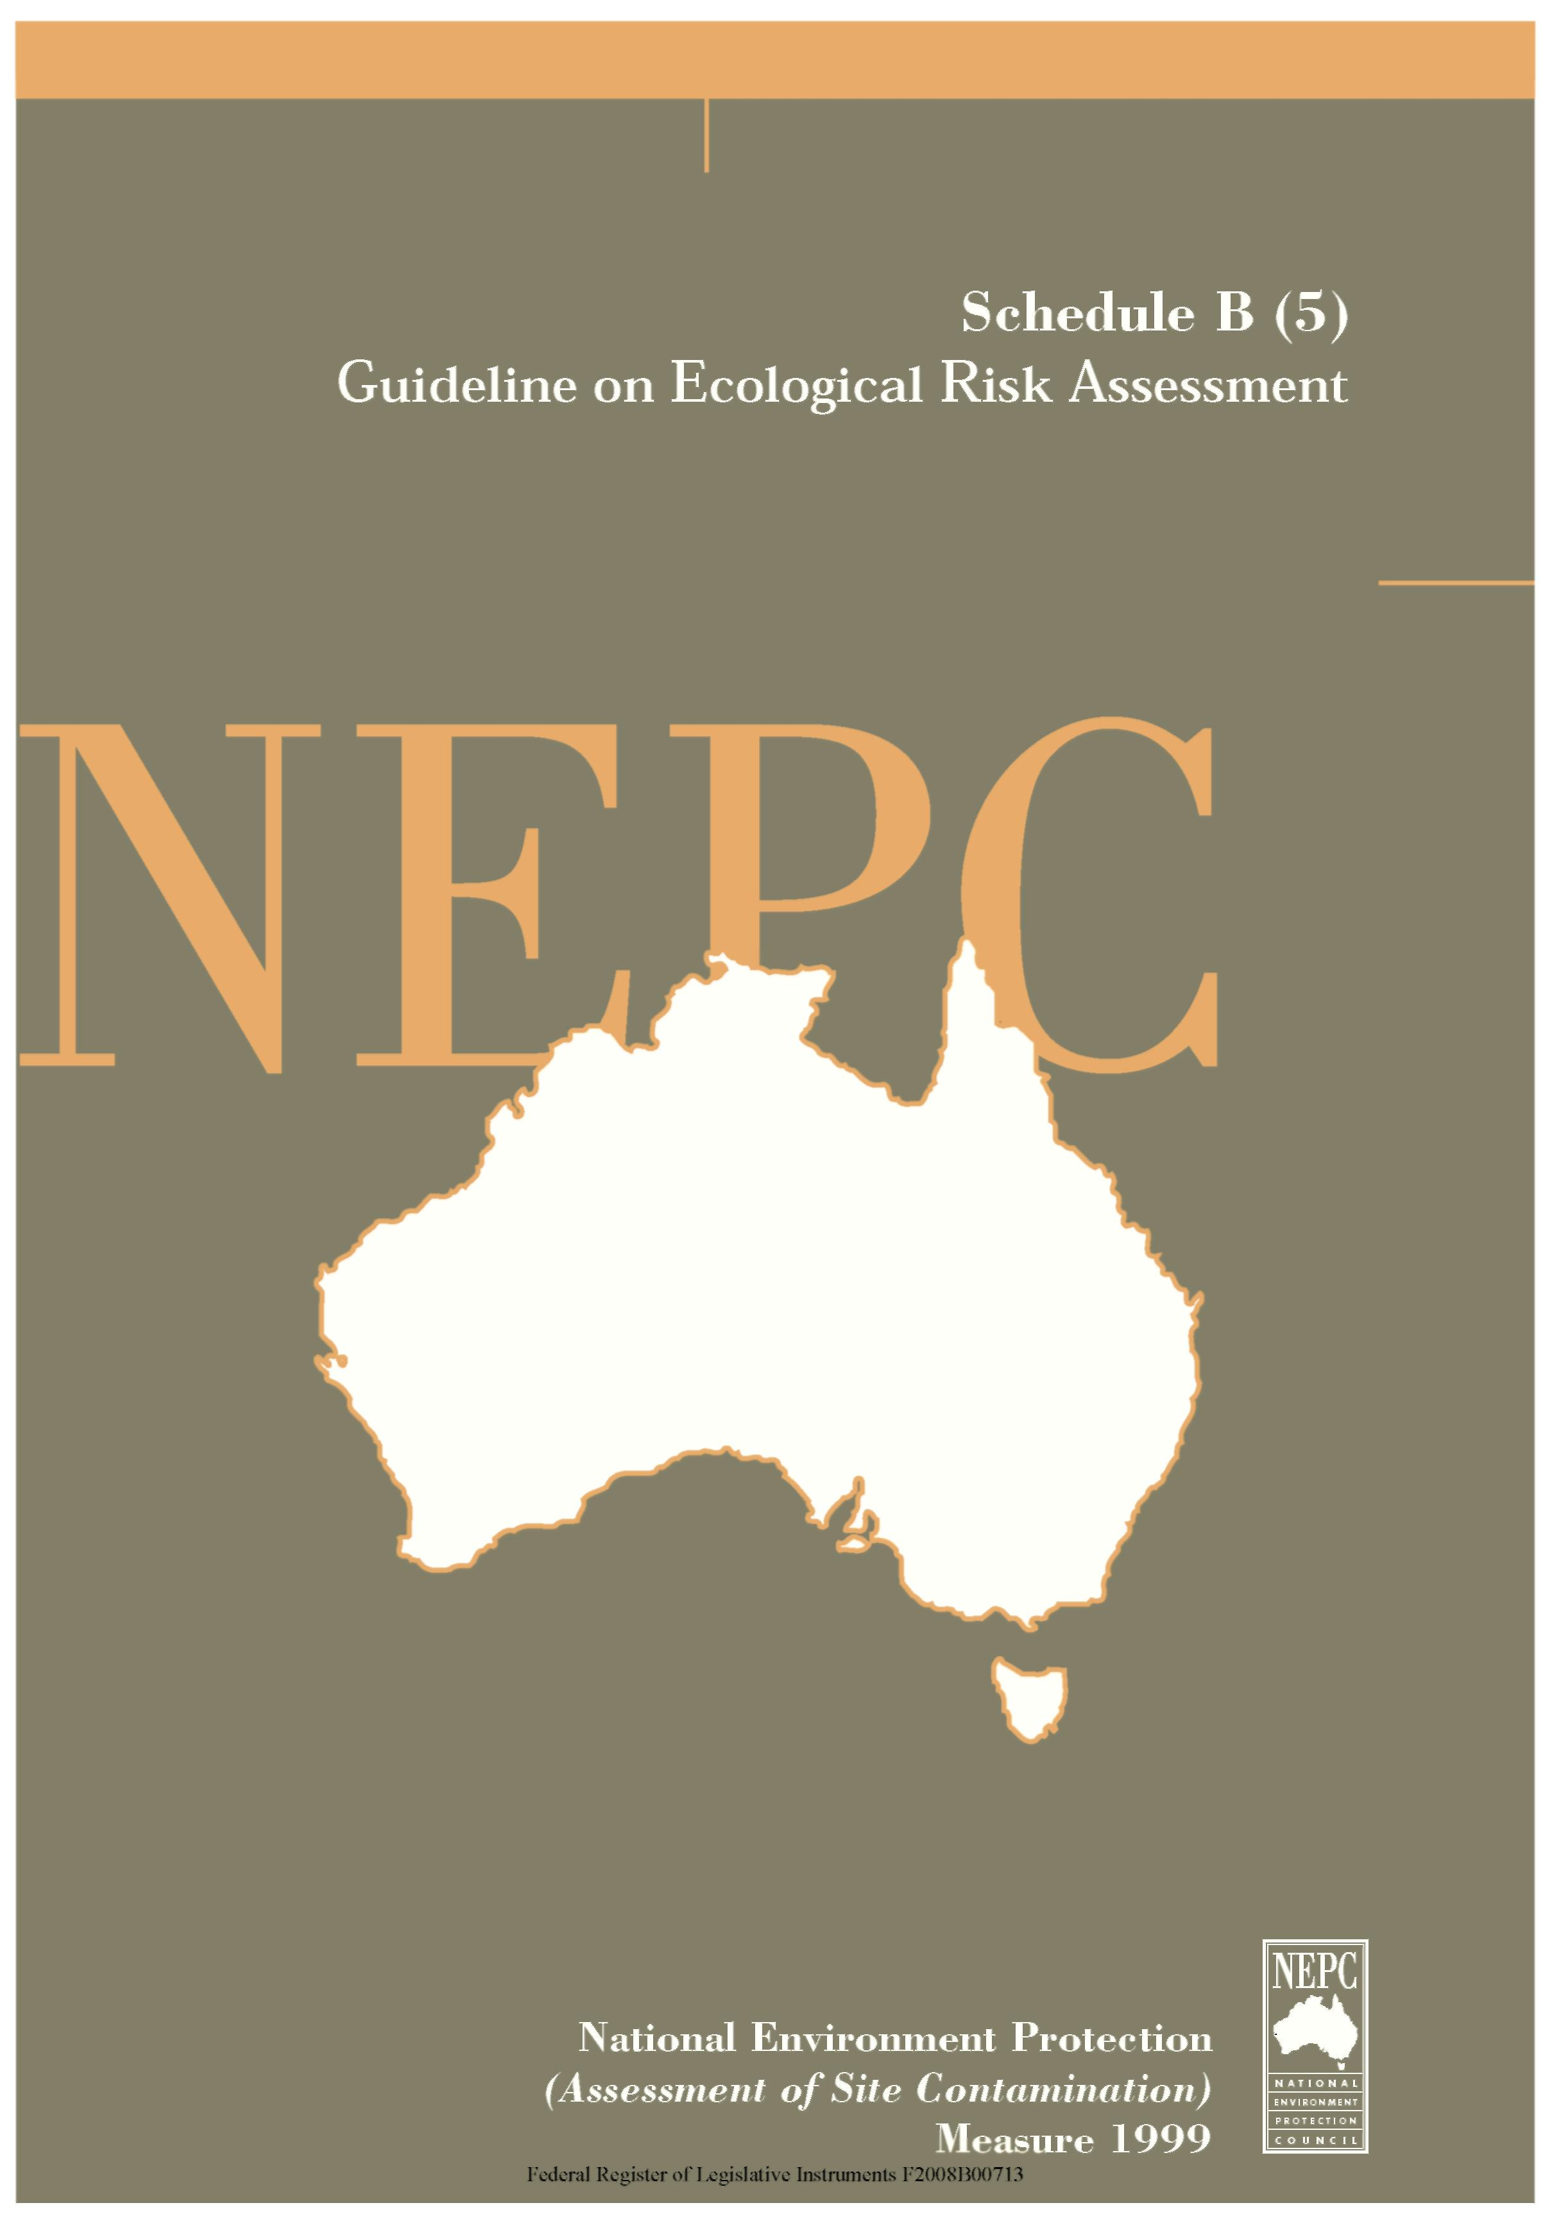

The following Guideline provides general guidance in relation to Ecological Risk Assessment in the assessment of site contamination.
This Guideline forms part of the National Environment Protection (Assessment of Site Contamination) Measure 1999 and should be read in conjunction with that document, which includes a Policy Framework and Assessment of Site Contamination flowchart
The National Environment Protection Council acknowledges the contribution of the National Health and Medical Research Council to the development of this Measure.

Contents
Ecological Risk Assessment
 |  |  | Page
1. | Glossary |  | 1
2. | Abbreviations |  | 3
3. | Introduction |  | 4
 | 3.1 | Background | 4
 | 3.2 | Aims of the Guideline | 5
 | 3.3 | Ecological Investigation and Response Levels | 5
 | 3.4 | Guideline Principles | 5
4. | Framework Description |  | 6
 | 4.1 | Introduction to the Framework | 6
 | 4.2 | Initiation of an Ecological Risk Assessment | 8
 | 4.3 | Components of an Ecological Risk Assessment | 9
 | 4.4 | Risk Management Decision | 13
 | 4.5 | No Action | 14
 | 4.6 | Monitoring | 14
 | 4.7 | Site Management/Remediation | 15
 | 4.8 | Proceeding to the Next Level of ERA | 15
5. | Ecological Values |  | 16
 | 5.1 | Introduction | 16
 | 5.2 | Generic and Site Specific Ecological Values | 17
6. | Levels of Ecological Risk Assessment |  | 22
 | 6.1 | Introduction | 22
 | 6.2 | Level 1 Assessment (Screening) | 22
 | 6.3 | Level 2 Assessment | 26
 | 6.4 | Level 3 Assessment | 30
7. | Uncertainty |  | 35
8. | Reporting |  | 38
 | 8.1 | Introduction | 38
 | 8.2 | Summary | 39

 | 8.3 | Problem Identification | 39
 | 8.4 | Receptor Identification | 40
 | 8.5 | Exposure Assessment | 40
 | 8.6 | Toxicity Assessment | 40
 | 8.7 | Risk Characterisation | 40
 | 8.8 | Uncertainty | 40
 | 8.9 | Conclusions | 41
 | 8.10 | Appendices | 41
9. | Approaches for the Derivation of Ecological Investigation Levels and Detailed Ecological Risk Assessment |  | 41
10. | References |  | 43
Appendix 1 Mixtures of Chemicals |  |  | 45

1. GLOSSARY
Background concentrations are naturally occurring ambient concentrations in the local area of a site (ANZECC/NHMRC, 1996).
Contaminant of concern means a chemical that is present at a site at concentrations that may result in adverse impacts to ecological values.
Contamination is the condition of land or water where any chemical substance or waste has been added at above background level and represents, or potentially represents, an adverse health or environmental impact.
Ecological Investigation Level (EIL) is the concentration of a contaminant above which further appropriate investigation and evaluation of the impact on ecological values will be required.
Ecological Impact Level (EIL_{soil}) is the concentration of a contaminant which, if exceeded, may adversely impact upon site-specific ecological values. Where an Ecological Impact Level is derived for a conservative, generic scenario, it may be used as an Ecological Investigation Level. Where an Ecological Impact Level is derived on a site-specific basis, it may be used as an Ecological Response Level.
Ecological Risk Assessment is a set of formal, scientific methods for defining and estimating the probabilities and magnitudes of adverse impacts on plants, animals and/or the ecology of a specified area posed by a particular stressor(s)and frequency of exposure to the stressor(s). (Stressors include release of chemicals, other human actions and natural catastrophes).
Ecological Response Level is the concentration of a contaminant at a specific site based on a site assessment for which some form of response is required with an adequate margin of safety to protect the ecological values.
Ecological Risk Management is a decision making process that entails consideration of political, social, economic, scientific and engineering information together with risk related information in order to determine the appropriate response to a potential environmental hazard (AS/NZS 4360, 1995).
Ecological/Environmental Values means plants, animals, fungi or ecological processes associated with a defined area that are considered to be of significant societal relevance, ecological or economic significance.
Exposure is the contact of a chemical, physical or biological agent with the outer boundary of an organism, eg by inhalation, ingestion or dermal contact.
Exposure Assessment is the estimation (qualitative or quantitative) of the magnitude, frequency, duration, route and extent (for example, number of organisms) of exposure to one or more contaminated media.
Generic Ecological Value is an ecological value associated with a state, region, local area or standardised land use category.

Hazard is the capacity of an agent to produce a particular type of adverse health or environmental effect eg. One hazard associated with benzene is that it can cause leukemia; one hazard associated with DDT is that it can cause the thinning of eggshells of some predatory birds.
Hazardous substance is a chemical that has the capacity to produce adverse effects. For the purpose of this framework, hazardous substance does not include radioactive, physical or biological agents.
Investigation Level is the concentration of a contaminant above which further appropriate investigation and evaluation will be required (ANZECC/NHMRC, 1997).
Modified EIL is a site specific EIL, derived in a Level 2 or Level 3 ecological risk assessment, taking into account ecological values (associated with the site), on-site soil conditions, specific toxicological data etc.
National Environment Protection Measure (Measure) means a Measure made under section 14(1) of the Commonwealth Act and the equivalent provisions of the corresponding Acts of participating States and Territories.
Receptor is the entity (organism, population, community, set of ecological processes) that may be adversely affected by contact with or exposure to a contaminant of concern (modified from EC, 1994).
Risk means the probability in a certain timeframe that an adverse outcome will occur in a person, a group of people, plants, animals and/or the ecology of a specified area that is exposed to a particular dose or concentration of a hazardous agent, ie it depends on both the level of toxicity of hazardous agent and the level of exposure.
Site means the parcel of land being assessed for contamination.
Site Specific Ecological Value is an ecological value that is specific to the site under investigation.
Soil is a complex heterogeneous medium that consists of variable amounts of mineral material, organic matter, pore water and pore air, and is capable of supporting organisms, including plants, bacteria, fungi, protozoans, invertebrates and other animal life. For the purposes of the Guideline for Ecological Risk Assessment of site contamination, soil includes geological materials (gravels, sands, silts, clays and porous rock), anthropogenically deposited fill material (eg. crushed rock, broken bricks, gasworks ash, foundry sand, ‘clean’ fill etc.) and sediment.
Toxicity means the quality or degree of being poisonous or harmful to plant, animal or human life.
Toxicity Assessment means the overall process of evaluating the type and magnitude of toxicity caused by a hazardous substance.

2. ABBREVIATIONS

ANZECC | Australian and New Zealand Environment and Conservation Council
CCME | Canadian Council of Ministers of the Environment
EC | Environment Canada
EIL | Environmental Investigation Level
EIL_{soil} | Environmental Impact Level for soil
ERA | Ecological Risk Assessment
Measure | National Environment Protection Measure
NHMRC | National Health and Medical Research Council
REIL | Regional Environmental Investigation Level
USEPA | United States Environmental Protection Agency

3. INTRODUCTION
3.1 Background
The general processes outlined for the assessment of ecological risks are compatible with the Policy Framework and the site assessment processes shown in Schedule A.
3.1.1 Ecological Risk Assessment
Ecological risk assessment (ERA) is a set of formal, scientific methods for defining and estimating the probabilities and magnitudes of adverse impacts on plants, animals and/or the ecology of a specified area posed by a particular stressor(s) and frequency of exposure to the stressor(s). (Stressors include released of chemicals, other human actions and natural catastrophes). It is a process which identifies the ecological receptors of concern, estimates the concentration that the ecological receptors are exposed to and, based on the magnitude of this concentration, determines whether the ecological receptors and ecological values may be at risk. Effectively ERA ‘uses the methods of systems of analysis to integrate aspects of ecology, environmental chemistry, environmental toxicology, hydrology and other earth sciences to estimate conditional probabilities of the occurrence of undesired ecological effects’ (Bartell and Biddinger, 1995).
Throughout Australia, jurisdictional environmental regulatory agencies have the principal legislative responsibility to protect the environment. ERA is a tool that gauges environmental impacts and therefore assists in maintaining and improving environmental quality. Increasingly, ERA is used to assess site contaminations as a means of estimating the environmental impacts caused by, or likely to be caused by, contamination. Until now there has been no guidance for the ecological risk assessment of contaminated soils in Australia. This document has been produced to promote a nationally uniform and scientifically defensible protocol for conducting ecological risk assessments of chemically contaminated soils and for deriving generic and site-specific ecological impact levels for contaminants in Australian soil. It is based on Part A of the Draft National Framework for Ecological Risk Assessment for Contaminated Sites (1997) developed by the Victorian Environment Protection Authority, under contract to Environment Australia, as part of the work program for the ANZECC/NHMRC Contaminated Sites Technical Review Committee.
The framework is directed at jurisdictional environmental regulatory agencies, risk assessors, risk managers and other interested parties who have input to ERA during the assessment of site contamination. It is applicable to the assessment of sites with varying degrees of complexity. It will enable the assessor to identify, evaluate and determine the risk that soil contaminants may pose to biota that are of ecological value and will support informed risk management decisions relating to site contamination.

3.2 Aims of the Guideline
The overall aim of this guideline is to promote a consistent, rational approach to ecological risk assessment of site contamination throughout Australia.
Specifically, this document aims to provide a clear framework for ecological risk assessment for chemically contaminated soils that can be readily and consistently used by jurisdictional environmental agencies and risk assessors.
3.3 Ecological Investigation and Response Levels
An Ecological Investigation Level is the concentration of a contaminant above which further appropriate investigation and evaluation of the impact on ecological values will be required.
An Ecological Response Level is the concentration of a contaminant at a specific site based on a site assessment for which some form of response is required with an adequate margin of safety to protect the ecological values.
The following framework largely uses the term ‘Ecological Impact Level’ which is the concentration of a contaminant which, if exceeded, may adversely impact upon site-specific ecological values. Where an ecological impact level is derived for a conservative generic scenario, it may be used as an Ecological Investigation Level. Where an Ecological Impact Level is derived on a site-specific basis it may be used as an Ecological Response Level. Schedule B(1) provides guidance on the application of Ecological Investigation Levels (EILs) during the assessment of site contamination. It also provides a range of interim EILs for urban settings.
3.4 Guideline Principles
The Guideline for ERA has been developed according to the following set of fundamental principles.
- This framework and methodology for deriving ecological investigation and response levels have been developed specifically for the protection of terrestrial biota (including avifauna) from the adverse effects of chemical contaminants in soil.
- The partitioning of contaminants from soil to other environmental media (ie air, water) and subsequent exposure to terrestrial biota is accounted for in the methodology. Information on assessing the risks to the environment from groundwater contamination can be found in Schedule B(6). Groundwater investigation levels derived in Schedule B(6) are based on nationally developed water quality criteria (refer to ANZECC, 1992; NHMRC/ARMCANZ, 1996).
The protection of ecological values is based on the question ‘what do we want to protect?’ Ecological values to be protected will vary according to the societal relevance, ecological and economic significance of biota that inhabit or visit (or are expected to inhabit or visit) the region, local area or site. The existing or proposed land use of a site assessed for contamination will influence the ecological values

selected. Ecological Impact Levels for soil (EIL_{soil}) are derived to protect ecological values that have been identified for the site.
- Ecological risk assessment considers ecological effects beyond a single organism. This may include individuals of one or more species and/or population, community and ecosystem level effects.
- The protection of the species that is at greatest risk within a set of identified ecological values is considered to be protective of all ecological values associated with the site.
- The ERA framework proposed is largely based on a predictive approach that uses exposure, toxicological and chemical parameters to estimate the level of contamination that will not cause adverse impacts on identified ecological values and then compares this against on-site contaminant concentrations. However, where environmental and ecological monitoring data is available, it may be used to assist in setting investigation or response levels, refine inputs to the predictive modelling or validate the results of predictive modelling.
Where the EIL_{soil} for a contaminant is less than the background soil concentration, the background concentration is considered sufficiently protective of the ecological values and becomes the EIL_{soil}.
• Where specific data are unavailable, conservative assumptions should be made to fill the data gaps to ensure the protection of ecological values. Assumptions must be explicit, protective and scientifically reasonable.
4. FRAMEWORK DESCRIPTION
4.1 Introduction to the Framework
Ecological Risk Assessment is defined as ‘a set of formal, scientific methods for estimating the probabilities and magnitudes of undesired effects on plants and animals of ecological value resulting from the release of chemicals, other human actions or natural catastrophes’. This framework specifically concerns the ecological risk assessment of chemical contaminants in soil.
This Guideline has been derived incorporating various aspects of the Canadian, American and Dutch systems for ecological risk assessment (Chek, 1996) and is illustrated in Figure 4-I. It consists of ‘initiation’, ERA and post ERA phases. The post ERA phase consists of a risk management decision and the outcomes of the risk assessment. Outcomes are ‘site management/remediation’, ‘monitoring’, ‘no action’ and ‘proceed to the next level of assessment’. Each of these is discussed in detail in this Section.
The framework (Figure 4-I) is an iterative process that has three levels of ERA. Each level consists of the same basic components but incorporates an increasing degree of data collection and complexity and decreasing uncertainty as an assessment proceeds from Level 1 to 3. The level of assessment required depends upon many factors including statutory requirements, the type of contaminant, the degree of

contamination, the availability of appropriate receptors, exposure and toxicity data, the sensitivity of ecological values and the economic value of the site.
Assessment at a higher level is built upon information and knowledge gained from the previous level. This staged approach offers a great degree of flexibility that allows the framework to be applied to sites of highly varied complexity. That is, it allows the level of ERA to suit the level of the problem, recognising that although ERA is a complex process, time and resources are limited at most sites.
The basic components of each level of assessment are summarised below:
4.1.1 Level 1 ERA
• simple screening method designed to suit generic situations and protect all biota likely to inhabit a state, region or land use;
involves comparison of the on-site soil contaminant concentrations with existing generic EIL_{soil} (in most cases these will be regional EILs developed by jurisdictional environmental regulatory agencies for particular regions).
4.1.2 Level 2 ERA
- largely a desktop study with some field studies that provide an increased level of detail to components of the ERA process;
- derives modified (site specific) EILssoil for contaminants of concern; and
- on site soil concentrations of contaminants of concern are compared with the modified EIL_{soil} to characterise the risk.
4.1.3 Level 3 ERA
- field studies and use of sophisticated computer models used to quantify exposure levels;
- detailed site-specific information gathered as part of receptor identification, exposure assessment and toxicity assessment;
- derives modified (site specific) EIL_{ssoil} for contaminants of concern that take into account ecological values at the site; and
- on site soil concentrations of contaminants of concern are compared with the modified EILs_{soil} to characterise the risk.
In most cases the number of contaminants exceeding the EILs_{soil} for a site will decrease as the level of assessment increases as EIL_{soil} concentrations are expected to increase as more specific data are included in their derivation. The basis for triggering progression to a higher level of ERA is outlined in Section 4.8.

Figure 4-I
Framework for Ecological Risk Assessment
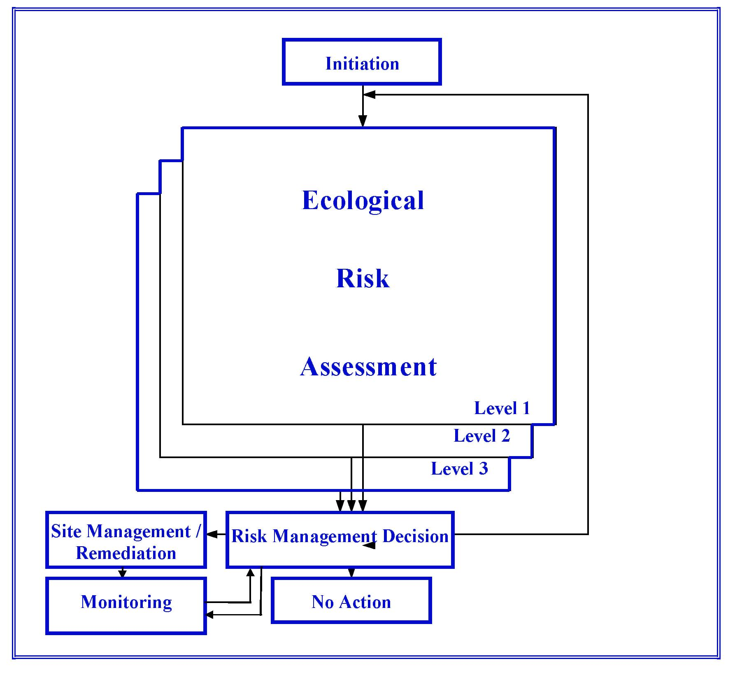
4.2 Initiation of an Ecological Risk Assessment
As shown in Figure 4-I, the first phase in the framework is the initiation of an ERA. Initiation refers to the reasons or situations that can lead to an ERA being undertaken.
Not all site contamination assessments will require the formal assessment of ecological risk. In many instances, eg. some highly modified sites, the ecological values to be protected may be very low and the risk assessment can be driven by other factors such as the protection of human health.
Schedule B(2), provides information on various types of investigations levels (health investigation levels, EILs_{soil}, groundwater investigation levels etc.) and risk assessment methodologies (relating to human health, ecology and groundwater) and provides guidance on their appropriate use.

Ecological risk assessments may be undertaken for a variety of reasons. The main situations that may initiate (trigger) an ecological risk assessment are listed below:
An environmental regulatory agency may request or require an ecological risk assessment to be conducted to determine the likelihood of environmental impacts where:
- a previous assessment of soil contamination at a site (undertaken in the knowledge of the regulatory authority) identifies significant areas of contaminant concentrations above background levels;
- site usage or history suggests the potential for adverse environmental impacts;
- other regulatory concerns exist, such as unacceptable data gaps in an assessment of contaminated soil, the presence of contaminants about which little is known, exposure conditions that are unpredictable or uncertain, a high degree of uncertainty about the existing toxicity data, or significant gaps in available information about the potential ecological receptors; or
- rare and endangered species or habitats that may be impacted by chemical contamination are known to exist in the vicinity of a site assessed for contamination.
The owner or occupier of the site may voluntarily conduct an ERA. This could be to identify potential environmental liabilities. Such risk assessments may also be conducted as part of environmental reporting requirements.
An environmental auditor (currently appointed and undertaking work of a statutory nature) may undertake an ERA when determining the suitability of land for its existing or proposed use.
These situations indicate that an assessment of contaminated soil can occur either before an ERA is conducted, or be part of it. In most cases it is expected that the soil contamination assessment is undertaken prior to the commencement of an ERA. Where this is not the case, the soil assessment becomes part of the Problem Identification component of ERA.
Once an ERA has been initiated, the ERA phase begins.
4.3 Components of an Ecological Risk Assessment
Regardless of the level of assessment, ERA consists of the five basic components Problem Identification, Receptor Identification, Exposure Assessment, Toxicity Assessment and Risk Characterisation. These components and the relationships between them are shown in Figure 4-II. This figure fits into the ERA box in Figure 4-I (Guideline for ERA).
Figure 4-II shows that the Receptor Identification, Exposure Assessment and Toxicity Assessment components are interrelated, as the assessment of any of these components is dependent upon the characteristics of the other two. Risk

Characterisation includes the combination of information gained in the Exposure and Toxicity Assessments.
A degree of uncertainty occurs in most ERA components. Any assumptions or extrapolations made in an ERA should be highlighted where they occur. Uncertainty is discussed in Section 7.
A brief discussion of each of the components of ERA follows. Each level of ERA is discussed in detail in Section 6.
Figure 4-II
Components of an Ecological Risk Assessment
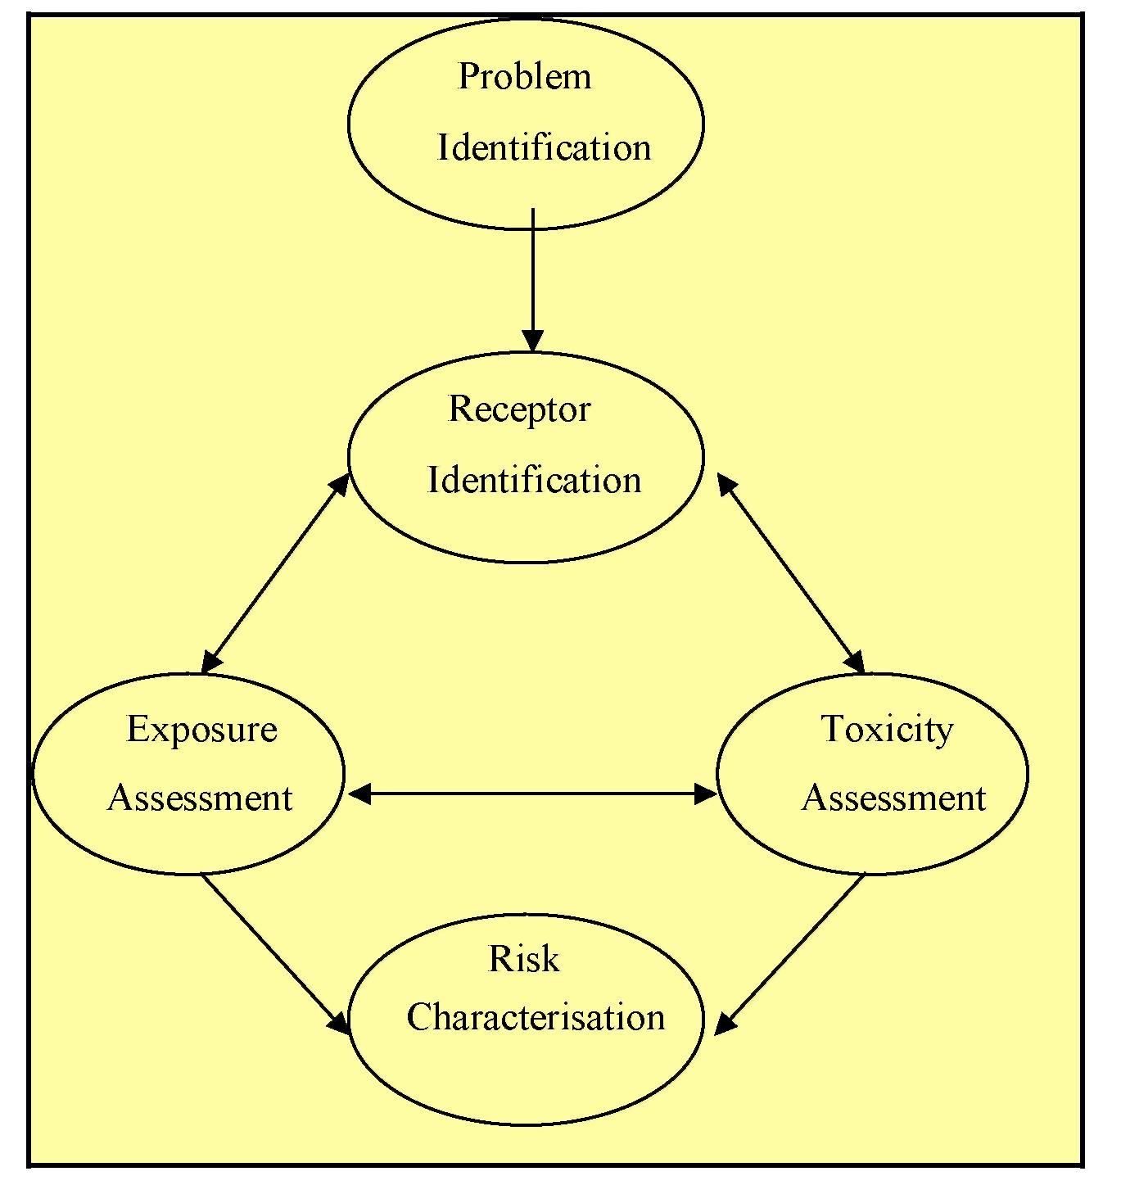
4.3.1 Problem Identification
The Problem Identification component is a scoping phase that establishes the objectives of the ERA and identifies the data required to achieve those objectives.
The basic objective of any ERA at a contaminated site is to determine if identified ecological values are likely to be adversely affected by on-site contamination so that

an informed risk management decision can be made. More specific objectives of an ERA may include:
- establish the extent and degree of on-site contamination;
- identify the contaminants of concern; and
- determine EILs_{soil} for contaminants of concern.
In most cases the first objective will already have been met by the existence of a soil contamination assessment. Where an ERA has been initiated in the absence of on-site soil contamination data, a soil contamination assessment must be undertaken. These assessments should include information such as site history, site conditions, proposed land use (ANZECC/NHMRC, 1992) and relevant environmental policies or regulations that may affect the site or actions to be taken. Sampling and analysis of contaminated soil should be undertaken in accordance with Schedule B(2) and Schedule B(3).
A contaminant of concern is a chemical that is present at a site at concentrations that may result in adverse impacts to ecological values. In Level 1 ERAs, they are contaminants that are identified in a site history or soil sampling and analysis program as a potential risk to biota. In Level 2 and 3 ERAs they are contaminants with on-site concentrations in soil above the EIL_{soil} (generic or site specific) for that contaminant.
The Problem Identification component is critical to ensure that the degree of assessment is appropriate for the problem. When progressing from one level of assessment to another, this component requires that objectives are re-set taking into account risk assessment and risk management information derived as a result of the previous level of assessment.
4.3.2 Receptor Identification
The Receptor Identification component focuses on ‘what species may be at risk?’ and ‘what do we want to protect?’. This concept proposes that not every organism is at risk and not every organism can be protected. The concept of acceptable (or unacceptable) ecological risk is developed in terms of protecting ecological values. It prompts the identification of local species, communities and ecological processes that may be of ecological value, taking into consideration societal relevance, ecological and economic significance. Ecological values to be protected are discussed in detail in Section 5.
4.3.3 Exposure Assessment
The Exposure Assessment component characterises the physical setting, identifies potential exposure pathways and estimates exposure duration, concentrations and intakes. The methodology of Part B of the draft National Framework for Ecological Risk Assessment for Contaminated Sites (1997) allows the assessor to estimate the dose that an ecological receptor may receive via each exposure pathway. The physical setting of the site significantly influences exposure since features such as soil

type, soil organic matter content, paving and buildings can impact upon exposure pathways and contaminant availability. Exposure is also influenced by physical and chemical properties of the contaminants (eg solubility in water, n-octonol/water partition coefficient, soil/water partition coefficient and volatility) and toxicological properties that may be obtained from the Toxicity Assessment component. Each of these parameters may be evaluated to take account of site conditions, therefore providing a more site specific estimate of the dose received.
4.3.4 Toxicity Assessment
The Toxicity Assessment component involves determining the toxicity effects of the contaminants and will establish the sensitivity of the receptors. The essence of Toxicity Assessment is estimating the relationship of effects to variance in exposure. In combination with Exposure Assessment, Toxicity Assessment determines the potential impact to the ecological values identified for the site. Toxicity Assessment is usually accomplished by toxicity testing, the measurement of toxicity of the contaminants of concern (or mixtures of chemicals) to one or more species. Toxicity tests can measure lethal and sub-lethal endpoints. Successful Toxicity Assessment will depend upon the Problem Identification (contaminants of concern), Receptor Identification (species to be protected) and Exposure Assessment (dominant exposure pathways) components. Where toxicity testing is undertaken as part of a toxicity assessment, it is crucial that the endpoint measured relates to the toxicants’ potential ecological impact (ie. measures impact beyond a single organism). Where site specific toxicity testing is not undertaken, appropriately adapted data from similar studies may be used.
4.3.5 Risk Characterisation
Risk Characterisation combines the exposure and toxicity information to determine the level of individual contaminants that may impact upon the receptors . Following this, the most relevant EIL_{soil} (generic or modified) is compared to the on-site soil concentrations of contaminants to evaluate the likelihood of impact due to chemical contamination of the soil, and therefore characterising the risk to the receptors. The uncertainty within on-site soil concentrations and that inherent in generic or modified EILs_{soil} and any conflicting results should be highlighted and discussed at this stage in any ERA.
If the on-site soil concentration of a contaminant is equal to or less than the most relevant (generic or modified) EIL_{soil} for each contaminant (and after taking the additive effects of chemical mixtures into account, see Appendix 1), the contaminant is unlikely to be having an adverse ecological impact.
If the on-site soil concentration of a contaminant is greater than the most relevant EIL_{soil} for any contaminant (and after taking the additive effects of chemical mixtures into account, see Appendix 1), the contaminant may be having an adverse ecological impact.

4.4 Risk Management Decision
At the end of each level of ERA a Risk Management Decision is necessary (Figure 4-I). This decision is based on both the Risk Characterisation component of ERA and risk management considerations and is expected to be made by the risk manager in consultation with the jurisdictional environmental regulatory agency. This step ensures that both risk assessment and risk management considerations (including conflicting results and uncertainty in any part of the ERA) are reviewed prior to the outcome being determined. It also ensures that risk assessors and risk managers are each aware of the objectives of the other. The risk management decision determines the outcome of the assessment. Further information on risk management in Australia can be obtained from the Australian Standard on risk management (AS/NZS 4360:1995).
The outcome of each level of ecological risk assessment, as determined by the Risk Management Decision, is one of the following:
- no action;
- monitoring;
- site management/remediation; or
- proceed to the next level of ecological risk assessment (except for a Level 3 assessment).
If the Risk Characterisation suggests that there is unlikely to be an adverse ecological impact (ie on-site soil concentrations are equal to or less than the EIL_{soil}), the risk manager must decide between the ‘no action’ or ‘monitoring’ outcomes (Sections 4.5 and 4.6).
If the Risk Characterisation suggests that there may be an adverse ecological impact (ie on-site soil concentrations are greater than the EIL_{soil}), the risk manager must decide to either:
- develop and implement a site management/remediation program (Section 4.7); or,
- proceed to the next level of ecological risk assessment (except in the case of a Level 3 assessment) (Section 4.8).
This iterative procedure allows each level of ERA to be reviewed to determine whether the assessment is meeting the objectives set and to establish what the next phase should be.
Factors that may influence a Risk Management Decision (and therefore determine ERA outcomes) are generally based on economic, ecological or societal considerations. Examples include:
- the size of the site, land value, cost of remediation (economic);
- the type of contaminants present, current and potential site land use, surrounding land use (societal), and;

• the ecological significance (eg a rare and endangered species or a species that supports a valued ecological process or a sensitive introduced species of low ecological significance) of the values identified in the Receptor Identification component of ERA to be protected.
The ERA outcome may also be determined by the need to refine the uncertainty of the information gathered and to fill data gaps
Where the risk assessor has identified a high level of uncertainty in the Risk Characterisation, the risk manager may decide to either:
- develop and implement a site management/remediation program (Section 4.7); or,
- proceed to the next level of ecological risk assessment (except in the case of a Level 3 assessment) (Section 4.8).
Risk managers may find elements of the Data Quality Objectives approach (USEPA, 1993) emphasises the importance of ensuring data collected for use in decision making regarding a site is of an appropriate quality on which to base decisions. A similar approach may be adopted in relation to data used in risk assessment and in making risk management decisions based on estimates of risk. Risk managers may find elements of the former Data Quality Objective approaches to site assessment useful in making Risk Management Decisions.
4.5 No Action
The ‘no action’ outcome implies that no site management or remediation, monitoring or further assessment is required at the site. It reflects a high degree of confidence that the ecological values of the site are adequately protected from the effects of contaminated soil. This outcome ceases the ERA process.
4.6 Monitoring
The monitoring outcome refers to biological, ecological or chemical monitoring that could be undertaken at a site where data uncertainty makes the risk assessor unsure if an impact has occurred, is occurring at a site, or may occur at some time in the future. This may be the case where:
- a range is given for on-site soil contamination that overlaps with that for the EIL_{soil};
- some other factor leads to the expectation that an impact may be occurring (contamination by a high profile contaminant below analytical detection limits);
- contamination characteristics may change over time (eg. due to acid mine drainage); or
- the consequences of uncertainty are unacceptable (ecologically sensitive site).

Biological monitoring describes the monitoring of individual biota for signs of chemical impact or exposure. Parameters monitored may include chemical or enzyme concentrations in tissues to assess exposure, or histopathological examination and behavioural change to assess impact.
Ecological monitoring examines populations or communities. Typical parameters may include species number, population number, number of offspring and biomass.
Chemical monitoring describes the chemical analysis of the various exposure vehicles. This may include analysis of soil, surface water, groundwater, air, dust or food.
While aspects of the biological, ecological and chemical monitoring can be used as part of a predictive ERA approach, they may also be used in ERAs where the approach is retrospective (Suter, 1993; USEPA, 1996).
Figure 4-I shows that monitoring can also be a result of the site management/remediation decision. Ecological monitoring during remediation activity may be undertaken to demonstrate that remediation does not impact upon a key species. Post management/remediation monitoring may also be used to demonstrate the effectiveness of site management or remediation. Monitoring may include chemical monitoring to demonstrate the level of exposure is acceptable, biological monitoring to demonstrate that exposure is acceptable and ecological monitoring over time may demonstrate that residing species and populations are not being affected or that key species are returning to the site.
After the monitoring program is completed, the results feed back into a Risk Management Decision for determination of a further outcome.
4.7 Site Management/Remediation
The risk manager considers this outcome when the on-site soil concentration of contaminants (after taking chemical mixtures into account, Appendix 1) is above the EIL_{soil} derived in the ERA. Site management includes any active control at the site that reduces the ecological impact to an acceptable level. This may include reducing the exposure of biota to the contaminants by reducing access to the site (eg fencing), maintaining a physical condition of the soil that reduces the contaminants availability/mobility, or encapsulating the soil. Remediation (clean up) of contaminated soil is considered to be a form of site management.
Monitoring may result from site management/remediation to assess the effectiveness of the program in reducing ecological impact (Section 4.6).
4.8 Proceeding to the Next Level of ERA
This outcome occurs when the on-site soil concentration of contaminants (after taking chemical mixtures into account, Appendix 1) is above the EIL_{soil} derived in the previous level of ERA and the risk manager believes that further assessment is the most cost effective or ecologically sensible step (eg. REIL used at Level 1 does not

protect all ecological values of relevance to a given site). Further assessment will produce a more precise, site specific characterisation of risk. This outcome can include the collection of further information in any component of an ERA (including the reassessment of ecological values to be protected) resulting in the re-calculation of the EIL_{soil}.
When following this outcome, the risk assessor should return to the Problem Identification component of ERA to review and if necessary re-establish the ERA objectives and data requirements taking into account knowledge gained from the previous level of assessment.
Where the soil concentrations exceed the EIL_{soil}, the EIL_{soil} nominated is likely to be protective of the ecological values for a given site and proceeding to the next level of ERA is not likely to be cost effective, the risk assessor/manager may proceed directly to the risk management stage (refer Figure 4-I). Proceeding to the next level of ERA may not be cost effective where the cost of management is relatively low.
5. ECOLOGICAL VALUES
5.1 Introduction
An important part of the Receptor Identification component of ecological risk assessment is identifying ‘what is to be protected’. This framework requires ecological values to be identified at a contaminated site undergoing ERA. Ecological values are plants, animals, fungi or the biota of supporting ecological processes associated with a defined area, that are considered to be of significant societal relevance, ecological or economic significance. They describe the biota that should be protected and the supporting ecological processes that should be maintained.
Biota may be affected as a result of direct exposure to chemically contaminated land, indirect exposure to the contaminant, the contaminants’ impact on supporting ecological processes or a combination of these. Therefore, in protecting ecological values, all potential impacts should be considered.
Ecological values naturally vary from area to area according to variation in the natural habitat, the degree to which humans have physically altered the natural environment to suit a designated land use and the expectations of society. Ecological values may be established regardless of the environment being natural or altered.
In identifying ecological values for a site, three important components should be considered:
1. Societal relevance
The expectations of society to protect biota within a specified area (eg the aesthetic benefit of seeing parrots in the trees and the ability to grow and enjoy native and introduced flora in residential gardens). The societal relevance of biota is varied (ie it generally only applies to biota with direct human interest) and is not constant over time (eg the importance of tree hollows for bird and arboreal species habitat has only

recently become appreciated by the broad community). It is clear that there are increasing expectations within the community for high standards of protection for the environment. The community, therefore, must be involved in the identification of ecological values and development of EILs_{soil}. For further information, readers are directed to Suter (1993) and Schedule B(8).
2. Ecological significance
The consideration of ecological significance should include the impact of the contaminated site on the species, population or community and on-flowing impacts on the structure and function of the ecosystem.
3. Economic significance
The economic importance (eg the contribution of local biota to tourism); and cost of maintaining biota.
It is accepted practice in Australia for jurisdictional environmental regulatory agencies, in consultation with ecological experts, industry and the local community to determine ecological values for site contamination. Site managers and consultants should consult with the relevant jurisdictional agency before finalising lists of ecological values.
5.2 Generic and Site Specific Ecological Values
5.2.1 Introduction
Ecological values can be generic or specific to a contaminated site. All ecological values fit into broad biotic groups. The following set of biotic groups have been provided as guidance for identifying generic or site specific ecological values. They are:
- native flora and fauna
- introduced flora and fauna
- transitory wildlife
- biota of supporting ecological processes (examples include bacteria, fungi and soil invertebrates that sustain the nutrient cycling process which is necessary for plant growth, the provision of shade and shelter (habitat) by some plants for other biota and specific symbiotic relationships).
Native flora and fauna describes native biota that is likely to inhabit the region or site without the influence of chemical contamination. Such biota may include flowering plants, ferns and terrestrial, subterranean or arboreal fauna.
Introduced flora and fauna describes introduced biota that are desired to inhabit a region or site. Such biota may include domestic animals, flowering plants, conifers and ferns.

Transitory wildlife includes animals that are of ecological value to other associated areas that are dependent on the region or site for a part of their life cycle, or for the foraging of food. Many birds, for example, are transitory over large areas.
Biota of supporting ecological processes includes the biota of all associated supporting ecological processes. These ecological processes include factors that influence a species’ ability to find shelter, food and water, to reproduce and ultimately survive as a viable species population. Examples include the nutrient cycling process which is maintained by bacteria, fungi and soil invertebrates that sustains plant growth, the provision of shade and shelter (habitat) by some plants for other biota and specific symbiotic relationships between species.
5.2.2 Generic ecological values
Generic ecological values are biota that may be expected to inhabit:
- a state, region or local area regardless of land use, or
- a specific land use within a state, region or local area.
The identification of generic ecological values involves knowledge of the broad range of biota within the state, region or land use. Generic ecological values are conservative in that they protect all biota considered of value within the state, region or land use regardless of whether or not they occur at the contaminated site. They provide the basis for the derivation of generic EILs_{soil} which may be used as investigation levels (ANZECC/NHMRC, 1997,Schedule B(1)). The step of identifying generic ecological values is undertaken in the Receptor Identification component of a Level 1 ERA.
Generic ecological values associated with a state or region include all biota expected to inhabit the state or region. A ‘region’ may be any area of interest (larger than the site) that has similar biogeographic characteristics that influence the components of an ERA. Examples of biogeographic regions in Australia are contained within Thackway and Cresswell (1995).
Generic ecological values associated with a land use include all biota expected to inhabit that land use within a state, region or local area. Society has varying expectations of the ecological values that should be protected for land. That is, the ecological values that the community expect to be protected in a heavy industrial site differ significantly from those of a National Park. Although there are many categories of land use within planning controls a number of standard land uses are considered suitable for the purposes of risk assessment. Table 5-A provides guidance by identifying the biotic groups (from which generic ecological values can be derived) that are associated with standard land use categories. Standard land use categories are:
- Residential
- Commercial
- Industrial

- Urban Parkland
- Agriculture
- Rural Parkland and nature reserves.
This approach has been utilized in developing exposure scenarios and exposure settings for health risk assessment (Taylor & Langley, 1996).
Residential This is land where the primary activity is human residency, such as at separate dwellings and townhouses, and is usually associated with an area of exposed soil or garden that is used for recreational purposes. Day care centres, pre-schools and primary schools can be regarded as equivalent to residential land use.
Commercial This is land where the primary activity is related to commercial operations and occupancy is not for residential or manufacturing purposes. Examples of commercial land use are: service stations, railways, roads, warehouses/distribution depots, convenience shops, shopping complexes and the main streets of towns.
Industrial This is where the primary activity involves the production, manufacture or construction of goods. Examples of industrial land use are: manufacturing factories, warehouses, transport depots, refineries and timber treatment plants.
Industrial land, particularly in long established industrial areas, is often heavily contaminated by past activities or fill material used to level the area prior to industrial use. In these cases jurisdictional environmental agencies may determine that no ecological values apply and that Health Investigation Levels (HILs) are the most appropriate soil quality criteria. That is, the community does not expect native flora and fauna, or desire introduced flora and fauna, to inhabit the area, or the biota of supporting ecological processes such as nutrient cycling to be protected in contaminated industrial land. In many cases the only generic ecological value for this land use will be ‘transitory wildlife’. This however, does not impede programs or legislation that prevents contamination or further contamination of industrial land from existing industrial land.
Urban parkland These lands include reserves, sporting grounds, parks, golf courses and other areas used for recreation and which are located in an urbanised area. Urban parklands may include urban land adjacent to waterways and rivers. In most circumstances, secondary schools and churches can be treated as urban parklands.
Agriculture These are lands where the primary activity is related to using the land for growing crops and/or producing livestock for commercial purposes. Examples of agricultural land include cattle and sheep farms, dairy farms, broad-acre cropping farms, orchards and other agricultural or horticultural properties.
Although identified in this document as a specific land use, any ecological risk assessment does not normally include agricultural species. Acceptable levels of soil contamination for agricultural species are traditionally derived by considering the health of the humans consuming the agricultural product. Therefore, agricultural

soil quality objectives are often based on maximum residue limits of the chemicals in the products for human consumption. Guidance on the acceptable levels of contaminants in the soil (those which are unlikely to exceed the maximum residue limits in produce and livestock) can be obtained from the relevant agricultural agencies.
An ERA for agricultural land should be undertaken on a site specific basis to protect the commercial (introduced and native) and transitory biota that are of ecological value to each site.
Rural parkland and nature reserves These are areas which are primarily used for passive recreation, such as National Parks, State Parks and State Forests. These reserves are generally considered to be of high environmental value and quality.
Mixed Land Use In cases of mixed land use, a combination of generic ecological values need to be considered. For example, in the case of an industrial site with a nature reserve, the ecological risk assessment would need to consider the protection of resident and transitory birds and wildlife.
Changing Land Use Where land is to be converted from one type of use to a more sensitive land use, the ecological values identified for those uses apply. For example, where industrial land is being converted to residential use, the ecological values of residential land should be assessed and protected.
Offsite Impacts Where there is potential for the contamination of one site to impact upon the ecological values of surrounding areas, the risk of impact upon these values should also be evaluated.

Table 5-A
Biotic Groups and Associated Standard Land Uses
LAND USE | ASSOCIATED BIOTIC GROUPS
Residential | native flora and fauna  introduced flora and fauna  transitory wildlife  biota of supporting ecological processes
Commercial | native flora and fauna  introduced flora and fauna  transitory wildlife
Industrial | transitory wildlife
Urban Parkland | native flora and fauna.  introduced flora and fauna  transitory wildlife  biota of supporting ecological processes
Agriculture | transitory wildlife  introduced flora and fauna  native flora and fauna  biota of supporting ecological processes
Rural Parkland and Nature Reserves | native flora and fauna.  introduced flora and fauna  transitory wildlife  biota of supporting ecological processes
5.2.3 Site Specific Ecological Values
Site specific ecological values describe those that are specific to the site under investigation. Identifying site specific ecological values involves knowledge of the biota that are expected to inhabit or visit the site. This information is part of the Receptor Identification component of Level 2 and 3 assessments and can be determined from jurisdictional government conservation agencies, local government, community groups etc.(Level 2) or by conducting a biological survey of the site (Level 3).

6. LEVELS OF ECOLOGICAL RISK ASSESSMENT
6.1 Introduction
Figure 4-I shows three levels of ERA situated within the overall framework for ERA. This Section discusses the components and data requirements of each level of ERA from a simple Level 1 (screening) assessment to Level 3. Although the framework involves a succession of three levels of ERA, the levels are nominal. That is, there is no requirement to begin an ERA at Level 1. An assessor may choose to begin an assessment at Level 2 or 3. Also, within each level, there is no need to collect data for all components. The assessor may choose to collect data from only one of the components (eg. fraction of organic carbon (foc) for Exposure Assessment, no observable effects concentration (NOEC) or toxicity test for Toxicity Assessment) prior to characterising the risk posed by on-site contamination. Ideally, an assessor will collect data that has the greatest influence on the resulting EIL_{soil} for each contaminant.
6.2 Level 1 Assessment (Screening)
6.2.1 Introduction
This section provides guidance for conducting a Level 1 ecological risk assessment. This level of assessment is highlighted within the ERA Framework in Table 5-A. Level 1 assessment is a screening method which is the least complex level of assessment. Screening level assessment is designed to suit generic situations and protects all biota likely to inhabit the state, region or land use.
Data collection consists predominantly of the collection of soil samples for analysis to characterise the extent and degree of contamination at the site. A summary of data requirements for a Level 1 ERA is included in Figure 6-I.
The Risk Characterisation component of a Level 1 assessment is the comparison of on-site soil contaminant concentrations against the most relevant (state, regional or land use specific) EIL_{soil}.

Figure 6-I
Level 1 Ecological Risk Assessment
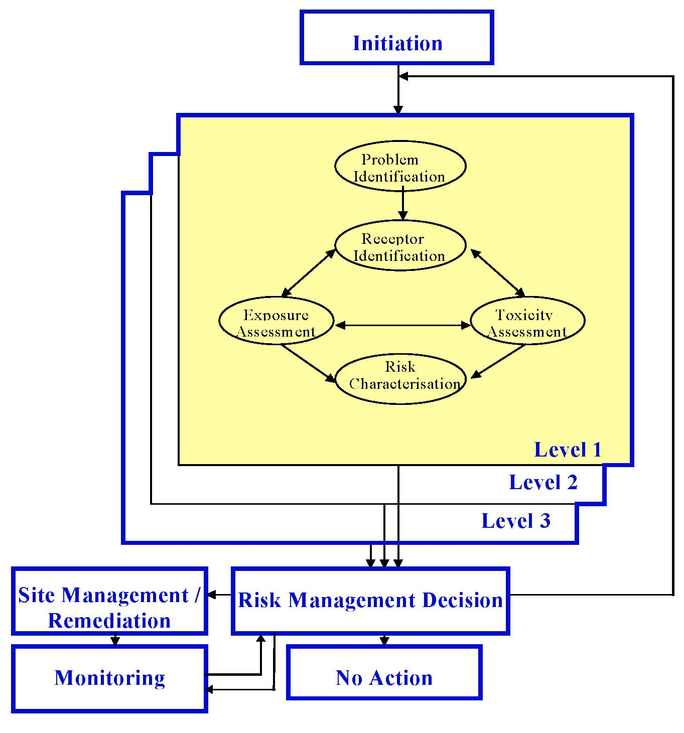
6.2.2 Problem Identification
The ecological risk assessment process begins with problem identification. This is a scoping phase used to establish the objectives of the risk assessment and identify the data requirements of the assessment.
The key objectives for a Level 1 ecological risk assessment are to:
- identify contaminants of concern;
- establish the extent and degree of contamination on the site; and
- identify the most relevant EILs_{soil} for soil contaminants.
In a Level 1 assessment, the contaminants of concern are identified after considering the site history and the analysis of soil samples collected on site. A comprehensive site history leads to a representative soil sampling and analysis program being developed and implemented for the site, resulting in a more representative indication of risk posed by contamination.

The extent and degree of on-site contamination is established by the sampling and analysis of soil from the site (including background samples). All investigations, sampling and analyses of soil at potentially contaminated sites should be undertaken consistent with Schedules B(2) and B(3). In most cases an assessment of on-site soil contamination will have been undertaken prior to an ERA being initiated.
The assessor, in consultation with the jurisdictional environment regulatory agency, will determine the ‘most relevant EIL_{soil}’ to be the most suitable generic EIL EIL_{soil} to the site in question, that has been developed for a state, region or land use. Where there are no suitable generic EILs_{soil} and on-site concentrations of contaminants of concern in soil are above background concentrations, the risk manager must decide to either proceed to level 2 or clean up to background concentration.
6.2.3 Receptor Identification
For a Level 1 (screening) assessment it is assumed that all biota that are of ecological value to the state, region or land use (considered in the derivation of generic EILs_{soil}) are of ecological value to the site. However, where biota of ecological value at the site are not considered in the derivation of the EIL_{soil} (eg Giant Gippsland Earthworm), the EIL_{soil} is inappropriate (ie should not be used as a screening/investigation level) and a higher level of assessment should be undertaken.
6.2.4 Exposure Assessment
For a Level 1 (screening) ecological risk assessment it is assumed that all exposure pathways considered in the derivation of generic EILs_{soil} are applicable. However, where pathways that are thought to be significant have not been considered, or where the magnitude of the exposure attributable to a pathway is suspected to be underestimated in the derivation of generic EILs_{soil}, a higher level of assessment should be undertaken.
6.2.5 Toxicity Assessment
For a Level 1 (screening) ecological risk assessment it is assumed that toxicity data and extrapolation factors used to determine the reference dose in the derivation generic EILs_{soil} are sufficiently protective of the biota. However, where it is suspected that this is not the case, a higher level of assessment should be undertaken.
6.2.6 Risk Characterisation
In a Level 1 (screening) ecological risk assessment Risk Characterisation consists of the comparison of on-site soil contaminant concentrations with the most relevant generic (state, regional or land use) EILs_{soil} for those contaminants.
If the on-site soil concentration of contaminants is equal to or less than the most relevant generic EIL_{soil} for each contaminant (and after taking the additive effects of chemical mixtures into account, see Appendix 1), the site contamination is unlikely to be having an adverse impact on ecological values.
If the on-site soil concentration of contaminants is greater than the most relevant generic EIL_{soil} for each contaminant (and after taking the additive effects of chemical

mixtures into account, see Appendix 1), the site contamination may be having an adverse impact on ecological values.
It is important to consider the background concentration of contaminants at or surrounding site contamination. If the most relevant generic EIL_{soil} for a contaminant is lower than the background concentration, the background concentration becomes the EIL_{soil}.
When comparing the conservative generic EILs_{soil} against on-site soil contaminant concentrations, the basic assumptions underlying the EILs_{soil} must be appropriate to the site and protective of the ecological values. For example, a default value for soil organic carbon content (f_{oc}) of 1% is often recommended. If the foc at the site is believed to be significantly less than 1%, the ecological values may not be protected and the generic EIL_{soil} developed using this default assumption is not appropriate for that site. As a result, a higher level of assessment should be undertaken.
Due to the general nature of data collected in the derivation of generic EILs_{soil}, they are generally conservative. Therefore, levels of contamination above a generic EIL_{soil} should not automatically necessitate remedial or clean up action. Because of this, generic levels may be more appropriately referred to as Investigation Levels (ANZECC/NHMRC, 1997, Schedule B(1)).
Table 6-A
Summary of Data Requirements for a Level 1 ERA
ERA COMPONENT | DATA REQUIREMENTS
Problem Identification | Site history,
 | Extent and degree of on-site soil contamination,
 | Most relevant generic EIL_{soil}.
Receptor Identification | Data included in generic EIL_{soil}.
Exposure Assessment | Data included in generic EIL_{soil}.
Toxicity Assessment | Data included in generic EIL_{soil}.
Risk Characterisation | On-site soil concentrations of contaminants of concern,
 | Most relevant generic EIL_{soil}.

6.2.7 Risk Management Decision and ERA Outcomes
After Risk Characterisation, a Risk Management Decision is necessary. This decision weighs the findings of the ERA against risk management considerations.
If the Risk Characterisation suggests that there is unlikely to be an adverse impact on ecological values (ie on-site soil concentrations are equal to or less than the most relevant EIL_{soil}), the risk manager must decide between the ‘no action’ or ‘monitoring’ outcomes (Sections 4.5 and 4.6).
If the Risk Characterisation suggests that there may be an adverse impact to ecological values, the risk manager must decide to either;
- develop and implement a site management/remediation program (Section 4.7); or,
- proceed to the next level of ecological risk assessment (except in the case of a Level 3 assessment) (Section 4.8).
Expected outputs from a Level 1 ERA include a report that highlights extent and degree of the on-site soil contamination and justifies the use and selection of the most relevant EIL_{soil}. An analysis of uncertainty in the data should be included. Uncertainty and reporting are discussed in Sections 7 and 8.
6.3 Level 2 Assessment
6.3.1 Introduction
This section provides guidance on conducting a Level 2 ecological risk assessment. Level 2 ERA is highlighted within the framework in Figure 6-II.
A Level 2 assessment is largely a desktop study with some field studies that provide an increased level of detail to components of the ecological risk assessment process.
Modified EILs_{soil} take into account site specific factors regarding Receptor Identification, Toxicity Assessment and Exposure Assessment. Further detail to the Problem Identification component may also provide valuable information. A summary of data that may be collected as part of a Level 2 assessment is included in Table 6-B.
On-site soil concentrations of contaminants of concern are compared with the modified EILs_{soil} to characterise the risk.

Figure 6-II
Level 2 Ecological Risk Assessment
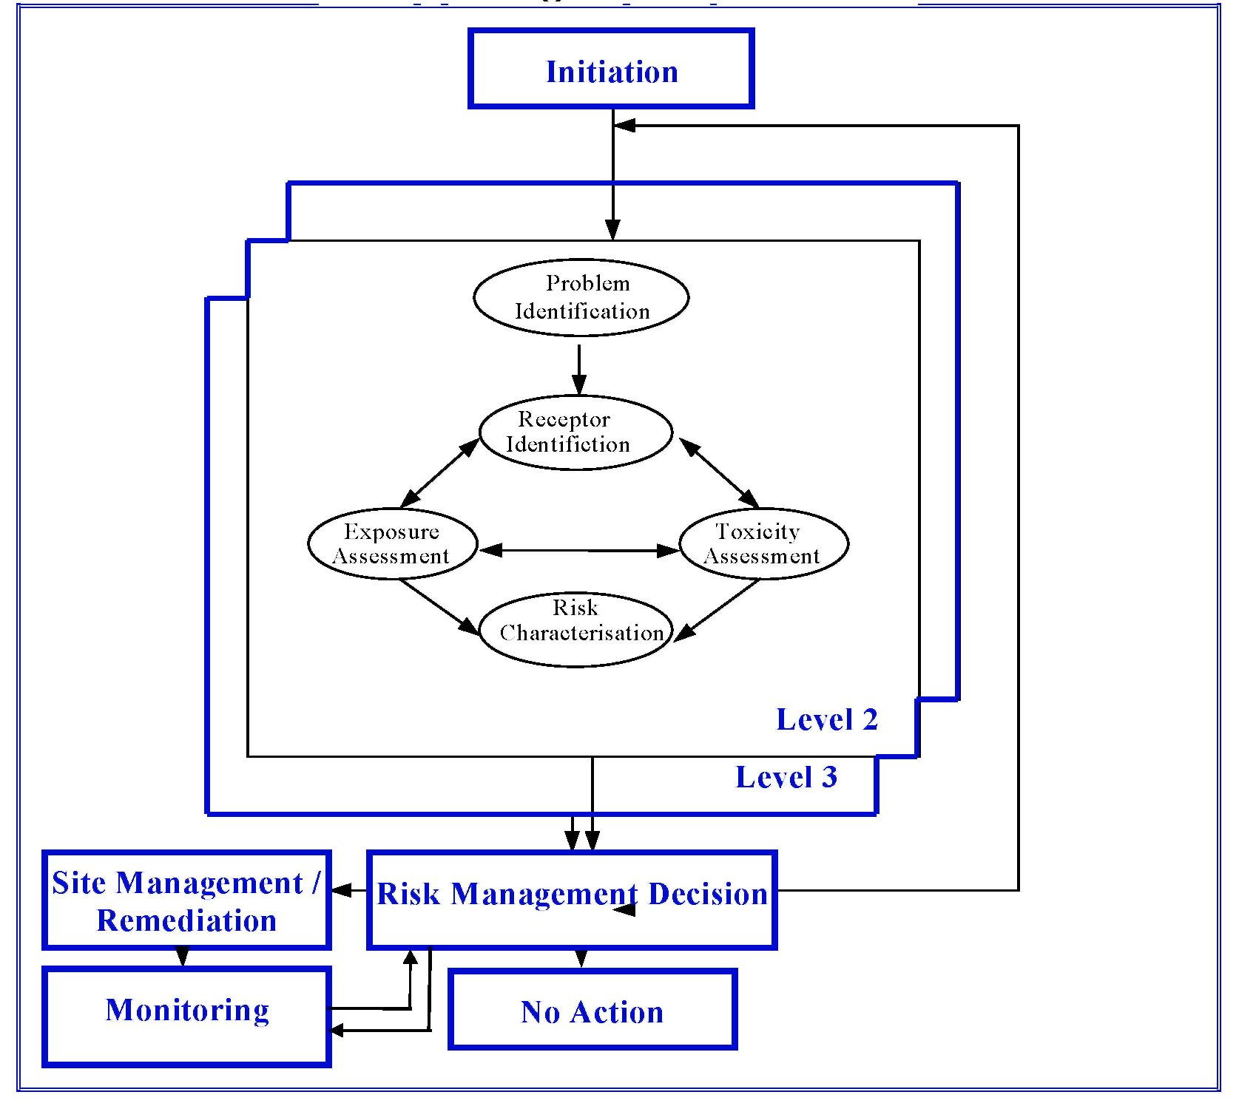
6.3.2 Problem Identification
The purpose of the problem identification stage for a Level 2 assessment is to define the objectives of the assessment and to identify contaminants of concern.
The key objectives of a Level 2 ecological risk assessment are to:
- identify the contaminants of concern (including mixtures and contaminant form eg As³⁺);
- determine the extent and degree of on-site soil contamination (if Level 1 ERA has not been undertaken);
- determine ecological values that are more specific to the site;
- evaluate physical, toxicological and biological parameters that affect the Exposure and Toxicity Assessment components; and
- determine modified (site specific) EILssoil for contaminants of concern.
The contaminants of concern are those that have on-site concentrations greater than the EIL_{soil} adopted in the Level 1 assessment (or those that have been identified in an assessment of on-site soil contamination if a Level 1 ERA has not been undertaken).

6.3.3 Receptor Identification
For a Level 2 assessment this component consists of identifying ecological values to be protected at a site and using these values to identify the most sensitive receptors specific to the site. Ecological values are discussed in Section 5.
Each ecological value includes species with variable spatial distribution. Jurisdictional conservation or environmental agencies may provide the location of specific biota. By only considering biota known to exist at or visit the site (Level 1 ERA considers all biota expected to inhabit a state, region or land use.), more appropriate EILs_{soil} may be derived to characterise risk.
6.3.4 Exposure Assessment
The purpose of the exposure assessment is to determine the range of exposure pathways for the contaminants. A site review should indicate if all considered exposure pathways of generic EILs_{soil} are relevant to the site. For example, where there is no potentially contaminated water source or body, the exposure pathway of contaminant intake by water ingestion is not present or likely to be present and therefore, should not be considered in developing modified EILs_{soil} for that site.
Information on environmental fate and transport should be incorporated wherever possible into the risk assessment, although it is not expected that a detailed contaminant fate and transport model would be used normally as part of a Level 2 assessment. The use of such models may however, assist in identifying the key exposure pathways and estimating the contaminant concentrations via those pathways (eg inhalation) when actual field data is inadequate or not available.
Specific biological information such as food, water and soil ingestion and inhalation rates may be available from the literature and provide a more specific Exposure Assessment for the derivation of a modified EIL_{soil}.
During the exposure assessment, soil properties that may affect contaminant mobility may be measured and used instead of the conservative default values assumed in the derivation of the state, regional or land use EIL_{soil} for example, fraction of organic carbon (foc).
The information gathered during the exposure assessment is used to modify the default assumptions and to recalculate the EIL_{soil}. This becomes the modified (site-specific) EIL_{soil}.
6.3.5 Toxicity Assessment
The toxicity assessment of a Level 2 ERA involves reviewing the toxicity data and properties of the contaminants. This will largely be a literature based review. It is not envisaged that a Level 2 risk assessment would involve detailed toxicological studies.
The purpose of the review is to update data on the chemical, physical and toxicological properties of the contaminants. Information such as No Observed Effect Concentration (NOEC), bioavailability, plant uptake and bioconcentration factors (BCF), which were not available during the development of generic EILs_{soil} (used in Level 1), may be incorporated to derive a modified EIL_{soil}.

6.3.6 Risk Characterisation
In a Level 2 ecological risk assessment, Risk Characterisation combines the site specific exposure and toxicity information to determine the level of individual contaminants that may impact upon the receptors (modified EIL_{soil}). Following this, the Level 2 EIL_{soil} is compared to the on-site soil concentrations of contaminants to evaluate the likelihood of impact due to chemical contamination of the soil and therefore, characterising the risk to the receptors.
If the on-site soil concentration of contaminants is equal to or less than the modified EIL_{soil} for each contaminant of concern (and after taking the additive effects of chemical mixtures into account, see Appendix 1), the site contamination is unlikely to be having an adverse ecological impact.
If the on-site soil concentration of contaminants is greater than the modified EIL_{soil} for each contaminant of concern (and after taking the additive effects of chemical mixtures into account, see Appendix 1), the site contamination may be having an adverse ecological impact.
It is important to consider the background concentration of contaminants at or surrounding contaminated sites. If the modified EIL_{soil} is lower than the background concentration for a chemical contaminant, the background concentration becomes the EIL_{soil}.
6.3.7 Risk Management Decision and ERA Outcomes
After Risk Characterisation, a Risk Management Decision is necessary. This decision weighs the findings of the ERA against risk management considerations.
If the Risk Characterisation suggests that there is unlikely to be an adverse impact to ecological values, the risk manager must decide between the ‘no action’ or ‘monitoring’ outcomes (Sections 4.5 and 4.6).
If the Risk Characterisation suggests that there may be an adverse impact to ecological values, the risk manager must decide to either;
- develop and implement a site management/remediation program (Section 4.7); or,
- proceed to the next level of ecological risk assessment (except in the case of a Level 3 assessment) (Section 4.8).
Expected outputs from a Level 2 ecological risk assessment include a report that extends the problem identification of the Level 1 assessment, provides detailed exposure and toxicity assessments for the contaminants, conclusions and recommendations. A report should detail the derivation of the modified EIL_{soil} for the contaminants and describe the uncertainties in the field data (ie contaminant levels and distribution) and in the modified EIL_{soil.} Uncertainty and reporting are discussed further in Sections 7 and 8.

Table 6-B
Data that may be collected as part of a Level 2 ERA.
ERA COMPONENT | DATA THAT MAY BE COLLECTED
Problem Identification | Extent and degree of on-site soil contamination (if Level 1 ERA has not been undertaken),
 | Identification of contaminants of concern (including mixtures and contaminant form)
Receptor Identification | Distribution of biota of ecological value at the site (from jurisdictional conservation agency, or local community group)
Exposure Assessment | Literature based data such as food, water and soil ingestion rates, air inhalation rate and skin absorption factor for relevant biota,
 | On-site soil properties that affect contaminant mobility/availability (eg foc)
 | Bioavailability factors
Toxicity Assessment | Literature review of relevant toxicological studies.
Risk Characterisation | Information on chemical mixtures,
 | On-site concentration of contaminants of concern (from Problem Identification)
6.4 Level 3 Assessment
6.4.1 Introduction
This section provides guidance in conducting a Level 3 ERA. Level 3 ERA is highlighted within the ERA framework in Figure 6-III.
In a Level 3 ecological risk assessment, the focus is on quantifying exposure levels through field studies and the use of sophisticated computer models. Emphasis is placed on gathering detailed, site specific information as part of the Receptor Identification, Exposure Assessment and Toxicity Assessment. A summary of data that may be collected as part of a Level 3 ERA is included in Table 6-C.
Based on site-specific information, modified ecological impact levels (EIL_{soil}) for soil are derived. The comparison of the on-site soil concentrations of contaminants of concern against the modified EILs_{soil} characterises the ecological risk at the site and influences any outcomes.

Figure 6-III
Level 3 Ecological Risk Assessment
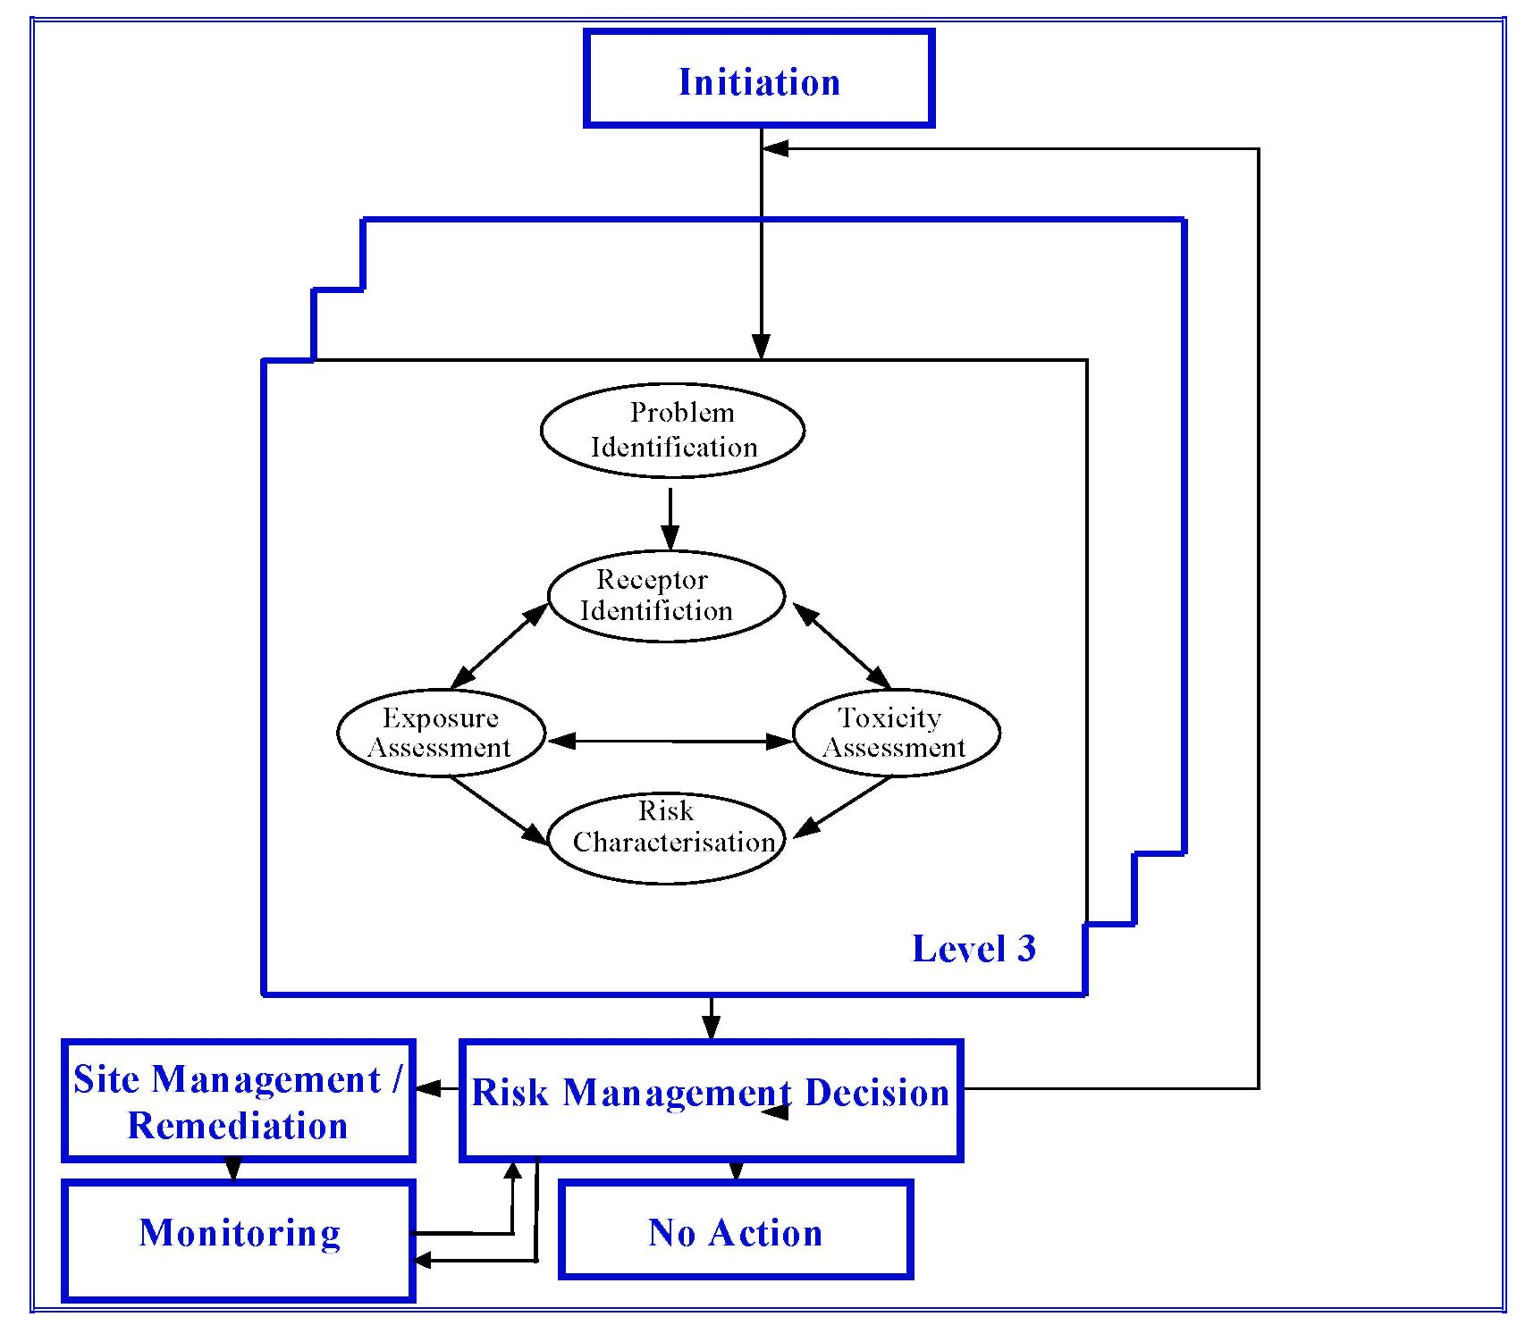
6.4.2 Problem Identification
The problem identification phase in a Level 3 assessment involves defining the objectives of the assessment and identifying the contaminants of concern.
The main objectives for a Level 3 ecological risk assessment are to:
- identify contaminants of concern (including mixtures and contaminant form eg As³⁺);
- produce precise, quantitative predictions regarding the current and future risks to site specific ecological values due to contaminants at the site; and
- determine modified EILs_{soil} that take into account the ecological values at the site.
6.4.3 Receptor Identification
For a Level 3 ERA, a biological survey of the site and surrounding areas may be conducted. The objective of this survey is to identify the key ecosystems, processes

and species that may be adversely affected by the contamination. This may involve an ecological survey and public consultation. Assumptions made linking site ecological values to receptors should be reported.
Ecological values associated with the land use at the site may also be associated with nearby or adjacent land uses. Nearby sensitive land uses and ecological values should be noted. If these ecological values are not to be protected then the basis of this decision should also be reported. Environmental and planning agencies may be able to provide assistance in this regard.
6.4.4 Exposure Assessment
Advanced quantitative models may be used to describe present and future transport, transformation and environmental partitioning of contaminants of concern. These models will need to be refined and calibrated using actual field data to enhance the level of assurance of the model predictions. Such fate and transport models not only need to look at partitioning between the environmental media but also the partitioning into the biota at or near the site.
In addition to transport models, specific information regarding food, soil, water, ingestion rates and inhalation rates may be estimated from site specific field data, providing a specific exposure assessment for each biota.
The sampling and analysis of other environmental media for contamination such as food, air and water supplies may also provide specific exposure information.
Other techniques of exposure assessment may include biopsy analysis of tissues, body fluids or excrement of biota from the site.
Detailed analysis of the uncertainty of the exposure assessment should also be conducted to define the boundaries of the risk posed by the uncertainty levels in the exposure assessment. Various statistical techniques are suitable to determine the level of uncertainty and also to identify the most sensitive exposure assessment parameters. This may guide further studies and field activities to reduce the uncertainty. Section 7 of this guidance document discusses uncertainty in more detail.
6.4.5 Toxicity Assessment
A detailed literature review should be conducted to update the toxicological profile of the contaminants. The toxicity of the contaminants and the effects of mixtures of contaminants may be determined through soil based toxicity tests. The chronic and acute toxicity effects for a range of key or indicator species can be measured in the field and/or under simulated field conditions in the laboratory. (ASTM 1990a,b; ISO 1991a,b; OECD 1984,a,b.). Such standard methods provide guidance to undertaking laboratory toxicity tests in a uniform manner, they do not always consider the toxicological implications associated with the use of the data for ERA and

establishing EILs_{soil} in particular. A detailed analysis of the uncertainty, strength and relevance of the toxicity data and assessment should be reported.
The objective of these studies is to derive the dose response relationships between these species and the contaminants. These dose response relationships may take into account the modifying factors in the receiving environment (eg soil fraction of organic carbon, soil pH, and the synergistic, additive or suppressive effects of other contaminants).
6.4.6 Risk Characterisation
Data gained during the exposure and toxicity assessment phases are used to modify the assumptions underlying the EILs_{soil}, resulting in calculation of modified (site specific) EILs_{soil} for soils. The on-site contaminant concentrations are compared against the modified EIL_{soil}.
If the on-site soil concentration of contaminants is equal to or less than the modified EIL_{soil} for each contaminant (and after taking the additive effects of chemical mixtures into account, see Appendix 1), the site contamination is unlikely to be having an adverse ecological impact.
If the on-site soil concentration of contaminants is greater than the modified EIL_{soil} for each contaminant (and after taking the additive effects of chemical mixtures into account, see Appendix 1), the site contamination may be having an adverse ecological impact.
It is important to consider the background concentration of contaminants at or surrounding contaminated sites. If the modified EIL_{soil} is lower than the background concentration for any chemical contaminant, the background concentration becomes the EIL_{soil}.

Table 6-C
Data that may be collected as part of a Level 3 ERA.
ERA COMPONENT | DATA THAT MAY BE COLLECTED
Problem Identification | Identification of contaminants of concern (including mixtures and contaminant form)
Receptor Identification | Biological survey of the site and surrounding area.
Exposure Assessment | Fate and transport modelling of contaminants of concern,
 | Species-specific inhalation, ingestion and absorption rates,
 | On-site soil properties that affect contaminant mobility/availability (foc, pH, bulk density, porosity, soil moisture),
 | Bioavailability factors
 | Sampling and analysis of food, water and air for effects of contamination
 | Information on biota behaviour relevant to assessing exposure
Toxicity Assessment | Detailed literature review of relevant toxicological studies In situ, field or laboratory toxicity tests
Risk Characterisation | Information on chemical mixtures, concentration of contaminants of concern (from Problem Identification)
6.4.7 Risk Management Decision and ERA Outcomes
After Risk Characterisation, a Risk Management Decision is necessary.
If the Risk Characterisation suggests that there is unlikely to be an adverse impact to ecological values (ie on-site soil concentrations are equal to or less than the most relevant EIL_{soil}), the risk manager must decide between the ‘no action’ or ‘monitoring’ outcomes (Sections 4.5 and 4.6).
If the Risk Characterisation suggests that there may be an adverse impact to ecological values, the risk manager must decide to develop and implement a site management/remediation program (Section 4.7).
Figure 6-III shows an arrow leading from the risk management decision back into the ERA process. This loop has been designed to allow for the further refinement of the characterisation of ecological risk using the predictive approach based on monitoring undertaken as part, or as a result of, site management/remediation.
Expected outputs from a Level 3 ecological risk assessment include a report that extends the problem identification of the Level 1 and 2 assessments, provides detailed exposure and toxicity assessments for the contaminants as well as conclusions and recommendations. The report should detail the derivation of the

modified EIL_{soil} for the contaminants and describe the uncertainties in the field data (ie contaminant levels and distribution) as well as in the modified EIL_{soil}.
7. UNCERTAINTY
ERA, as with any mathematical predictive process, comprises four basic components: measurements, parameters, models and prediction. Measurements are made to estimate the parameters of a model, which is used to predict the severity of an event or, likelihood of an event occurring.
For example, the volume of air breathed and number of breaths over time are measurements that may be used to estimate the Air Inhalation Rate (AIR) parameter. The AIR maybe one of many parameters used in a mechanistic model to calculate an ecological impact level (EIL_{soil}). This in conjunction with the statistically modelled level of soil contamination, may be used to make a prediction of risk. From this it can be seen that a single prediction of risk is based on several models, which in turn may be dependent upon many parameters that are estimated from a large number of measurements.
Figure 7-I represents aspects of an ERA in terms of the components of a predictive process.
Figure 7-I
Hierarchical Pyramid of Dependence for Prediction
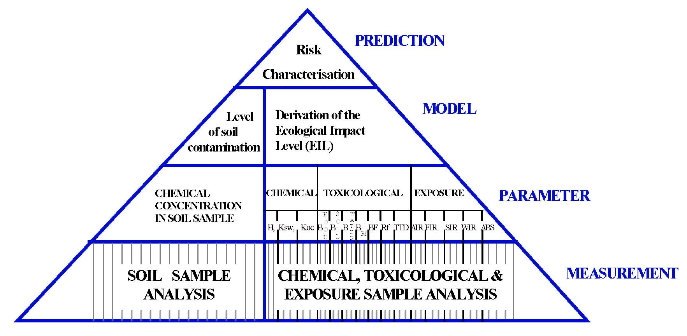
The left hand side of the pyramid illustrates the process used to statistically model the level of chemical contamination at a site. From this it can be seen that the level of contamination modelled for the site is dependent on the chemical concentration measured from the analysis of many soil samples. The right hand side of the pyramid illustrates the process used to derive the Ecological Impact Level (EIL_{soil}) of the site. From this it can be seen that the EIL_{soil} of the site is dependent on the three classes of parameter; chemical, toxicological and exposure. These parameters may be

estimated by measuring particular characteristics of each parameter for a number of samples. The EIL_{soil} in conjunction with the level of contamination characterises the risk (Section 4.3.5) forming the basis of a prediction.
As a result of this successive dependence, the uncertainty associated with each component is compounded by the uncertainties of other components. Therefore, uncertainty associated with a prediction of risk is related to the uncertainties of the model, the uncertainties in the estimate of the parameters used in the model, and the uncertainties associated with the measurements used to estimate the parameters. Figure 7-II represents aspects of uncertainty in an ERA in association with the components of a predictive process. Uncertainties in bold type represent the uncertainty that are directly associated with the component and are independent of other components.
Figure 7-II
Hierarchical Pyramid of Dependence for the Uncertainty of Prediction
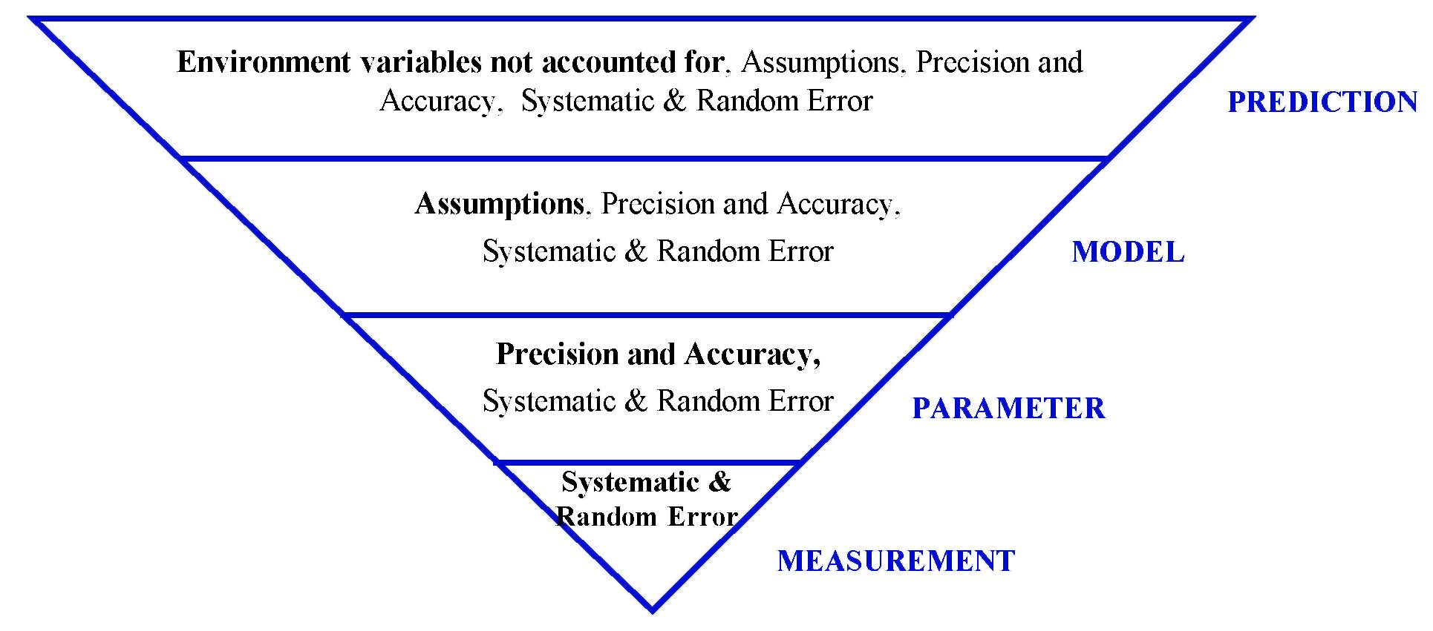
While the uncertainty of each component may exhibit this dependence, aspects of its uncertainty are also unique to the component. For example, the analytical nature of the Measurement Component gives rise to an uncertainty that is related to an analytical error. These may include, systematic errors associated with the technique and measurement apparatus, as well as the random error associated with operator technique. Also, while the uncertainty of a Parameter is dependent on the measurement component, it is also related to the fact that a parameter is an estimate of a true value. Therefore, the uncertainty of a parameter is also described in terms of the precision and accuracy of the estimate. While the uncertainty of a Model is dependent on the uncertainty of its parameters, it is also dependent on the assumptions upon which the model is based. Also, the uncertainty of a Prediction is not just a function of the model upon which it is based but, is also influenced by the complex nature of the environment. That is, it is also a function of the uncertainty

associated with unmeasurable complex environmental factors that influence an outcome.
The Framework is designed to take into account the uncertainty of an ERA using an iterative approach (Section 4.1). The Framework adopts a three level system that, together with monitoring, successively addresses the independent aspects of uncertainty for each basic component of the predictive process.
Figure 7-III represents aspects of an ERA in terms of the components of a predictive process, its uncertainty and levels of analysis. Uncertainties in bold type represent the uncertainty that are directly associated with the component and may be the focus of the ERA uncertainty analysis.
Figure 7-III
Hierarchical Pyramids of Dependence for Prediction Associated Uncertainty and Uncertainty Analysis
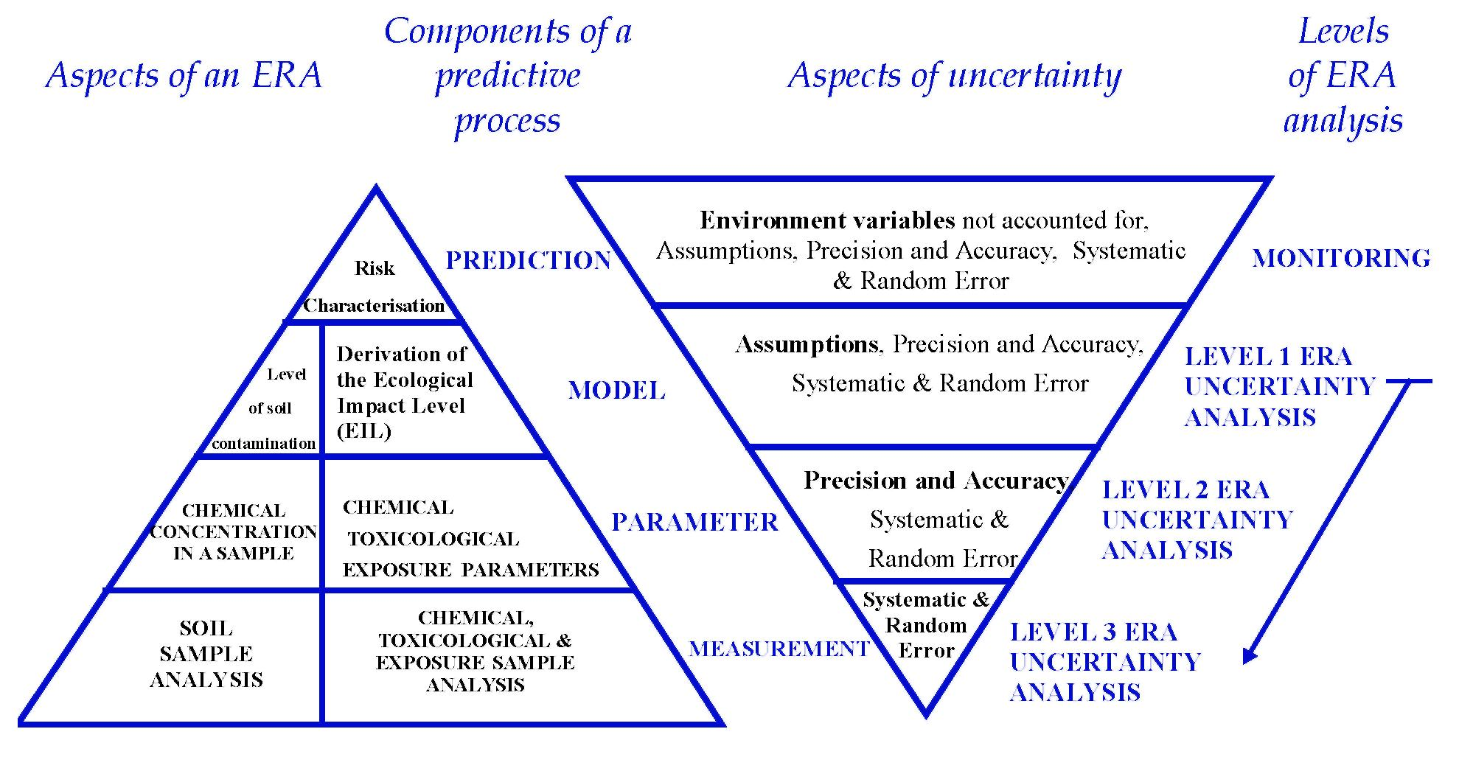
For example, a Level 1 analysis should address the uncertainty dependent on the model component. This analysis should check the assumptions of the models to ensure they are applicable to the site under investigation.
A Level 2 analysis may refine the assumptions of the model and apply more suitable estimates that address the precision and accuracy of the parameters.
A Level 3 analysis of uncertainty may involve specific measurements of known analytical error. This may then provide a precise estimate of a parameter with known

accuracy that can then be applied to a refined model to predict the risk of chemical contamination.
However, in the event the uncertainty of the prediction is significant, monitoring at the site may provide a validation check, as this takes into account environmental variables that could not be modelled.
Best and conservative estimates of risk may be made as a means of gauging analytical uncertainty. Best estimates of risk and variables used to calculate risk should statistically describe the most likely occurring value. However, where statistical description is unavailable, the best estimate may represent the most likely value based on a weight of evidence. Conservative estimates should statistically describe the conservative 95% confidence limits of the best estimate. However, where statistical description is unavailable, the conservative estimate may represent a value that is considered with a high degree of certainty to be conservative based on the weight of evidence.
For a detailed discussion on the mathematical analysis of uncertainty, the reader is directed to the texts Cox and Baybutt (1981), Hoffman and Gardener (1983) and Gardener et al., (1981). A number of uncertainty analysis computing programs have also been developed that may be of use (PRISM code of Gardener et al., 1983, @ RISK and Crystal Ball).
8. REPORTING
8.1 Introduction
The following Section provides a guide to the structure and content of an ERA report. This should only be treated as a guide, as the structure and content of reports will be heavily influenced by site-specific issues as well as client and regulatory requirements. The basic intent of this guide is to provide a logical structure in a report that will enable easier understanding of the outcomes of the risk assessment by the risk managers and other readers of the reports.
Ecological risk assessment reports will generally follow soil contamination assessment reports. Guidelines have been prepared for the conduct and reporting of site assessments (ANZECC/NHMRC, 1992, Schedule B(2)), therefore these types of reports will not be discussed here. If, however, the site assessment and ecological risk assessment are reported in a single report, both sets of guidelines should be followed.
The ecological risk assessment report should have the following main components:
- Summary
- Table of Contents
- Introduction
- Problem Identification

- Receptor Identification
- Exposure Assessment
- Toxicity Assessment
- Risk Characterisation
- Uncertainty
- Conclusions
- References
- Appendices.
Some of the contents of the sections in a report are self evident (such as table of contents, introduction and references) and will not be further discussed.
The level of ecological risk assessment will also determine the degree of complexity and completeness of the information and of the data analysis in each of these sections.
8.2 Summary
The Summary should have the following components: background to the site, rationale and objectives for conducting the ERA, description of the level of ecological risk assessment conducted, description of the elements of the risk assessment, and a summary of the key conclusions of the risk assessment and recommendations arising from it.
The summary should be written in non-technical language and contain sufficient information to enable a non-technical reader to understand the approach and results of the risk assessment, independent of the rest of the document.
8.3 Problem Identification
This section of the report should discuss issues such as:
- objectives of the risk assessment;
- background of the events leading to the conduct of a risk assessment;
- level of ecological risk assessment being conducted;
- site description and history;
- a summary of site information and data contained in any previous site assessment reports. This could have information on land use, site geology, soil contaminant concentrations and distribution, background concentrations, regional and local hydrology;
- an evaluation of quality assurance/quality control data on any previous field measurements and laboratory analysis contained in site assessment reports;
- uncertainty estimates with respect to the site assessment data;
- identification of key contaminants of concern (based on site history and any previous site assessment reports).

8.4 Receptor Identification
A discussion on receptor identification should include:
- ecological values to be protected;
- the approach used to identify ecological values that are potentially at risk;
- an assessment of the possible spatial and temporal overlap of receptors and contaminants of concern (this would link in with the exposure assessment);
- basic life history and behaviour information on species identified as key receptors; and
- the sources and estimates of uncertainty.
8.5 Exposure Assessment
The exposure assessment should discuss:
- the sources of the contaminants (if not discussed in Problem Identification);
- the environmental fate and transport of the contaminants;
- the magnitude, duration and frequency of exposure;
- the applicable pathways with respect to the ecological receptors; and
- the sources and estimates of uncertainty.
8.6 Toxicity Assessment
This section should provide a discussion on the:
- toxicity of the contaminants;
- characterisation of potential ecological effects at the individual organism, population and community levels;
- known toxicity modifying factors (both synergistic and antagonistic resulting from exposure to multiple contaminants);
- indicators of ecological responses (eg suitable endpoints).
- the sources and estimates of uncertainty.
8.7 Risk Characterisation
Using information gathered from the exposure and toxicity assessment sections of the report, estimate the magnitude, probability and significance of ecological impacts occurring as a result of the level of contaminants present. An analysis of uncertainty should accompany this risk estimate.
8.8 Uncertainty
A discussion of uncertainty should include:

- summaries of the discussions of uncertainty contained in report component already presented;
- discussion of overall uncertainty based on an assessment of all levels of uncertainty;
- discussion of the implications of uncertainty for the finding of the report; and
- methods and cost of reducing uncertainty (ie. moving to higher levels of data collection, exposure assessment, etc.).
8.9 Conclusions
The conclusion section of the risk assessment should be brief and use the information provided in the conclusion sections of the elements of the body of the report. The section should summarise the results of the risk assessment within the context of the objectives of the study. Recommendations by the risk assessor to the risk manager regarding the characterisation of risk and possible ERA outcomes should be summarised in this section. Conclusions should be integrative in nature, combining all aspects of the assessment.
8.10 Appendices
Supporting documentation and information such as previous site assessment reports and analytical data should be provided in the appendices of the report.
9. APPROACHES FOR THE DERIVATION OF ECOLOGICAL INVESTIGATION LEVELS AND DETAILED ECOLOGICAL RISK ASSESSMENT
A number of detailed methodologies for ecological risk assessment and the derivation of ecological investigation levels (or their equivalent) have been or are being developed internationally. A number of these methodologies may be broadly consistent with the framework established in this guideline.
One example of a methodology is contained within Part B of the Draft National Framework for Ecological Risk Assessment for Contaminated Sites. Part B of the National Framework presents a detailed methodology for the derivation of ecological impact levels (which may be used to derive investigation or response levels). This has been developed in Australia following a review of overseas approaches. The approach outlined in Part B is based on protection of the biota associated with the nominated ecological values in the context of the ecosystem in which they are found. This involves consideration of exposure of biota by multiple pathways (eg. direct contact, ingestion of contaminated food) and the impact of contamination on supporting ecological processes (eg. nutrient cycling).
The approach outlined in Part B is largely predictive, as are many of the ecological risk assessment methodologies. The results of environmental and ecological

monitoring, where available, are used to set ecological investigation or response levels or to refine inputs to, and validate the results of, predictive modelling-based risk assessment approaches used to establish investigation and response levels.
Part B is available from Environment Australia
(Website: http://www.environment.gov.au/epg/contam).
The United States Environmental Protection Agency (USEPA) Risk Assessment Forum developed the Framework for Ecological Risk Assessment to form the foundation for further, more comprehensive guidelines. At present it describes the process of ecological risk assessment in broad terms and is neither a procedural guide nor a regulatory requirement within the US. The USEPA is currently developing a methodology to derive ecologically-based Soil Screening Levels, which are intended to be similar in application to EILs.
In Canada, a framework for ecological risk assessment has been developed (CCME, 1994) to provide guidance in the conduct of ERAs. In common with the Australian framework, it proposes a tiered approach which provides the flexibility to conduct an ERA at a level appropriate to the complexity of the site being assessed.
The Dutch Ministry for Housing, Spatial Planning and the Environment published “Environmental Quality Objectives in the Netherlands” in 1994 which provides risk-based limits for a range of chemicals in soil, air and water. Target and Intervention Levels are nominated for soils, based largely on consideration of human health and ecotoxicology. The Target Level represents a goal toward which The Netherlands should aim in managing site contamination, and is generally set at a level 1/100th of the maximum permissible concentration. The Intervention Value is a value which, if exceeded at a site, triggers the requirement for remediation and/or management, although the timescale for such action is dependent on the actual risk posed by the site. This reflects the policy objective of restoring the “multifunctionality” of land. The ecotoxicologically-based intervention and target levels are based on statistical reduction of available ecotoxicological data. Where chemicals are known to be particularly bioaccumulative, separate consideration is given to the impact of secondary poisoning of higher species. Differing levels or guidelines can be established for differing risk levels. For example the ecotoxicologically-based Intervention Values are set to theoretically protect 50% of species, with 95% confidence. The Target Values for most metals are set on the basis of typical background or ambient concentrations, rather than 1/100th of the concentration that would theoretically protect 95% of species with 95% confidence, as is the case for other chemicals.
All ecological risk assessment methodologies are relatively data intensive. Irrespective of the method chosen, limitations in the information currently available regarding Australian ecosystems, environmental conditions and native species, mean that all methodologies require use of appropriate assumptions and information from a range of sources. Some of this information may have been developed for overseas species and conditions and may not be directly applicable to the assessment of ecological risk in Australia. All data should be critically reviewed for scientific

validity and relevance to Australian conditions and, where appropriate, the site-specific conditions prior to use. It is recognised that, in the short to medium term, limitations will remain in the information directly applicable to species of ecological value in Australia. Therefore, when assessing possible ecological risk and developing regional ecological investigation levels it will be necessary to employ professional and scientific judgement, taking care to ensure that any assumptions are explicit, protective and reasonable. Any judgement exercised should reflect the multidisciplinary nature of ecological risk assessment, drawing on expertise in environmental chemistry, ecotoxicology, ecology and risk assessment/risk management, as appropriate.
Any methodology proposed for use, including those noted above, should be critically evaluated against the framework presented in this guideline to ensure consistency with the principles of ERA and the derivation of EILs_{soil} prior to use. Section 8 of this guideline provides an outline of the information that should be considered in any ecological risk assessment report.
10. REFERENCES
ANZECC 1996. Guidelines for the Laboratory Analysis of Contaminated Soil, Australian and New Zealand Environment and Conservation Council and National Health and Medical Research Council.
ANZECC/NHMRC 1997. The Assessment and Management of Contaminated Sites: Policy Framework, Australian and New Zealand Environment and Conservation Council and National Health and Medical Research Council.
ANZECC/NHMRC 1992. Australian and New Zealand Guidelines for the Assessment and Management of Contaminated Sites, Australian and New Zealand Environment and Conservation Council and National Health and Medical Research Council.
ANZECC 1992. Australian Water Quality Guidelines for Fresh and Marine Waters, National Water Quality Management Strategy, Australian and New Zealand Environment and Conservation Council, ISBN 0 642 18297 3.
AS 4482.1, 1997 - ‘Guide to the Sampling and Investigation of Potentially Contaminated Soil, Part 1: Non volatile and semi-volatile compounds’ Standards Australia (in press).
AS/NZS (Australian Standard) 4360 1995. Risk Management.
Bartell, S.M., and Biddinger, G.R., 1995. Critical Issues in Ecological Risk Assessment in Hughes, J.S., Biddinger, G.R., and Mones, E. (1995) Environmental Toxicology and Risk Assessment, American Society for Testing and Materials, Volume 3, STP 1218, pp 3-26.
CCME 1994. A Protocol for the Derivation of Ecological Effects-Based and Human Health-Based Soil Quality Criteria for Contaminated Sites - Final Draft, Canadian Council of

Ministers for the Environment Subcommittee on Environmental Quality Criteria for Contaminated Sites, July 1994.
Chek, W.L., 1996. Ecological Risk Assessment Methodologies in Markey, B.R., and Langley, A.J., eds Proceedings of The 3rd National Workshop on the Health Risk Assessment and Management of Contaminated Sites, Sydney, May 1995, South Australian Health Commission, pp 365-384.
Cox, D.C., and Baybutt, P., 1981. Methods of uncertainty analysis: a comparative survey. Risk Analysis, Volume 1, pp 251-258.
EC 1994. A Framework for Ecological Risk Assessment at Contaminated Sites in Canada: Review and Recommendations, C. Gaudet, EVS Environmental Consultants and ESSA Environmental and Social Systems Analysts, Environment Canada, Scientific Series No. 199, 1994.
Gardner, R. H., O’Neil, R.V., Mankin, J.B., and Carney, J.H., 1981. A comparison of sensitivity analysis and error analysis based on a stream ecosystem model. Ecological Modelling, Volume 12, pp 177-194.
Hoffman, F.O., and Gardner, R.H., 1983. Evaluation of uncertainties in environmental radiological assessment models in Till, J.E., and Meyer, H.R. (eds), Radiological Assessment: A Textbook on Environmental Dose Assessment, US Nuclear Regulatory Commission, Washington DC, pp 11-1-11-55.
NHMRC/ARMCANZ, 1996. Australian Drinking water Guidelines. National Health & Medical Research Council/Agriculture & Resource Management Council of Australia and New Zealand.
Suter G. W. II, 1993. Ecological Risk Assessment. Lewis Publishers. Michigan.
Taylor, R. and Langley, A.J. 1996. Exposure Scenarios and Exposure Settings, in Markey, B.R., and Langley, A.J., eds Proceedings of The 3rd National Workshop on the Health Risk Assessment and Management of Contaminated Sites, Sydney, May 1995, South Australian Health Commission, pp 111-136.
Thackway R., and Cresswell I. D. 1995. An Interim Biogeographic regionalisation for Australia, Version 4.0, Australian Nature Conservation Agency, Canberra
USEPA 1993. Data Quality Objectives Process for Superfund, United States Environmental Protection Agency, EPA540-R-93-071, PB94-963203, September 1993.
USEPA 1996. Proposed Guidelines for Ecological Risk Assessment, United States Environmental Protection Agency, EPA/630/R-95/002B, August 1996.

APPENDIX 1
MIXTURES OF CHEMICALS
The risk posed by mixtures of chemicals may not be the same as that for individual chemicals. This issue has been addressed in a variety of ways internationally. Where the effects of chemicals in a mixture are proportionally additive, the hazard quotient approach has been adopted for the Guideline for Ecological Risk Assessment. This concept has been adopted in other risk assessment frameworks (DeSesso 1995, US EPA 1988, Vouk et al. 1987). For guidance with respect to synergistic or antagonistic effects of chemical mixtures refer to texts such as Vouk et al., (1987).
The Hazard Quotient (HQ) approach requires the ratio of existing soil contaminant concentrations and the EIL_{soil} for each individual chemical to be calculated.
That is, HQ = X/E
where | X is the concentration of a contaminant in soil; and
 | E is the EIL_{soil} for that contaminant.
Where the effects of contamination are known (or conservatively assumed) to be proportionally additive (eg half the toxic dose for one chemical in combination with half the toxic dose of another, leads to an effect equivalent to the full dose of either chemical given in isolation) the sum of the Hazard Quotients for each contaminant is calculated. The sum of the Hazard Quotients for each contaminant is called the Hazard Index (HI).
That is, HI = HQ_{A} + HQ_{B} + HQ_{C}
where | HQ_{A} is the Hazard Quotient for contaminant A (ie X_{A}/E_{A});
 | HQ_{B} is the Hazard Quotient for contaminant B (ie X_{B}/E_{B}); and
 | HQ_{C} is the Hazard Quotient for contaminant C (ie X_{C}/E_{C}).
Where HI is equal to or less than 1, ecological values are assumed to be protected. Where HI is greater than 1, there is potential for adverse impacts to ecological values. That is, the sum of effects of simultaneous sub-threshold exposures to several contaminants may induce an effect equivalent to greater than the maximum tolerable dose for a single contaminant given in isolation. This method assumes that the magnitude of adverse effect will be proportional to the sum of the ratios of the sub-threshold exposures to acceptable exposures (USEPA, 1989).

