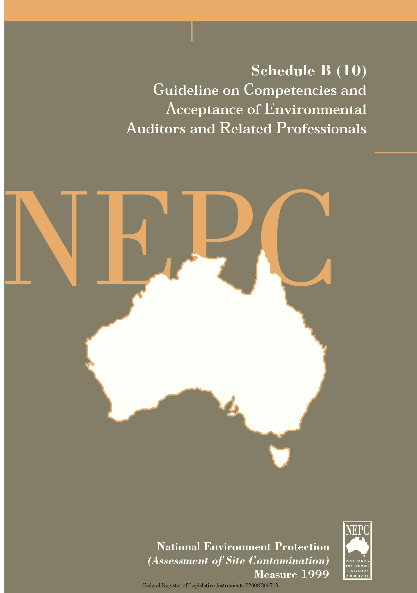

The following guideline provides general guidance in relation to Competencies and Acceptance of Environmental Auditors and Related Professionals in the assessment of site contamination.
This Guideline forms part of the National Environment Protection (Assessment of Site Contamination) Measure 1999 and should be read in conjunction with that document, which includes a Policy Framework and Assessment of Site Contamination flowchart.
The National Environment Protection Council acknowledges the contribution of the National Health and Medical Research Council to the development of this Measure.

Contents
Competencies and Acceptance of Environmental Auditors and Related Professionals

 |  | Page
1 | Introduction | 1
2 | Purpose | 1
3 | Use of These Guidelines | 1
4 | Application for Acceptance | 2
5 | Assessment Criteria | 3
 | 5.1 Basis of Application | 3
 | 5.2 Legislative Understanding | 4
 | 5.3 National Framework | 4
 | 5.4 Experience and Expertise | 4
 | 5.5 Professional Societies | 4
 | 5.6 Professional Experience | 5
 | 5.7 Principles of Audits | 5
 | 5.8 Literature | 5
6 | Acceptance Processes and General Conditions | 5

1 INTRODUCTION
The assessment of contaminated sites is a specialised professional area involving a number of disciplines. Practitioners must have a range of competencies and be able to recognise the need for supporting professional advice beyond their expertise when assessing contamination and its effects on land use and the environment. The extent to which these competencies are applied varies with the complexity of contamination issues on individual sites.
Professional assessments of site contamination deal with health and environmental issues of concern to landowners, occupiers and the public. These assessments are required by regulatory and planning authorities for the management of contaminated land and in development approval processes.
This guideline should assist the development of arrangements which provides consistency and recognition of competent professionals across Australian jurisdictions for contaminated site assessment particularly related to sites involving complex contamination issues.
2 PURPOSE
The purpose of this guideline is to:
- describe the competencies which are essential to contaminated site assessment and investigation; and
- provide a general framework for appointment or acceptance by regulatory authorities of contaminated land professionals who are required under statute to certify site assessments.
3 USE OF THESE GUIDELINES
These guidelines are primarily intended for use by regulatory authorities within the scope of their environmental and planning legislation. They may be used for appointment or acceptance of:
- contaminated site auditors where their role is to conduct contaminated land audits; and
- specialised professionals who are required under statute to demonstrate relevant qualifications and experience when presenting contamination assessment reports to regulatory authorities and to certify assessment work under statutory declarations.
Application of a high level of competency assessment would apply to appointment of accredited auditors and to the acceptance of professionals who are certifying assessments of complex contaminated sites. Depending on the legislative requirements applying in individual jurisdictions, a less stringent interpretation of

these competencies may be applied in relation to assessment of sites with a lower level of contamination complexity eg a jurisdiction may wish to establish grades of accreditation.
Landowners, developers and consultants may also use these guidelines to assist with decision making in the employment or training of professionals for contaminated site assessment work.
4 APPLICATION FOR ACCEPTANCE
Professionals applying to individual jurisdictions for acceptance of their qualifications and experience in certification of contaminated site assessment work should supply the following information to the regulatory authority:
- Curriculum Vitae
- A detailed statement of the applicant’s experience and expertise in:
- contaminated land assessment and management
- soil sampling design and methodology
- assessment and management of major environmental issues involving discharge/disposal of industrial waste onto land or into the air or aquatic environments
- other environmental sampling design and methodology eg industrial wastewater, regulated waste or air sampling programs
- groundwater sampling design and methodology
- assessments of impacts on groundwater from contaminated sites
- interpretation of chemical analytical data
- quality control/assurance procedures
- industrial processing, chemical use and waste disposal practices
- environmental chemistry
- soil science
- hydrogeology
- human toxicology
- environmental toxicology
- environmental impact assessment associated with land water and air pollution.
- contaminant transport and assessment of exposure pathways and risk
- remedial technologies and geotechnology
- risk communication in relation to contaminated land issues including demonstration of a high level of oral communication skills
- health and safety issues associated with field work for contamination land
- other relevant specialised competencies.

- A statement demonstrating the applicant’s understanding of the relevant provisions of environmental legislation in the particular jurisdiction and knowledge of policy, regulations and procedures.
- Nomination of people or companies who will provide support to the applicant in the areas of (2) above in which the applicant is not an expert and information which demonstrates the applicant’s experience in forming appropriate multidisciplinary teams for complex assessments.
- A copy of the professional liability insurance policy held by the applicant or on the applicant’s behalf by the company employing the applicant, which demonstrates an appropriate level of coverage.
- An example of a relevant report or study on contaminated site management and/or remediation previously undertaken by the applicant. The sample report should have been substantially prepared by the applicant and demonstrate a high level of written communication skills. The report should clearly support the statements made by the applicant under item (2) above. The role of the applicant in conducting the study (consultancy) and in preparing the report must be clearly indicated. Consent must be obtained from the client(s) before the application is submitted. All the reports will be treated as confidential and will be returned to the applicant.
- Summary information about additional reports and studies undertaken may be presented indicating the title of the project, the role of the applicant and the purpose of the project.
- Nomination of two referees not directly associated with the applicant or the company employing the applicant who can confirm the applicant’s experience in (2) above.
5 ASSESSMENT CRITERIA
This section details appropriate criteria which should be considered by jurisdictions in the assessment of applicants seeking acceptance for certification of contaminated site assessment work.
5.1 Basis of Application
The applicant should be able to demonstrate extensive experience and a high level of expertise in the following core competencies.
- contaminated site assessment and management
- soil sampling design and methodology
- interpretation of chemical data, and
- assessment of contaminant exposure pathways and risk.

In addition, the applicant should demonstrate an equivalent level of competence in at least one of the following areas and reasonable proficiency in the remaining areas.
- groundwater sampling design and methodology
- assessment of impacts on groundwater from contaminated sites
- quality control/assurance procedures.
5.2 Legislative Understanding
The applicant would need to be able to demonstrate an understanding of relevant legislation, regulations and guidelines relating to site contamination in each jurisdiction for which acceptance is sought.
5.3 National Framework
The applicant should be able to demonstrate an understanding of the Australian and New Zealand Guidelines for the Assessment and Management of Contaminated Sites (ANZECC / NHMRC 1992) and the National Environment Protection (Assessment of Site Contamination) Measure
5.4 Experience and Expertise
The applicant should be able to demonstrate his/her expertise in, or access to relevant expertise in:
- environmental chemistry
- soil science
- hydrogeology
- human toxicology
- environmental toxicology
- contaminant transport and assessment of exposure pathways and risk
- remedial technologies and geotechnology.
The applicant should demonstrate a sound ability to form and manage a multidisciplinary team for complex site assessment which contains the appropriate balance of expertise.
5.5 Professional Societies
The applicant should be a member of one or more relevant professional societies determined by jurisdictions (eg The Institution of Engineers, Australia, the Royal Australian Chemical Institute, Australian Institute of Geoscientists.

When considering professional societies, which may be acceptable for the purposes of this section, jurisdictions must consider the following criteria:
- discipline or area of expertise or interest relates directly to the assessment and management of contaminated sites
- membership must be qualification based
- membership must require adherence to an appropriate code of ethics.
5.6 Professional Experience
Applicants would be expected to have at least five years experience in the assessment and management of contaminated sites for appointment as accredited auditors or for acceptance as professionals involved in preparation and certification of assessments of complex contaminated sites. Individual jurisdictions may also consider applicants with less than 5 years contaminated land experience but with 10 or more years of relevant and related environmental experience including assessment and management of major environmental issues involving complex sampling design and chemical or hydrogeological data collection and interpretation. In jurisdictions where applicants are required, under statute to certify the assessment of less complex contaminated sites eg fuel storage installations with no groundwater impacts, or cattle dip sites with a limited zone of contamination and known contaminants, relevant industrial and environmental experience of shorter duration may be considered.
It is desirable that experience includes at least two years of relevant work in Australia and two years in the role of project manager involving a multidisciplinary team approach to contaminated land or related environmental assessment and management. It is preferable if the experience in contaminated sites work is broadly based in terms of the scale of work undertaken, the range of contaminants encountered and the scope of work performed.
5.7 Principles of Audits
The applicant should be able to demonstrate a thorough understanding of the principles of, and methods for, conducting environmental audits.
5.8 Literature
The applicant should be able to demonstrate up-to-date knowledge of relevant scientific, technical developments and regulatory literature relating to new legislation and court proceedings and decisions relating to contaminated sites.
6 ACCEPTANCE PROCESSES AND GENERAL CONDITIONS
The regulatory authority may consider the establishment of a panel to assess applications. Typical panels would have not less than three professionals including a suitably qualified chairperson. Panel members would need to be experienced in

contaminated land assessment and management. Apart from core competencies and other assessment criteria outlined in Section 5, the panel must consider all the relevant professional and environmental experience of each applicant.
Provision should be made for updating the professional training and experience of accepted professionals at regular intervals. The regulatory authority may conduct independent audits and peer reviews of assessment work and adopt a system which involves the annual or biannual review of the status of appointed professionals. Reviewers within jurisdictions should have appropriate qualifications and experience.
In the event of proven malpractice by accepted persons, the regulatory authority may suspend or revoke the acceptance and apply appropriate additional penalties.

