
Statutory Rules 1990 No. 1
_____________
Declaration under the Superannuation Act 1976
I, RALPH WILLIS, Minister of Finance, hereby make the following declaration under section 110d of the Superannuation Act 1976.
Dated 20 June 1990.
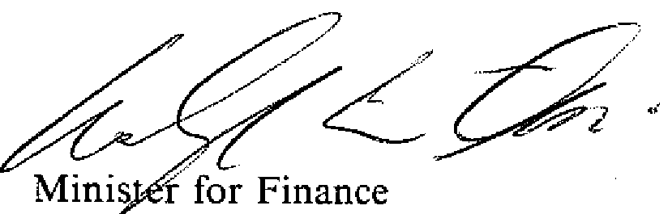
____________
DECLARATION UNDER SECTION HOD OF THE SUPERANNUATION ACT 1976
Citation
1. This Declaration may be cited as "Productivity Contribution Declaration No. 1".
Table of productivity contributions
2. In relation to the period commencing on 1 July 1990, the Table in subsection 110c (1) of the Superannuation Act 1976 is to have effect as if the amount specified in Column 3 of an item in the following table were substituted for the amount specified in Column 2 of that item:
TABLE
Column 1 | Column 2 | Column 3
Item | Present Amount | Substituted Amount
1 | $846 | $880
2 | $25.40 | $26.40
3 | $1,300 | $1,418
4 | $1,950 | $2,127
5 | $39.00 | $42.54

(S.R. 198/90)—Cat. No. | 8/14.6.1990

NOTE
1. Notified in the Commonwealth of Australia Gazette on 1990.

Printed by Authority by the Commonwealth Government Printer

