Commonwealth of Australia
Currency Act 1965
Currency Determination No. 4 of 1996
I, JAMES ROBERT SHORT, Assistant Treasurer, acting for the Treasurer, make the following Determination under subsection 13A(1) of the Currency Act 1965.
Dated 23 September 1996.
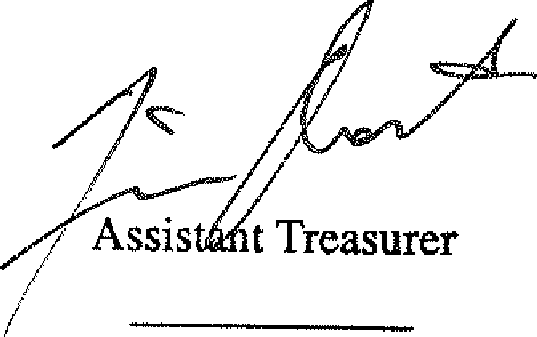
Citation
1. This Determination may be cited as Currency Determination No. 4 of 1996.
Commencement
2. This Determination commences on 27 September 1996.
Application of the Determination
3. This Determination does not affect any other determination of the specifications or design of a coin.
Specifications and designs of $5 silver coins
4. (1) This clause sets out the specifications and designs of 5 coins of the denomination of $5 the standard composition of which includes not less than 92.5% silver and 7.5% other metal.
- The shape of each coin is circular.
- The edge of each coin is milled.
- The standard weight of each coin is 35.79 grams.
- A variation of 0.63 grams from the standard weight is allowed.
- The diameter of each coin is 38.90 millimetres.

- The thickness of each coin is 3.50 millimetres.
- The obverse of each coin bears:
- an effigy of the Queen; and
- the inscriptions:
(i) "ELIZABETH II'; and
(ii) "AUSTRALIA"; and
(iii) "1996".
(9) The reverse of the first coin bears:
- an effigy of Tom Roberts against a background of his painting "Shearing the Rams"; and
- the inscriptions:
(i) "5 DOLLARS"; and
(ii) "Tom Roberts".
(10) The reverse of the second coin bears:
- an effigy of Henry Lawson against a background representation of a book open at the page where the poem "To My Friend" is inscribed; and
- the inscriptions:
(i) "5 DOLLARS"; and
(ii) "Henry Lawson".
(11) The reverse of the third coin bears:
- an effigy of Dame Nellie Melba; and
- the inscriptions:
(i) "5 DOLLARS" and
(ii) "Dame Nellie Melba".
(12) The reverse of the fourth coin bears:
- a representation of a stockman on a horse;
- the inscriptions:
(i) "5 DOLLARS" and
(ii) "Stockman".
(13) The reverse of the fifth coin bears:
(a) a representation of 2 horses racing; and
(b) the inscriptions:
(i) "5 DOLLARS" and
(ii) "Horse Racing"."

