Australian Capital Territory
(Planning and Land Management) Act 1988
Section 19
APPROVAL OF AMENDMENT 23
OF THE NATIONAL CAPITAL PLAN
(CANBERRA CENTRE CONSOLIDATION)
I, Ian Douglas Macdonald, Minister for Regional Services, Territories and Local Government, pursuant to Section 19 of the Australian Capital Territory (Planning and Land Management) Act 1988, APPROVE Amendment 23 of the National Capital Plan set out in the attached Schedule.
Dated this 24th day of May 1999.

Ian Macdonald
Minister for Regional Services,
Territories and Local Government


NATIONAL CAPITAL AUTHORITY
Australian Capital Territory
(Planning and Land Management) Act 1988
NATIONAL CAPITAL PLAN
AMENDMENT 23
CANBERRA CENTRE CONSOLIDATION
May 1999

Amendment 23 of the National Capital Plan
Canberra Centre Consolidation
1. Amend Figure 18 Main Avenues and Approach Routes facing page 25 by deleting the heavy black line from the portion of Ainslie Avenue between the Canberra Centre and the eastern side of Ballumbir Street shown hatched in the diagram below
2. Amend Figure 3 Designated Areas immediately preceding page 15 by deleting the Designated Area symbol from the areas shown hatched in the diagram below.
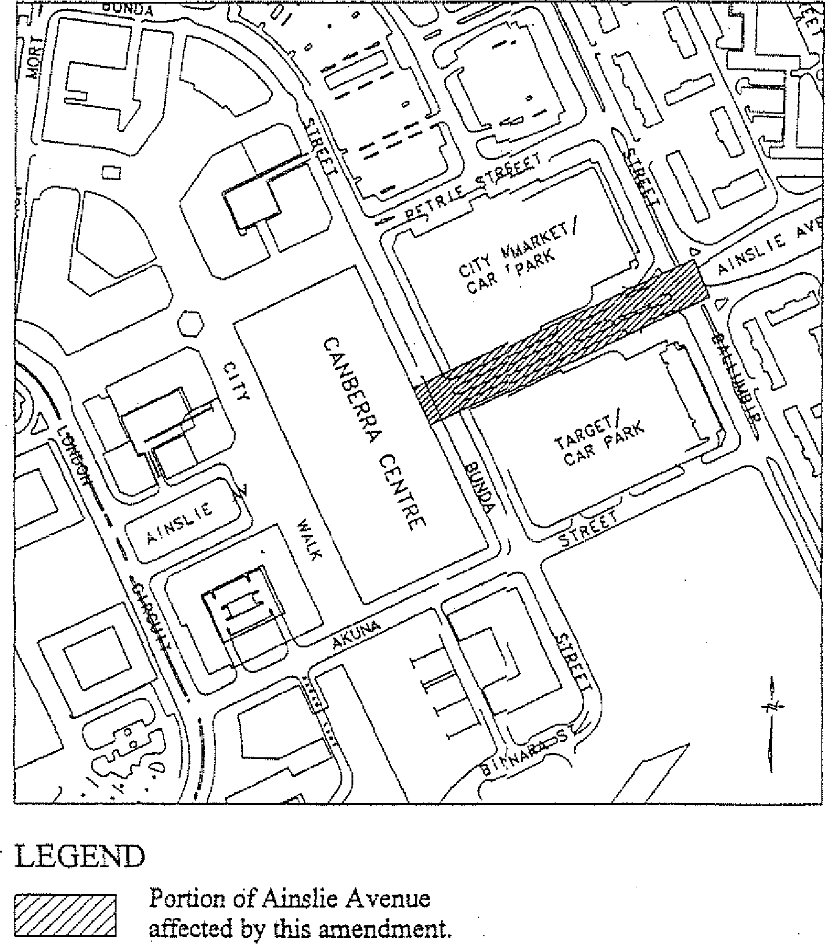
Note: This amendment uplifts the 'Designated Area' status of this portion of Ainslie Avenue.

