Instrument number CASA 316/07
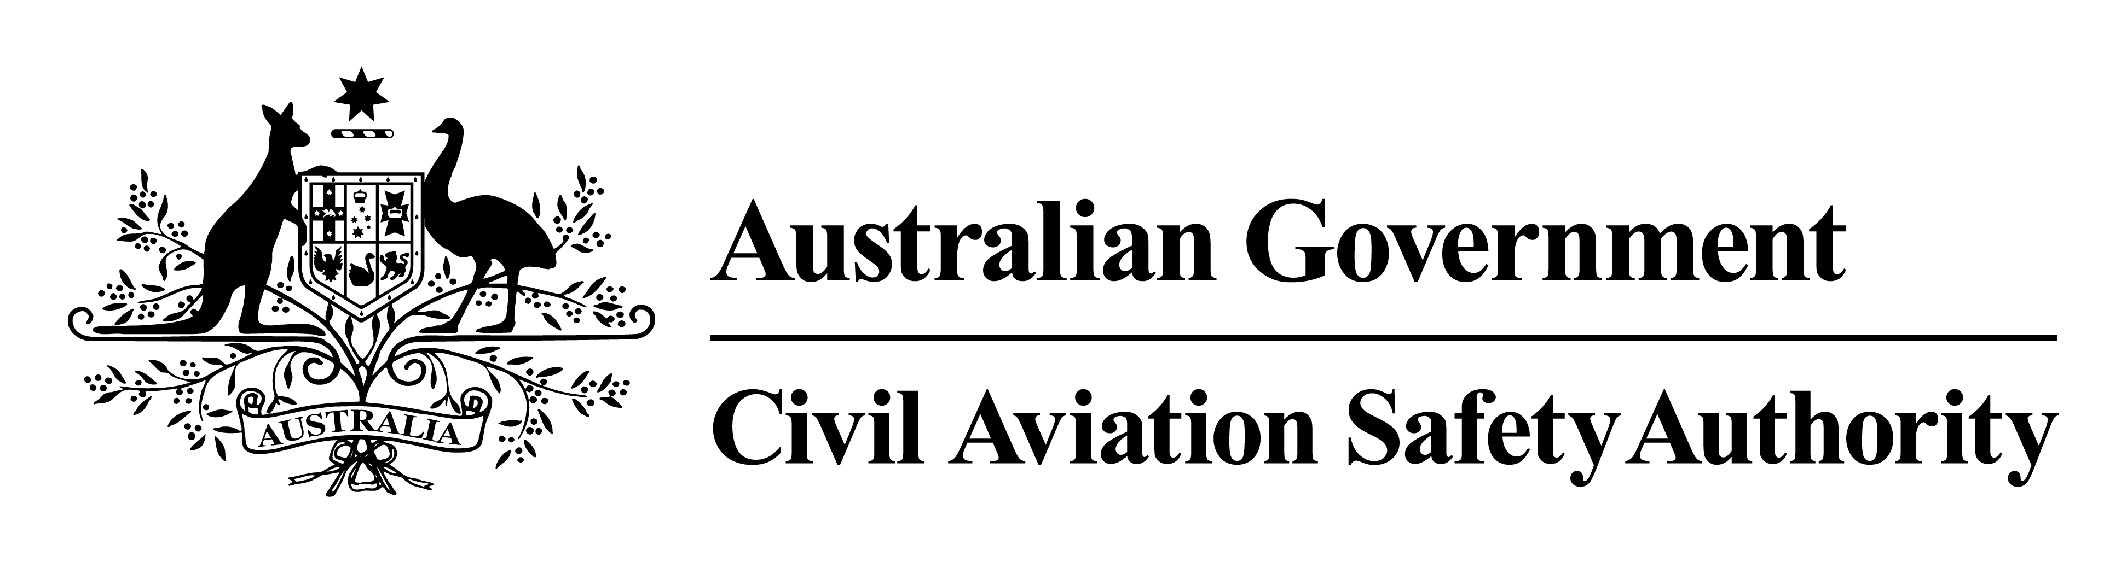
I, William Bruce Byron, Director of Aviation Safety, on behalf of CASA, make this instrument under regulation 11.245 of the Civil Aviation Safety Regulations 1998.
[Signed Bruce Byron]
Bruce Byron
Director of Aviation Safety and
Chief Executive Officer
24 August 2007
Direction — Cessna 441 Conquest
1 Commencement
This instrument commences on 25 August 2007.
2 Application
This instrument applies to each operator, and each pilot, of a Cessna 441 Conquest (the aircraft) that:
(a) has 22 500 hours or more time-in-service; and
(b) is:
(i) an Australian aircraft; or
(ii) a foreign registered aircraft in Australian territory.
3 Direction
The aircraft may not be flown at any time or for any purpose while this direction is in force unless, being satisfied that it is safe to do so, the Director approves in writing the details of the flight, including the time, route, purpose and risk mitigators.
Note 1 The aircraft manufacturer, Cessna Aircraft Corporation, has issued a Supplemental Inspection Document (SID) which recommends that the aircraft be retired when it has accumulated 22 500 flight hours because continued airworthiness can no longer be assured.
Note 2 Depending on the circumstances, the Director may permit an aircraft that is otherwise grounded by the direction to return to base if it would be safe to do so.

