Commonwealth of Australia

Native Title Act 1993

Subsection 203AD(1A)

Recognition as Representative Aboriginal/Torres Strait Islander Body
2007 (No. 13)

I, Mal Brough, Minister for Families, Community Services and Indigenous Affairs, acting under subsection 203AD(1A) of the Native Title Act 1993, recognise the Yamatji Marlpa Barna Baba Maaja Aboriginal Corporation as the representative Aboriginal/Torres Strait Islander body for the transitionally affected areas described in Schedules 1 and 2.

This recognition commences on 1 July 2007 and ceases to have effect at the end of 30 June 2011.

Dated 18 June 2007.

Mal Brough

Minister for Families, Community Services and Indigenous Affairs

Schedule 1

Description of transitionally affected area
(Pilbara)

- The Pilbara area is the area of land and waters bounded by a line commencing at the intersection of the western coastline of Exmouth Gulf and the southern boundary of the Exmouth Gulf Station, and then proceeding generally westerly along the southern boundary of the Exmouth Gulf Station boundary to its intersection with the 1991 Local Government Area (LGA) of Exmouth, then generally southerly and south-easterly along the southern boundary of that LGA to the intersection with Ashburton LGA, then generally south-easterly and northerly by the western and southern boundaries of that LGA to the intersection with Ullawarra Station, then generally northerly and south-easterly by the boundary of that Station to a point of intersection on the eastern boundary of Ullawarra Station and the western prolongation of the southern boundary of East Pilbara LGA, then generally easterly to the point of intersection with the eastern boundary of Native Title Claimant Application WG6110/98 (Martu), then generally northerly by the eastern boundary of that Application to its intersection with the eastern boundary of Native Title Claimant Application WG6077/98 (Ngurrara), then generally westerly and northerly by the southern and western boundaries of that Application to the south-east corner of Native Title Claimant Application WG6100/98 (Karajarri Combined), then generally westerly by the southern boundary of that Application to the intersection of the south-west corner of the said Application and the northern boundary of East Pilbara LGA, then generally westerly by the northern boundary of that LGA to its intersection with the coastline of mainland Australia, then due west by a straight line to its intersection with the outer limit of the exclusive economic zone of Australia (EEZ), then generally south-westerly by that outer limit to the intersection with latitude 21 degrees 45 minutes south, then due east to the intersection with the centre thread of the Exmouth Gulf, then generally southerly along the centreline of Exmouth Gulf to its intersection with latitude 22 degrees 22 minutes south, and then generally south-westerly by a straight line to the point where the line began.

Note: where Native Title Claimant Applications are referenced these are as per the Register of Native Title Claims at 10 May 2000.

- In this Schedule:
exclusive economic zone means the exclusive economic zone within the meaning of the Seas and Submerged Lands Act 1973.
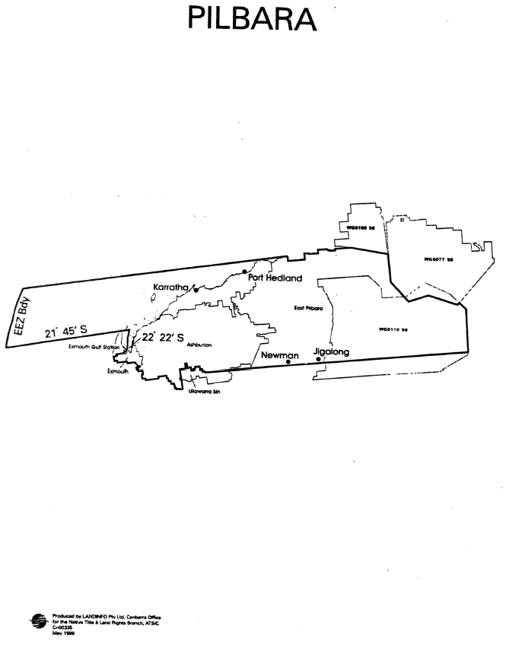
Schedule 2

Description of transitionally affected area
(Geraldton)

- The Geraldton area is the area of land and waters bounded by a line commencing at the intersection of the western coastline of Exmouth Gulf and the southern boundary of the Exmouth Gulf Station, and then proceeding generally westerly along the southern boundary of the Exmouth Gulf Station boundary to its intersection with the 1991 Local Government Area (LGA) of Canarvon, then generally easterly along the northern boundary of that LGA to its intersection with the Upper Gascoyne LGA, then generally easterly and northerly along the northern boundary of that LGA to its intersection with Ullawarra Station, then generally northerly, easterly and southerly along the boundary of that Station to its intersection with the Upper Gascoyne LGA, then generally easterly and southerly along the northern and eastern boundaries of that LGA to its intersection with the centre thread of the Gascoyne River, then generally easterly along that centreline to its intersection with the Census Collectors District 5020403, then generally north-easterly along that boundary to its intersection with the Great Northern Highway, then generally south-westerly along that highway to its intersection with Wiluna Road, then generally easterly along that road to its intersection with the Meekatharra LGA, then generally south-westerly along the eastern boundary of that LGA to its intersection with the Sandstone LGA, then generally easterly, southerly and westerly along the northern, eastern and southern boundaries of that LGA to its intersection with the Yalgoo LGA, then generally westerly along the southern boundary of that LGA to its intersection with the Perenjori LGA, then generally westerly along the southern boundary of that LGA to its intersection with the Carnamah LGA, then generally westerly along the southern boundary of that LGA to its intersection with the coastline of mainland Australia, then due west in a straight line to the intersection with the outer limit of the exclusive economic zone of Australia, then generally northerly along that outer limit to the intersection with latitude 21 degrees 45 minutes south, then due east to the intersection with the centre thread of Exmouth Gulf, then generally southerly along the centreline of Exmouth Gulf to its intersection with latitude 22 degrees 22 minutes south, and then generally south-westerly to the point where the line began.

- In this Schedule:
exclusive economic zone means the exclusive economic zone within the meaning of the Seas and Submerged Lands Act 1973.
