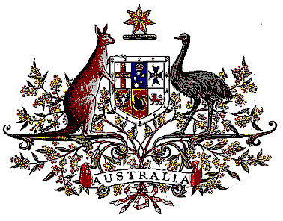

Veterans’ Entitlements Act 1986

Determination of Hazardous Service

I, Bruce Billson, Minister for Veterans’ Affairs:

  - revoke the Determination made under paragraph 120(7) of the Veterans’ Entitlements Act 1986 (the Act) on 19 July 2006 in relation to service in Afghanistan with the United Nations Office for Co-ordinating Assistance to Afghanistan (UNOCA) or the United Nations Mine Clearing Training Team (UNMCTT) on or after 8 June 1992; and
  - determine that:
    - service rendered as a member of the Australian Defence Force with the United Nations Office for Co-ordinating Assistance to Afghanistan (UNOCA) or the United Nations Mine Clearing Training Team (UNMCTT) on or after 8 June 1991 in the specified area, is hazardous service for the purposes of the definition of “hazardous service” in paragraph 120(7) of the Act, and
    - the specified area comprises Afghanistan.
  - This Determination is taken to have commenced on 8 June 1991.

Dated 24th May 2007

Signed Bruce Billson

BRUCE BILLSON
Minister for Veterans’ Affairs

