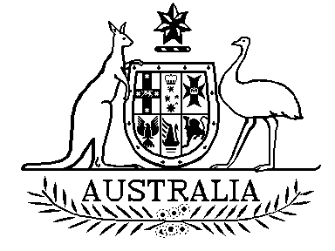

Australian Participants in British Nuclear Tests (Treatment) Act 2006

Section 18

Instrument of Approval

I, Bruce Billson, Minister for Veterans’ Affairs, in accordance with
subsection 18(5) of the Australian Participants in British Nuclear Tests (Treatment) Act 2006 (the Act), hereby approve the attached Instrument –
Repatriation Pharmaceutical Benefits Scheme (Australian Participants in British Nuclear Tests) 2006 - that modifies the Instrument described as the “Repatriation Pharmaceutical Benefits Scheme” incorporated-by-reference in the Act by subsection 18(1) of the Act.

Dated this 3rd day of January 2007

BRUCE BILLSON MP
Minister for Veterans’ Affairs

