National Capital Plan 1990 (December 1990)
made under the
Australian Capital Territory (Planning and Land Management) Act 1988
Compilation No. 30
Compilation date: 21 March 2024
Includes amendments: F2024L00360
Registered: 1 May 2024
This compilation is in 4 volumes
Volume 1: [Introduction, Governance, Part One–Part Four]
Volume 2: [Part Four(A) 4.0–4.6]
Volume 3: [Part Four(A) 4.7–4.10]
Volume 4: [Part Four(A) 4.11–4.22, Part Four(B) 4.23–4.28, Appendices A
and B and Endnotes]
Each volume has its own contents
About this compilation
This compilation
This is a compilation of the National Capital Plan 1990 (December 1990) that shows the text of the law as amended and in force on 21 March 2024 (the compilation date).
The notes at the end of this compilation (the endnotes) include information about amending laws and the amendment history of provisions of the compiled law.
Uncommenced amendments
The effect of uncommenced amendments is not shown in the text of the compiled law. Any uncommenced amendments affecting the law are accessible on the Register (www.legislation.gov.au). The details of amendments made up to, but not commenced at, the compilation date are underlined in the endnotes. For more information on any uncommenced amendments, see the Register for the compiled law.
Application, saving and transitional provisions for provisions and amendments
If the operation of a provision or amendment of the compiled law is affected by an application, saving or transitional provision that is not included in this compilation, details are included in the endnotes.
Editorial changes
For more information about any editorial changes made in this compilation, see the endnotes.
Modifications
If the compiled law is modified by another law, the compiled law operates as modified but the modification does not amend the text of the law. Accordingly, this compilation does not show the text of the compiled law as modified. For more information on any modifications, see the Register for the compiled law.
Self-repealing provisions
If a provision of the compiled law has been repealed in accordance with a provision of the law, details are included in the endnotes.

Contents
INTRODUCTION 1
GOVERNANCE 3
The Australian Capital Territory (Planning and Land Management) Act 1988 3
National Capital Plan 3
Object of the Plan 3
Functions of the Plan 3
Objectives of the National Capital Plan 4
Works approval 4
Relationship with the Territory Plan 4
Development and management of National Land 5
Definitions 5
PART ONE – THE NATIONAL SIGNIFICANCE OF CANBERRA AND THE TERRITORY 6
Explanatory Statement 6
1.1 Matters of National Significance 6
1.2 Designated Areas 8
PART TWO – STATEMENT OF PLANNING PRINCIPLES 11
Explanatory Statement 11
2.1 General matters 11
2.2 Productivity 12
2.3 Sustainability 12
2.4 Liveability 13
2.5 Accessibility 14
PART THREE – LAND USE PLANS AND GENERAL LAND USE CONTROLS 16
Explanatory Statement 16
3.1 General Policy Plans 16
3.2 National Capital Open Space System 22
3.3 Urban Areas 39
3.5 Employment location 42
3.6 Broadacre Areas 45
3.7 Rural Areas 47
PART FOUR – DESIGNATED AREAS AND SPECIAL REQUIREMENTS 50
Explanatory Statement 50

List of figures
Figure 1: Designated Areas 10
Figure 2: General Policy Plan – Metropolitan Canberra 20
Figure 3: General Policy Plan – Australian Capital Territory 21
Figure 4: Inner Hills – North Canberra (east) 25
Figure 5: Inner Hills – North Canberra (west) 26
Figure 6: Inner Hills – South Canberra (west) 27
Figure 7: Inner Hills – South Canberra (east) 28
Figure 8: Permitted location of commercial accommodation at the National Arboretum Canberra (Forests 69 and 76) 31
Figure 9: Site layout and built form requirements for commercial accommodation at the National Arboretum Canberra (Forests 69 and 76) 32
Figure 10: Defined Activity Centres 44
Figure 11: Tidbinbilla Deep Space Communication Complex zone constraints 48

INTRODUCTION
The National Capital Plan (the Plan) is the strategy and blueprint giving effect to the Commonwealth’s interests and intentions for planning, designing and developing Canberra and the Territory.
Australia's National Capital officially came into being in January 1911, when title to 911 square miles of land in the ‘district of Yass-Canberra’ was passed to the Commonwealth by the State of New South Wales. The Seat of Government Acceptance Act of 1909 provided that the Territory would be acquired by the Commonwealth for the Seat of Government and that it would be known as the Federal Capital Territory.
Canberra's function as the Seat of Government and as the nation's capital have been the basis for the establishment of Australia's principal governmental, judicial, cultural, scientific, educational, and military institutions. It has resulted in foreign governments establishing diplomatic missions and residences, and in an increasing number of national organisations and institutions seeking a presence in the capital.
The gradual accumulation of important national functions has been accompanied by a growing awareness of Canberra's significance in Australia's national and international life.
The present city of Canberra is far bigger than most of its founders ever imagined. But at each stage of its growth, great care has been taken to maintain a quality and standard of development appropriate to Australia’s capital.
The introduction of self-government for the Australian Capital Territory in 1988 created a circumstance where two governments, the Australian Government and the Australian Capital Territory Government (ACT Government), share responsibility for the further development of the Territory.
The ACT Government is responsible for managing the affairs of the Territory on a parliamentary, legislative, administrative and financial basis comparable to the Australian States. The ACT Government also manages those functions which, in the States, are performed by local government. The ACT Legislative Assembly has the general power to make laws for the peace, order and good government of the Territory.
Canberra's role and functioning as the National Capital remains a responsibility of the Australian Government. The Australian Government has a direct responsibility for locations and functions that reflect Canberra as the National Capital.
The Australian Constitution provides that:
‘The Seat of Government of the Commonwealth shall be determined by the Parliament, and shall be within territory which shall have been granted to or acquired by the Commonwealth, and shall be vested in and belong to the Commonwealth…’.
Under the Constitutional provision, the Commonwealth remains the owner of land in the Territory even after the granting of self-government. The Australian Capital Territory (Planning and Land Management) Act 1988 provides that land used by or on behalf of the Commonwealth may be declared National Land, and managed by the Commonwealth. The remaining lands of the Territory are Territory Land and these lands are managed by the ACT Government on behalf of the Commonwealth.
In order to maintain a broad oversight of planning in the Territory as a whole, and to ensure its involvement in the planning, design and development of those areas having the special characteristics of the National Capital, the Commonwealth established the National Capital Authority to reflect its interests and carry out its intentions.
The purpose of the Plan is to ensure that the Commonwealth’s national capital interests in the Territory are protected, without otherwise involving the Commonwealth in matters that should be the prerogative of the Canberra community. The Plan establishes the following matters of national significance in the planning and development of Canberra and the Territory:
- The pre-eminence of the role of Canberra and the Territory as the centre of National Capital functions, and as the symbol of Australian national life and values.
- Conservation and enhancement of the landscape features which give the National Capital its character and setting, and which contribute to the integration of natural and urban environments.
- Respect for the key elements of the Griffins’ formally adopted plan for Canberra.
- Creation, conservation and enhancement of fitting sites, approaches and backdrops for national institutions and ceremonies as well as National Capital Uses.
- The development of a city which both respects environmental values and reflects national concerns with the sustainability of Australia’s urban areas.
Having regard to these matters, at its broadest level the Plan prescribes broad land use controls across the whole of the Territory. At its most detailed level, the Plan sets out detailed conditions of planning, design and development for those areas identified as having the special characteristics of the National Capital.
The matters of national significance and principles and policies of the Plan ensure that the physical setting of the National Capital and the quality of its buildings and public spaces are befitting of the National Capital.

GOVERNANCE
The Australian Capital Territory (Planning and Land Management) Act 1988 (the Act) establishes the requirements for the National Capital Plan (the Plan) and its administration. For full information it is important to refer to the legislation itself. A summary of key provisions is outlined below.

The Australian Capital Territory (Planning and Land Management) Act 1988
The Act was proclaimed on 31 January 1989.
The Act introduced new arrangements for the planning and development of the Territory, designed to provide for continuing Commonwealth involvement in the development of the National Capital, while ensuring that the interests of the people of Canberra are both fully represented and protected.
The necessity for the new planning arrangements was a consequence of the Commonwealth's decision to introduce self-government to the Australian Capital Territory. This was provided for by the Australian Capital Territory (Self Government) Act 1988 which established the ACT Legislative Assembly to govern the Territory.

National Capital Plan
The Plan is prepared and administered by the National Capital Authority.

Object of the Plan
The Plan has a single statutory object:
…to ensure that Canberra and the Territory are planned and developed in accordance with their national significance.

Functions of the Plan
The Plan is a statutory document which:
- specifies areas of land that have the special characteristics of the National Capital to be Designated Areas
- defines the planning principles and policies for giving effect to the object of the Plan and sets general standards and aesthetic principles to be adhered to in the development of the National Capital
- sets out general policies to be implemented throughout the Territory, being policies of land use and the planning of national and arterial road systems
- sets out the detailed conditions of planning, design and development for Designated Areas
- sets out Special Requirements for the development of areas (not being in a Designated Area) that are desirable in the interests of the National Capital.

Objectives of the National Capital Plan
Building on the object of the Plan and the matters of national significance are the key objectives of the Plan – goals for the city and what the planning and development of Canberra and the Territory should achieve.
Key objectives of the Plan are to:
- Recognise the pre-eminence of the role of Canberra and the Territory as Australia’s National Capital.
- Further develop and enhance a Central National Area which includes the National Triangle and its setting, Lake Burley Griffin and its foreshores and the diplomatic sites and national institutions, as the heart of the National Capital.
- Emphasise the national significance of the main approach routes and avenues.
- Respect the geometry and intent of the Griffins’ formally adopted plan for Canberra.
- Maintain and enhance the landscape character of Canberra and the Territory as the setting for the National Capital.
- Protect the undeveloped hill tops and the open spaces which divide and give form to Canberra’s urban areas.
- Provide a plan offering flexibility and choice to enable the Territory Government properly to fulfil its functions.
- Support and promote environmentally responsible urban development practices.

Works approval
Works (as defined by the Act) within Designated Areas require approval from the National Capital Authority. The National Capital Authority uses the Plan to assess applications for works approval.

Relationship with the Territory Plan
The Act describes the specific nature of the relationship between the Plan and the Territory Plan:
‘The Territory Plan has no effect to the extent that it is inconsistent with the National Capital Plan, but the Territory Plan shall be taken to be consistent with the National Capital Plan to the extent that it is capable of operating concurrently with the National Capital Plan.’
The Act requires the ACT Legislative Assembly to make laws to establish a Territory planning authority and confer functions on that authority to prepare and administer a plan in a manner not inconsistent with the Plan.
The object of the Territory Plan is ‘to ensure, in a manner not inconsistent with the National Capital Plan, the planning and development of the Territory to provide the people of the Territory with an attractive, safe and efficient environment in which to live and work and have their recreation’.
The Act requires the Territory Plan to define the planning principles and policies for giving effect to the object of the plan and provides that it may include the detailed conditions of planning, design and development of land and the priorities in carrying out such planning, design and development.
The Territory Plan does not apply to land within Designated Areas. In all other areas, and within the framework of the Plan, the Territory Plan will guide the day to day planning and development of Canberra and the Territory.

Development and management of National Land
The Act provides that land used by or on behalf of the Commonwealth may be declared National Land, and managed by the Commonwealth.
Given the significant presence of Commonwealth Departments and authorities in the Territory and the extent of their National Land holdings, it is appropriate that procedures be established to assess Commonwealth development proposals and that the provisions of both the National Capital and Territory Plans be observed. Accordingly, the Plan:
- includes large National Land sites within Designated Areas where it is considered that they have the special characteristics of the National Capital
- contains Special Requirements for Development Control Plans to be prepared and agreed by the National Capital Authority in respect of the remaining National Land sites which are not included within Designated Areas
- requires that proposals to develop, subdivide or lease National Land must be referred to the National Capital Authority who will assess consistency with the provisions of the Plan.

Definitions
The meaning of terms used in the Plan are defined within Appendices A and B, or within the Act.

PART ONE – THE NATIONAL SIGNIFICANCE OF CANBERRA AND THE TERRITORY

Explanatory Statement
Section 9 of the Australian Capital Territory (Planning and Land Management) Act 1988 (the Act) states that the object of the National Capital Plan (the Plan) is to ensure that Canberra and the Territory are planned and developed in accordance with their national significance.
In order to establish an effective relationship between the Commonwealth’s role in the planning and development of Canberra and the Territory as the National Capital, and the ACT Government’s role in the planning and development of the Territory in the interests of good government of the Territory, it is essential to have an understanding of the implications and intent of the concept of ‘national significance’ as presented in the Plan.
Part One provides a narrative describing the national significance of Canberra and the Territory. This narrative describes the aspiration of our forebears and the subsequent selection of the site for the nation’s capital, the winning plan for a city which now symbolises Australian democracy, the values, ideas and achievements of Australian people, and the city as a place of foreign representation. Following this narrative, a series of ‘matters of national significance’ are nominated. These matters of national significance are those considered vital to advancing the aspects of Canberra and the Territory which are special to the character of the city and to the National Capital role.
Having regard to the national significance of Canberra and the Territory and the matters of national significance, Part One specifies Designated Areas in accordance with section 10(1) of the Act. These areas represent those places and spaces deemed to have the special characteristics of the National Capital.

1.1 Matters of National Significance
Canberra is nationally significant as a major outcome and symbol of the Federation of Australia and home of Australia’s democracy. The city was conceived as an ideal city, a National Capital worthy of the aspirations, passions, values and patriotism of the Federation movement for the fledgling Australian nation. Canberra is home to the Parliament and Executive, is the centre of national administration and home to many of Australia’s national institutions. It is a city which embodies the Australian spirit, and symbolises Australian life and achievement.
Canberra is one of the few cities in the world designed on a greenfield site through an international town planning competition. The result of this is a city in which the character and setting are unique – a beautiful city of identifiably Australian character, based on ‘city beautiful’ and ‘garden city’ town planning concepts prevalent at the time of the city’s inception.
An international competition for the design of Australia's National Capital was announced in 1911. Walter Burley and Marion Mahony Griffin's (the Griffins’) winning plan, on which the development of Canberra was first based, was more than sympathetic to the aspirations of those in Federal Parliament at the time. The Griffins’ used the topography to provide fitting sites, approaches, outlooks and backdrops for great buildings to house the nation's major institutions of democracy, for ceremonial occasions, and for other purposes related to the national functions of the city. The open space system, the hills, and grand avenues accentuate natural axes and become both the symbolic and functional base for the Capital.
Adherence to the vision of the National Capital as a ‘great and beautiful city’, has ensured that the immediate landscape setting of the City as well as the distant mountains in the Australian Capital Territory have been consciously protected from development; has protected the environment of the ACT from excessive pollution; has created the open space system which separates individual towns yet binds the whole together into the city of Canberra; and has preserved the integrity of land and buildings for national purposes.
As the seat of Australia’s robust democracy, Canberra provides the Australian community with public spaces for vibrant exchange between the citizenry and their parliamentary representatives. Canberra has been the site for momentous decisions and movements for change that have impacted on the lives of all Australians and continue to resonate today.
The city is significant for its role in commemoration – the celebration of people, events or ideas that have meaning and value for the community, and sites or objects which are a physical expression of prevailing ideas and beliefs of the Australian people. The central national areas of Canberra are home to the many commemorative works representing people, ideas and events that have cultural significance for the nation, which reflect the evolving values, ideas and aspirations of the Australian community, and which contribute to the education of all Australians by enhancing our sense of place and increasing our understanding of cultural diversity.
The major criteria defined in the aspirations of our first Members of Parliament and translated so eloquently in the Griffins’ plans, are the keys to the character of the Canberra of today. These principles and the city they produced were judged to be of national significance when first espoused in 1907, and remain so today.
Matters of national significance in the planning and development of Canberra and the Territory include:
- The pre-eminence of the role of Canberra and the Territory as the centre of National Capital functions, and as the symbol of Australian national life and values.
- Conservation and enhancement of the landscape features which give the National Capital its character and setting, and which contribute to the integration of natural and urban environments.
- Respect for the key elements of the Griffins’ formally adopted plan for Canberra.
- Creation, conservation and enhancement of fitting sites, approaches and backdrops for national institutions and ceremonies as well as National Capital uses.
- The development of a city which both respects environmental values and reflects national concerns with the sustainability of Australia’s urban areas.

1.2 Designated Areas
In identifying lands that have the ‘special characteristics of the National Capital’ and deciding the extent of the Designated Areas, three primary factors are relevant:
- Canberra hosts a wide range of national functions – activities which occur in Canberra because it is the National Capital and which give Canberra a unique function within Australia.
- The Griffins’ strong symbolic design for Canberra Central has given the National Capital a unique and memorable character.
- Canberra's landscape setting and layout within the Territory have given the Capital a garden city image of national and international significance.
The National Capital functions include Parliamentary uses; key Australian Government policy departments which have a close association with Parliament; official residences of the Prime Minister and the Governor-General; chanceries and diplomatic missions of foreign countries; major national institutions such as the High Court, Australian National Gallery and the like; and major national associations.
Land has also been set aside and developed for non-building uses. Examples are Anzac Parade, which performs a ceremonial purpose as well as functioning as a roadway, and Anzac Park which is set aside for national memorials. All of these examples and like activities and functions have the ‘special characteristics of the National Capital’, and should be included within Designated Areas of the Plan for their national significance to be recognised, and assured.
The Griffins’ design incorporated the hills of (inner) Canberra – Mount Ainslie, Black Mountain, Red Hill and Mount Pleasant – and the lake and its foreshores into the plan, as much as buildings and roads.
The Griffins’ design had four main elements:
- the use of topography as an integral design feature and as a setting
- a symbolic hierarchy of land uses designed to reflect the order and functions of democratic government
- a geometric plan with the central triangle formed by grand avenues terminating at Capital Hill, the symbolic centre of the nation
- a system of urban centres.
Canberra has been developed as a series of separate but linked towns, established in valleys and shaped and separated from each other by a system of open space. This arrangement has protected the major hills and ridges from development, and has created a scenic backdrop and natural setting for the urban areas. It has reinforced the garden character for which Canberra is renowned. This landscape setting makes a major contribution to the environmental quality which is a feature of Canberra's character. Conserving and enhancing the landscape setting is important in retaining the character of the National Capital.
Within Designated Areas the National Capital Authority has sole responsibility for determining Detailed Conditions of Planning, Design and Development, and for Works Approval.
The use of land within Designated Areas for a purpose not specifically set out in a Precinct Code may be permitted by the National Capital Authority where it is satisfied that a particular proposal is not inconsistent with relevant principles and policies of the Plan.
Designated Areas comprise:
- Lake Burley Griffin and its Foreshores
- the National Triangle and adjacent sites
- the balance of the Central National Area adjoining the Lake and the Triangle, and extending from the foot of Black Mountain to the airport
- sites set aside solely for Diplomatic use
- the Inner Hills which form the setting of the Central National Area
- the Main Avenues and Approach Routes between the ACT border and the Central National Area.
Figure 1 illustrates the Designated Areas.
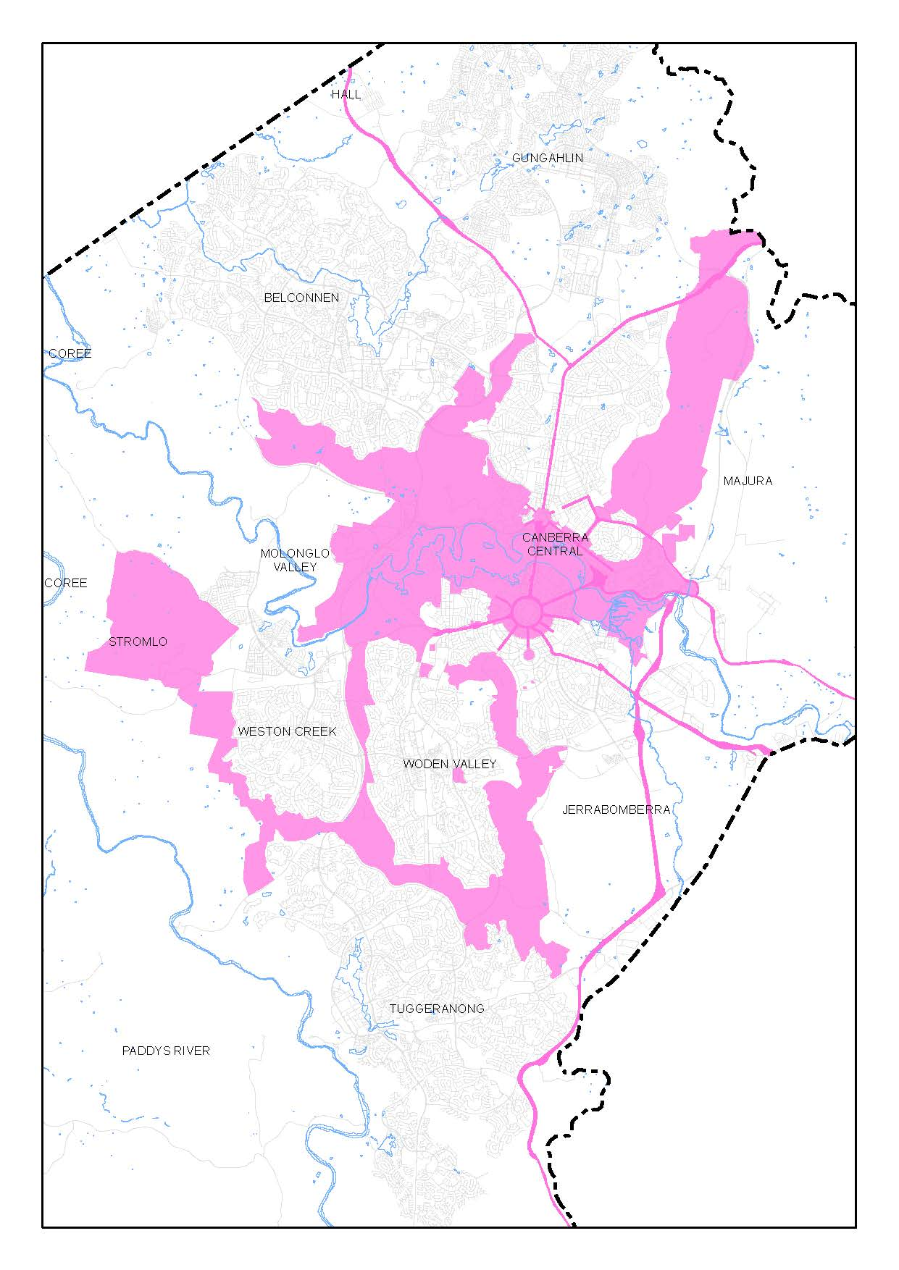
Figure 1: Designated Areas

PART TWO – STATEMENT OF PLANNING PRINCIPLES

Explanatory Statement
The Statement of Planning Principles (the Principles) sets out the principles for giving effect to the object of the National Capital Plan (the Plan) as required by the Australian Capital Territory (Planning and Land Management) Act 1988 (the Act). The object of the Plan is ‘to ensure that Canberra and the Territory are planned and developed in accordance with their national significance’.
The content of Part Two is organised under the themes of:
- General matters
- Productivity
- Sustainability
- Liveability
- Accessibility.
Primary objectives are identified for each theme, followed by principles which further detail consideration of these matters to ensure that Canberra and the Territory are planned and developed in accordance with their national significance.
The ordering of the Principles is not intended to convey any notion of relative priority, and each needs to be given due consideration where relevant to a proposal. The Principles provide a framework for the policy content of the Plan and have been considered against matters of national significance. These Principles must be considered in the planning and development of Canberra and the Territory and in policies guiding these matters. The objectives and principles stated in this section are binding on both the Australian and ACT Governments.

2.1 General matters

Objective
Retain the distinct urban form for which Canberra is well known, of a city within bush surrounds.

Principles
- The hills, ridges and other major open space which form the separation between towns will be kept largely free of urban development. The planning and development of urban areas will encourage measures through which urban intensification may occur and will be sympathetic to the landscape setting of the National Capital.

2.2 Productivity

Objective one – Infrastructure and employment
Ensure that infrastructure supports the development of Canberra’s National Capital functions.

Principles for Objective one – Infrastructure and employment
- Infrastructure must support the effective functioning of Canberra with proper consideration of the environmental and visual impact and be integrated with land use decisions.
- Infrastructure must be planned and provided in an integrated and timely manner to facilitate the development of Canberra and the Territory and ensure safety and security of supply and operation.
- Energy and water supply and security issues will be given due consideration in the planning and development of any new infrastructure.
- The infrastructure of Canberra and the Territory must be planned and provided to:
- ensure that public utilities infrastructure is available and maintained for Commonwealth and ACT Government needs and activities.
- minimise the visual impact of electricity and telecommunication facilities, particularly along major vistas, corridors and major open space.
- give due consideration to energy and water, supply and security issues.
- ensure safety and security of supply and operation.

Objective two – Infrastructure and employment
Ensure that the location of employment supports the local economy and Canberra’s National Capital role.

Principles for Objective two – Infrastructure and employment
- The location of employment in Canberra and the Territory should enhance rather than detract from the city’s role as the National Capital.
- Major employment generating land uses will be located within Defined Activity Centres. Major employment location proposals must be determined with regard to their transportation and environmental impacts.

2.3 Sustainability

Objective one – Environmental sustainability and open space
Ensure the development of a city that both respects environmental values and reflects national concerns with the sustainability of Australia’s urban areas.

Principles for Objective one – Environmental sustainability and open space
- Urban expansion should be contained so as to minimise impacts on valuable natural and rural areas.
- A substantial portion of new development must be located within existing urban areas such as town centres and along public transport routes or other strategic sites that allow for efficient use of infrastructure.
- The natural environment of Canberra and the Territory will be protected and improved by reducing resource consumption and waste, improving water security and quality, energy and food security and improving and protecting soil quality.
- Ecological communities, threatened flora and fauna species, water catchments and water quality will be protected and supported by sustainable resource management.
- Development will respect environmental values including water catchments and water quality and ensure resilience to the impacts of climate change.

Objective two – Environmental sustainability and open space
Protect the nationally significant open-space network, visual backdrop and landscape setting of the National Capital.

Principles for Objective two – Environmental sustainability and open space
- The hills, ridges and other major open space will be kept largely free of urban development and will act as a natural backdrop to the National Capital.

2.4 Liveability

Objective one – Urban design and heritage
Enhance and preserve Canberra’s symbolic and unique design and role as the National Capital.

Principles for Objective one – Urban design and heritage
- The National Capital role requires that planning and development, in Canberra Central in particular, and generally throughout the Territory, should reflect contemporary thinking in urban design practice.
- Planning controls should seek to ensure that development in all forms, including landscaping in urban and non-urban areas, complements and enriches its surroundings.
- Substantial works of architecture, engineering and landscape within the Territory should be designed to contribute positively to the overall composition, symbolism and dignity of the National Capital.
- Development in the National Capital should seek to achieve harmony between architecture and landscape to give continuing effect to the City Beautiful and Garden City characters of the city.
- Within Canberra Central, roads, bridges, waterways and public landscaping projects should reinforce and complement the geometric lines of the Main Avenues.
- Vistas to major landscape features must be protected from and enhanced by development.
- Buildings in Canberra Central should be of a height generally not greater than the height of the mature tree canopy (typically 3-4 storeys), except where otherwise permitted by the Plan. In Canberra Central no building or structure which protrudes substantially above the tree canopy must exceed a height of RL617.
- Opportunities should be encouraged for the enhancement and reinforcement of the physical, symbolic and visual linkages to adjoining areas of the Inner Hills and the Central National Area.
- Urban development will be planned in a manner which promotes community vitality and safety, applies the principles of crime prevention through environmental design and recognises the needs of people with disabilities.
- New development, including public spaces, should:
- exemplify sustainability principles
- demonstrate excellence in urban design, landscape and architecture
- facilitate pedestrian connectivity and bicycle movements where appropriate
- encourage energy efficient development and land use.

Objective two – Urban design and heritage
Enhance the character of Canberra and the Territory as the National Capital by identifying, protecting, conserving and presenting natural, Indigenous and historic heritage places.

Principles for Objective two – Urban design and heritage
- The National Capital Authority will consider heritage places in Designated Areas as Commonwealth Areas for the purposes of protecting the environment in the manner currently afforded under the Environmental Protection and Biodiversity Conservation Act 1999 (EPBC Act) and any subsequent legislation.
- Within Designated Areas, the National Capital Authority may require Heritage (or Conservation) Management Plans to accompany development applications for heritage places which should be prepared to meet requirements equivalent to those in the EPBC Act. The National Capital Authority may require Heritage Impact Statements to accompany development applications for a heritage place.
- Development should be consistent with the requirements of any relevant Heritage (or Conservation) Management Plan for that particular place.
- The management of heritage places should ensure that their use and presentation is consistent with their heritage values. Heritage places will be presented and interpreted to increase public awareness, understanding and enjoyment of the natural and cultural heritage of the National Capital and its conservation, subject to any reasonable requirements for privacy or confidentiality.
- The National Capital Authority will adopt the Australian Natural Heritage Charter and the Burra Charter as key guiding documents respectively for natural and cultural heritage places within Designated Areas.

2.5 Accessibility

Objective – Transport and movement
Support a connected and equitable multi-modal transport system.

Principles for transport and movement
- Accessible movement systems for a diversity of pedestrian, cycle, public transport and private transport modes will be provided, with good connections between different modes of transport.
- An accessible movement system will be achieved by:
- maintaining the national and arterial road systems
- supporting efficient and sustainable pedestrian, bicycle and public transport systems that reduce car dependency
- maintaining movement around the city for a diversity of pedestrian, cycle, public transport and private transport modes
- providing streets that foster a connected and pedestrian-friendly environment
- reducing the barriers created by major roads to make it easier for people to access the public spaces of the city, particularly in the Central National Area.

PART THREE – LAND USE PLANS AND GENERAL LAND USE CONTROLS

Explanatory Statement
Section 10(2)(b)(i) of the Australian Capital Territory (Planning and Land Management) Act 1988 (the Act) requires the National Capital Plan (the Plan) to set out general policies to be implemented throughout the Territory, being policies of:
- land use (including the range and nature of permitted land use)
- the planning of national and arterial road systems.
This part of the Plan sets out general provisions for land use across the whole of the ACT. This includes identifying broad land use categories, as well as specifying permitted land uses and other general development requirements.
The first components of Part Three are the General Policy Plans, which set the broad framework for land use in the Territory, including the general location of town centres and industrial areas. In addition to setting out broad land use arrangements, the General Policy Plans show areas that may be suitable for future urban development, and also indicate the national and arterial road system.
The first section of Part Three describes the main elements that make up the General Policy Plans. General policies, including the range of permitted land use within each land use category, follow this introductory section.

3.1 General Policy Plans

3.1.1 Broad land use categories
Figure 2 ‘General Policy Plan – Metropolitan Canberra’ and Figure 3 ‘General Policy Plan – Australian Capital Territory’ set the broad framework for land use in the Territory. These general policy plans show which areas are planned for urban development and which areas are not to be developed for urban use. Written policies supporting the general policy plans establish provisions relating to aesthetics and the environment, to protect and enhance the character of Canberra and the Territory.
A wide range of land uses are permitted for each land use category. The use of land for a purpose not included in the specified range may be permitted where the Authority has been consulted and, after satisfying itself that a particular proposal is not inconsistent with relevant principles and policies of the Plan, has given its agreement in writing.
The policies identifying permitted land uses do not confer any rights to use land for any purpose. The range of uses are set out in the Territory Plan or the Precinct Codes for Designated Areas. The statutory requirements for the Territory Plan to not be inconsistent with the Plan permits consideration of any or all, or any sub-category of, the identified uses for inclusion in the Territory Plan.

3.1.2 Potential Future Urban areas
Figure 2 ‘General Policy Plan – Metropolitan Canberra’ shows potential future urban areas at Jerrabomberra–Symonston, in the Majura Valley, and in the West Murrumbidgee area. Final resolution of land uses in these areas will be made following the completion of detailed studies.
In the case of Jerrabomberra–Symonston, decisions on the nature, scale and timing of urban development in this area need to be taken in the context of a wider land use policy review. The review will need to consider the need for a buffer zone around major Commonwealth facilities in the area.
This review would also encompass long-term land use and transport relationships and address, from the view point of both the Plan and the Territory Plan, the key issues of traffic flows and transportation infrastructure in the city's inner areas, especially in the Parliamentary Zone and its setting.
The Commonwealth agrees that expansion of urban areas into areas identified as being a potential future urban area may occur without further amendment to the Plan. Prior to expansion of the urban area in these locations, the proponent is required to obtain certification from the National Capital Authority that the proposed changes are not inconsistent with the principles and policies of the Plan.
The National Capital Authority will assess proposals to expand urban areas against:
- the stated objectives of the Plan
- matters of national significance
- the Statement of Planning Principles
- any other principle or policy of the Plan deemed relevant by the National Capital Authority.
The proponent must obtain certification from the National Capital Authority for such land use proposals prior to commencing the Territory Plan variation process.
The National Capital Authority will make public its decision on such proposals and a statement of reasons supporting the decision.

3.1.3 National and arterial roads
Figure 2 ‘General Policy Plan – Metropolitan Canberra’ sets out the general location of national and arterial roads within the Territory.
For the purposes of the Plan, national roads are deemed to include the major approach routes to the city which link Canberra with other capital cities and with the national highway network. These are the Barton, Federal and Monaro Highways from the Territory border to their eventual junction at State Circle in the vicinity of Parliament House. All roads within the National Triangle are also classed as National Roads.
The arterial road network comprises two elements:
- arterial roads within urban areas, which are major traffic collectors and distributors
- the network of peripheral parkways which carry traffic between towns along routes lying largely at the periphery of the built-up areas.

Policies for national and arterial roads
- The National and Arterial Roads System will:
- generally not provide frontage access to development, except where such access will meet appropriate design standards and road safety needs
- generally intersect with the local road network through distributor roads.
- The final alignment of proposed arterial roads is subject to consultation with the National Capital Authority.

3.1.4 Inter-town Public Transport System
Figure 2 ‘General Policy Plan – Metropolitan Canberra’ sets out the general location of Inter-town public transport corridor within the Territory.

Policies for Inter-town Public Transport System
- Public transport planning and provision will:
- Reserve a route for the development of a public transport service to link major employment nodes. As far as practicable the service will be segregated from other transport systems and will operate with priority of right-of-way.
- A corridor between the city centre, the town centres and major employment nodes, suitable for priority or segregated right-of-way for use by public transport services will be reserved against a possible future need to develop a system of inter town and express routes suitable for buses or other public transit modes as appropriate.

3.1.5 General policies for all land use categories
- Aircraft noise under airfield approaches is an unavoidable by-product of flying operations associated with airports. The Australian Noise Exposure Forecast (ANEF) system, expressed by noise contours centred on the airport, is a scientific measure of forecast noise exposure levels based on current and future projections of operational activities in the vicinity of the runway approaches. The system can assist in planning and development decision making. Information about forecast noise exposure in relation to Canberra International Airport can be obtained from the Commonwealth agencies with responsibility for aircraft noise regulation.
- Protected airspace provisions in relation to Canberra International Airport apply to development independently of the Plan. To satisfy a requirement of the Airports (Protection of Airspace) Regulations 1996, Canberra International Airport Pty Ltd has prepared a diagram prescribing protected airspace. The diagram is incorporated in the Airport Master Plan prepared under the Airports Act 1996. Detailed information may be obtained from the Commonwealth agency with responsibility for protected airspace.
- Within five kilometres of Mount Stromlo, development or installations which may, through night time illumination or significant vibration, adversely affect the operation of the Mount Stromlo Observatory or the associated seismological vault at Mount Stromlo, must be referred to the Australian National University for examination and comment and reasonable steps must be taken to mitigate adverse impacts.
- The Commonwealth, a Commonwealth Authority, the Territory or a Territory authority must not do anything which adversely affects the historic landscape and heritage values of the Lanyon Bowl Area.
- Forestry (where permitted) must be managed in a manner which reinforces the landscape character and which allows for their use as multiple purpose areas. Native vegetation in plantations should be retained, particularly along plantation edges, public roads and rivers and creeks, to preserve wildlife corridors and habitats.

Subdivision within Designated Areas
- Any proposal to subdivide land within Designated Areas will require the approval of the National Capital Authority.

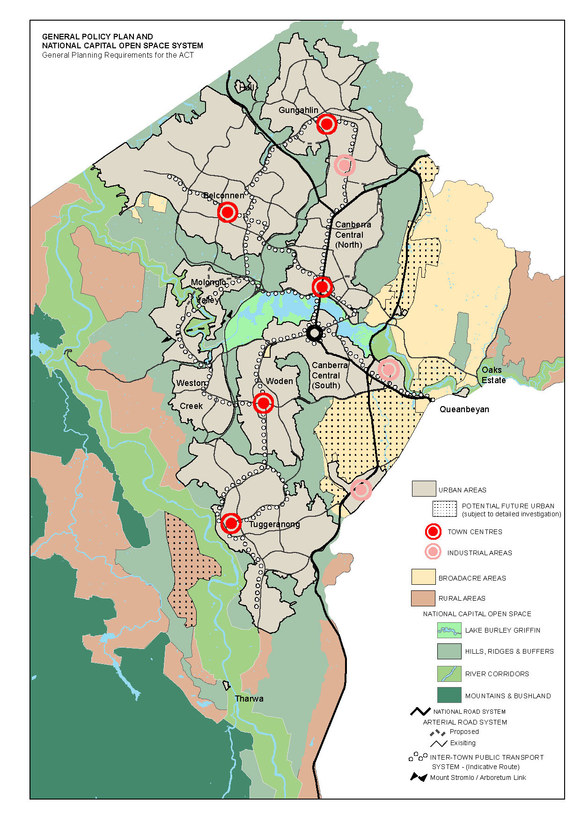
Figure 2: General Policy Plan – Metropolitan Canberra

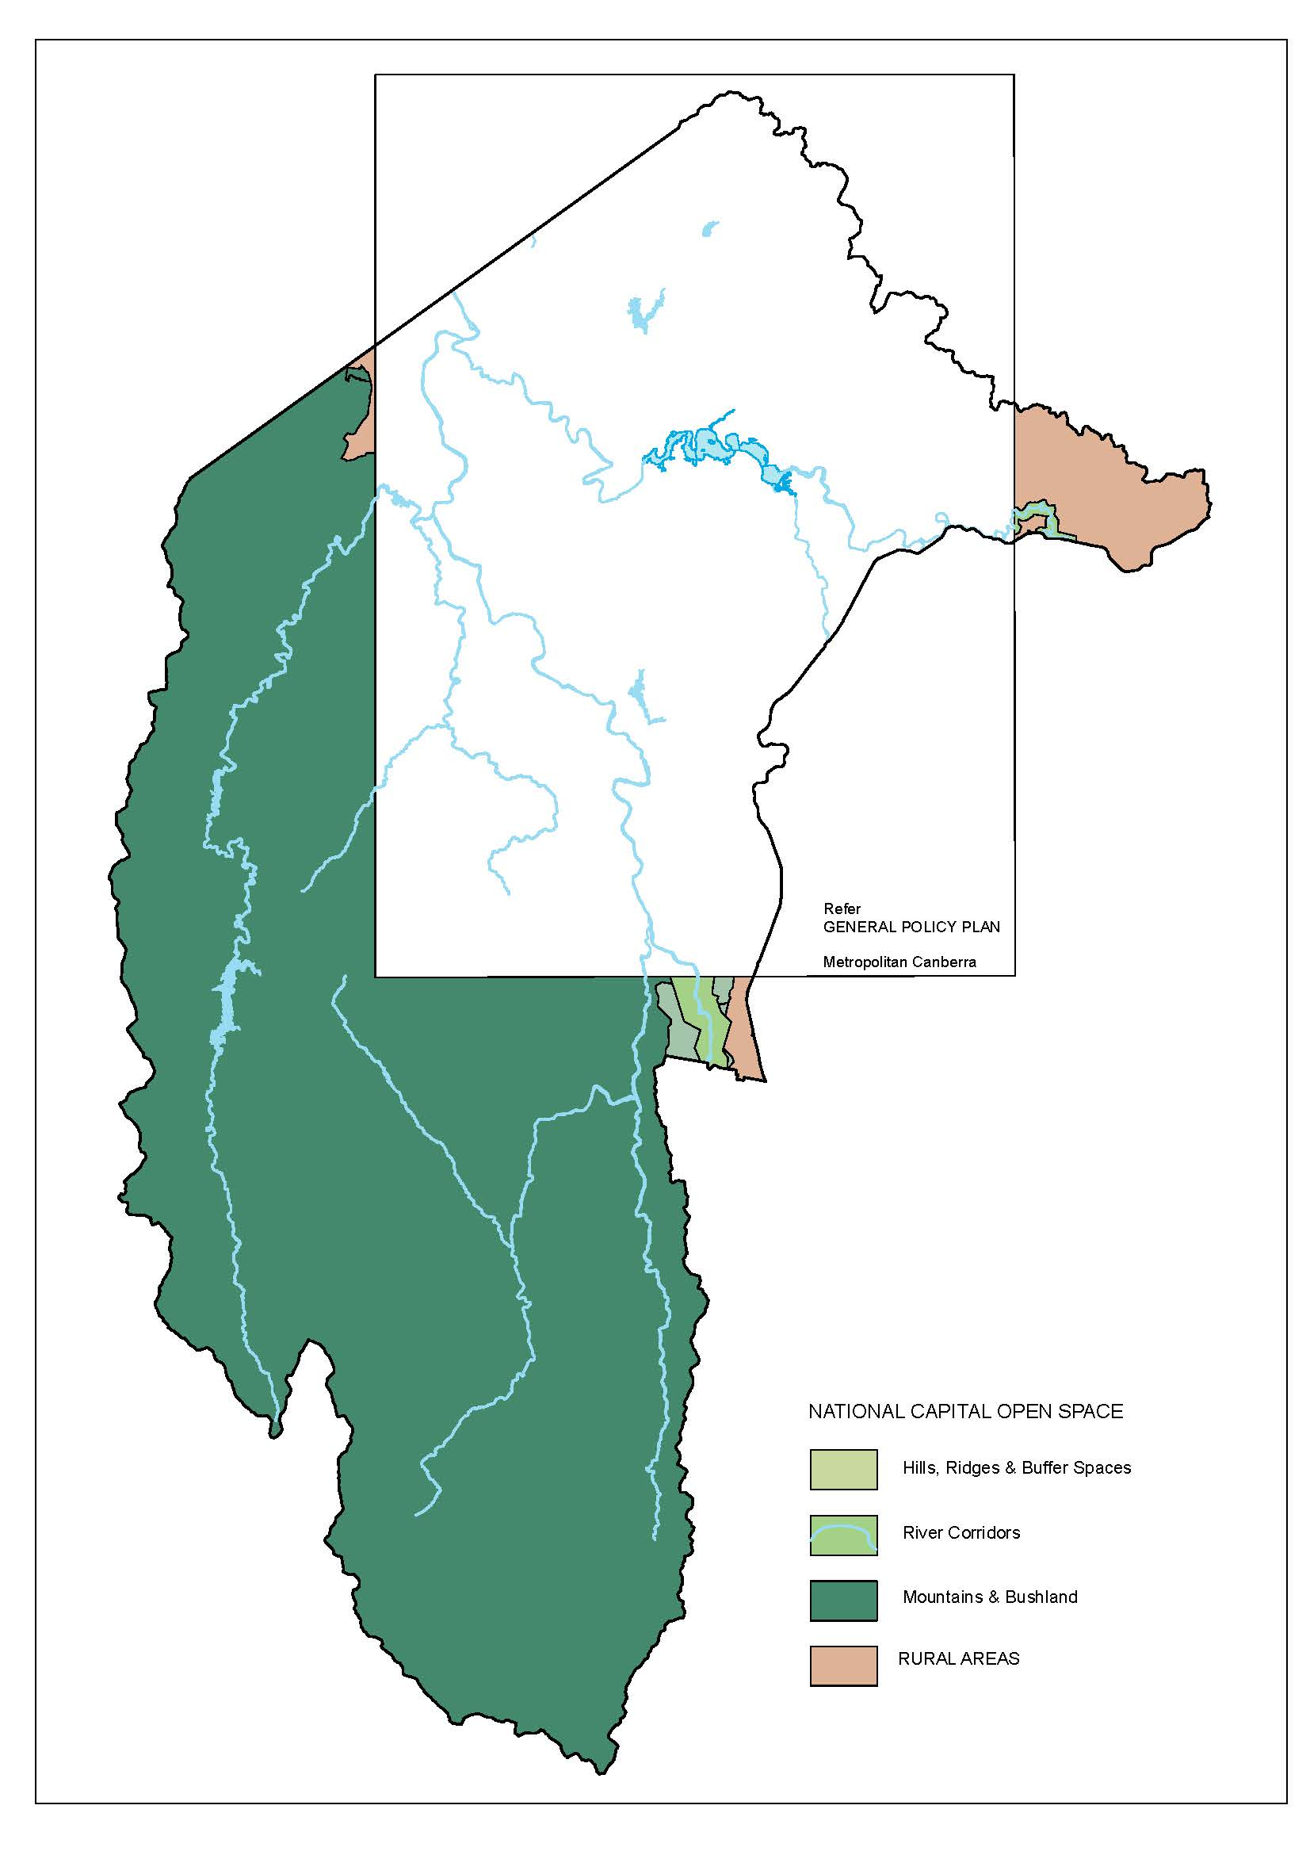
Figure 3: General Policy Plan – Australian Capital Territory

3.2 National Capital Open Space System

3.2.1 Background
The importance of the natural setting of the National Capital has been recognised by the creation and formal adoption of the concept of the National Capital Open Space System (NCOSS). This system essentially comprises the inner hills and ridges which surround and frame the urban areas, the major lakes and river corridors, and the distant mountains and bushland to the west of the Murrumbidgee River. Closely associated with the NCOSS are the Territory’s rural lands which also contribute significantly to the landscape setting.
There are four different functions performed by the NCOSS, each with its own planning and management requirements.
First, there are symbolic spaces that embody the national importance of the landscape in a diverse cultural environment and the intrinsic connection between the physical setting and continuing legacy of Canberra as a planned city.
Conservation spaces are those that protect, conserve and enhance the natural environment, the heritage and cultural values of the ACT, and which provide for ecological connectivity.
Living spaces are those that provide direct health and wellbeing benefits to the broad range of users in close proximity to urban areas and which afford appropriate movement to people, fauna and flora.
Finally there are linking spaces that physically join and visually unite the city to its immediate setting and to the region. The values contained in these spaces include the spatial and temporal continuity provided to the setting of the National Capital.
Together these open spaces constitute a system which protects the environmental quality of Canberra’s present and future water catchments, river systems, and important ecological and heritage areas from the increasing pressure of Canberra’s growth. While each part has its own land use and character they are all interrelated as parts of a total system. It is important therefore that the system is planned, developed and managed on an integrated basis.
Mount Stromlo Observatory is within NCOSS. It is a nationally and internationally prominent centre for astronomical research. The amount of night sky light pollution suffered at the observatory impacts on the effectiveness of its operation. Two factors have bearing on this:
- the area of urban development and its proximity to the observatory
- the nature of the development insofar as it affects the amount of light radiated into the night sky.
The gradual encroachment of urban development into areas previously undeveloped or used for non-urban purposes, has contributed to the deterioration of observing conditions. Because of the observatory’s national significance, a measure of protection is necessary.
The principles and policies that follow establish NCOSS as a multiple-use system which protects the environment while providing for the recreational and other needs of the National Capital.
Planning and management for NCOSS in the interests of both the National Capital and Territory residents will require co-operation between Commonwealth and Territory authorities. The National Capital’s requirements will be specified through its detailed land use policies in those parts of NCOSS which are Designated Areas, and through the general policies of the Plan for other NCOSS areas. The Territory will provide for its requirements through the Territory Plan. Management plans, usually prepared by Territory authorities, will be the key to successful implementation of these policies and plans.
Consistency of planning and management and the realisation of an open space system which symbolises the character of the National Capital and provides a unique landscape for the city must be achieved through consultation and by means of joint studies in those areas where both the National Capital Authority and Territory planning authority have a significant interest.
The NCOSS is incorporated in the Plan under four separate land use categories:
- Lake Burley Griffin and Foreshores
- Hills, Ridges and Buffer Spaces
- River Corridors
- Mountains and Bushland.
Principles and policies for each of these categories are preceded by the following principle and policies for the NCOSS as a whole. General policies for the Hills, Ridges and Buffer Spaces, River Corridors, and Mountains and Bushland categories follow.
Policies for Lake Burley Griffin and Foreshores are included within the Lake Burley Griffin and Foreshores Precinct Code (refer Part Four of the Plan) as this area forms part of the Designated Areas.

3.2.2 Principle for the National Capital Open Space System
The NCOSS is required to protect the nationally significant open-space framework, visual backdrop and landscape setting for the National Capital. NCOSS will blend city and country in a way that symbolises the character of the National Capital and provides a balanced range of uses which reinforces the natural, cultural, scenic and recreational values of the ACT.

3.2.3 Policies for the National Capital Open Space System
- The NCOSS will be planned as an integrated system so as to protect its environmental qualities, to promote a continuum of natural and park-like settings for the National Capital, and to frame and enhance existing and future urban areas.
- The natural and cultural resources of the NCOSS must be protected in order to provide educational, cultural and recreational opportunities.
- Public utilities and roads will be located in the NCOSS only where technical, environmental and visual assessments clearly demonstrate that the impacts on an area’s conservation and landscape values can be reduced to an acceptable level.
- Within Designated Areas of the Plan, all Operational Plans must be prepared in close consultation with the National Capital Authority. Operational Plans may identify future works to be undertaken in parts of the NCOSS within Designated Areas and may serve for the purpose of granting works approval. The National Capital Authority may grant works approval covering a period of 12 months for works identified in an Operational Plan as being low risk and low impact.

3.2.4 Hills, Ridges and Buffer Spaces

3.2.4.1 Background
The hill areas do not attract the same intensity of use as the lakes and rivers of the NCOSS but they play a greater role in satisfying the landscape function of NCOSS. It is therefore critical that the hill areas be preserved from urban development and their essential landscape/environmental character retained and reinforced to provide the unified background and landscape setting for the National Capital.
It is not intended that the hills and ridges serve only as public open space. They are intended for multiple-use appropriate to the location and character of each hill area. They will be used as vantage points from which people can view the city and to provide a quiet refuge from urban living. They will also serve as wildlife and access corridors linking urban areas with other parts of the Territory’s open space system. Their continued use for recreation, tourism and appropriate urban services must be in a manner consistent with maintenance of their environmental qualities.

The Inner Hills
The areas identified in Figure 4, Figure 5, Figure 6 and Figure 7 are specified as a Designated Area and will be known as the Inner Hills. The Inner Hills includes Black Mountain, Mount Ainslie, Mount Majura, Mount Pleasant, Russell Hill, Red Hill, Mount Mugga, O’Connor Ridge, Bruce Ridge, Mount Painter, The Pinnacle, Lyneham Ridge, Oakey Hill, Mount Taylor, Isaacs Ridge, Mount Stromlo, Mount Arawang, Neighbour Hill, Wanniassa Hill, and Narrabundah Hill.
The Inner Hills provide the scenic backdrop and natural setting for Canberra’s urban areas, and within Canberra Central they are integral to the Griffins’ composition. Accordingly their planning, design and development as open space areas are central to the maintenance and enhancement of the character of the National Capital. Including these areas within Designated Areas is the most appropriate way of securing this.
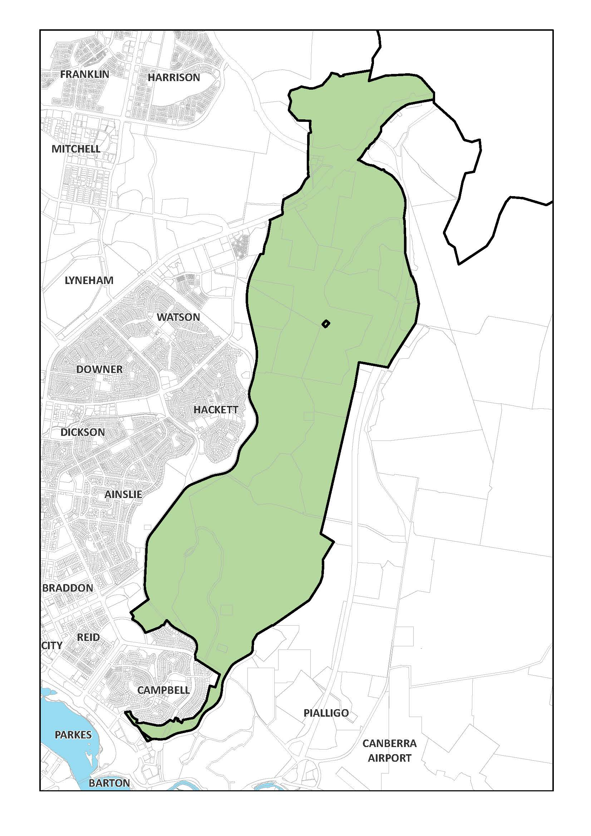
Figure 4: Inner Hills – North Canberra (east)
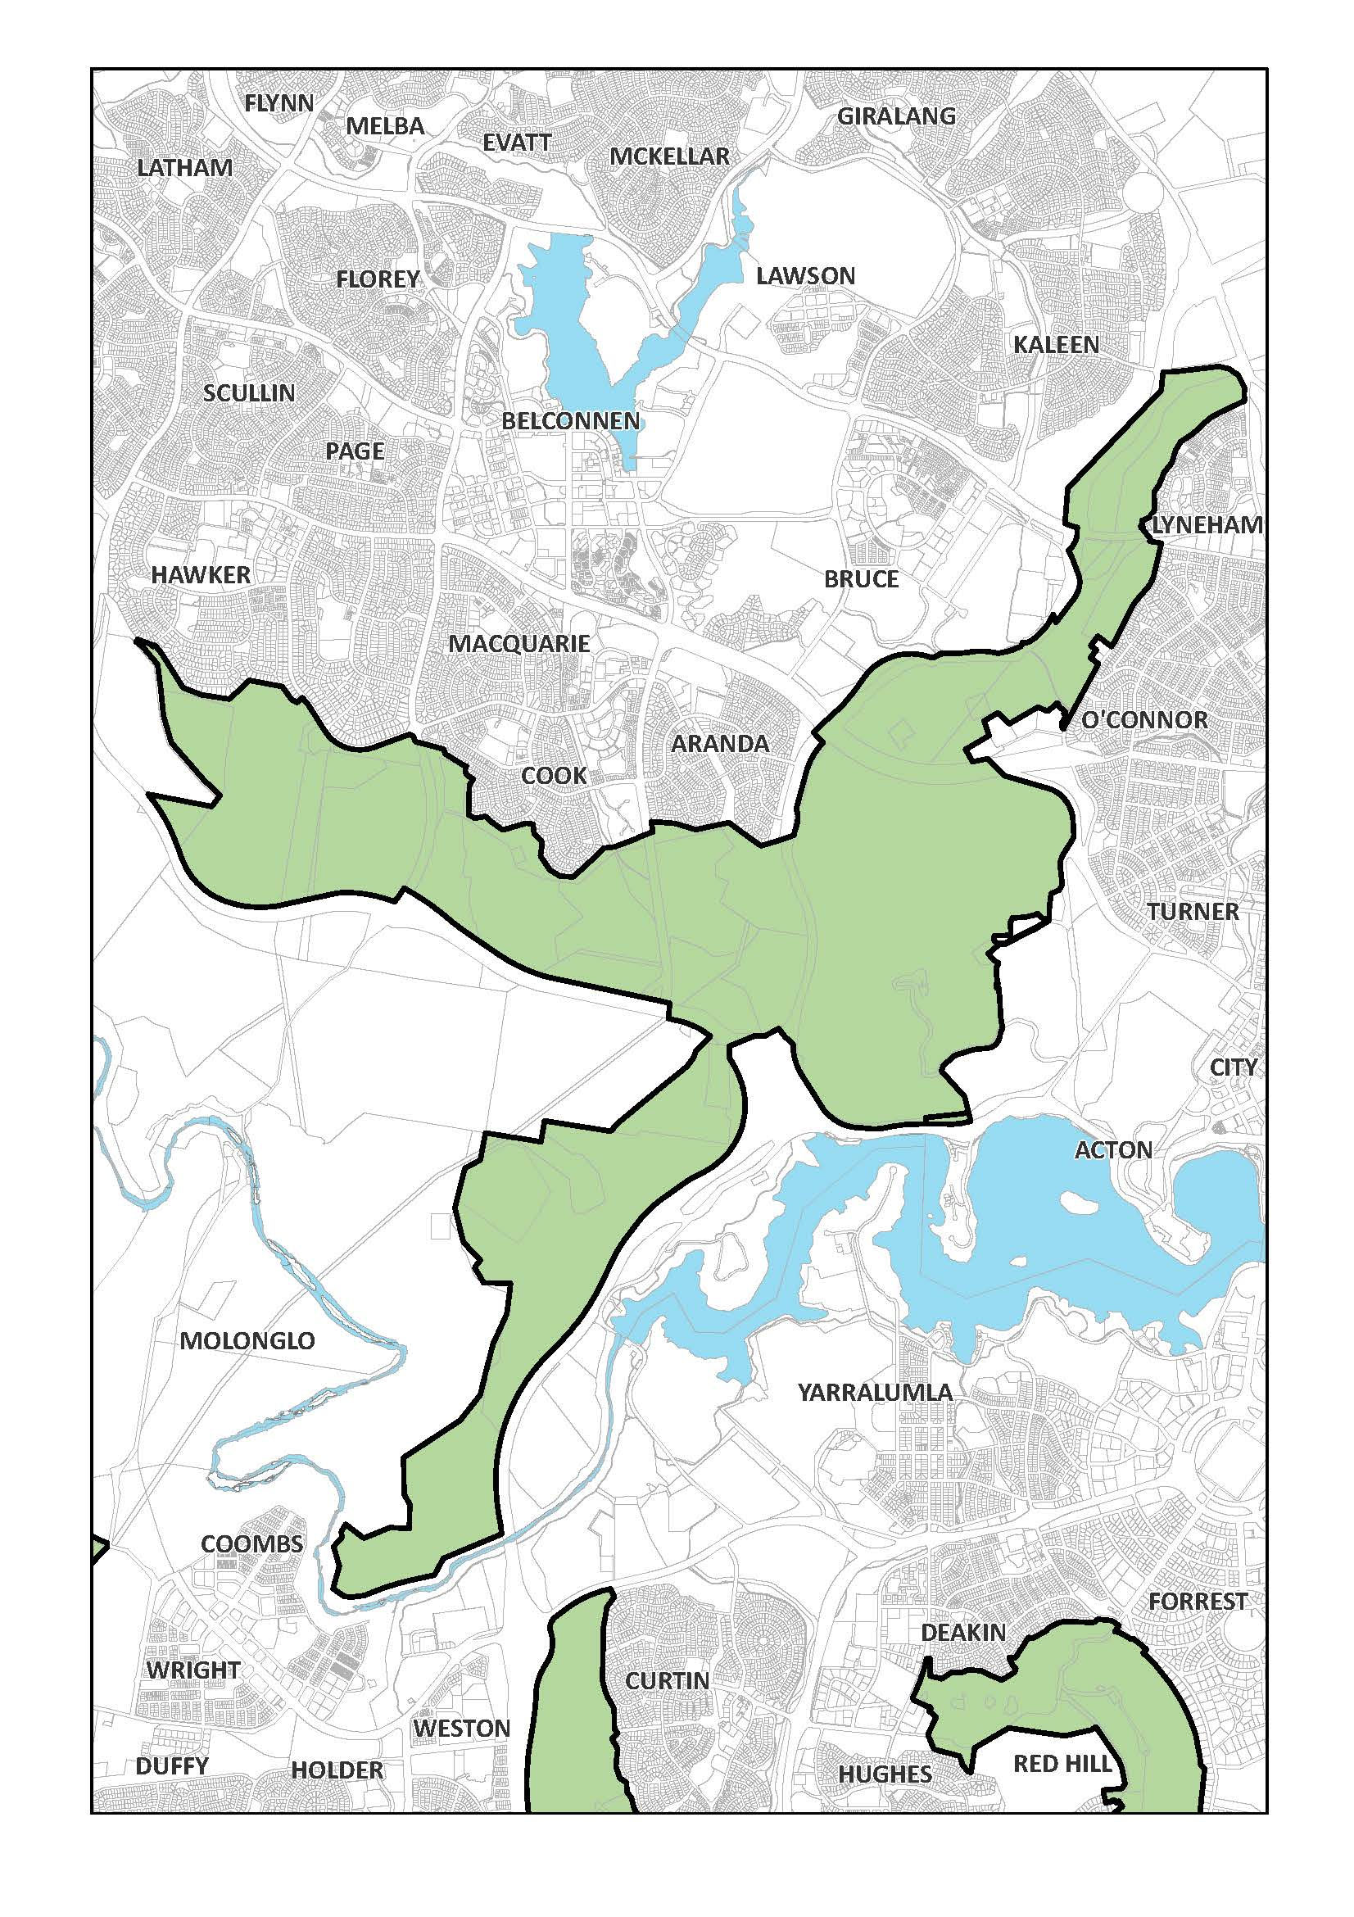
Figure 5: Inner Hills – North Canberra (west)
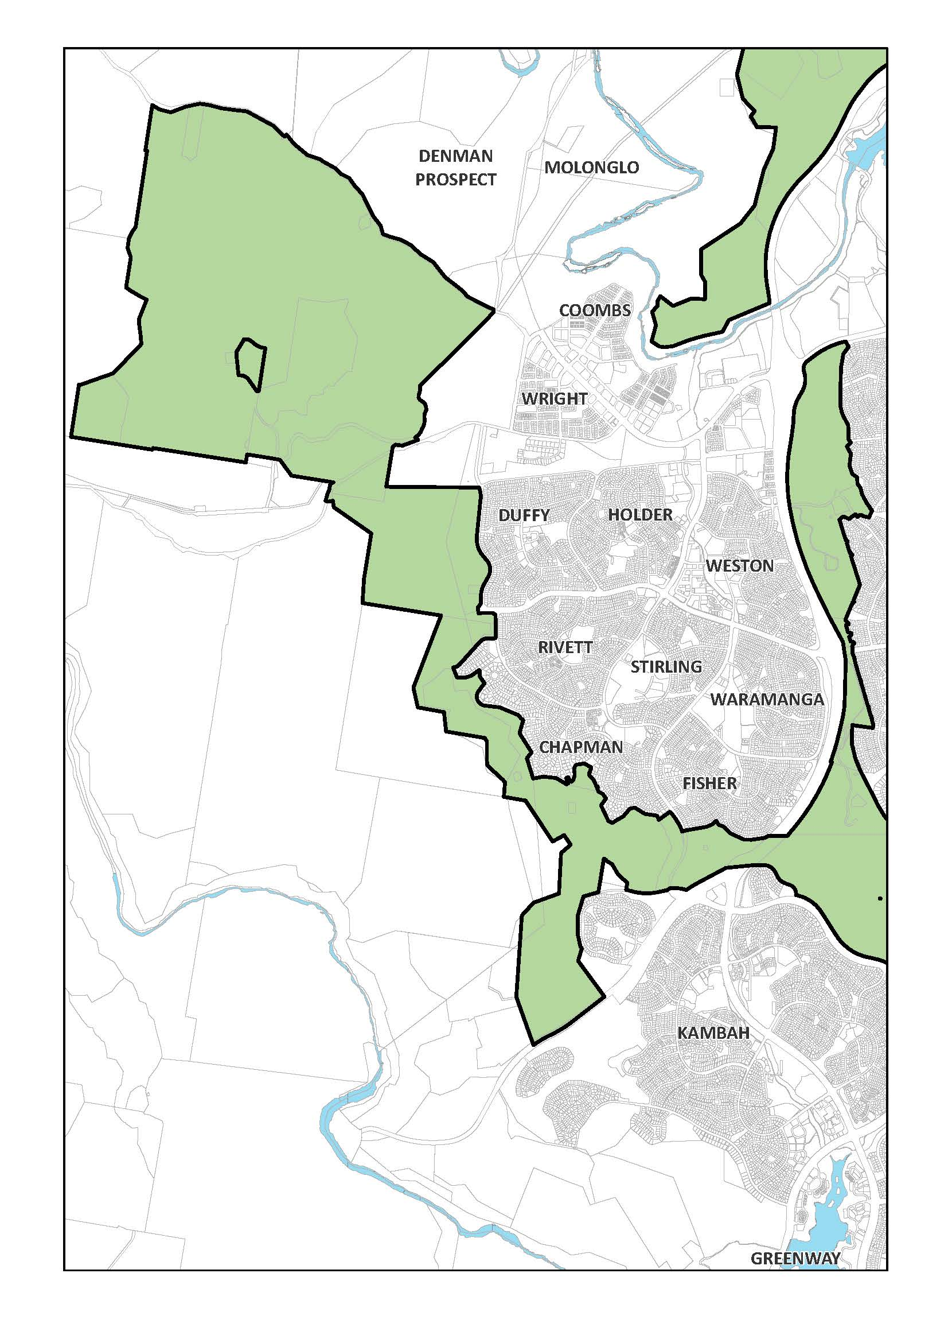
Figure 6: Inner Hills – South Canberra (west)
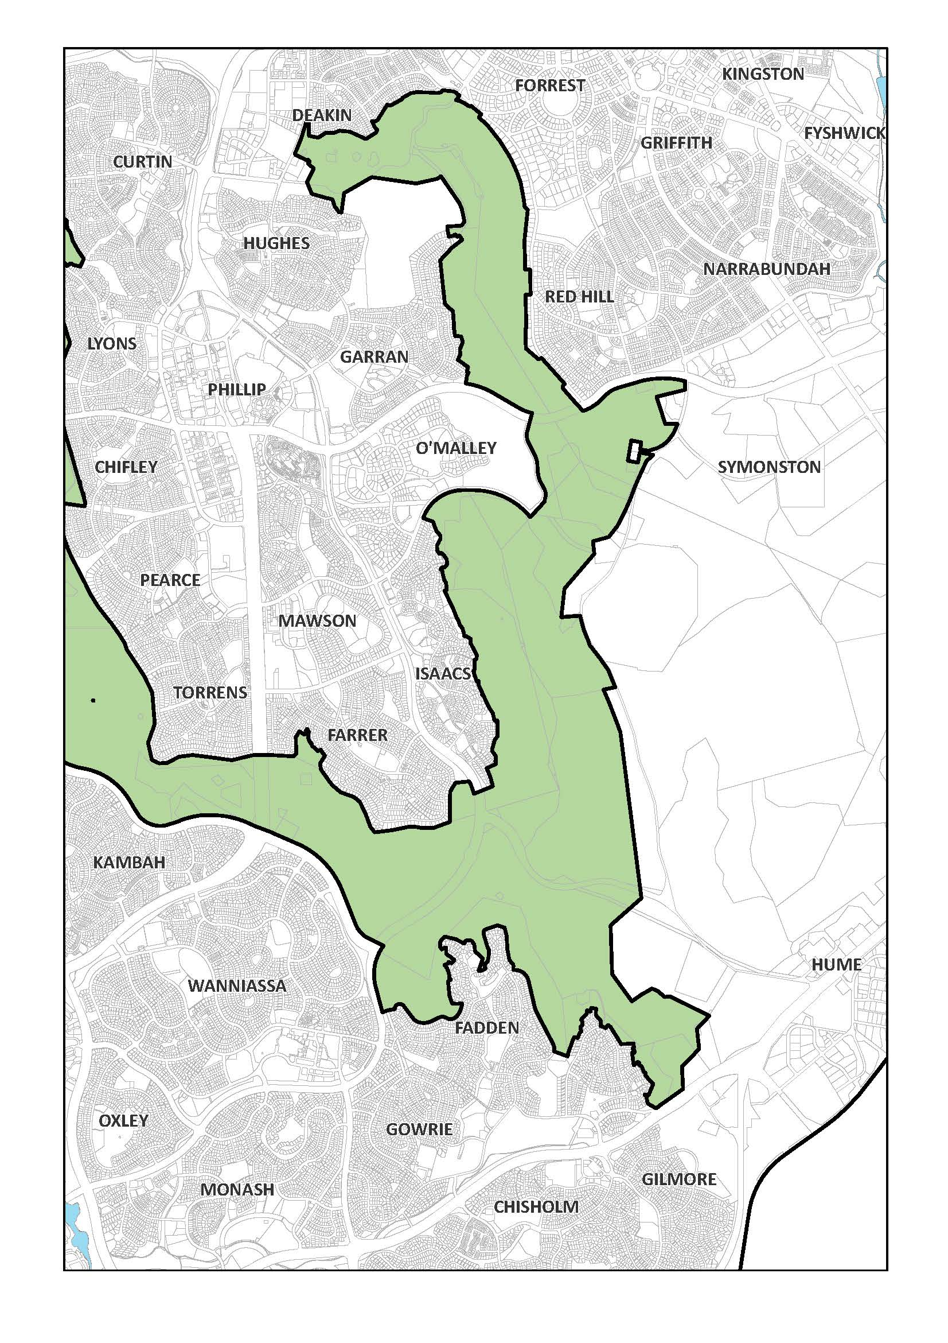
Figure 7: Inner Hills – South Canberra (east)

3.2.4.2 Principle for Hills, Ridges and Buffer Spaces
Hills, ridges and buffer spaces are to remain substantially undeveloped in order to protect the symbolic role and Australian landscape character of the hills and ridges as the scenic backdrop to the Parliamentary Zone, the City Centre and other National Capital precincts, to maintain the visual definition and physical containment of the surrounding towns and to ensure that their landscape, environmental and recreation values become an integral part of the National Capital.

3.2.4.3 Policies for Hills, Ridges and Buffer Spaces
- The Inner Hills will be protected as key symbolic and landscape elements in the Plan expressing the defined land, water and municipal axes and providing the dominant backdrop feature to the city.
- The hills and ridges must be planned and managed as a multiple-use recreation and environmental system with different parts having their own special character and use.
- The hill tops will continue to be used as key vantage points for viewing and understanding the National Capital. Development will be sited so as to minimise its visual impact on the Central National Area and any environmental impact on the hill tops.
- The environment and Australian landscape character of the hills and ridges will be protected and enhanced to provide a unified landscape setting for the National Capital.
- The rural landscape in the areas adjacent to the ACT border between Hall and the Murrumbidgee River will be retained as an intrinsic part of the National Capital character and with additional landscape treatment provide physical containment to this part of Belconnen. A similar landscape buffer will be provided between Belconnen and Gungahlin.
- Black Mountain, Mt Taylor, Tuggeranong Hill and Isaacs Ridge will continue to provide locations for current telecommunications facilities.

3.2.4.4 Permitted land uses within Hills, Ridges and Buffer Spaces
- The range of uses permitted in the Hills, Ridges and Buffer Spaces part of the NCOSS is as follows:
- Aquatic Recreation Facility (Stromlo Forest Park only)
- Agriculture
- Commercial Accommodation, not including a motel, guest house, caravan park/camping ground, serviced apartment, serviced house (Forest 69 and 76, National Arboretum - only)
- Extractive Industry (Mugga Quarry only)
- Forestry (Green Hills, Tuggeranong, Ingledene, Stromlo and Fairbairn pine plantation and woodlots only)
- General Farming
- Indoor Recreation Facility (Stromlo Forest Park only)
- Landscape Buffer
- Nature Conservation Area
- Open Space
- Outdoor Education Establishment
- Outdoor Recreation Facility (not including stadiums, showgrounds, racecourses, motor racing and like activities)
- Park
- Personal Services Establishment (Forest 76, National Arboretum only)
- Pathway Corridor
- Public Utility
- Road
- Scientific Research Establishment
- Tourist Centre (Gold Creek and Gilmore only)
- Overnight Camping (Stromlo Forest Park and Elm Grove campsite only)
- Tourist Facility (Stromlo Forest Park only)
and may include Dwelling, if necessary, for the operation of any of these uses.
The nature of uses permitted in the Hills, Ridges and Buffer Spaces part of the NCOSS is defined in Appendix A.

3.2.4.5 Detailed conditions of planning, design and development – Commercial Accommodation at the National Arboretum Canberra

General principles and policies
- Built form must sit within the landscape setting of the Inner Hills, with the landscape to remain the dominant feature.
- Buildings and landscape must exhibit design excellence in recognition of the site’s visual prominence from the Central National Area, Governor-General’s residence, and its location within the Inner Hills.
- Buildings must explicitly adopt a similar materials palette to existing buildings at the arboretum so as to create an identifiable family of arboretum buildings.
- Landscaping must be complementary to the existing and intended design themes of the arboretum.

Location
Commercial Accommodation is restricted to Forests 69 and 76 of the National Arboretum Canberra, as identified in Figure 8. Personal Service Establishment is restricted to Forest 76 of the National Arboretum Canberra.
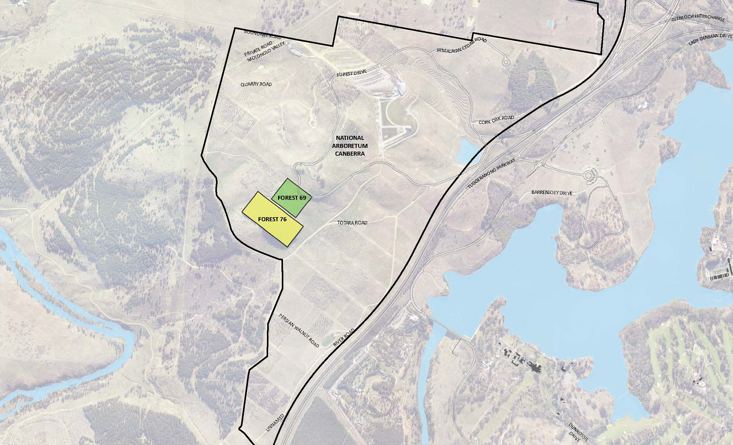
Figure 8: Permitted location of commercial accommodation at the National Arboretum Canberra (Forests 69 and 76)

Built form
Buildings on the eastern slope of Forest 69 must be no more than a single storey or seven metres above datum ground level in height. Buildings on the western slope of Forest 69 must be no more than two storeys in height and must not exceed the maximum RL of the top of any building located on the eastern slope. Buildings on the southern slope of the site, within Forest 76, must be no more than seven metres above datum ground level in height and two storeys. The maximum height of seven metres is to be measured at the intersection of the highest point of built form with the natural ground level.
Buildings must be designed and sited to be visually recessive and sit within the landscape when viewed from the Central National Area. Built form should consist of a series of buildings within a generous landscape and forest setting. The materials palette for new buildings must explicitly adopt similar materials to those used for existing buildings at the arboretum.
A visual analysis must be undertaken to demonstrate the impact of development from the Central National Area and key vantage points such as Lake Burley Griffin, the Governor-General’s residence, and Parliament House.
Service areas and facilities such as loading zones, water tanks, waste enclosures must be incorporated into the building form.
Requirements for built form, and design and siting of development are shown in Figure 9.
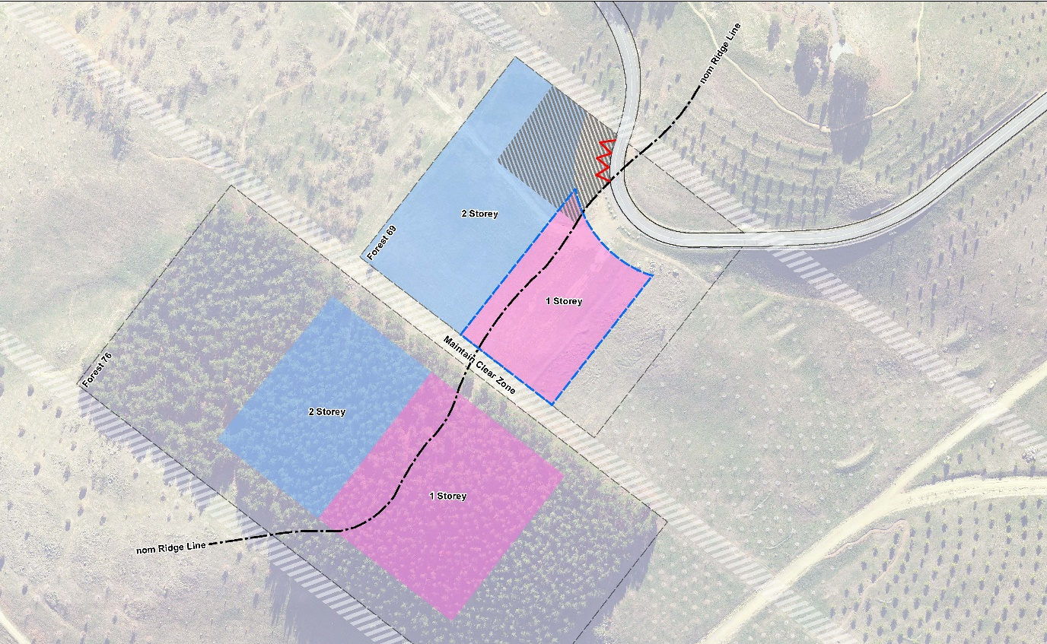Figure 9: Site layout and built form requirements for commercial accommodation at the National Arboretum Canberra (Forests 69 and 76)

Design and siting
Development must demonstrate excellence in architecture, landscape architecture and urban design, including through the use of high quality and durable materials.
The total footprint of all buildings must not occupy more than ten per cent of the total site area of Forests 69 and 76.
A maximum of 40 guest rooms is permitted. Guest rooms are not permitted in the single storey precinct of Forrest 69.
Additional amenities such as a restaurant and supporting back of house facilities are permitted within the hotel where it can be demonstrated that they are necessary for the successful operation of the hotel.
Development should achieve best practice in environmentally sustainable design through the use of innovative technology, design and ongoing building operation. Development should be designed to:
- reduce energy consumption, reduce total operating greenhouse gas emissions, and reduce peak demand through particular design measures such as appropriate building orientation, space allocation for solar panels, and shading to glazed surfaces
- improve water efficiency, reduce total operating potable water use, collect and reuse stormwater, use alternative water sources (such as greywater)
- provide a healthy indoor environment including the provisions of fresh air, cross ventilation and natural daylight, reduce reliance on mechanical heating, ventilation, lighting and cooling
- minimise noise levels and noise transfer within and between buildings and associated external areas
- incorporate the use of water sensitive urban design, including stormwater collection and reuse.
Building and landscape design should incorporate biophilic design patterns that enhance connectivity with nature, and contribute to the health and well-being of visitors. Examples of how this may be achieved include:
- using the site’s location within the arboretum to create opportunities for direct visual connections to nature, living systems and natural processes
- designing buildings that allow natural fluctuations in temperature, airflow, and humidity to mimic natural environments
- providing opportunities to experience the place through the seeing, hearing or touching of water
- the use of biomorphic forms and patterns in building materials and landscape design, including contoured, patterned, textured or numerical arrangements that persist in nature
- landscape design that entices people to travel deeper into the environment
- the use of materials or landscape elements from nature that, through minimal processing, reflect the local ecology or geology and create a distinct sense of place.
Building and landscape design must consider the privacy and security of guests. Fencing is not permitted. Landscape should be used to delineate between the public and private realms.
Buildings should be sited to take advantage of views and vistas to the Brindabella Ranges to the west and north-west, and to the Central National Area in the east.
Development must demonstrate consideration of climatic conditions, including wind and heat. Proposals must also demonstrate consideration of resilience to extreme weather events, such as bushfire, and the measures proposed to manage the impacts from such events.
Development proposals must incorporate measures to address noise generated from external sources, including from the Tuggeranong Parkway. Measures may include the use of building materials to reduce noise levels in building interiors, the use of landscape, and the siting and orientation of the residential components away from noise sources.

Landscape
Soft landscaping around buildings should incorporate a range of planting types of varying scales, including trees, shrubs and ground-covers to create a rich, diverse garden setting.
Buildings and landscape design must reflect the original design intent of the arboretum masterplan. Tree plantings should act as an extension of the planted forests of the arboretum. Within Forest 69, tree plantings must predominantly be Chinese Golden Larch. New tree plantings within Forest 76 must predominantly be Radiata Pine.
As far as practicable, Radiata Pine plantings in Forest 76 should be retained to protect the site from southerly winds. New tree plantings and landscape design should afford protection from other predominant winds.
Landscape design should ensure that when trees are mature, development of the site does not significantly detract from the view from Dairy Farmer’s Hill.
Planting on buildings and structures is encouraged as a way of enhancing the integration between built form and landscape, and to provide amenity, improve air quality and microclimate, and reduce direct energy use and stormwater runoff. Where planting on buildings and structures is proposed, landscape materials should respond to local context and complement arboretum species.

Access, parking, and movement
Primary vehicle access to the site is to be from Forest Drive. Secondary access, including for emergency vehicles, must be provided and agreed by the relevant authorities.
Car parking must be screened from view to the maximum extent possible from Forest Drive, Dairy Farmers Hill, and the Central National Area. Parking provision shall be in accordance with the following:
- 1 space per guest room, plus
- 10 spaces per 100m² GFA of bars, restaurant, function rooms and supporting back of house facilities, plus
- 3 spaces per 5 employees
Basement car parking is encouraged to increase the site area that can be landscaped, and to reduce light spill. Where surface car parking is proposed, parking must be incorporated into the landscape design of the site, by extending planting and materials into car parking spaces. Parking must be located on the western side of the ridge. Shade trees should be planted between every 4 car parking spaces to reduce increased surface temperatures from large areas of paving.
Access arrangements must demonstrate consideration of increased traffic on Forest Road as visitation to the National Arboretum Canberra increases, and the role of Forest Drive as a designated cycling route. The design of access arrangements should be designed to ensure pedestrian and cycle priority, and that conflict between vehicles, and cyclists and pedestrians, is minimised.
Path networks across the site must:
- Accommodate the needs of people with a wide range of abilities, including:
  - ensuring that access arrangements and public spaces are appealing for all users, and avoids segregating or stigmatizing any users
  - providing equitable privacy, security and safety for all users
  - minimizing hazards and the adverse consequences of accidental or unintended actions.
  - demonstrate consideration of existing recreation trails and how these integrate with new facilities and infrastructure.
- Provide a visually engaging experience, for example through landscape design and public art.
- Be of sufficient width to accommodate all intended users, including pedestrians and vehicles associated with the movement of people and goods between commercial accommodation facilities. Where possible, separate path networks should be constructed to improve safety and amenity.

Signage
A cohesive and co-ordinated signage suite must be developed that:
- responds to the scale, proportion and detailing of the development
- utilises wayfinding markers, both integrated with the built form and within the landscape to identify destinations and points of reference
- includes parking and other regulatory signage integrated with the public realm design and complementary to signage used throughout the arboretum
Illuminated signage must not be visible from the Central National Area.
No animated or flashing signage is permitted.

Lighting
All outdoor lighting, including security and car park lighting, must be designed and sited to minimise light pollution. Lighting solutions must carefully consider any impact on Mount Stromlo Observatory, and views to the site from the Central National Area.
All outdoor lighting (including lighting fixed to structures) must use full cut-off light fittings. Any up-lighting of buildings should be carefully designed to keep night time overspill and glare to a minimum.

3.2.5 River Corridors

3.2.5.1 Background
The corridors of the Murrumbidgee and Molonglo Rivers define zones for which the primary aim is to reinforce and preserve their landscape and heritage values and their ecological continuity, while providing for a balanced range of recreational and tourist related uses.
Policies for the river corridors recognise that recreation is the key land use, and conservation of its natural and cultural values is the primary goal.

3.2.5.2 Principle for River Corridors
Protect and enhance the environmental quality, landscape setting and the natural and cultural resources of the Murrumbidgee and Molonglo River Corridors. The Murrumbidgee River Corridor is to be conserved as an important national resource and a key open space element which provides a definable edge to the developed urban areas.

3.2.5.3 Policies for River Corridors
- Corridors for the major rivers in the ACT will be protected from urban encroachment and inappropriate development.
- The ecological resources and environmental quality of the rivers should be conserved and the character of their landscape retained and reinforced.
- The streamflow and water quality of the rivers must be protected from adverse external influences and maintained in a manner which ensures compatibility between land uses, water uses and the environmental character of the rivers.
- The River Corridors must primarily provide a balanced range of recreational activities appropriate to the characteristics of the river and adjacent land and in a manner that reinforces and protects them as unified systems.
- Built facilities for use of the Murrumbidgee River and Molonglo River Corridors must provide for access at levels consistent with the protection of their natural and cultural resources, and primarily be located at development nodes.
- Cultural heritage resources and their landscape context will be protected from inappropriate uses and development. Lanyon must be maintained as an important cultural resource providing for public access and use consistent with its national significance.
- Extraction of sand and gravel may be considered in order to maintain stream channel and flood plain stability or to protect aquatic habitats and recreation areas and to control flooding. Extraction is to be undertaken in a manner consistent with protection of downstream land and water uses and in accordance with relevant environment protection legislation and with an agreed management and restoration plan.
- Development may be limited by constraints related to the Tidbinbilla Deep Space Communication Complex. For details refer to Policies for Rural Areas.

3.2.5.4 Permitted land uses within River Corridors
- The range of uses permitted in the River Corridors part of the NCOSS is as follows:
- Agriculture
- Forestry (Ingledene, Kowen, Stromlo and Uriarra pine plantations and woodlots only)
- General Farming
- Intensive Farming
- Nature Conservation Area
- Overnight Camping
- Park
- Public Utility
- Recreation
- Road
- Special Development
and may include Dwelling, if necessary, for the operation of any of these uses.
The nature of uses permitted in the River Corridors part of the NCOSS is defined in Appendix A.

3.2.6 Mountains and Bushland

3.2.6.1 Background
The Bullen Range, together with the mountain ridges of the Tidbinbilla and Brindabella Ranges provide the middle and distant landscape backdrop to the National Capital. A major feature of the Territory is Namadgi National Park. Namadgi National Park forms part of the regional system of alpine parks of south-east Australia (the Australian Alps National Parks) and provides a secure, long-term semi-wilderness backdrop to the National Capital, and one which increasingly will become nationally and internationally known as a feature of the city.
In the Tidbinbilla/Paddy’s River area there are development opportunities which take advantage of its location on tourist routes and its proximity to Canberra. The area’s diverse natural, cultural and rural resources can provide a rich setting for additional tourist uses, and there is scope for the Tidbinbilla Nature Reserve to continue to develop as a major Australian fauna display on the doorstep of the National Capital.

3.2.6.2 Principle for Mountains and Bushland
The Mountains and Bushland area is to be maintained as an important visual background to the National Capital; to protect both its nature conservation values, and Canberra’s existing and future water supply, and to develop appropriate National Capital and tourist uses, particularly in the Tidbinbilla/Paddy’s River area.

3.2.6.3 Policies for Mountains and Bushland
- The water resource, nature conservation, cultural and wilderness values of Namadgi National Park are to be maintained and protected for public appreciation, research, education, natural resource based recreation, and water supply to the National Capital.
- The Cotter and Gudgenby catchments should be managed to protect the water supply to the National Capital in a manner consistent with their nature conservation values. The quality of water supply in the Cotter catchment is to be assured primarily by controls over catchment uses.
- The area comprising Tidbinbilla Nature Reserve, Bullen Range, Paddy’s River, and Gibraltar Creek should be used for appropriate National Capital and tourist uses consistent with protection of the area’s natural, cultural and rural resources. This area should be protected and used as an important transition and open space system linking urban Canberra and the remote mountain and bushland area.
- The North Cotter area should be planned and managed in a manner consistent with Namadgi National Park in terms of protection for nature conservation and water supply requirements, with the additional potential of use for low to medium intensity recreation.
- The Tennant area should be planned and managed to protect its long term use as the location for an additional water supply reservoir for the National Capital. Interim use for rural and nature conservation purposes is to be permitted with steeper slopes progressively revegetated to protect and enhance the area’s future role as a water supply catchment.
- Urban development may be limited by constraints related to the Tidbinbilla Deep Space Communication Complex. For details refer to Policies for Rural Areas.

3.2.6.4 Permitted land uses in Mountains and Bushland
- The range of uses permitted in the Mountains and Bushland part of the NCOSS is as follows:
- Agriculture
- Educational Establishment
- Forestry (Pierce’s Creek, Uriarra, Tidbinbilla, Ingledene and Gibralter Valley pine plantations and woodlots only)
- General Farming
- Intensive Farming (not in Namadgi National Park or the Cotter catchment)
- Nature Conservation Area
- Overnight Camping
- Public Utility
- Recreation
- Road
- Scientific Research Establishment
- Tourist Facility
- Wilderness Area
and may include Dwelling, if necessary, for the operation of any of these uses.
The nature of uses permitted in the Mountains and Bushland part of the NCOSS is defined in Appendix A.

3.3 Urban Areas

3.3.1 Background
Urban land in the Territory should be organised as a series of distinct and relatively self-contained towns separated from adjacent towns by hills, ridges and other major open spaces. The Plan provides for the continuation of urban development in the ACT as separate and distinct towns set in broad landscaped valleys, with the immediate hills, ridges and other major open space providing separation between towns and the distant mountains providing a natural landscape backdrop.
For the foreseeable future, urban land in Metropolitan Canberra will comprise:
- the towns of Canberra Central, Woden/Weston Creek, Belconnen, Tuggeranong and Gungahlin
- the villages of Hall, Oaks Estate and Tharwa
- Molonglo and North Weston
- land at Hume, Mitchell and Fyshwick.
Areas identified as ‘Potential Future Urban Areas’ will form part of Metropolitan Canberra following certification by the National Capital Authority of these areas for urban use.
One of the key principles of Canberra’s urban structure has been that a hierarchy of centres has been developed, with each town having a centre acting as a focal point for higher order retail functions, commercial services, offices and community facilities.
This hierarchical principle, at the metropolitan level, means that:
- Canberra Central continues to be the main location of office employment
- City is to be encouraged to develop as the most specialised retail, commercial, cultural, entertainment and tourist centre
- town centres provide retail, commercial, cultural, entertainment and other facilities to meet community needs, and serve also as locations for office-based employment.
Each town should have a town centre. The Territory Plan will provide for a range of lower order centres to meet the varying needs of residents.
Centres at each level in the hierarchy form the focus of a range of retail, commercial and community facilities and services, in which specialisation increases at successively higher levels.
Continued expansion of services and facilities should be provided for and encouraged in each of the town centres.
Canberra’s secondary and service industries have been accommodated in industrial estates at Fyshwick, Mitchell, Hume and Bruce and in the area immediately west of Oaks Estate. The location of industry within estates, the placement of these estates where they contribute to overall transport efficiency, and the avoidance of haphazard industrial location throughout the Urban Areas, have contributed to the structure and character of Canberra’s development. The National Capital Authority supports the development of further industrial estates as a means of increasing the industrial base of Canberra’s economy, and in doing so provide a greater diversity of employment opportunities.

3.3.2 Principles for Urban Areas
- Canberra’s future growth is to be accommodated by continuing the development of distinct and relatively self-contained towns.
- A hierarchy of centres will be maintained, with each town having a centre acting as a focal point for higher order retail functions, commercial services, offices and community facilities.
- Industrial estates will continue to be located on the edge of the Urban Areas and have good accessibility to the national highway network for long-distance freight movements.

3.3.3 Policies for Urban Areas
- The urban area of Canberra will comprise:
- the towns of Canberra Central, Woden/Weston Creek, Belconnen, Tuggeranong and Gungahlin
- the villages of Hall, Oaks Estate and Tharwa
- Molonglo and North Weston
- land at Hume, Mitchell and Fyshwick.
- ‘Potential Future Urban Areas’ will be considered as urban areas following certification by the National Capital Authority of these areas for urban use.
- The planning of urban areas should seek to introduce measures through which urban consolidation may occur.
- The hills, ridges and other major open space will form the separation between towns and will be kept largely free of urban development, to act as a backdrop and setting for the city.
- Except where the boundaries are aligned with an existing leasehold, the detailed planning of urban development by the Territory planning authority will determine the boundary between Urban Areas and other land use categories. Before detailed plans are approved, certification must be obtained from the National Capital Authority that the proposals are not inconsistent with the Plan.
- Any areas potentially affected by Scrivener Dam flood inundation may only be developed where it is demonstrated that Scrivener Dam meets flood safety and operational requirements, based on the applicable Australian National Committee on Large Dams (ANCOLD) guidelines.
- Planning of urban areas in Molonglo should make provision for a distinct, accessible and legible link, of a minimum width of 70 metres between Stromlo Forest Park and the National Arboretum Canberra.

3.3.4 Permitted land uses in Urban Areas
- The range and nature of uses permitted in Urban Areas includes those uses compatible with residential, commercial, community, cultural, recreational and industrial activity, other than uses not permitted in the Territory Plan. In particular, however, the range of permitted uses includes:
- Parliamentary Use, National Capital Use and Diplomatic Missions, within Designated Areas
- other Commonwealth purposes, on National Land.

3.5 Employment location

3.5.1 Background
One of the key principles of Canberra’s urban structure has been that a hierarchy of centres has been developed, with each town having a centre acting as a focal point for higher order retail functions, commercial services, offices and community facilities.
This hierarchical principle, at the metropolitan level, means that:
- Canberra Central continues to be the main location of office employment
- City is to be encouraged to develop as the most specialised retail, commercial, cultural, entertainment and tourist centre
- town centres provide retail, commercial, cultural, entertainment and other facilities to meet community needs, and serve also as locations for office-based employment.
Consideration of employment location should have regard to objectives that are of importance to the quality and significance of the National Capital. These are to:
- avoid deterioration of the environmental and visual quality of the Central National Area of Canberra
- maintain the option of further employment in the Town Centres
- preserve the setting and significance of the Central National Area as a location for major national institutions
- ensure the dominant role of the City Centre (City) is maintained in the hierarchy of centres.
For these reasons the National Capital Authority’s principles and policies with respect to employment location are as follows.

3.5.2 Principles for employment location
- The location of employment in Canberra and the Territory should enhance rather than detract from the city’s role as the National Capital. Major employment location proposals must be determined with regard to their transportation and environmental impacts.
- Centres at each level in the hierarchy form the focus of a range of retail, commercial and community facilities and services, in which specialisation increases at successively higher levels.
- Continued expansion of services and facilities should be provided for and encouraged in each of the town centres.
- Each town should have a town centre. The Territory Plan will provide for a range of lower order centres to meet the varying needs of residents.

3.5.3 Policies for employment location
- Major employment generating land uses should be located with the Defined Activity Centres as indicated in Figure 10 and listed below:
  - Barton and Forrest
  - Belconnen Town Centre
  - Bruce
  - City
  - Canberra International Airport
  - Fyshwick industrial area
  - Gungahlin Town Centre
  - Hume industrial area
  - Mitchell industrial area
  - Parkes
  - Russell
  - Tuggeranong Town Centre
  - West Deakin
  - Woden Town Centre.
- Any new major employment generating land uses should consider the transportation and environmental impacts of the location.
- Public sector office employment should be encouraged to locate in the City Centre and the Town Centres.
- Industrial development should be located in the main industrial areas of Fyshwick, Mitchell and Hume and in the Fern Hill Technology Park at Bruce. The National Capital Authority will co-operate with the Territory planning authority to investigate and define appropriate areas for new industrial development.
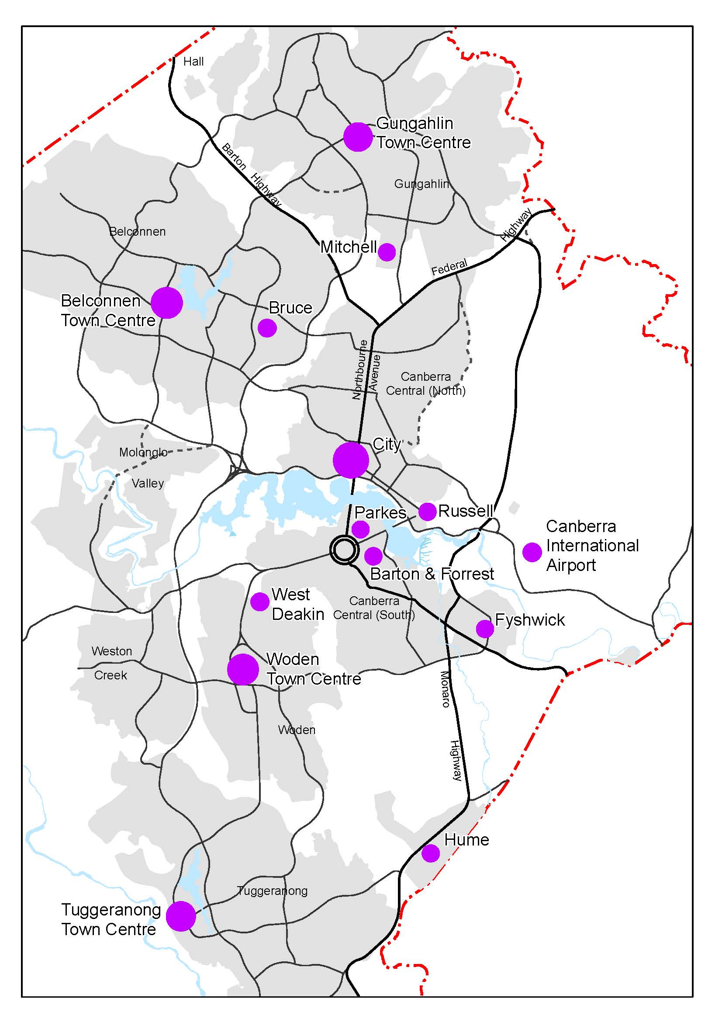
Figure 10: Defined Activity Centres

3.6 Broadacre Areas

3.6.1 Background
Beyond the Urban Areas are areas of land set aside for broadacre uses. Subject to the outcome of detailed study and the qualifications detailed below, these areas may offer the opportunity for further urban development. Some broadacre areas may be suitable for the siting of industry, transport facilities, defence installations, institutions and other activities requiring large sites. They may become of considerable economic importance to Canberra over time, and offer a basis for the further economic development of the city in a manner complementary to its function as the National Capital.

3.6.2 Principle for Broadacre Areas
Broadacre Areas may act as buffers between towns, provide sites for uses which require large land areas or may benefit from or be best located within a non-urban setting, and provide a land bank for future Urban Areas.

3.6.3 Policies for Broadacre Areas
- Building, site and landscape development must be sympathetic to and not be discordant with the landscape setting of the National Capital.
- All proposals for development within two kilometres of HMAS Harman must be referred to the Department of Defence for examination and comment and such comment must be taken into account in arriving at a decision.

3.6.3 Permitted land uses in Broadacre Areas
- The range of uses permitted in Broadacre Areas is as follows:
- Administrative and Utility Services
- Agriculture
- Animal Care Facility
- Airport (Canberra International Airport only)
- Caravan Park/Camping Ground
- Community Facility
- Education and Office establishments used by the Department of Defence
- Forestry (Majura and Kowen plantations only)
- General Farming
- Intensive Farming
- Landscape Buffer
- Open Space
- Outdoor Recreation Facility
- Park
- Retail Plant Nursery
- Scientific Research Establishment
- Tourist Facility
- Transport Facility, including Road and Rail
- Mobile Home Park (Blocks 6 & 8 Section 97 and Block 17 Section 102 Symonston only).
and may include Dwelling, if necessary, for the operation of any of these uses.
The nature of uses permitted in Broadacre Areas is defined in Appendix A.

3.7 Rural Areas

3.7.1 Background
Much of the ACT’s rural land has the potential to support agriculture on a long term sustainable basis and this should be supported in leasing and other arrangements. However, some provision will be necessary for future National Capital and Territory needs but these should be planned for and located so that rural activities can be continued and the distinctive rural landscape character of each area retained.
These rural lands, and the wider NCOSS, provide a unique and dramatic setting for Australia’s capital city, one which increasingly marks this city as internationally distinct and at the same time one of Australia’s most significant achievements.
The ACT contains a number of national communication installations which, to operate efficiently, require protection from the effects of urban settlement and associated development.
The Commonwealth has obligations to protect tracking stations from any electrical or other interference from urban settlement, power transmission lines, radio transmitters or electrical, scientific, medical and industrial equipment. The Tidbinbilla Deep Space Communication Complex will be protected.

3.7.2 Principle for Rural Areas
The rural areas of the ACT should be retained and utilised on a sustainable yield basis whilst providing a distinctive rural landscape setting for the National Capital.

3.7.3 Policies for Rural Areas
- Land uses or developments should not significantly diminish National Capital landscape values. Rural holdings must not be subdivided into units which cannot support long term economic farming or agriculture, or which create small units primarily used for residential purposes, except where agreed by the National Capital Authority.
- On rural lands soils should be conserved and natural tree cover enhanced in order to protect both the resources and the landscape setting of the National Capital.
- Urban development near Tidbinbilla Deep Space Communication Complex is limited by the following zone constraints (refer Figure 11):
- Zone ‘A’ – no development is permitted within a 1.25 kilometre radius from the centre of the complex
- Zone ‘B’ – no industrial development is permitted within a three kilometre radius of the centre
- Zone ‘C’ – an arc from the north-west to the south-west which is modified by the terrain.
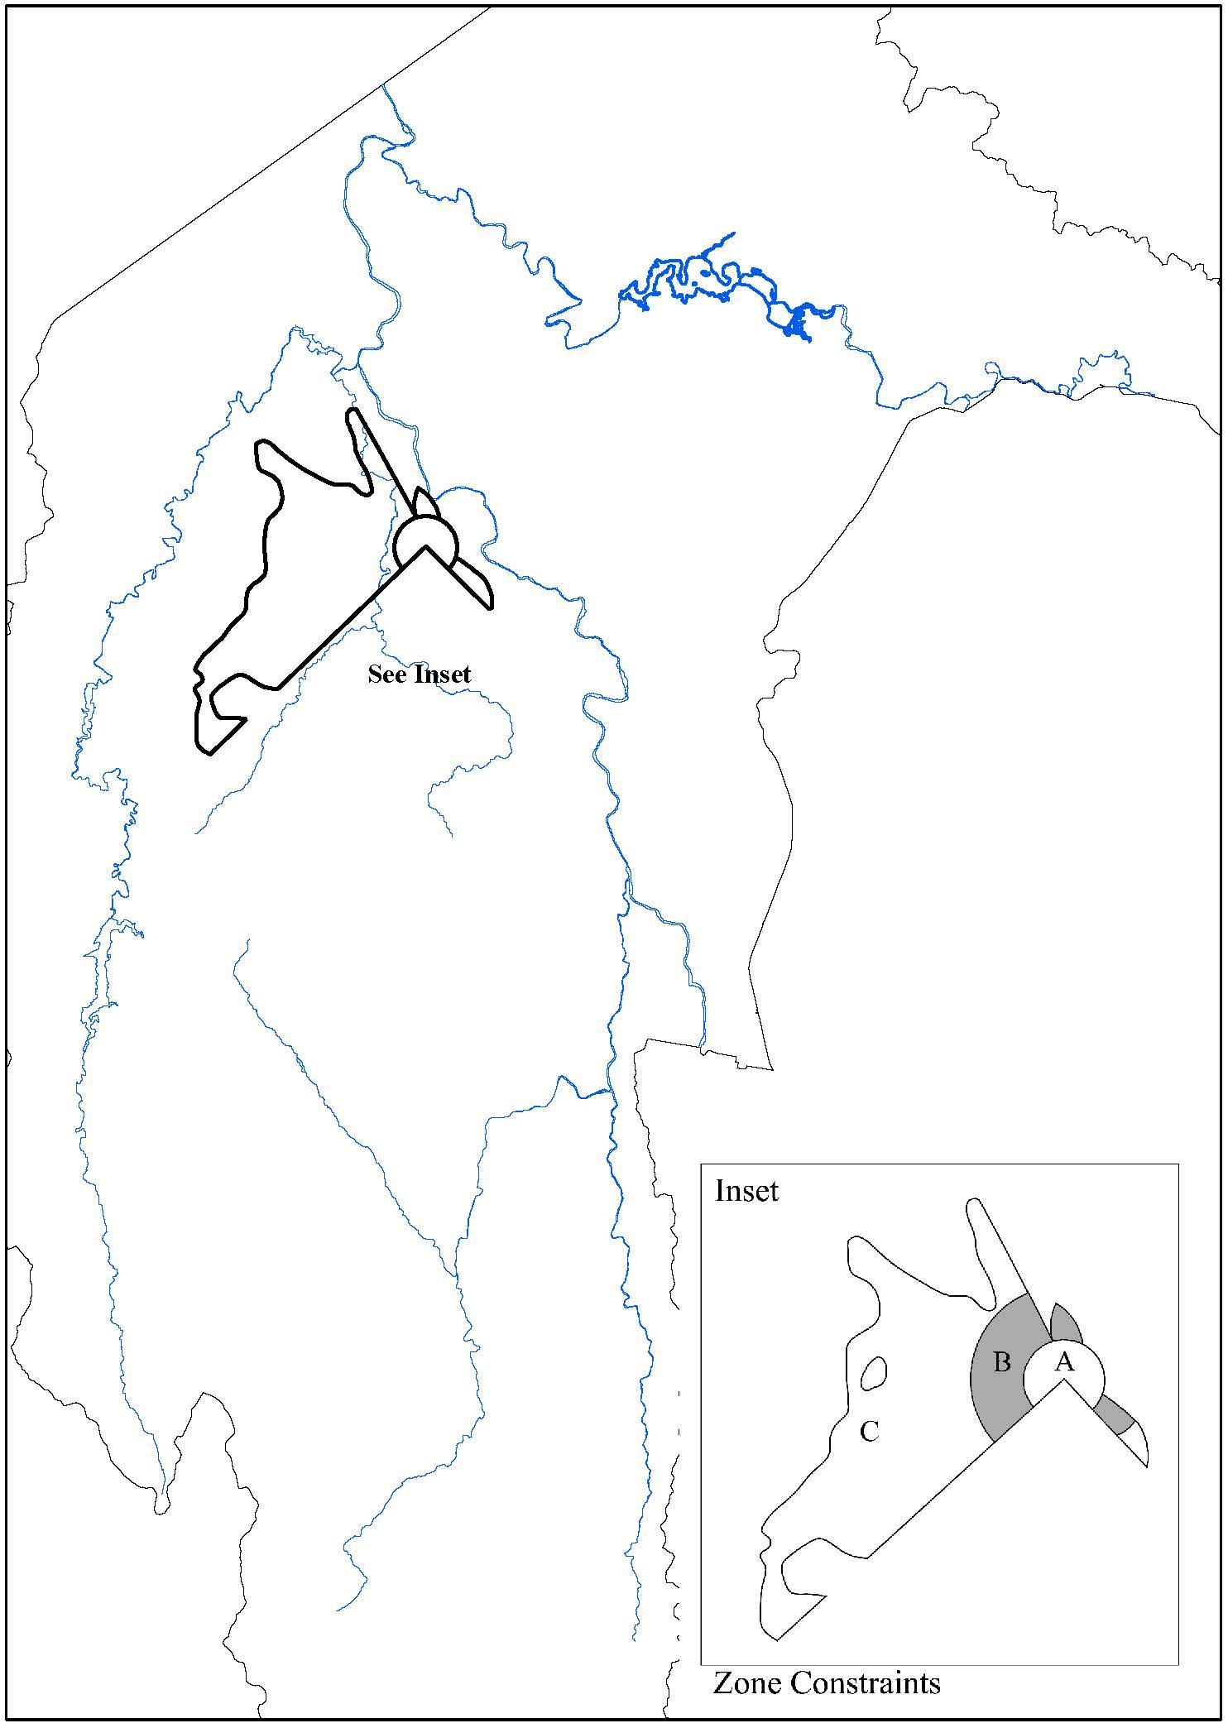
Figure 11: Tidbinbilla Deep Space Communication Complex zone constraints

3.7.4 Permitted land uses in Rural Areas
- The range of uses permitted in Rural Areas is as follows:
- Agriculture
- Forestry (Kowen and Pierce’s Creek pine plantations only)
- General Farming
- Intensive Farming
- Landscape Buffer
- Outdoor Recreation Facility
- Overnight Camping
- Park
- Public Utility
- Road
- Scientific Research Establishment
and may include Dwelling, if necessary, for the operation of any of these uses.
The nature of uses permitted in Rural Areas is defined at Appendix A.

PART FOUR – DESIGNATED AREAS AND SPECIAL REQUIREMENTS

Explanatory Statement
Section 10(1) of the Australian Capital Territory (Planning and Land Management) Act 1988 (the Act) states that the National Capital Plan (the Plan) may specify areas of land that have the special characteristics of the National Capital to be Designated Areas. The Act (section 10 (2)(c))further states that the Plan may set out detailed conditions of planning, design and development in Designated Areas and the priorities in carrying out such planning, design and development.
Finally, section 10(2)(d) of the Act states that the Plan may set out special requirements for the development of any area (not being a Designated Area), being requirements that are desirable in the interests of the National Capital.
Part Four of the Plan therefore:
- identifies those areas of the Territory deemed to have the special characteristics of the National Capital, and divides this area into ‘precincts’
- sets out conditions of planning, design and development for each precinct through ‘Precinct Codes’ and ‘General Codes’
- sets out Special Requirements that are desirable in the interests of the National Capital.
To give effect to the above, Part Four has been structured as follows:
Part Four(a) ‘Principles and Policies for Designated Areas and Special Requirements for National Land outside Designated Areas’ sets out conditions for those areas where the Commonwealth has planning approval responsibility. This includes both Designated Areas and National Land outside Designated Areas.
Part Four(b) ‘Special Requirements for Territory Land’ sets out Special Requirements for those areas where the Commonwealth maintains a high level of interest, but where the Territory planning authority has planning approval responsibility (Territory Land subject to Special Requirements).
Further information is available in separate explanatory statements for Part Four(a) and Part Four(b).

