National Capital Plan 1990 (December 1990)
made under the
Australian Capital Territory (Planning and Land Management) Act 1988
Compilation No. 24
Compilation date: 28 August 2018
Includes amendments up to: F2018L01189
Registered: 5 September 2018
This compilation is in 4 volumes
Volume 1: [Introduction, Governance, Part One–Part Four]
Volume 2: [Part Four(A) 4.0–4.6]
Volume 3: [Part Four(A) 4.7–4.10]
Volume 4: [Part Four(A) 4.11–4.26, Appendices A and B and Endnotes]
Each volume has its own contents

About this compilation
This compilation
This is a compilation of the National Capital Plan 1990 (December 1990) that shows the text of the law as amended and in force on 28 August 2018 (the compilation date).
The notes at the end of this compilation (the endnotes) include information about amending laws and the amendment history of provisions of the compiled law.
Uncommenced amendments
The effect of uncommenced amendments is not shown in the text of the compiled law. Any uncommenced amendments affecting the law are accessible on the Legislation Register (www.legislation.gov.au). The details of amendments made up to, but not commenced at, the compilation date are underlined in the endnotes. For more information on any uncommenced amendments, see the series page on the Legislation Register for the compiled law.
Application, saving and transitional provisions for provisions and amendments
If the operation of a provision or amendment of the compiled law is affected by an application, saving or transitional provision that is not included in this compilation, details are included in the endnotes.
Editorial changes
For more information about any editorial changes made in this compilation, see the endnotes.
Modifications
If the compiled law is modified by another law, the compiled law operates as modified but the modification does not amend the text of the law. Accordingly, this compilation does not show the text of the compiled law as modified. For more information on any modifications, see the series page on the Legislation Register for the compiled law.
Self-repealing provisions
If a provision of the compiled law has been repealed in accordance with a provision of the law, details are included in the endnotes.

Contents
4.7 WEST BASIN PRECINCT CODE 1
4.8 CONSTITUTION AVENUE AND ANZAC PARADE PRECINCT CODE 18
4.9 AUSTRALIAN DEFENCE FORCE ACADEMY AND ROYAL MILITARY COLLEGE DUNTROON PRECINCT CODE 48
4.10 AUSTRALIAN NATIONAL BOTANIC GARDENS PRECINCT CODE 62

List of figures
Figure 52: West Basin Precinct location 1
Figure 53: Land use for the West Basin Precinct 3
Figure 54: West Basin – Indicative urban structure 6
Figure 55: West Basin – Indicative development 7
Figure 56: West Basin – Indicative extension of the city to the lake 8
Figure 57: West Basin – Indicative lake reclamation and land bridge 10
Figure 58: West Basin – Heritage 11
Figure 59: West Basin – Indicative landscape/streetscape 12
Figure 60: West Basin – Indicative section waterfront promenade 13
Figure 61: West Basin – Indicative waterfront promenade 13
Figure 62: West Basin – Indicative cycle ways and ferry routes 14
Figure 63: West Basin – Indicative active frontages 15
Figure 64: West Basin – Indicative section along Marcus Clarke Street extension 15
Figure 65: West Basin – Indicative street cross sections 16
Figure 66: West Basin – Indicative road hierarchy 16
Figure 67: West Basin – An artist’s impression of extending the City to the Lake 17
Figure 68: Constitution Avenue and Anzac Parade Precinct location 18
Figure 69: Land use for the Constitution Avenue and Anzac Parade Precinct 20
Figure 70: Constitution Avenue and Anzac Parade – Indicative urban structure (1) 24
Figure 71: Constitution Avenue and Anzac Parade – Indicative urban structure (2) 24
Figure 72: Constitution Avenue and Anzac Parade – Indicative main pedestrian connections 25
Figure 73: Constitution Avenue and Anzac Parade – Landscape structure 25
Figure 74: Constitution Avenue and Anzac Parade – Indicative landscape structure 26
Figure 75: Constitution Avenue and Anzac Parade – Indicative public transport, access and circulation 27
Figure 76: Constitution Avenue and Anzac Parade – Indicative road structure 27
Figure 77: Constitution Avenue and Anzac Parade – Indicative cycle ways 28
Figure 78: Constitution Avenue and Anzac Parade – Indicative streetscape design 29
Figure 79: Constitution Avenue and Anzac Parade – Indicative typical cross section Parkes Way between Commonwealth and Kings Avenue 29
Figure 80: Constitution Avenue and Anzac Parade – Indicative active frontage 30
Figure 81: Constitution Avenue and Anzac Parade – Indicative building height and form 31
Figure 82: Constitution Avenue and Anzac Parade - Measurement of building height 32
Figure 83: Constitution Avenue and Anzac Parade – Indicative stormwater (proposed) 33
Figure 84: Constitution Avenue and Anzac Parade – Indicative development 35
Figure 85: Constitution Avenue and Anzac Parade – An artist’s impression of Constitution Avenue 35
Figure 86: Section 5 Campbell – Illustrative development plan 36
Figure 87: Section 5 Campbell – Public Space 37
Figure 88: Section 5 Campbell – Built form envelopes 38
Figure 89: Section 5 Campbell – Primary building line setbacks from boundary 39
Figure 90: Section 5 Campbell - Building height 40
Figure 91: Section 5 Campbell – Preferred sites for deep soil landscape locations 41
Figure 92: Section 5 Campbell – Landscape treatment at corner of Constitution Avenue and Anzac Park East 43
Figure 93: Section 5 Campbell – Indicative streetscape development location plan 44
Figure 94: Section 5 Campbell – Wendouree Drive 44
Figure 95: Section 5 Campbell – Park edge street (Getting extension) 45
Figure 96: Section 5 Campbell – Park edge street (Chowne Street alignment) 45
Figure 97: Section 5 Campbell – Shared Way (Chowne Street alignment) 46
Figure 98: Section 5 Campbell – Memorial streets 46
Figure 99: Section 5 Campbell –Anzac Park East 47
Figure 100: Australian Defence Force Academy and Royal Military College Duntroon Precinct location 49
Figure 101: Australian Defence Force Academy and Royal Military College Duntroon – Constraints Plan 52
Figure 102: Land use for the Australian Defence Force Academy and Royal Military College Duntroon Precinct 53
Figure 103: Australian Defence Force Academy and Royal Military College Duntroon – Zone map 54
Figure 104: Academy Close concept design 61
Figure 105: Australian National Botanic Gardens Precinct location 63
Figure 106: Land use for the Australian National Botanic Gardens Precinct 66
Figure 107: Australian National Botanic Gardens Master Plan 67

4.7 WEST BASIN PRECINCT CODE

4.7.1 Precinct location
The West Basin Precinct is bounded by London Circuit and Commonwealth Avenue to the east, Lake Burley Griffin to the south, the Australian National University to the west and Edinburgh Avenue to the north.
Figure 52 illustrates the location of the West Basin Precinct.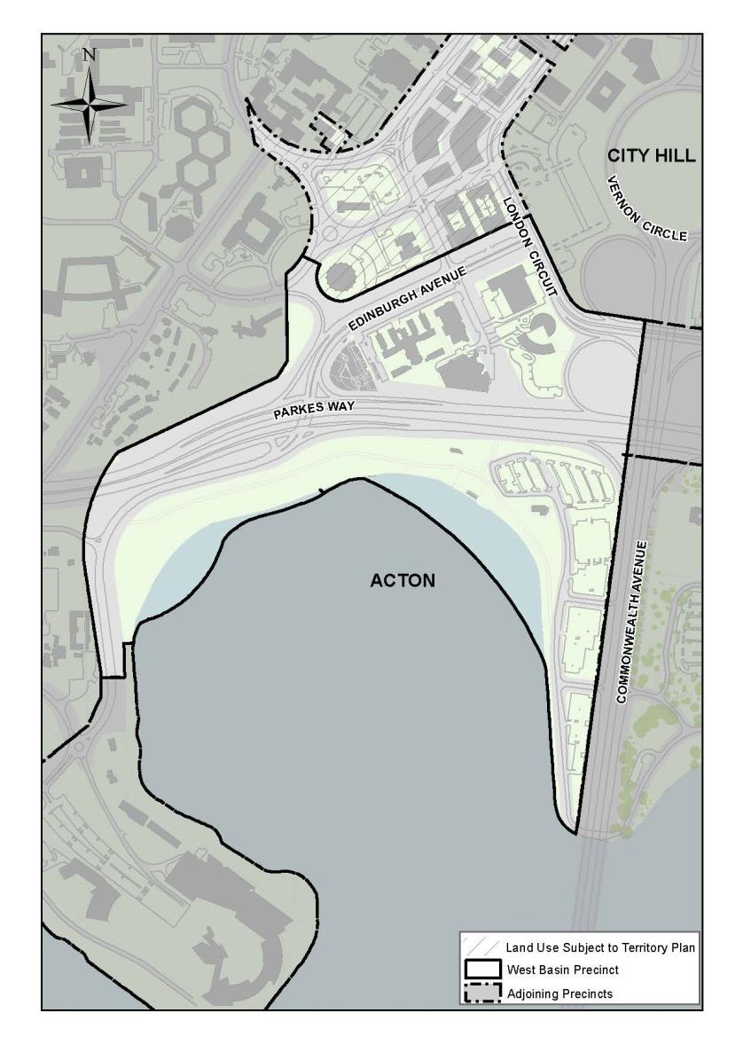
Figure 52: West Basin Precinct location

4.7.2 Background
The West Basin precinct forms one of the key elements of the geometry and intent of the Grifﬁn Plan at West Basin.
West Basin will be a vibrant cultural and entertainment precinct on a waterfront promenade. The area will create a new city neighbourhood, extending the city to the lake with a cosmopolitan mixture of shops, businesses, cafés, recreation, tourist activities and accommodation.

4.7.3 Objectives for West Basin Precinct
  - Create a legible network of paths and streets by extending the city grid of streets and paths to enhance connectivity and accessibility to the lake.
  - Create a vibrant public waterfront promenade in the Central National Area.
  - Enhance the range of tourism and recreation experiences available on Lake Burley Grifﬁn.
  - Develop a built environment which demonstrates design excellence.
  - Develop West Basin precinct with a mix of uses and create a public domain which demonstrates urban design excellence.
  - Provide continuous public access around West Basin with links to the surrounding national attractions.
  - Contribute to the visitor and recreation experience of the Lake Burley Grifﬁn parklands with an active waterfront promenade that permits a high level of tourist, entertainment, accommodation and leisure uses.
  - Enhance Commonwealth and Edinburgh Avenues as important physical, visual and symbolic links of Canberra.
  - Reinforce Commonwealth Avenue, a signiﬁcant approach route and vista to Parliament House, as a corridor of activity, leading pedestrians from the city into the Parliamentary Zone.
  - Develop a signiﬁcant public building, cultural attraction or landscape space on the water axis on the western shore of West Basin.
  - Ensure new development meets leading practice for environmental sustainability including energy efficiency and water sensitive urban design measures.

4.7.4 Land Use for West Basin Precinct
Land use for the Acton Peninsula Precinct should be in accordance with Figure 53.
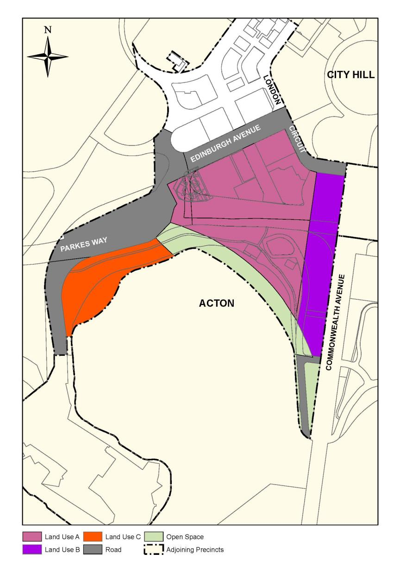
Figure 53: Land use for the West Basin Precinct
Permitted land uses for ‘Land Use A’ are:
- Bank and Cooperative Society
- Café, Bar, Restaurant
- Car Park
- Club
- Commercial Accommodation (Hotel, Motel or Serviced Apartment only)
- Cultural Facility
- Diplomatic Mission
- Indoor Recreation Facility
- Ofﬁce
- Park
- Personal Service Establishment
- Place of Assembly
- Public Utility
- Residential
- Retail
- Road
- Social/Community Facility
- Tourist facility
Permitted land uses for ‘Land Use B’ are:
- Bank and Cooperative Society
- Café, Bar, Restaurant
- Car Park
- Club
- Commercial Accommodation (Hotel, Motel or Serviced Apartment only)
- Cultural Facility
- Diplomatic Mission
- Indoor Recreation Facility
- Ofﬁce
- Park
- Personal Service Establishment
- Place of Assembly
- Public utility
- Residential
- Road
- Social/Community Facility
- Tourist Facility
Ancillary land uses permitted are:
- Retail
Permitted land uses for ‘Land Use C’ are:
- Aquatic Recreation Facility
- Cultural Facility
- Diplomatic Mission
- Place of Assembly
- National Capital Use
- Waterfront promenade
Ancillary land uses permitted are:
- Car park
- Hotel
- Park
- Public utility
- Recreation
- Tourist facility (not including a service station)
Permitted land uses for ‘Open Space’ are:
- Aquatic Recreation Facility
- Café, Bar, Restaurant
- Car Park
- Cultural Facility
- Indoor Recreation Facility
- Park
- Pathway Corridor
- Public utility
- Recreation
- Road
- Tourist facility (not including a service station)

4.7.5 Detailed conditions of planning, design and development

General

Urban Structure
Reinforce the Main Avenues framing the National Triangle as important symbolic connections and formal approaches to Parliament House (Commonwealth Avenue) and City Hill (Commonwealth and Edinburgh Avenues).
Extend the city grid of streets and paths from city to West Basin, maintaining the connectivity and accessibility of the urban block pattern.
Extend the city’s urban structure to the lake.
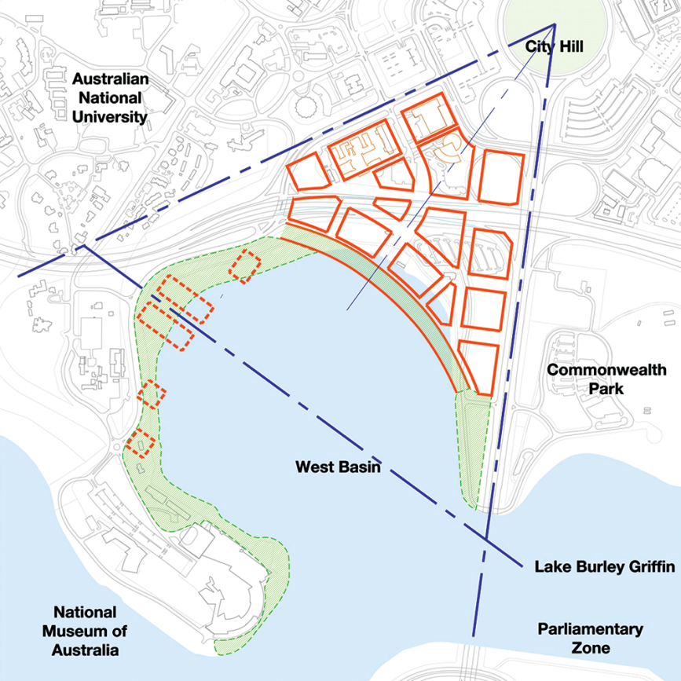
Figure 54: West Basin – Indicative urban structure
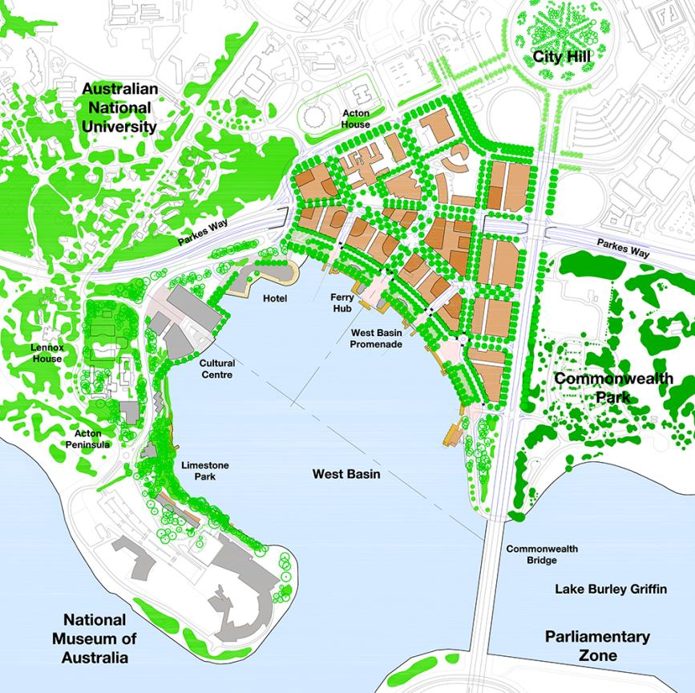
Figure 55: West Basin – Indicative development
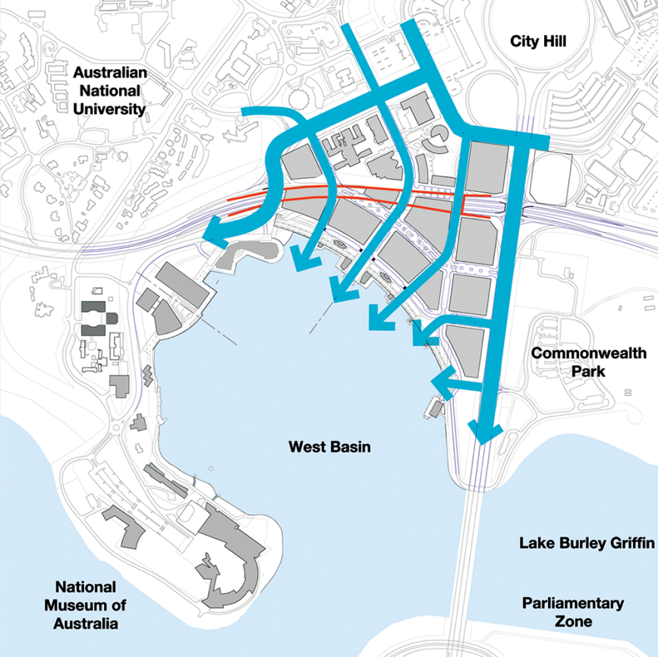
Figure 56: West Basin – Indicative extension of the city to the lake

Building Height and Form
Building height will generally be medium rise up to 25 metres.
Taller building elements may be considered on sites north of Parkes Way having regard to:
  - access to sunlight
  - visual and environmental amenity
  - microclimate.
Building height on the waterfront promenade will be limited to 8 metres (maximum two storeys).
The parapet height of buildings fronting the promenade will be a maximum of 16 metres.
Taller building elements to a maximum of 25 metres, and not exceeding 30 per cent of the site area, may be considered.
Minimum floor-to-ceiling heights within buildings are to be as follows:
Location | Min. floor height
Ground Floor facing Constitution Avenue and roads where ‘Indicative Active Frontages’ are located | 6.5 metres floor to ceiling (mezzanine level permitted over 30% of ground floor)
Ground Floor (Residential) | 3.3 metres floor-to-ceiling
Ground Floor (other uses, including commercial/office use) | 3.6 metres floor-to-ceiling
Residential (general) | 2.7metres floor-to-ceiling minimum for all habitable rooms, 2.4 metres is the preferred minimum for all non-habitable rooms however 2.25 metres is permitted.  For two-storey units, 2.4 metres minimum for second storey if 50 percent or more of the apartment has 2.7 metre minimum ceiling heights.  For two-storey units with a two-storey void space, 2.4 metre minimum ceiling heights.  Attic spaces are permitted, with a 1.5 metre minimum wall height at edge of room with a 30 degree minimum ceiling slope.

Development should generally be constructed to the street boundary to define and enclose streets and create continuous street frontage while allowing variations in individual buildings and uses.
Building forms, materials and finishes should be responsive to microclimate issues including solar access and wind. Use of sunscreen devices as articulation elements should be employed to achieve climate responsive façades.
Buildings above 25 metres in height are to be the subject of wind testing, including down draught conditions and turbulence, to ensure the development does not have adverse impacts on building entrances and the public domain.
Provide continuous climate protection to areas where retailing and service based developments form the predominant ground level use at the street.
Buildings should generally be modulated to clearly express the grid of the building. Tactility, silhouette and human scale in relation to built form should be achieved with the design of buildings.
Building design, layout and construction should take account of the impacts of noise on surrounding uses.
New buildings are encouraged to be delivered through design competitions in order to encourage innovation and design excellence.
Public art and art spaces in new development should be encouraged.

Land reclamation and land bridge
Replace the clover leaf intersection of Parkes Way and Commonwealth Avenue with a signalised grade-separated intersection.
Create a land bridge over a section of Parkes Way for streets to extend to the lake.
Reclaim land from the lake to establish a public waterfront promenade, reflecting the geometry of the 1918 Griffin Plan.
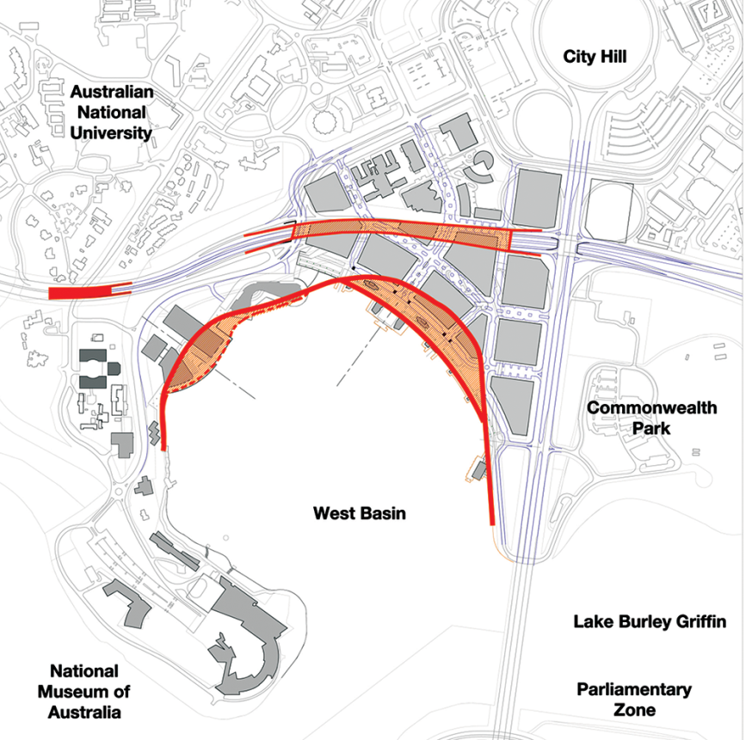
Figure 57: West Basin – Indicative lake reclamation and land bridge

Heritage
Provide public access to local heritage places around West Basin.
Create a public waterfront promenade reflecting the geometry and intent of the 1918 Griffin Plan.
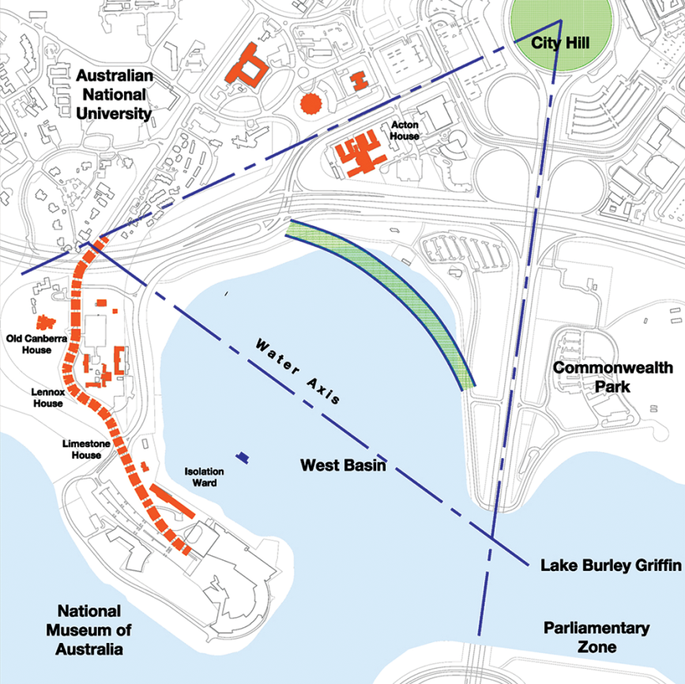
Figure 58: West Basin – Heritage

Landscape/Streetscape
Landscape planting should reinforce the urban structure of West Basin and its integration with the setting of the Central National Area and the Lake Burley Griffin parklands.
A formal treatment should be applied to the main avenues, major streets and the waterfront promenade, and continuous street trees should define the pattern of city streets extending to the lake.
The visual impact of parking on the public domain should be minimized by integrating parking layouts with street tree plantings and pavement design.
A limited palette of high quality pedestrian pavement materials, street furniture and lighting should be used. Pavement and landscape design should have an elegant, simple and bold design emphasising the geometry and formality of the main avenues.
A range of soft and hard landscape treatments are to be incorporated into the waterfront promenade and foreshore.
Streetscapes must be well lit for pedestrians and made safe for night time use.
Footpath areas should be wide enough to cater for pedestrians and specific land use requirements and allow for seating areas, outdoor cafés, planting and urban art.
Public art should be included as an integral component of development proposals and the public domain.
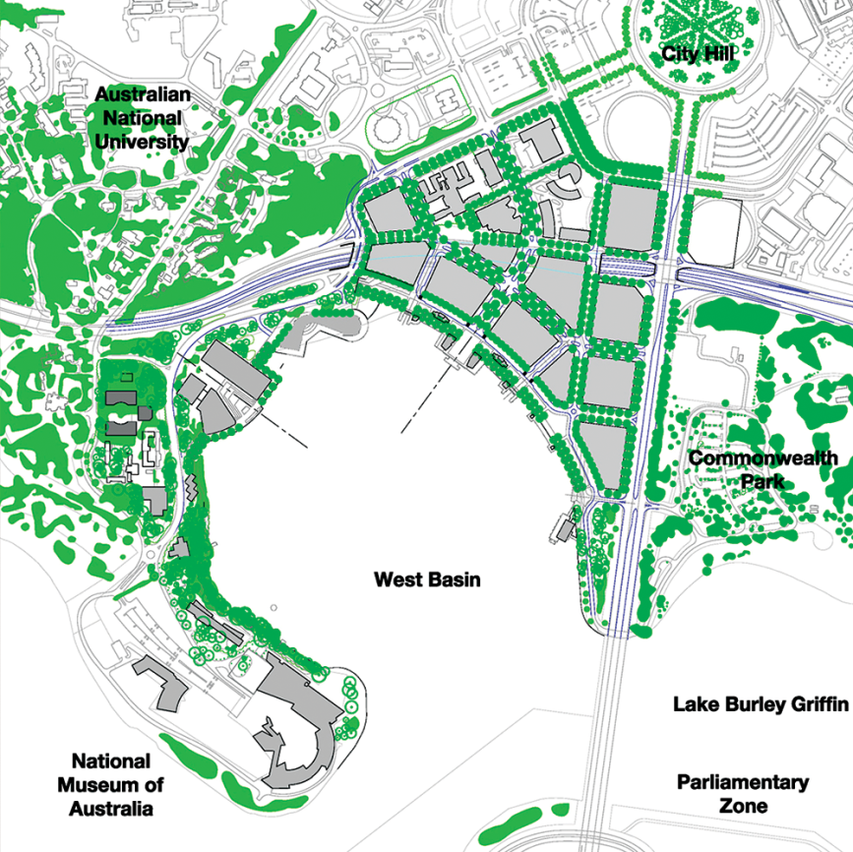
Figure 59: West Basin – Indicative landscape/streetscape

Waterfront Promenade
Maintain a continuous public pedestrian network with access to the foreshore with high quality pedestrian amenities including lighting, furniture, signage and landscape materials.
Provide well lit public areas and close-by on-street parking.
Link national attractions with a continuous pedestrian network.
Incorporate recreation and tourist activities along the waterfront promenade.
Provide for a shared pathway network along the waterfront promenade designed for all users.
Provide a minimum width of 55 metres for footpaths.
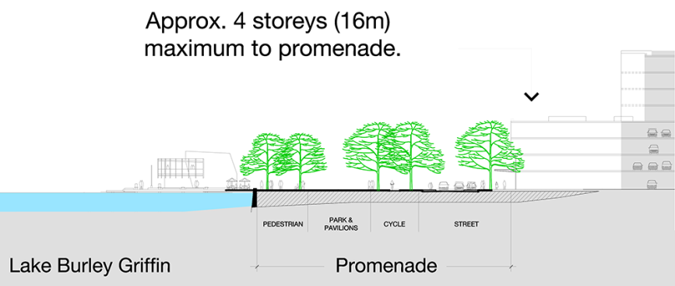
Figure 60: West Basin – Indicative section waterfront promenade
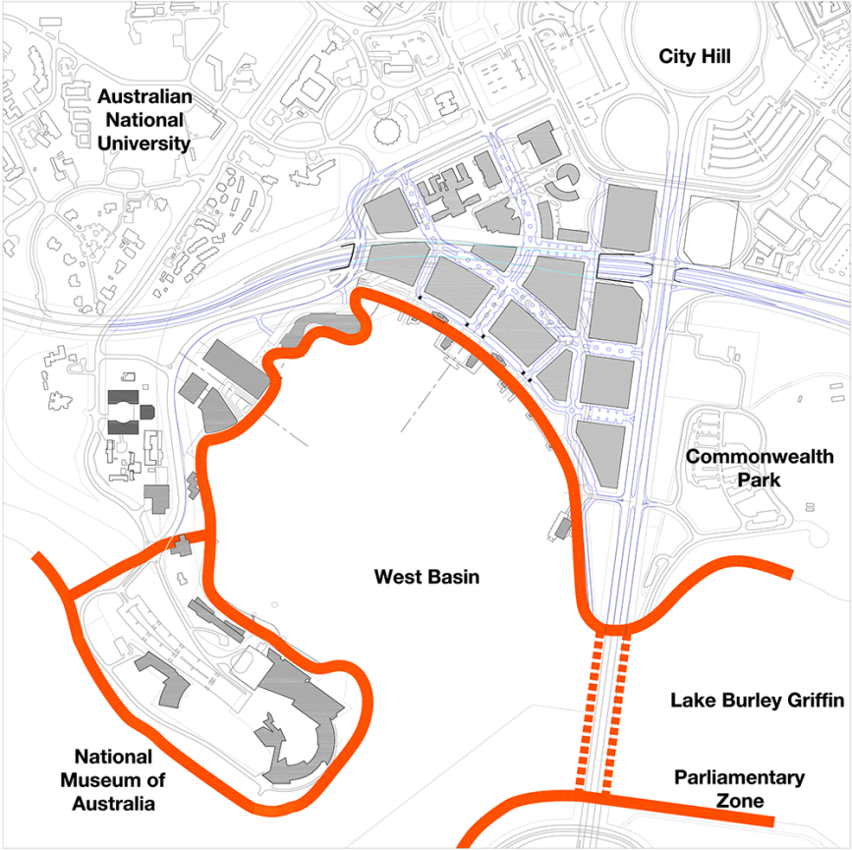
Figure 61: West Basin – Indicative waterfront promenade

Cycle ways and Ferry
Provide a network of cycle ways catering to recreation and commuter needs, separated spatially and by visual character where appropriate to prevent pedestrian conflicts.
Provide ferry landings at key nodes around West Basin which incorporate lake based recreation and tourist activities.
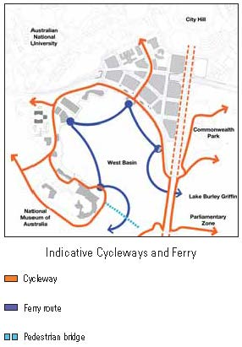
Figure 62: West Basin – Indicative cycle ways and ferry routes

Active Frontage
Individual buildings will contribute to the definition of blocks and streets, with the greatest levels of public activity, shops and building entrances on main avenues, major streets and public spaces.
Identified active frontages are to present an attractive pedestrian-oriented frontage providing active uses and are to have a minimum of 80 percent active uses. All other streets are to have a minimum of 50 percent active frontages.
Residential uses should generally be avoided at street level.
Blank walls are strongly discouraged.
Pedestrian entries should be clearly visible from the public domain.
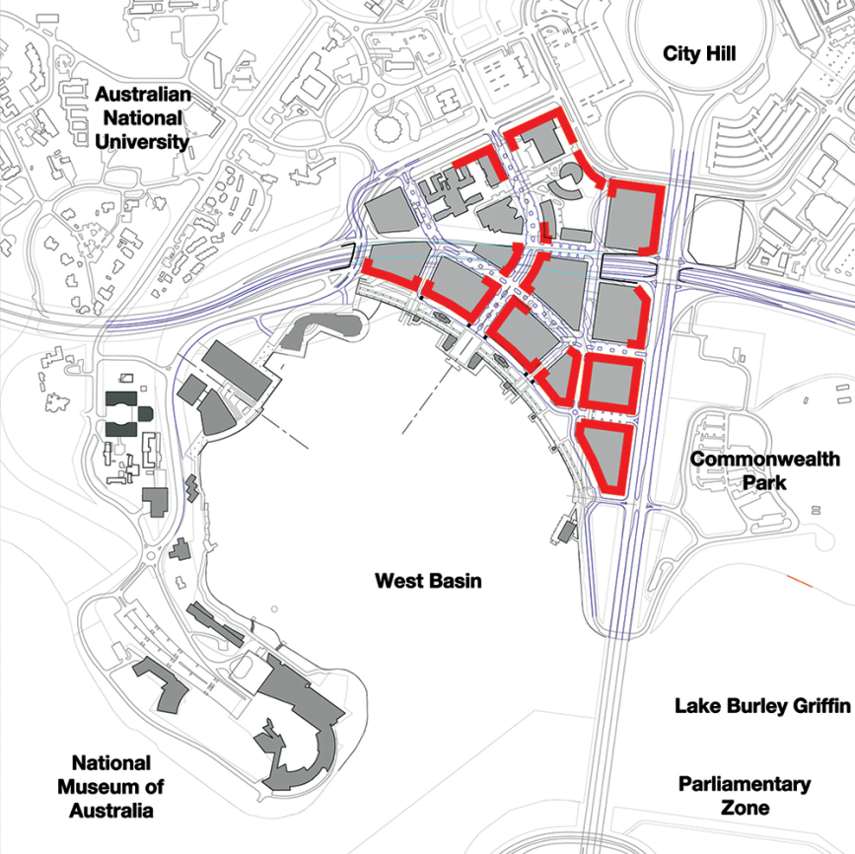
Figure 63: West Basin – Indicative active frontages

Road Hierarchy
Maximise connections into the site from surrounding main avenues.
Provide a hierarchy of streets being main avenues, major streets and minor streets.
Provide a flexible road network that can accommodate temporary closures of minor streets to vehicles for significant pedestrian events.
Ensure that minor streets are low-speed urban streets which give priority to pedestrians.
Design traffic engineering devices to promote pedestrian amenity, safety and access.
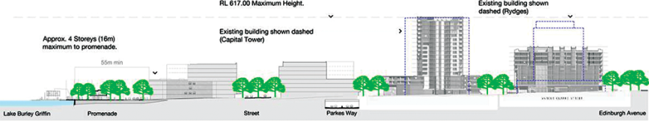
Figure 64: West Basin – Indicative section along Marcus Clarke Street extension
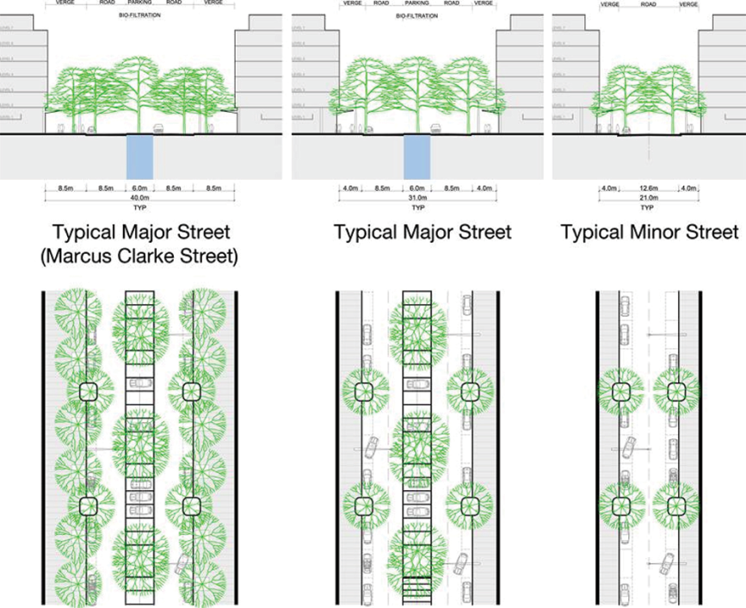
Figure 65: West Basin – Indicative street cross sections
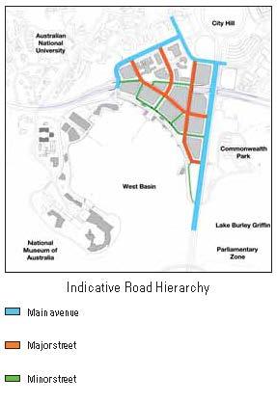
Figure 66: West Basin – Indicative road hierarchy
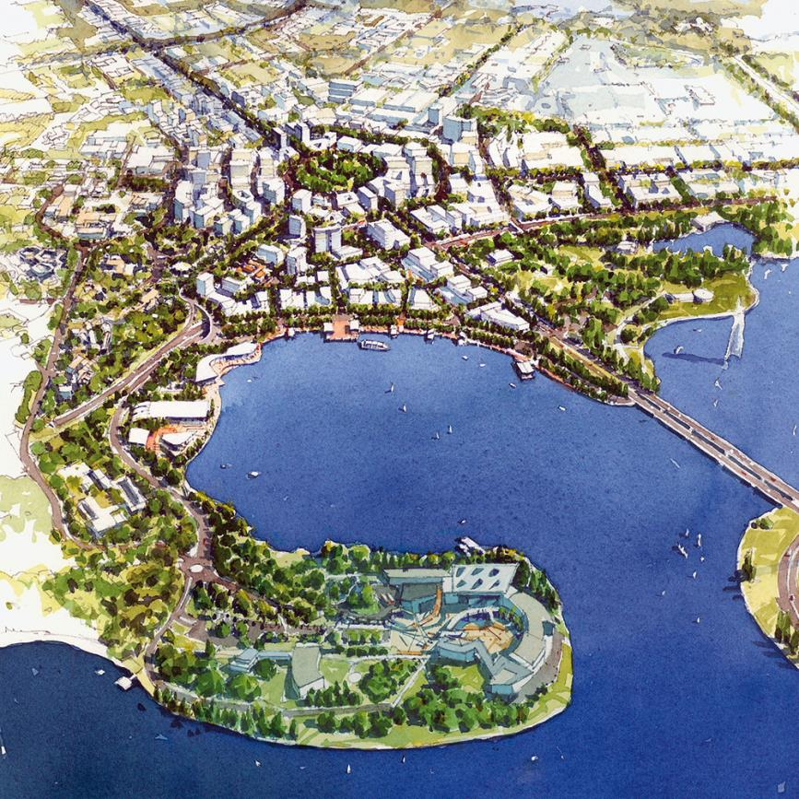
Figure 67: West Basin – An artist’s impression of extending the City to the Lake

4.8 CONSTITUTION AVENUE AND ANZAC PARADE PRECINCT CODE

4.8.1 Precinct location
The Constitution Avenue and Anzac Parade Precinct comprises the land between Constitution Avenue and Parkes Way, the Russell apex of the National Triangle, Anzac Parade and the Australian War Memorial, and various sites to the north of Constitution Avenue.
Figure 68 illustrates the location of the Constitution Avenue and Anzac Parade Precinct.
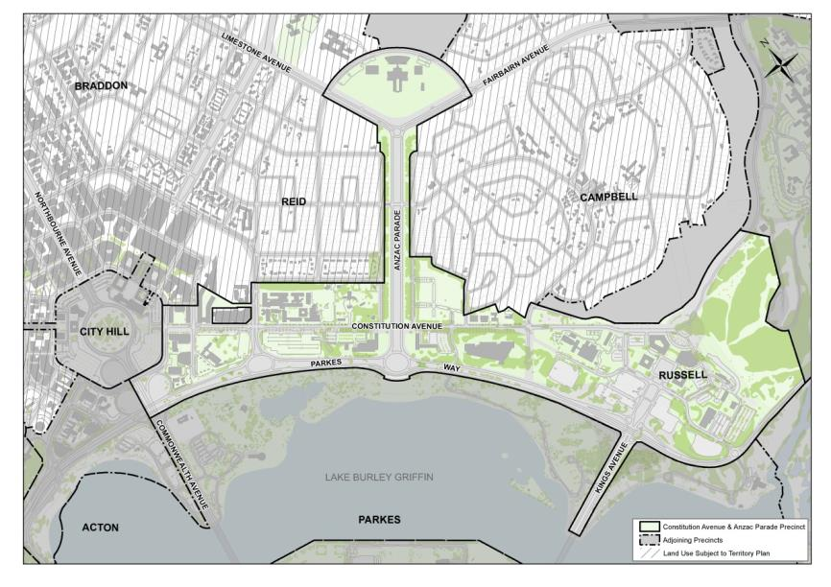
Figure 68: Constitution Avenue and Anzac Parade Precinct location

4.8.2 Backround
A key element of Griffins’ formally adopted plan for Canberra is the central triangle formed by grand avenues. Constitution Avenue is the base of this geometric element (the National Triangle) and was the Municipal Axis of the Griffins’ plan.
Constitution Avenue is central to the implementation of the Griffin Legacy. Constitution Avenue will become an elegant and vibrant mixed use grand boulevard linking London Circuit to Russell, increasing the vitality of the Central National Area and completing the National Triangle. This will be supported by an integrated transport system, broad tree-lined footpaths and outdoor dining and street parking.
Anzac Parade is set along the Land Axis, which forms a key feature of the Griffins’ original 1912 plan of the city. The Australian War Memorial stands at the top end of Anzac Parade. The two together are central to the commemoration of Australian military service and sacrifice.
There is a national capital interest in ensuring that:
- sites on Constitution Avenue are developed in accordance with their national significance, as part of Griffin’s National Triangle
- the symbolic importance of the Constitution Avenue as a Main Avenue and the base of the National Triangle is protected and supported through the design and development of the adjacent blocks and the landscaping and design of the avenue
- fitting sites on Anzac Parade are available for commemoration and remembrance
- balanced building massing at the sites at the southern end of Anzac Parade is maintained as far as practicable and is reinstated as a result of any redevelopment of those sites, to ensure the portal function on the Anzac Parade frontages of those sites is maintained for the benefit of the Parliament House Vista.

4.8.3 Objectives for Constitution Avenue and Anzac Parade
- Establish Constitution Avenue as a diverse and active grand boulevard lined with shops, cafés and a mix of commercial, entertainment and residential uses.
- Establish Constitution Avenue as a prestigious address for National Capital Uses.
- Link education and high-tech employment clusters located in the corridor between the Australian National University and the Canberra International Airport.
- Complete the base of the National Triangle.
- Support Constitution Avenue with an integrated transport system and mix of land uses contributing to the life of the National Triangle.
- Establish Constitution Avenue with higher density development, public transport, broad tree-lined footpaths and outdoor dining and street parking.
- Develop a built environment which demonstrates design excellence.
- Achieve leading practice environmentally sustainable development.

4.8.4 Land use for Constitution Avenue and Anzac Parade Precinct
Land use for the Constitution Avenue and Anzac Parade Precinct should be in accordance with Figure 69.
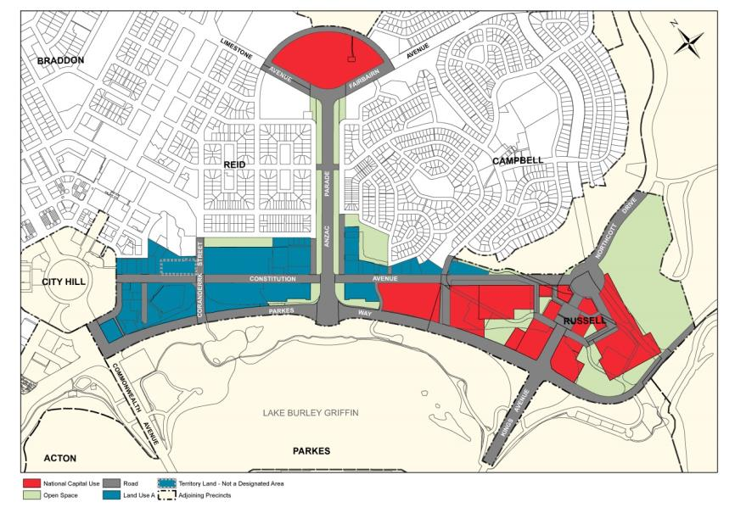
Figure 69: Land use for the Constitution Avenue and Anzac Parade Precinct
Permitted land uses for ‘Land Use A’ are:
- Administrative Use
- Aquatic recreation facility
- Bank and cooperative society
- Café, bar, restaurant
- Car park
- Club
- Commercial Accommodation (Serviced Apartment only)
- Consulting Rooms
- Cultural facility
- Diplomatic Mission
- Education establishment
- Health Centre
- Hotel
- Indoor recreation facility
- Motel
- Ofﬁce
- Park
- Personal service establishment
- Place of assembly
- Public utility
- Residential
- Retail (ground floor of buildings only)
- Road
- Social/Community facility
- Tourist facility
Ancillary land uses for ‘Land Use A’ are:
- Child Care Centre
- Retail (either ground floor or above)
Permitted land uses for ‘Open Space’ are:
- Café, bar, restaurant
- Car park
- Child care centre
- Cultural facility
- Indoor recreation facility
- Park
- Pathway corridor
- Public utility
- Recreation
- Road
- Tourist facility (not including a service station)
For ‘National Capital Use’ sites, ancillary land uses permitted are:
- Bank
- Café, bar, restaurant
- Car Park
- Child care centre
- Club
- Consulting rooms
- Cooperative society
- Diplomatic Mission
- Health centre
- Indoor recreation facility
- Personal services establishment
- Public utility
- Retail
- Social/community facility

4.8.5 Detailed conditions of planning, design and development

General
- Built form and landscape design should respond to the primacy of the geometry of Constitution Avenue and the Russell apex of the National Triangle with building form emphasising the alignments of Constitution Avenue, Kings Avenue and Parkes Way.
- Reinforce the city’s three-dimensional structure based on its topography and the landscape containment of the Inner Hills.
- Develop Constitution Avenue (generally east of Anzac Parade) as a prestigious setting for national capital uses, related employment and amenities.
- Reduce the barrier created by Parkes Way and its high speed intersections along its length by changing the character of Parkes Way to become a boulevard addressed with prestigious buildings, at grade pedestrian crossings and appropriately scaled road reserves and intersections.
- Provide a mix of land uses that contributes to the creation of a 24 hour community with dynamic activity patterns including retail, restaurants, residential and hotels close to public transport, employment areas, cultural attractions and the parklands of Lake Burley Grifﬁn.
- Integrate public transport priority in the design of Constitution Avenue including provision for future light rail.
- Development should include a high level of access to a diversity of uses and activities, have cohesion and diversity in design character and detail, and be able to respond to changes over time.
- Provide a transition in building scale and use to protect the amenity of adjoining residential areas.
- Ensure conveniently located parking in a manner that does not dominate the public domain. All basement and service vehicle entries are to be located from secondary street frontages.
- Create an open and legible network of paths and streets that extends and connects City Hill and the adjoining suburbs of Reid and Campbell to Constitution Avenue, Kings and Commonwealth Parks and Lake Burley Grifﬁn.
- Create a public domain that forms a linked sequence of spaces that are accessible, safe, comfortable, and pedestrian-scaled, that promotes walking and use of public transport and minimises reliance on cars.
- Integrate perimeter security, if required, with streetscape elements that enhance the public domain.
- Architectural character should develop a contemporary palette of styles and materials, reﬂecting the varied land uses and providing activity and interest, particularly at street level. Particular attention should be paid to building form and roof proﬁles in areas of high visibility.
- Design proposals should be site responsive, taking maximum advantage of varying characteristics and features of each site, complementing adjoining development – both existing and proposed – and expressing physical and environmental features.
- The street network, building form and facilities should be inherently ﬂexible to accommodate changing uses and demands across the site and within buildings over time.
- Development should command high standards of urban design, sustainability, architecture and social inclusion reﬂecting the character of the national capital and providing a model for city development in Australia in the 21st century.

Urban structure
Reinforce Constitution Avenue as the base of the National Triangle and the Russell apex with appropriate urban form.
Create a street grid, sympathetic to Griffin’s intended pattern of streets and city blocks that provides a high level of integration with the street and path network of City, Reid and Campbell and link these areas with Lake Burley Griffin and Kings and Commonwealth Parks.
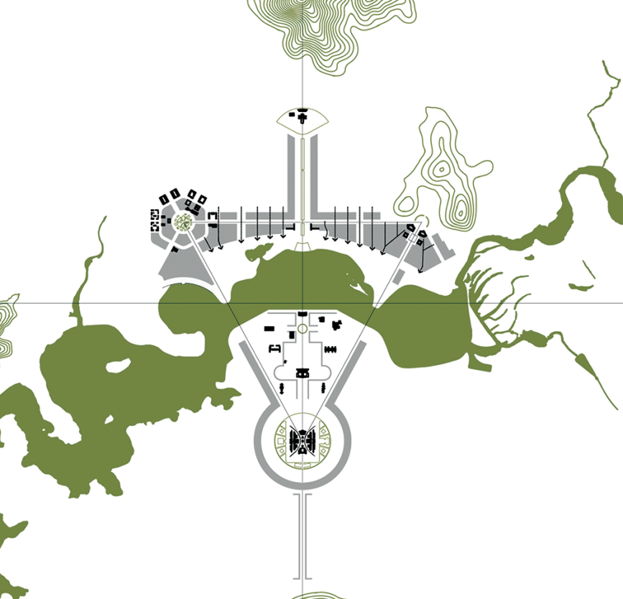
Figure 70: Constitution Avenue and Anzac Parade – Indicative urban structure (1)
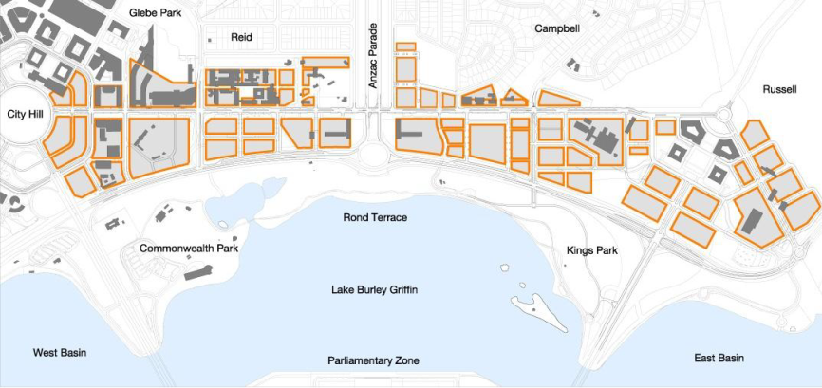
Figure 71: Constitution Avenue and Anzac Parade – Indicative urban structure (2)

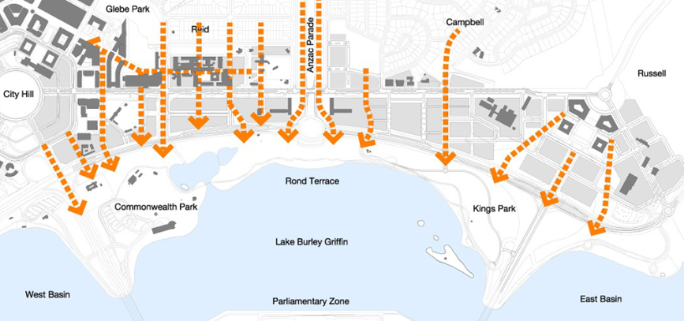
Figure 72: Constitution Avenue and Anzac Parade – Indicative main pedestrian connections

Landscape structure
Landscape planting should reinforce the urban structure of Constitution Avenue and its integration with the setting of the Central National Area and the Lake Burley Griffin parklands.
A formal treatment should be applied to the main avenues including Constitution, Kings and Commonwealth Avenues, as well as Parkes Way. Continuous street trees should define the pattern of major and minor streets.
The visual impact of parking on the public domain should be minimised by integrating parking layouts with street tree plantings and pavement design.
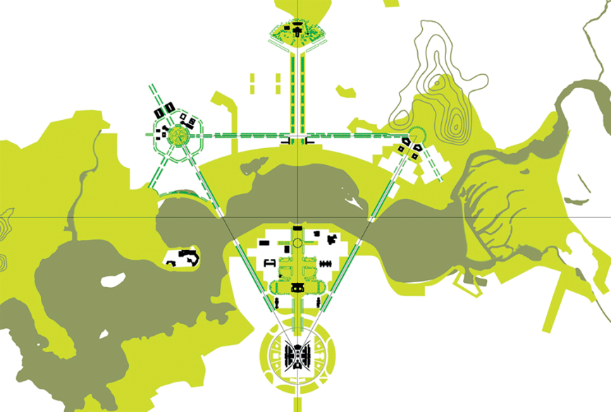
Figure 73: Constitution Avenue and Anzac Parade – Landscape structure
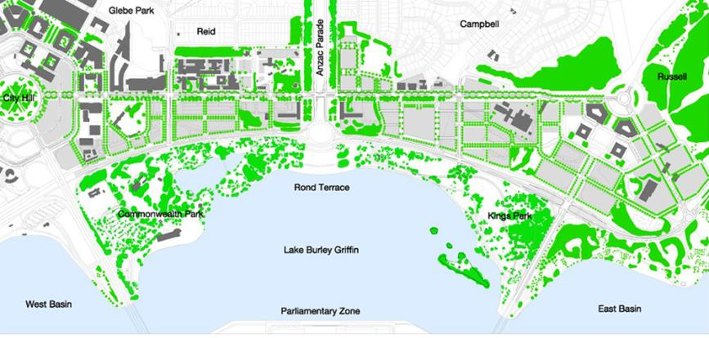
Figure 74: Constitution Avenue and Anzac Parade – Indicative landscape structure

Public transport, access and circulation
Allow for an integrated public transport system with Constitution, Kings and Commonwealth Avenues and London Circuit as the principal public transport route.
Provide a hierarchy of pedestrian routes ranging from Constitution, Commonwealth and Kings Avenues and London Circuit as urban boulevards, major streets (including Coranderrk Street and Blamey Crescent and Sellheim Avenue), minor streets, laneways and arcades.
Ensure safety and comfort for pedestrians, with intersections designed to minimise slip lanes for fast turning traffic.
Provide on-street parking on all streets where practicable.
Access to the western portion of Block 7 Section 3 Parkes from Block 6 Section 3 Parkes must be maintained to allow access to Commonwealth Park via underpass from the northern side of Parkes Way.

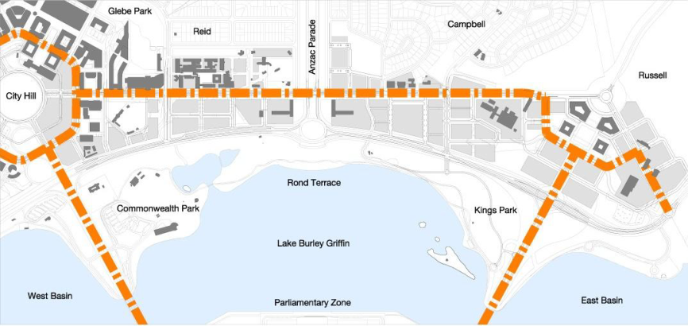
Figure 75: Constitution Avenue and Anzac Parade – Indicative public transport, access and circulation

Road hierarchy
The road hierarchy provides a legible and connective framework for moving throughout the area with:
- Constitution, Commonwealth and Kings Avenues and Parkes Way having the role of principal routes for through traffic and pedestrians connecting other parts of the city to the area
- major connecting streets including Coranderrk Street, Blamey Crescent and Sellheim Avenue having a role of providing the main connections from the City Centre and adjoining neighbourhoods
- minor streets having a local access role with priority for pedestrians and cyclists
- lanes, shareways and arcades having a service, access and pedestrian network role.
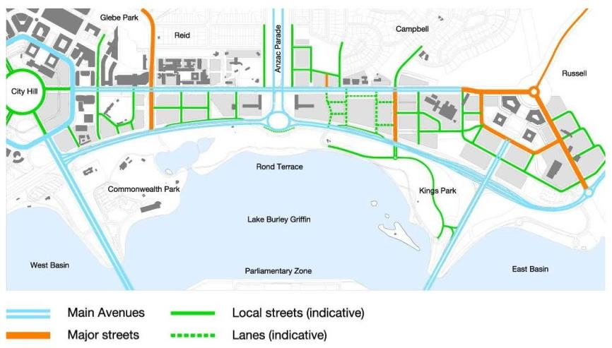
Figure 76: Constitution Avenue and Anzac Parade – Indicative road structure

Cycle ways
Provide an attractive and direct network for pedestrians and cyclists catering to recreation and commuter needs, separated spatially and by visual character where appropriate to prevent pedestrian conflicts.
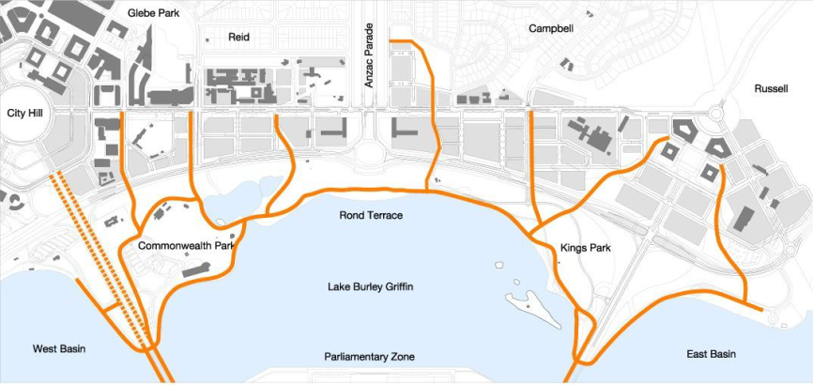
Figure 77: Constitution Avenue and Anzac Parade – Indicative cycle ways

Streetscape design
Provide a complementary hierarchy of streetscape elements that relates to the road hierarchy giving primacy to the main avenues, emphasising continuity along their length through avenues of appropriately scaled street trees, consistent pedestrian pavement materials, street furniture and lighting.
Development should generally be constructed to the street boundary to define and enclose streets and create continuous street frontage while allowing variations in individual buildings and uses.
Use a limited palette of high quality pedestrian pavement materials, street furniture and lighting. Pavement and landscape design should have an elegant, simple and bold design emphasising the geometry and formality of the main avenues.
Ensure streetscapes are well lit for pedestrians and optimise security and safety for night time use. Footpath areas should be wide enough to cater for pedestrians and specific land use requirements and allow for seating areas, outdoor cafés, planting and urban art.
Wider pavements for outdoor cafés and public amenity are to be located on the sunny southern side of the avenue.
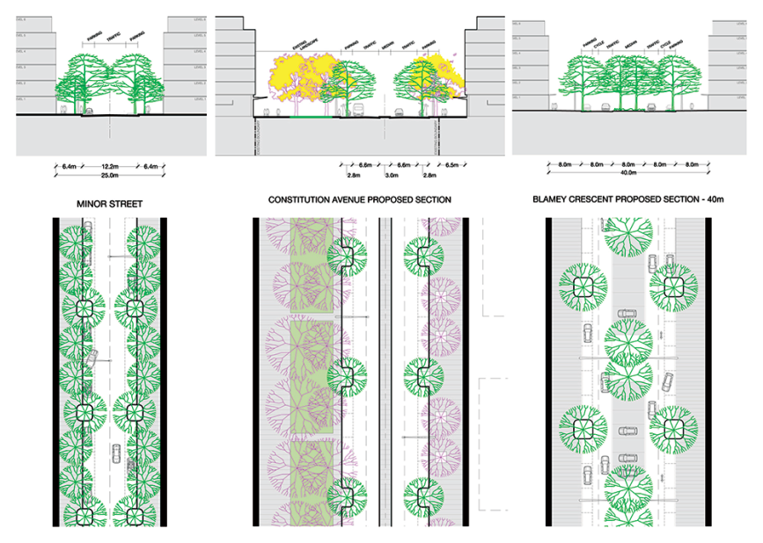
Figure 78: Constitution Avenue and Anzac Parade – Indicative streetscape design
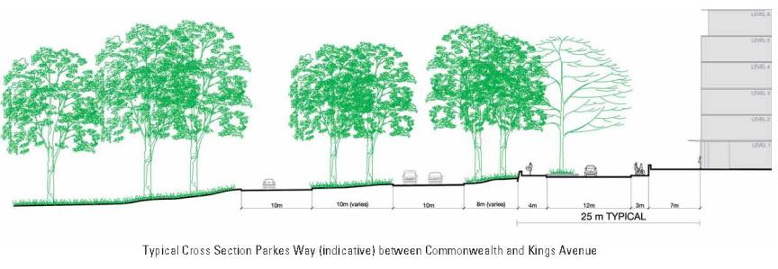
Figure 79: Constitution Avenue and Anzac Parade – Indicative typical cross section Parkes Way between Commonwealth and Kings Avenue

Active frontages
Individual buildings will contribute to the definition of blocks and streets, with the greatest levels of public activity, shops and building entrances on main avenues, streets and public spaces.
Blank façades to public spaces and streets are to be avoided.
Active streets should be a priority along Constitution Avenue and other streets throughout the area, with new development generally incorporating active ground level frontages to enliven public streets and spaces and provide passive surveillance.
Ground level frontages will present an attractive pedestrian-oriented frontage providing active uses for a minimum of 30 percent of the street frontage. Key active frontages are to have a minimum of 75 percent active uses.
Residential uses, except for home offices, should be avoided at street level at those locations identified as having an active frontage in Figure 80.
Blank walls are discouraged. Pedestrian entries should be clearly visible from the public domain.
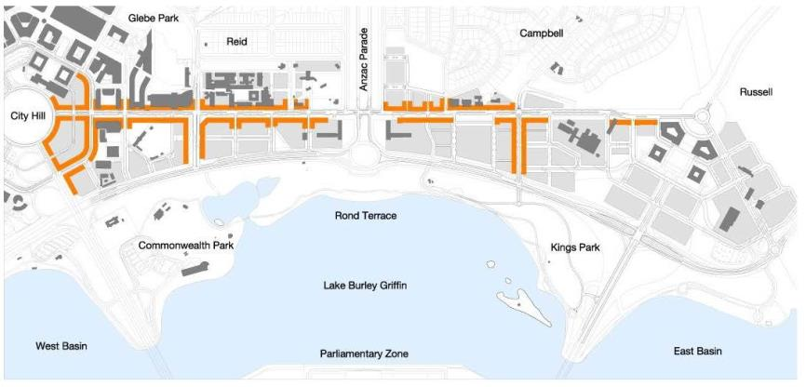
Figure 80: Constitution Avenue and Anzac Parade – Indicative active frontage

Building height and form
Provide climate protection to areas where retailing and service based developments form the predominant ground level use at the street.
Buildings above 25 metres in height are to be the subject of wind testing, including down draught conditions and turbulence, to ensure the development does not have adverse impacts on building entrances and the public domain.
Buildings heights will generally be medium rise up to 25 metres above adjacent kerb levels to retain the landscape backdrop of the inner hills of Central Canberra.
Buildings to a maximum height of RL600 are permitted in the locations identified in Figure 81. Buildings to RL600 are contingent on meeting applicable heritage requirements. To ensure that a balanced building massing and portal effect is maintained at the southern end of Anzac Parade, buildings on the second site to be developed must be equal in height to those of the first site to be redeveloped. This is applicable only to buildings in the area subject to the maximum RL600 height limit.
buildings in the area subject to the maximum RL600 height limit on
A landmark building to RL 617 adjacent to Commonwealth Avenue will be subject to consultation.
Minor building elements that extend building heights above 25 metres will be considered where this enhances the architectural quality of the building, and fosters energy efficiency, indoor amenity and appropriate urban scale.
Building height should transition down in scale to a maximum of 3 storeys (generally 12 metres above natural ground level) to be sympathetic to scale of adjoining suburbs of Reid and Campbell.
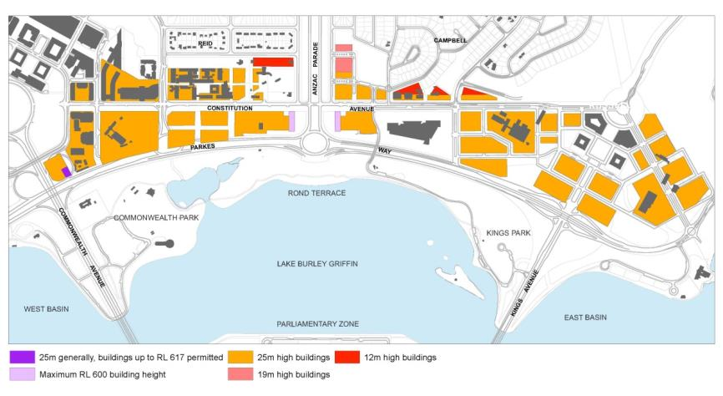
Figure 81: Constitution Avenue and Anzac Parade – Indicative building height and form
Development should generally be constructed to the street boundary to define and enclose streets and create continuous street frontage while allowing variations in individual buildings and uses. Development on the northern side of Constitution Avenue will be set back a minimum of 6.5 metres from the block boundary.
Where buildings are required to be set back to achieve security stand-off distances, continuity of the building line should be reflected in the design of passive security measures (for example, building plinth walls on the street boundary).
Where fronting residential streets in Campbell and Reid, building setbacks should generally complement existing building setbacks.
Building forms, materials and finishes should be responsive to microclimate issues including solar access and wind. Use of sunscreen devices as articulation elements should be employed to achieve climate responsive façades.
Buildings should generally be modulated to clearly express the grid of the building. Tactility, silhouette and human scale in relation to built form should be achieved with the design of buildings.
New buildings are encouraged to be delivered through design competitions in order to encourage innovation and design excellence.
Building design, layout and construction should take account of the impacts of noise on surrounding uses.
Building height is to be measured from and between the finish footpath level at each corner of a development block.
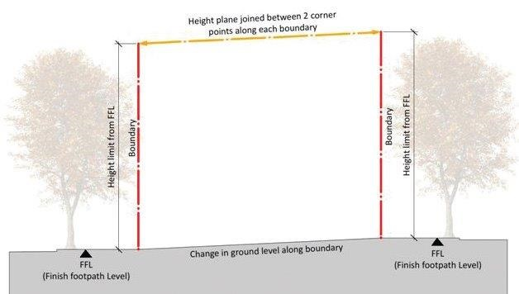
Figure 82: Constitution Avenue and Anzac Parade - Measurement of building height
Minimum floor-to-ceiling heights within buildings are to be as follows:
Location | Min. floor height
Ground Floor facing Constitution Avenue and roads where ‘Indicative Active Frontages’ are located | 6.5 metres floor to ceiling (mezzanine level permitted over 30% of ground floor)
Ground Floor (Residential) | 3.3 metres floor-to-ceiling
Ground Floor (other uses, including commercial/office use) | 3.6 metres floor-to-ceiling
Residential (general) | 2.7metres floor-to-ceiling minimum for all habitable rooms, 2.4 metres is the preferred minimum for all non-habitable rooms however 2.25 metres is permitted.  For two-storey units, 2.4 metres minimum for second storey if 50 percent or more of the apartment has 2.7 metre minimum ceiling heights.  For two-storey units with a two-storey void space, 2.4 metre minimum ceiling heights.  Attic spaces are permitted, with a 1.5 metre minimum wall height at edge of room with a 30 degree minimum ceiling slope.

Water sensitive urban design
Implement water sensitive urban design strategies, including bio-filtration systems integrated with street and landscape design, to protect lake water quality.
To protect the water quality of Lake Burley Griffin, a catchment management approach should be implemented to detain and filter stormwater in the upper catchment or at the source.
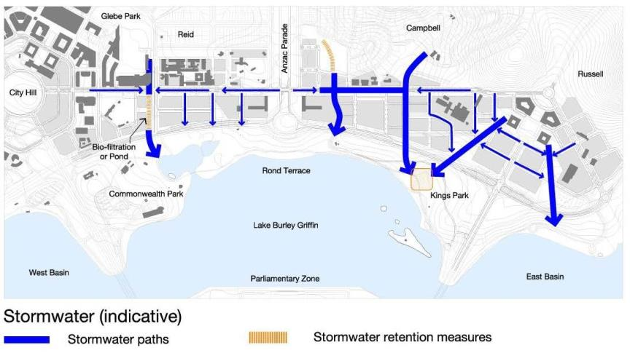
Figure 83: Constitution Avenue and Anzac Parade – Indicative stormwater (proposed)

Parking
Provide on-street car parking and conveniently-located bicycle parking to support retail uses, pedestrian amenity and after-hours activity.
Large off-street permanent surface car parks are to be avoided; car parking is to be accommodated in basements or in above-ground structures concealed from public areas by habitable building façades.
Development of existing surface car parks will need to demonstrate that an adequate public car parking provision (on-street or in appropriately designed structures) will meet the needs of Constitution Avenue.
Car parking for new development should accord with the following rates:
Land use(s) | Car parking rate | Locational requirements
Residential | One space per dwelling and one visitor space per four dwellings or part thereof. | Long-stay resident parking: on-site  Short stay/visitor parking: on-site or off-site immediately adjacent to the site.
Office | One space per 100 square metres of gross floor area. | On-site or off-site immediately adjacent to the site.
Administrative use; Bank; Child Care Centre; Consulting Rooms; Cooperative Society; Health Centre; Personal Services Establishment | Two spaces per 100 square metres of gross floor area. | On-site or off-site immediately adjacent to the site, with the exception of Child Care Centre where parking must be provided on-site.
Bar, Café, Restaurant, Retail | Two and a half spaces per 100 square metres of gross floor area. | On-site or off-site immediately adjacent to the site.
Hotel, Motel | One space per employee, plus one space per guest room or unit for establishments up to 36 units; or  25 spaces plus 0.3 spaces per guest room for establishments of more than 36 units. | On-site.

Land uses for which car parking rates are not prescribed above will be subject to individual assessment.
Proponents must demonstrate the access and parking capacity of the proposed development, and its impacts on the transport network and surrounding area. A higher on-site and/or off-site parking provision for any use may be required by the National Capital Authority after taking into account the relationship between on-site parking, off-site parking opportunities, the capacity of public transport in the area at the time of development, and anticipated future levels of public transport.
Additional parking will be provided for bicycles, motorcycles and vehicles owned and operated under car-sharing schemes.

Integrated urban art and signage
Public art and art spaces in new development should be encouraged.
Public art should be included as an integral component of development proposals and the public domain. There must be a high level of integration between advertising and signage, which contributes to the character of the place.
Opportunities for animated signs to create focal points when viewed from across public spaces may be considered where this does not impact adversely on the overall character of the place.
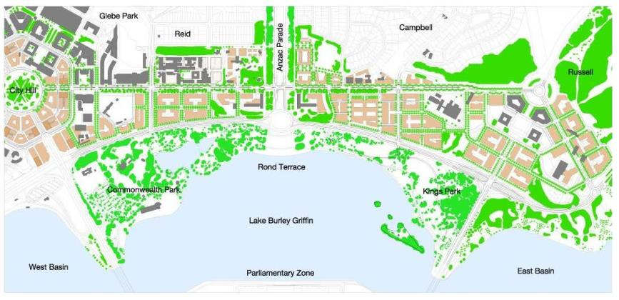
Figure 84: Constitution Avenue and Anzac Parade – Indicative development
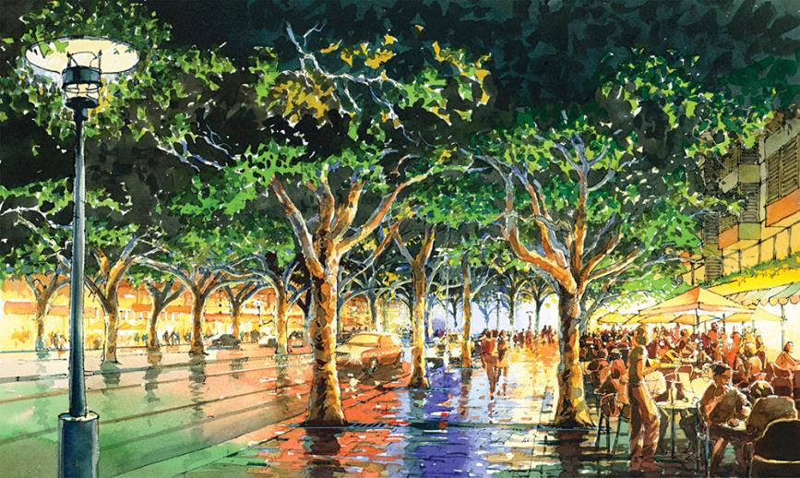
Figure 85: Constitution Avenue and Anzac Parade – An artist’s impression of Constitution Avenue

Location specific

Section 5 Campbell
The following conditions apply to the area bounded by the eastern edge of Anzac Parade, Constitution Avenue, and Creswell, Chowne and Page Streets.
All residential and commercial development proposed for Section 5 Campbell is subject to public notification and consultation.
Where an inconsistency arises between these detailed conditions and the general conditions of the Precinct Code, these detailed conditions prevail.
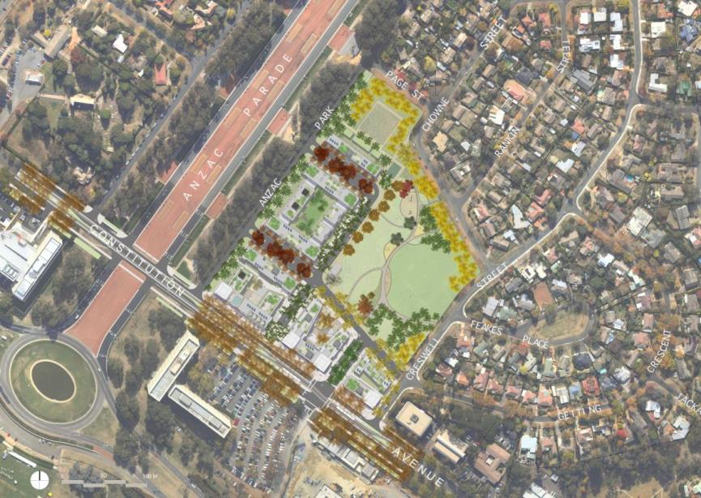
Figure 86: Section 5 Campbell – Illustrative development plan

Public space
The overall structure of public space is to respond to the established network of streets, parks and public spaces, and enhance the connectivity, accessibility and legibility of this network. At a finer scale, public spaces are to respond to site topography through designs that resolve access and drainage.
The design of public space is to provide increased amenity for residents within and adjacent to the site, through improvements to passive surveillance and visual permeability.
The general arrangement of streets and sections is shown in Figure 87.
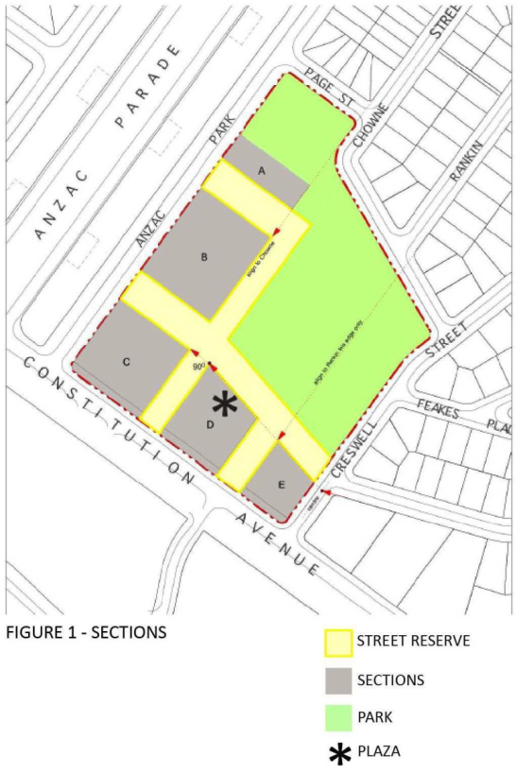
Figure 87: Section 5 Campbell – Public Space

Building form
Building forms are to respond to the scale and pattern of development on Constitution Avenue, the proposed network of public space and achieve a transition that responds to the established residential urban form.
Building designs are to provide controlled solar gain and cross-ventilation, to reduce energy consumption and improve the amenity for building occupants. The maximum permissible building depths for residential buildings as measured across the floorplate are shown in Figure 88. Minor departures are permitted where it can be demonstrated that optimum solar gain and cross ventilation is achieved and where it can be demonstrated to improve the public domain.
Amalgamation of sections will not be permitted where building forms adversely impact pedestrian movement or visual access. Building elements (other than awnings) are not to be built over roads.
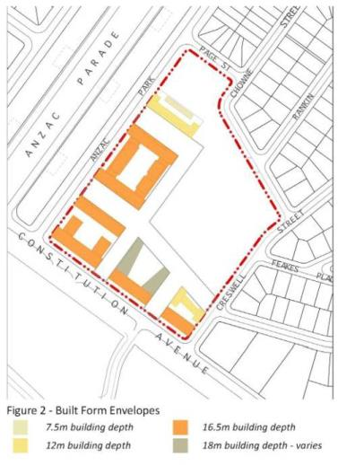
Figure 88: Section 5 Campbell – Built form envelopes

Site access and set-backs
Primary vehicle access to Section 5 Campbell is to be from Constitution Avenue, with the exception of basement car parks. Service entries must not face Constitution Avenue, Anzac Park East and new roads bordering Open Space. All service entries are to be located and designed to minimise their impact on the streetscape. Access to service rooms and areas should be achieved within buildings to minimise adverse impacts on public space.
Pedestrian access to each building is to be provided at adjacent ground level, whilst maintaining privacy for private residences and passive surveillance.
Direct pedestrian access from the public domain is to be provided to each ground floor unit or tenancy where they have a clear relationship to the public domain. The level of ground floor entries should not be less than the finished level of the footpath and not more than 450mm above the footpath level.
The required building setbacks are shown in Figure 89. Balconies and other articulation elements may encroach into the setback zone. Any such encroachments must not exceed 30% of the setback area and are not permissible on the ground floor. Encroachments within the setback area must not include internal habitable space.
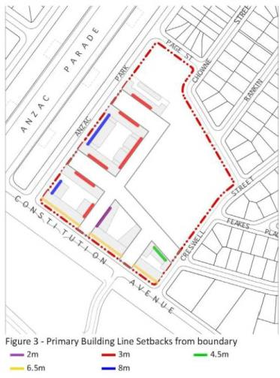
Figure 89: Section 5 Campbell – Primary building line setbacks from boundary

Building height
Overall building heights are to comply with those shown in Figure 90. Minor departures from heights shown in Figure 90 will only be considered where it can be demonstrated that the mass and bulk of buildings is not significantly increased, and where it enhances the architectural quality of the building, and fosters energy efficiency, indoor amenity, appropriate urban scale, and adds visual interest to the skyline. Building design is to take advantage of natural light and orientation for occupants and visitors.
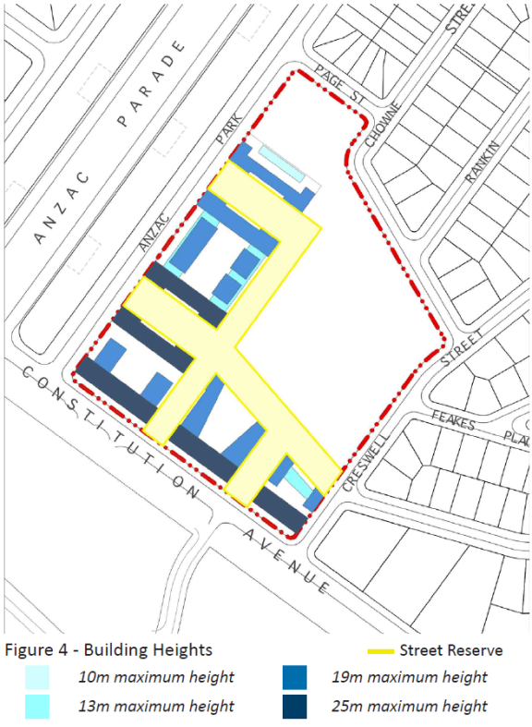
Figure 90: Section 5 Campbell - Building height

Building façades
Street corners are to be expressed by giving visual prominence to parts of the building façade such as a change in articulation, material or colour, roof expression and/or increased height.
Building articulation, material and colour must be sympathetic to the heritage values of the adjacent National and Commonwealth Heritage listed places. Building entries are to be clearly identified through building form, material and colour.
The use of built form elements such as balconies, projections, awnings and hoods are encouraged to provide shelter and ameliorate wind and downdraft in public spaces.

Parking
A minimum of 150 on-street visitor parking spaces should be provided above ground.
Ground level or above ground parking structures are not permitted.

Materials
Materials should be selected for their permanence and durability. Materials should not be highly reflective, to avoid glare and focused transfer of heat. Materials should have potential for recycling.

Landscape
Trees planted within the road reserve should be consistent with the existing landscape character of Campbell and provide continuous canopy to shade roads and footpaths in summer. Trees planted within road reserves must be capable of achieving the heights and canopy spread indicated in Figure 94, Figure 95, Figure 96, Figure 97, Figure 98 and Figure 99 at maturity.
The landscape zone within blocks is consolidated to provide for substantial mature plantings that will afford privacy to neighbours and maintain winter sunlight to properties where available. Landscape plantings within each block must include a selection of large scale trees, capable of reaching a minimum 15 metres in height with a broad canopy and that are consistent with the landscape character of Campbell when mature. Deep soil space to be provided is shown in Figure 91.
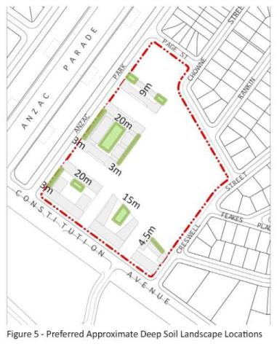
Figure 91: Section 5 Campbell – Preferred sites for deep soil landscape locations

Heritage
Development of Section 5 Campbell will respect the cultural heritage values of the National and Commonwealth Heritage listed places in the vicinity of the site.

Anzac Park East
Off-site landscaping is required to assist in reducing the visibility of building form from Anzac Parade, and in providing a green backdrop to memorials.
Existing Arbutus unedo in the southern verge of Anzac Park East will be retained to provide a dense evergreen screen. Trees may be removed to allow construction of new streets. Existing Arbutus unedo are to be interplanted with Eucalyptus cinerea to add a second canopy layer.
Where gaps exist in the rows of Eucalyptus bicostata on Anzac Parade, new plantings are required to match the plantings on the western side of Anzac Parade.
The landscape treatment at the corner of Constitution Avenue and Anzac Parade/Anzac Parade East should generally be in accordance with Figure 92.
Works Approval will not be granted for residential and commercial development on Section 5 Campbell until such time as off-site landscape works on Anzac Park East and Anzac Parade have been completed.

Section 5
Particular attention should be given to the building form/façade at the corner of Anzac Parade East and Constitution Avenue. The design of buildings should be articulated using a variety of messing; solids and voids; and materials and colours to ameliorate any impacts on the adjacent National and Commonwealth Heritage listed places.
Buildings should not intrude on the public appreciation of the eastern handle of the New Zealand Memorial as the gateway to the Memorial Parade or interrupt the symmetrical characteristics of the East and West portal buildings in framing the Parliament House Vista.
The architectural design of the buildings on Site C must be sympathetic to the heritage values of the adjacent National and Commonwealth Heritage listed places.

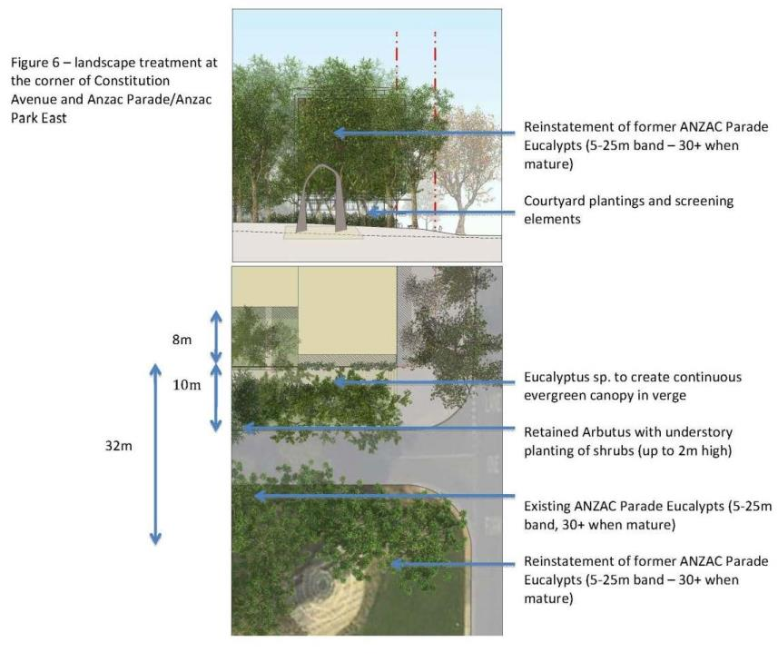
Figure 92: Section 5 Campbell – Landscape treatment at corner of Constitution Avenue and Anzac Park East

Lighting
The impact of outdoor lighting in proximity to Anzac Parade and the memorials should be minimised.
Heritage Management Plans for National and Commonwealth Heritage listed places should be considered in developing external lighting designs. The colour and finish of light poles and other light fittings should be sympathetic to the heritage values of the adjacent National and Commonwealth Heritage listed places.
New building façade lighting installations should use full cutoff light fittings that are carefully integrated into the building’s structure. External lighting to building entrances, window displays and signage should be restricted to assist in providing a dramatic backdrop. Consideration will be given to building lighting where it contributes to identity, legibility, silhouette, architectural expression, and façade articulation.
All street and footpath lighting is to be full cutoff.

Indicative development – Streetscape
The following indicative development streetscape sections are provided to illustrate the proposed relationship between public space, landscape and transport uses (see legend provided at Figure 93 for locations):
- Wendouree Drive
- Park Edge Street (Getting extension)
- Park Edge Street (Chowne Street Alignment)
- Shared-way (Chowne Street Alignment)
- Streets adjoining Anzac Park East
- Anzac Park East
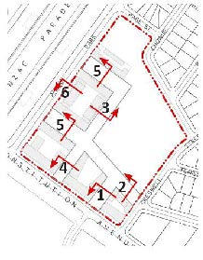
Figure 93: Section 5 Campbell – Indicative streetscape development location plan
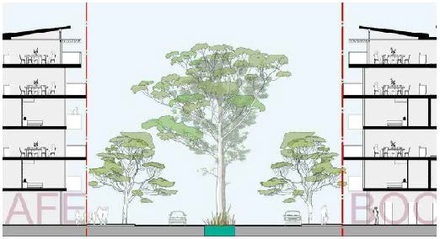
Figure 94: Section 5 Campbell – Wendouree Drive
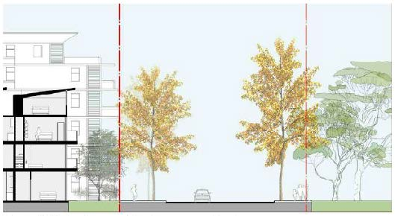
Figure 95: Section 5 Campbell – Park edge street (Getting extension)
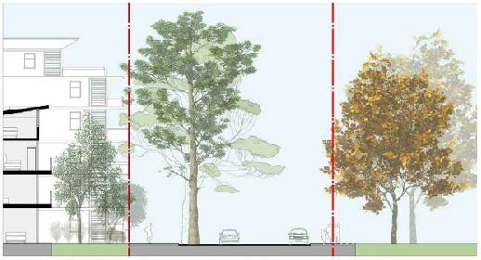
Figure 96: Section 5 Campbell – Park edge street (Chowne Street alignment)
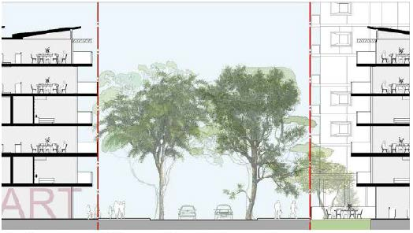
Figure 97: Section 5 Campbell – Shared Way (Chowne Street alignment)
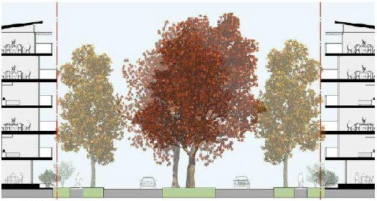
Figure 98: Section 5 Campbell – Memorial streets
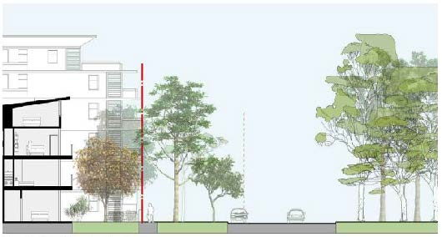
Figure 99: Section 5 Campbell –Anzac Park East

Anzac Park East and West
Detailed conditions of planning, design and development must be agreed by the National Capital Authority prior to development of the land. The detailed conditions must address (at a minimum) the following:
- building facades, including articulation, materials and colour
- access and circulation
- building form
- landscape structure and open space
- lighting.
Detailed conditions of planning, design and development for the sites must not be inconsistent with heritage values.

4.9 AUSTRALIAN DEFENCE FORCE ACADEMY, ROYAL MILITARY COLLEGE DUNTROON, AND CAMPBELL PARK PRECINCT CODE

4.9.1 Precinct location
The Australian Defence Force Academy (ADFA), Royal Military College Duntroon (RMC), and Campbell Park Precinct encompasses the two military training facilities of ADFA and RMC, the military residential area of Academy Close, and Department of Defence offices at Campbell Park.
The provisions of the Precinct Code relate primarily to ADFA and RMC. A number of the figures within this Precinct Code do not include Academy Close and Campbell Park as they do not form part of the military training institutions. Site specific provisions are included for these areas.
The ADFA, RMC, and Campbell Park Precinct comprises the two military training facilities of ADFA and RMC, which together occupy a total area of around 231 hectares approximately 3.5 kilometres south-east of the Canberra city centre. Campbell Park offices are located to the north of the two military training facilities, separated by open space forming part of the Inner Hills.
ADFA and RMC are surrounded by Mount Pleasant to the north-east and separated from the suburbs of Campbell and the Russell offices to the west by a bushland ridge which forms a physical barrier. To the north-east is open land used for grazing. Canberra Airport is located to the east and the Molonglo River and Jerrabomberra Wetlands are located to the south of the site.
Figure 100 illustrates the location of the ADFA, RMC, and Campbell Park Precinct.
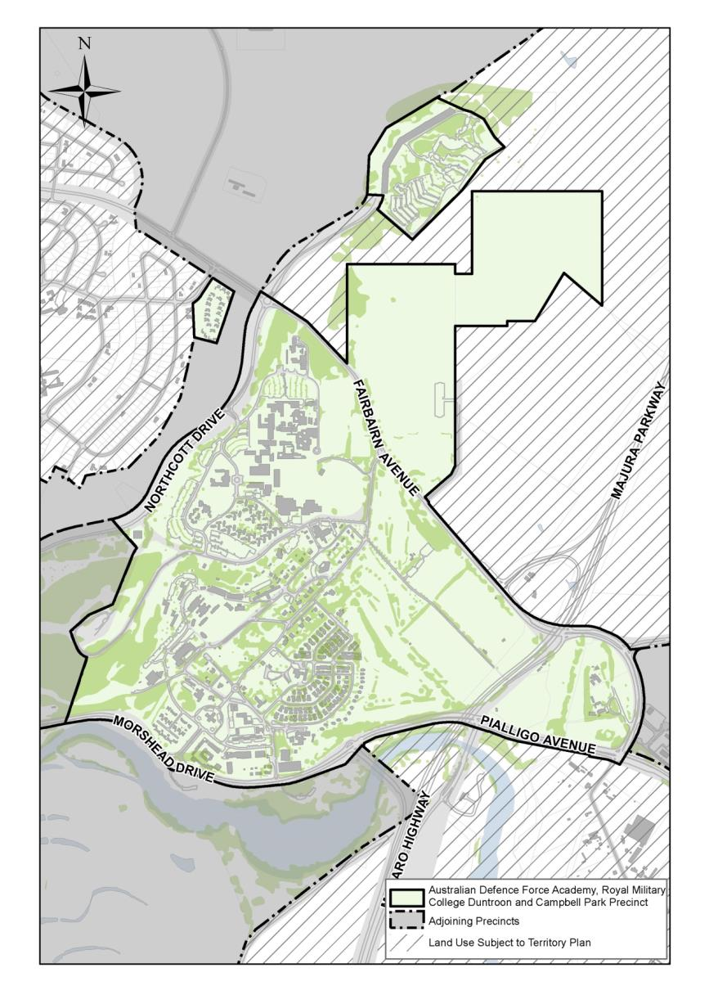
Figure 100: Australian Defence Force Academy, Royal Military College Duntroon, and Campbell Park Precinct location

4.9.2 Background
The foundation of the RMC in Canberra was initiated concurrently with the competition for the design of Canberra in 1911. The Griffin plan identifies the site for a ‘Military Post’ at the eastern end of the municipal axis and in a later version, identifies the Military College on its present site.
The pastoral property of Duntroon was acquired by the Australian Government in 1912 and cadets from the college played a prominent role in the life of the new city.
RMC provides military training for all potential Army General Service Officers (GSO). RMC also undertakes the military component of training for army cadets at ADFA.
The landscape character of the site varies according to topography and land use. The upper slopes have a native woodland character, linking the site to the Inner Hills. The dominant landscape character of the mid-slopes consists of mixed exotic species, including some eucalypts, with an understorey of hedges and screen shrubs. An open landscape character dominates the flat areas, where large canopy trees define spaces for playing fields and closed training areas.
The current ADFA campus was designed and planned in the early 1980s, as the primary tertiary institution for the Australian Defence Force and was officially opened on 11 December 1986.

4.9.3 Objectives for Australian Defence Force Academy, Royal Military College Duntroon, and Campbell Park Precinct
The vision for RMC and ADFA is that they will continue to provide premier academic and military facilities and meet the academic and military training needs for the Australian Defence Force for the foreseeable future.
Both Institutions represent a vital element of Canberra’s role as the National Capital. RMC is the only Army officer training facility in Australia, and, given its historical significance, sense of tradition and heritage character, is an important representation of Army presence in the national capital. ADFA is the centre for tertiary education for the Australian Defence Force (ADF) and educates approximately 30% of all Officer cadets within the tri-services of the ADF.
Objectives in achieving the vision are:
- To encourage shared use facilities, located centrally to both ADFA and RMC
- To achieve greater efficiency and increased flexibility in buildings and infrastructure to reflect changing uses
- To consolidate housing within existing residential areas
- To maintain and enhance sporting and recreational facilities to meet ADFA and RMC needs
- To conserve and manage significant natural, cultural and Indigenous heritage values.
The site is located within the Central National Area and a high quality of planning and development should be achieved within a design context appropriate to its location.
Planning for RMC and ADFA is to be based on an integrated and sustainable approach to future use and development of both sites. Improved integration between the two sites and greater opportunities for shared use of facilities are expected outcomes.
The Master Plan is to facilitate upgrading domestic, academic and recreational facilities to ensure that they meet contemporary military and academic training needs and comply with current access, health and safety standards.
The urban design values of RMC and ADFA are to be recognised, protected and enhanced as an integral component of future development. In particular, the urban composition that incorporates the Headquarters Building, Morshead Drive and the Fairbairn Avenue Entry (the ‘Gun Gates’) is to be recognised for its significance to the urban character of RMC.
Development is intended to occur in a manner consistent with the principles of water sensitive urban design incorporating integration of stormwater treatment into the landscape, protection of water quality (particularly in relation to the Molonglo River and its tributaries), and reduction of run-off and peak flows.

4.9.4 Constraints
The Constraints Map (Figure 101) provides a context for the Master Plan and describes the primary planning issues to be considered with respect to development of the site. Significant constraints are illustrated on the Constraints Map and are described below.

Environmental constraints
Several areas of vegetation and potential fauna habitats listed under Australian Government environment legislation occur on site. These include:
- White Box – Yellow Box – Blakely’s Red Gum Grassy Woodland and Derived Native Grassland (including Leucochrysum albicans var. tricolor (Hoary Sunray)
- Natural temperate Grassland of the Southern Tablelands of NSW and the Australian Capital Territory (including habitat for several threatened fauna species).

Heritage
The RMC Duntroon Conservation Area is listed on the Commonwealth Heritage List. Individual buildings or locations within the RMC Duntroon Conservation Area are also listed individually on the Commonwealth Heritage List. These include Duntroon House and Garden, Changi Chapel and the ANZAC Chapel of St Paul, Parade Ground and Associated Buildings Group, and individual residences and sheds.

Airport generated constraints
The northern portion of ADFA is affected by constraints generated by its proximity to Canberra International Airport, including:
- Areas of high aircraft generated noise (High Noise Corridor) – residential development and other noise sensitive land uses would be restricted in this area
- The Airport Obstacle Limitation Surface (AOLS) – height limitations apply to all forms of development within areas affected by this constraint.
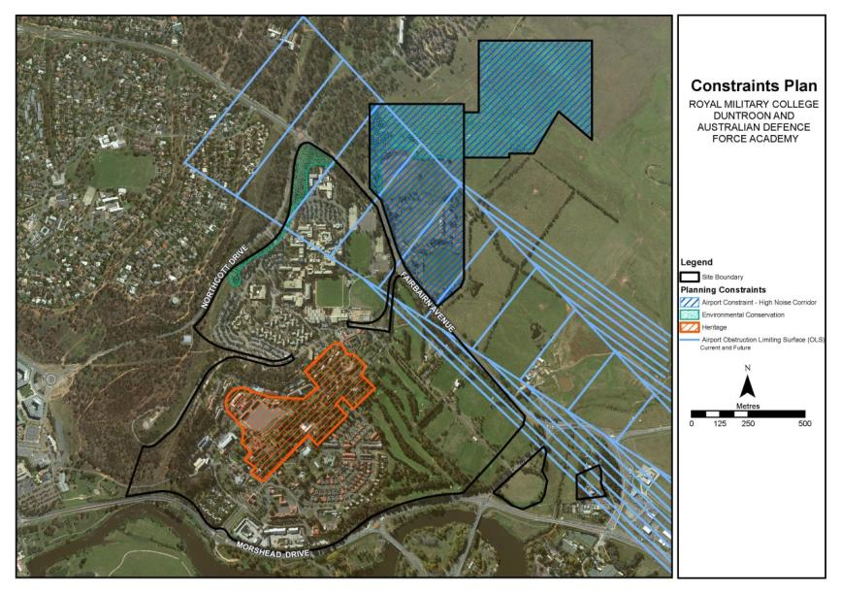
Figure 101: Australian Defence Force Academy and Royal Military College Duntroon – Constraints Plan

4.9.5 Land use for Australian Defence Force Academy, Royal Military College Duntroon, and Campbell Park Precinct
Land use for the Australian Defence Force Academy, Royal Military College Duntroon, and Campbell Park Precinct should be in accordance with Figure 102.
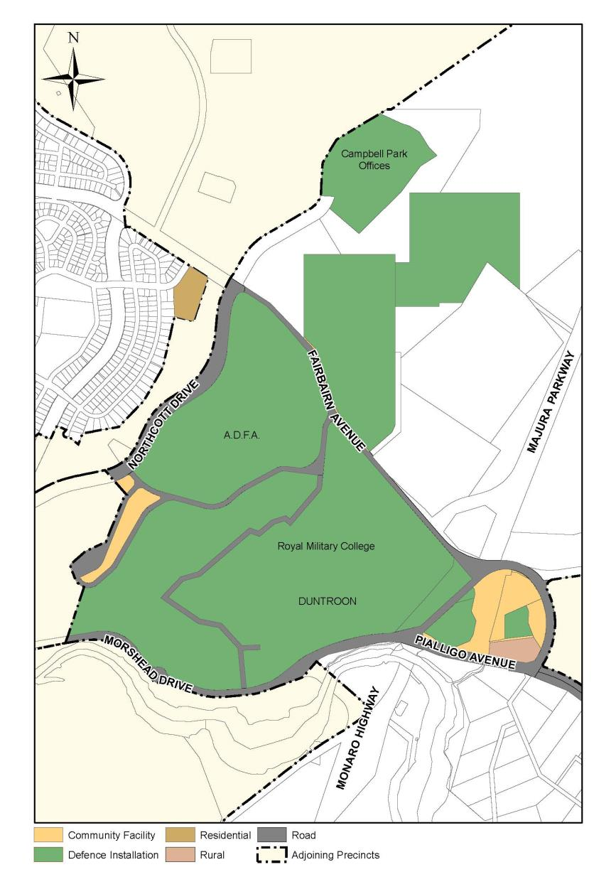
Figure 102: Land use for the Australian Defence Force Academy, Royal Military College Duntroon, and Campbell Park Precinct
ADFA and Duntroon are further divided into ‘zones’ that correspond with the primary purposes within the overall function of the facility as a military training and academic institutions (refer Figure 103. Likely land uses which are permissible within each zone are listed in Table 1.

Campbell Park Offices and Academy Close
The range and nature of uses permitted at Campbell Park Offices is:
- Defence Installation
- Office (up to a maximum of 55,000 m2 gross floor area).
The range and nature of uses permitted on land at Academy Close is Residential.
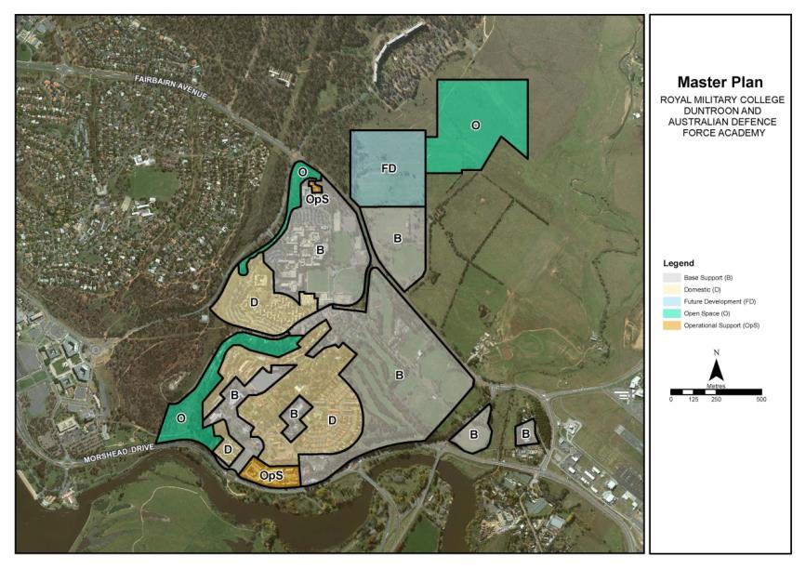
Figure 103: Australian Defence Force Academy and Royal Military College Duntroon – Zone map
Table 1: Australian Defence Force Academy and Royal Military College Duntroon - Permissible likely uses within Precincts
Precinct | Primary purpose | Permissible likely uses
Operational Support Precinct | To provide areas for buildings or infrastructure for personnel supporting key capability functions. | This precinct is intended to provide facilities for a Defence Installation and Scientific Research Establishment.
Base Support Precinct | To provide areas for activities associated with the general occupation and function of an establishment or facility, without adversely affecting operational or operational support activities. | This precinct is intended to provide facilities for a Defence Installation. Support activities that would be appropriate for this precinct would include Community Facility, Community Protection Facility, Child Care Centre, Indoor Recreation Facility, Outdoor Recreation Facility and Personal Services Establishment.
Domestic Precinct | To provide areas for activities associated with the domestic functions of an establishment or facility, without adversely affecting operational, operational support or base support activities. | This precinct is intended to provide Residential and Social/Community Facilities.
Open Space Precinct | To provide buffers between incompatible internal and external activities; to enable conservation and/or enhancement of land with significant environmental values; and to avoid land being targeted for future development on land that is unsuitable for such purposes. | This precinct is intended to provide facilities for a Defence Installation (training and recreation equipment), Landscape Buffer and Open Space.
Future Development Precinct | To identify larger parcels of developable land that can facilitate the future expansion of activities within the base or establishment. | This precinct applies to uncommitted land and is to be retained for the future uses of the Defence Installation.

New developments with potential to provide services, recreational or community facilities to both ADFA and RMC should generally be located within the vicinity of General Bridges Drive.
Priority should be given to land uses which strongly relate to the academic and military training functions of the sites.

4.9.6 Detailed conditions of planning, design and development

Urban design, building height and setback
New buildings, site works and landscape treatment should complement and enhance the existing facilities with special emphasis on three areas:
- The RMC Duntroon Conservation Area;
- The Main Entry to RMC Duntroon from Morshead Drive (‘The Badge Gates’); and
- The Entry from Fairbairn Avenue (‘The Gun Gates’).
All new work in the RMC Duntroon Conservation Area is to be consistent with the existing character in scale and by use of materials, treatment of façades and landscape works.
A limit of three storeys applies to all new buildings at RMC and four storeys at ADFA to maintain consistent scale of built form and protect the amenity of neighbouring buildings.
New residential buildings (excluding Live In Accommodation (LIA)) should be a maximum of two storeys in height. New residential buildings should generally be consistent with the height of existing residential development and be designed to protect the amenity of neighbouring buildings.
Where the development site abuts an existing dwelling or LIA, sufficient spatial separation should be provided to ensure the development does not adversely impact on residential amenity.
The siting and location of new development should be compatible with external land uses and set back 20 metres from arterial roads (Morshead Drive and Fairbairn Avenue) to provide a landscape buffer.

Landscape
A landscape structure is to be devised which adds to the legibility of the site by reinforcing the identity of each precinct, establishing pedestrian links and a hierarchy of vehicle circulation.
The open area of land along the ridgeline adjacent to General Bridges Drive will remain as a landscape buffer between RMC and ADFA. No buildings will be constructed within this zone.
Strong vegetative screening is to be maintained along Morshead Drive adjacent to the Operational Support Zone.
Landscape treatment of the perimeter areas is to be compatible with the adjacent land use, the adjacent road and the quality and character of the existing landscape. The perimeter landscape treatment must be a minimum of 20 metres wide, measured from the road verge (except where constrained by existing conditions).
The landscape treatment and the urban design elements (portals, etc) of the Main Entry (‘The Badge Gates’) to RMC should reflect the formal, prestigious role of the College. The planting of the entry avenue is to be of a formal, deciduous character, similar to the RMC Duntroon Conservation Area.
The Fairbairn Avenue (‘The Gun Gates’) entry, from Fairbairn Avenue to the RMC Duntroon Conservation Area (Robert Campbell Road) will be planted with Eucalypts to create a link to the rural surrounds and to retain views beneath the canopy to ADFA.
At the junction of the entry avenue and the RMC Duntroon Conservation Area emphasis is to be given to the change in landscape character. Beyond this point the road verge planting is to be continued in deciduous trees and the character of the spaces formalised.

Car parking, access and movement
All car parking demand generated by day to day activities should be accommodated within the confines of RMC and ADFA. Any parking that is displaced by new development is to be replaced elsewhere on the site.
Car parking should be designed and sited to ensure the safe and efficient movement of vehicles, including buses.
Developments should be integrated with the internal pedestrian network and provide safe and convenient access for pedestrians.
Development should ensure access is maintained to key sites along General Bridges Drive including the Duntroon Health Centre and General Bridges’ Grave.
Car parking is to be provided in small lots, well screened and landscaped.

Architectural character
The architectural character and quality of all buildings should be of a consistently high standard and should seek consistency in terms of scale, materials, colours, finishes and detail.
Perimeter development should be of a consistent architectural character and quality, befitting the national significance of the site and the Approach Routes to the National Capital.
Within the Operational Support Precinct, large stores and workshop buildings should be designed so as to limit their bulk and visual intrusion by, for example, articulation with recessed elements and varied setbacks.
The articulation, material and colour of building should be sympathetic to the heritage values of any adjacent heritage listed place.

Royal Military College Duntroon main entrance
Portal entry structures (‘Badge Gates’) should be retained to mark formal entry to the college from Morshead Drive.
New buildings should be located symmetrically of the avenue axis. Building character, materials and massing should be consistent with the character of the Parade Ground buildings.
Strong formal avenue planting should be established with a visual link to the round-about. Screening of residential and logistics complex from avenues is required.

4.9.7 Academy Close – Detailed conditions of planning design and development

4.9.7.1 Planning and urban design objectives
The site is to be redeveloped in single ownership to a quality appropriate to its location adjacent to an Approach Route. Specifically, development should:
- make provision for Australian Defence Force personnel accommodation
- respect the natural features, character and scale of the landscape in the locality
- enhance the landscape character of Fairbairn Avenue as one of Walter Burley Griffin’s approach routes and as one of the main approaches to the Australian War Memorial
- be carefully sited within a landscaped setting and screened from view of Fairbairn Avenue
- allow for flexibility in design to ensure integration with the surrounding urban context
- allow for buildings with an appropriate urban scale relationship to Fairbairn Avenue and adjacent suburban Campbell
- ensure a high level of amenity is provided in site layout and urban design and that noise impacts are mitigated through appropriate building design, materials and construction
- maintain and reinforce, where possible, the existing landscape character of the site to achieve a high quality redevelopment within a natural setting.

4.9.7.2 Concept plan
Figure 104 illustrates a proposed concept plan for development of the site. Specifically, the concept plan shows the following:
- a detailed plan of dwelling layout and densities, that provides for appropriate dwelling orientation to achieve maximum solar access for the majority of dwellings
- building setbacks, building height and scale (up to a maximum of two storeys above natural ground level)
- indicative development staging (if necessary)
- a general landscape plan that encourages the retention of existing trees of high quality and integration of these into the new landscape (where possible)
- a parking plan showing scope for all visitor and resident parking on-site
- requirements for fencing, including provision for fencing consistent with nature reserve and bushfire risk management
- provisions for continued public right-of-way along the western side of the site adjacent to Blocks 26, 27, 28 and 29 Section 59 Campbell
- continued vehicular access/egress to Truscott Street.

4.9.7.3 Site layout, built form, setbacks and solar access
- Site density is to be a maximum of 18 dwellings per hectare.
- Individual blocks must not be less than 260m².
- All dwellings must be setback from the boundary of Block 3 Section 65 Campbell a minimum of four metres. Dwellings must be setback the following minimum distances from individual internal block boundaries:
- three metres to the front
- two metres to the side
- four metres to the rear.
- All dwellings must be sited to allow a minimum of three hours of direct sunlight onto the floor or internal wall of the main daytime living area of the dwelling between the hours of 9.00am and 3.00pm on 21 June (winter solstice).
- A minimum of 36m² of private open space must be provided per dwelling. This area of private open space is to be located to the rear of the dwelling.
- A minimum of 120m² of open space per dwelling must be provided in public open space areas.

4.9.7.4 Building materials and architectural quality
- Buildings and other permanent structures should be designed to a high architectural design standard.
- All building materials used on site must comprise high quality durable materials consistent with the character of Campbell. Highly reflective external materials are not permitted
- Building plant such as airconditioners must be contained within building form, or totally screened from view.
- Building materials, construction and finishes are to be responsive to microclimate issues. A high level of environmentally sustainable design is encouraged.

4.9.7.5 Landscape treatment and fencing
- A high standard of landscape design and verge treatment is required for the Truscott Street and Fairbairn Avenue frontages.
- Mature vegetation should be retained to the maximum extent practicable and integrated into the landscape design. Where existing trees must be removed, this should be compensated for by planting elsewhere on the site. A tree report must accompany proposals for development and justification provided for the removal of medium or high quality trees.
- All proposed fencing to external site boundaries must be constructed of high quality materials and integrated with the overall landscape design of the site.
- Landscape treatments on site must be sympathetic to the surrounding area. Native species of advanced stock should dominate new plantings.
- Additional landscape planting will be provided along the Truscott Street and Fairbairn Avenue verges adjacent to the site to reinforce the landscape character of this entrance to Campbell.
- Dwellings must be setback a minimum of 20 metres to the Truscott Street site boundary, and 10 metres from the Fairbairn Avenue site boundary.

4.9.7.6 Access and parking
- A single site access point to the site will be from Truscott Street. No access is permitted from Fairbairn Avenue.
- Access to individual dwellings must be from an internal, private loop road.
- Internal roads are to have a minimum road reservation of six metres and a minimum road pavement width of 3.5 metres. Visitor parking and passing bays are permitted on internal roads.
- All parking must be accommodated on site.
- Each dwelling must have a minimum of one car parking space. One visitor space per four dwellings or part there of must be provided.
- All private driveways and garages must front internal roads. No access to individual blocks will be permitted from Truscott Street or Fairbairn Avenue.
- A traffic and parking assessment must accompany development proposals for the site.
- Pedestrian right-of-way must be maintained along the western boundary of the site, to allow direct pedestrian access from Truscott Street through to the Canberra Nature Reserve.

4.9.7.7 Environmental considerations
- Any adverse environmental impacts from on-site developments or on adjacent land must be identified and redressed to the extent practicable.
- Environmental protection measures must be adopted to minimise possible adverse impacts of any new development or redevelopment on the physical environment, in terms of air quality, noise, waste water run-off, storm water run-off, dust, steam and smoke.

4.9.7.8 Lighting
- All outdoor lighting must be designed and sited to minimise light pollution. Outdoor lighting must use full cut-off light fittings.

4.9.7.9 Detailed design
- Detailed plans prepared for the development on the site will be subject to public notification and consultation.
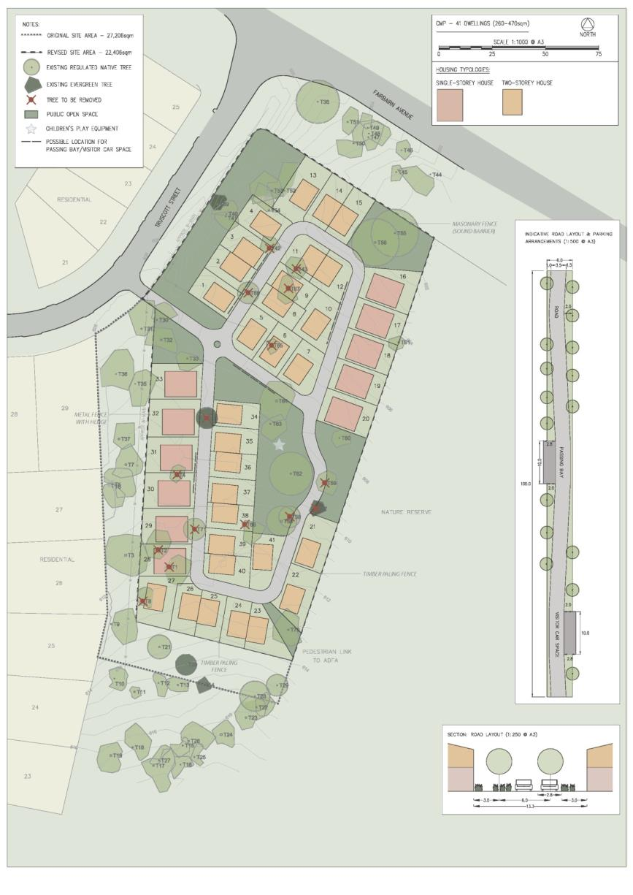
Figure 104: Academy Close concept design

4.10 AUSTRALIAN NATIONAL BOTANIC GARDENS PRECINCT CODE

4.10.1 Precinct location
The Australian National Botanic Gardens Precinct lies on the eastern slopes of Black Mountain. The Precinct is bound by the Commonwealth Scientific and Industrial Research Organisation (CSIRO) Black Mountain campus to the north-east, Clunies Ross Street and Parkes Way to the east and south, and the upper slopes of Black Mountain to the north and west.
Figure 105 illustrates the location of the Australian National Botanic Gardens Precinct.
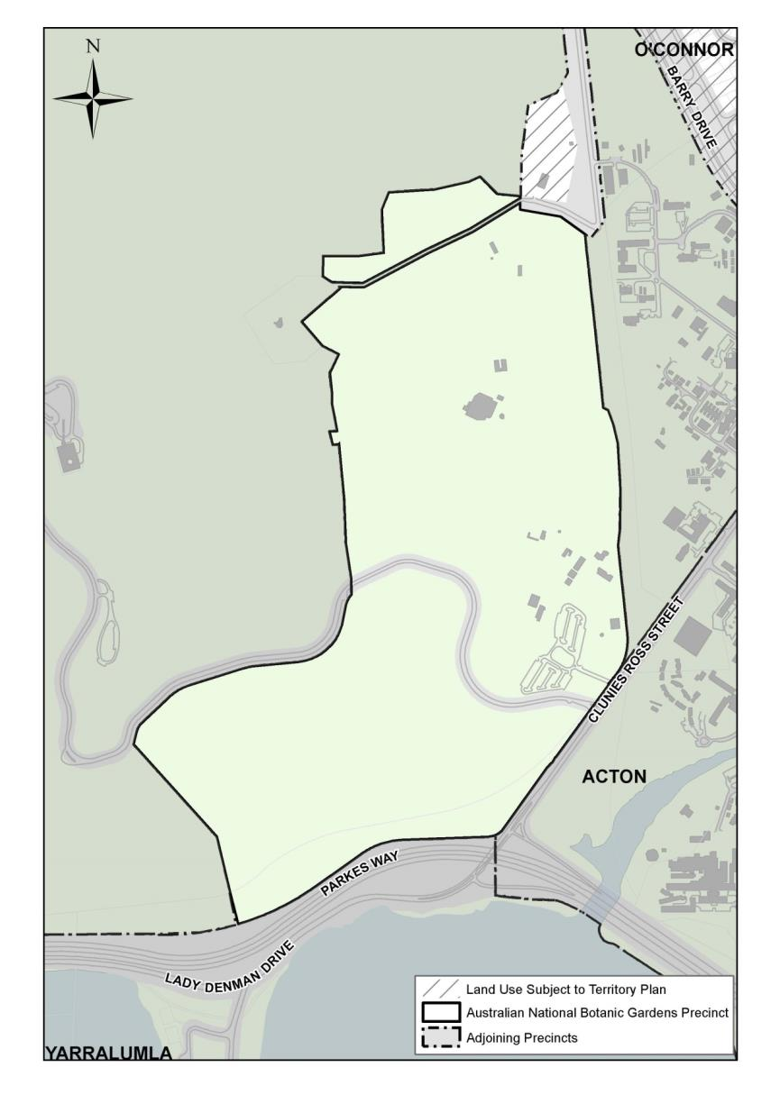
Figure 105: Australian National Botanic Gardens Precinct location

4.10.2 Background
The Australian National Botanic Gardens (the Gardens) enjoy a prominent position within the Central National Area of the National Capital. The location of the Gardens on the slopes of Black Mountain and in close proximity to Lake Burley Griffin gives a rare scenic beauty to the Precinct. The predominant landscape environment and the sensitive siting of buildings under the natural tree cover further enhance the setting.
The Gardens have been consistently planned to serve as a scientific institution with an educational role while also providing visitors with a quiet natural haven complete with walking trails and picnic spots. Looking from the Gardens across Lake Burley Griffin, one can see such Canberra landmarks as Parliament House, and the National Library. Although somewhat camouflaged by the leafy canopy, the Gardens are visible from vantage points all around Lake Burley Griffin and the Central National Area, and including other locations such as the Australian National University, City and the CSIRO.
As a key feature of the original Griffin plan, the Gardens have special national significance. Situated partly within the original location and on adjacent land on the lower slopes of Black Mountain, the Gardens fulfil their role as a landscape backdrop to central Canberra. A favourable micro-climate allows an unequalled array of native flora to flourish thereby contributing positively to the character of the capital.
The gardens were included in the Griffin plan because they were an important element in a relationship which united the National Triangle, the Central National Area and other Designated Areas.
The commitment of the Gardens to Australian flora has a wider context. Since the inaugural tree planting in 1949, the Gardens have developed as the major national scientific and educational collection of Australian flora. The display of Australian native plants is recognised nationally and internationally as one of the most comprehensive in the world including, as an integrated resource, a national collection of living and herbarium specimens for study, conservation, interpretation and display.
The Gardens support the goal of Ecologically Sustainable Development (ESD) as outlined by the Australian Government. One of the principles of ESD, the maintenance of bio-diversity, is the basis of policies which sustain and expand the environmental resource base. The Gardens recognise the need to extend the range of species in cultivation for Australian flora to be adequately preserved, interpreted and protected for posterity. In doing so, it will further increase the botanical significance of the collection.
The scientific, aesthetic and recreational values of the Gardens have been recognised by inclusion in the Commonwealth Heritage List, thereby ensuring the protection of the philosophy, policies and physical structure of this precious natural resource.
The national significance of the Gardens is recognised as follows:
- the Gardens are a national institution
- the use of the site forms an integral component of Griffin's composition for Canberra
- the Gardens contribute to the visual quality of the National Capital.

4.10.3 Objectives for Australian National Botanic Gardens Precinct
- Ensure all developments are consistent with ESD principles.
- Contribute to the special characteristics of the National Capital within the context of a cohesive framework.
- Development of the Gardens will evolve incrementally and be capable of incorporating worthy changes within the framework in response to economic, administrative, management and environmental circumstances and in accordance with its national significance.
- Development will allow for the establishment, maintenance and display to the highest possible standard of the national collection of Australian native flora and related species. This is to include research, conservation, education and recreation enhancing the existing standard of landscape, built form and environmental design.
- Opportunities for the maintenance and enhancement of the linkages to adjacent sites and in particular the Central National Area, through paths and/or visual landscape corridors will be encouraged.

4.10.4 Land use for Australian National Botanic Gardens Precinct
Land use for the Australian National Botanic Gardens Precinct should be in accordance with Figure 106.
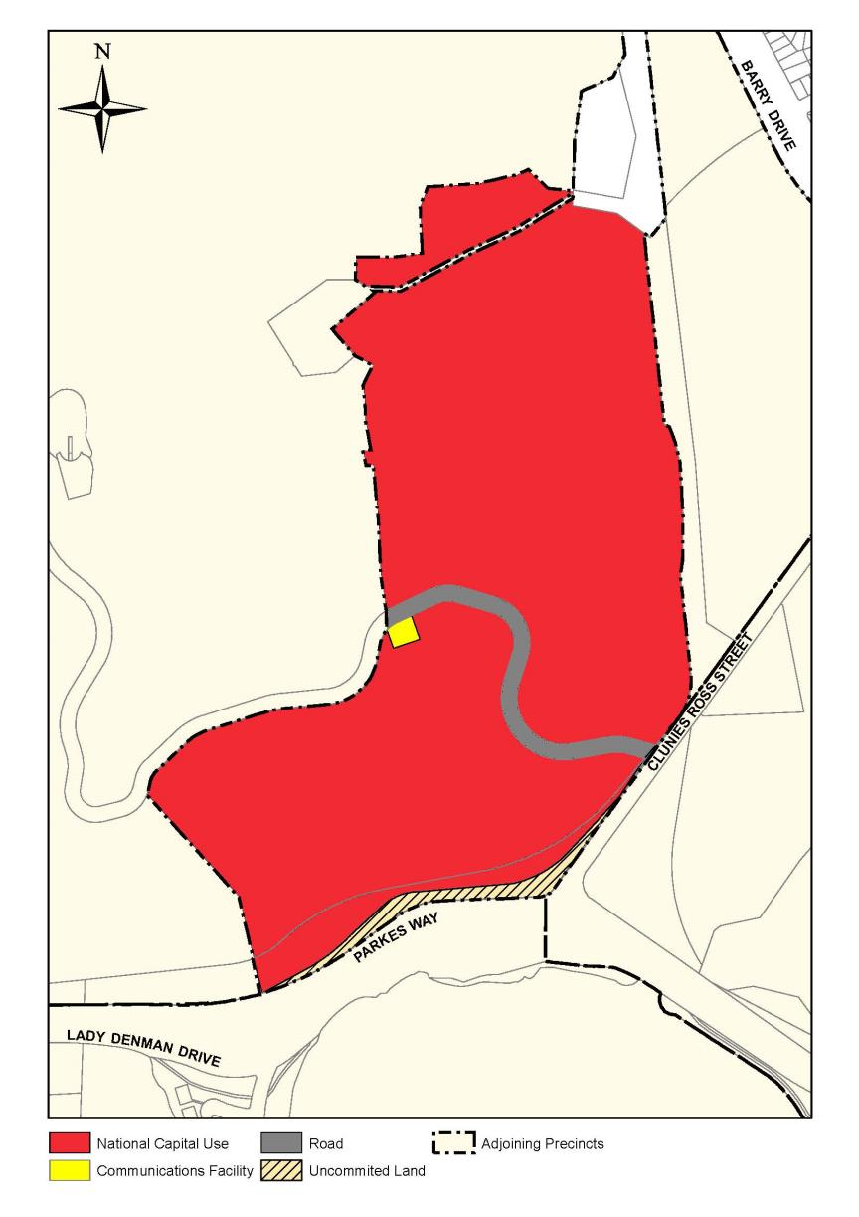
Figure 106: Land use for the Australian National Botanic Gardens Precinct
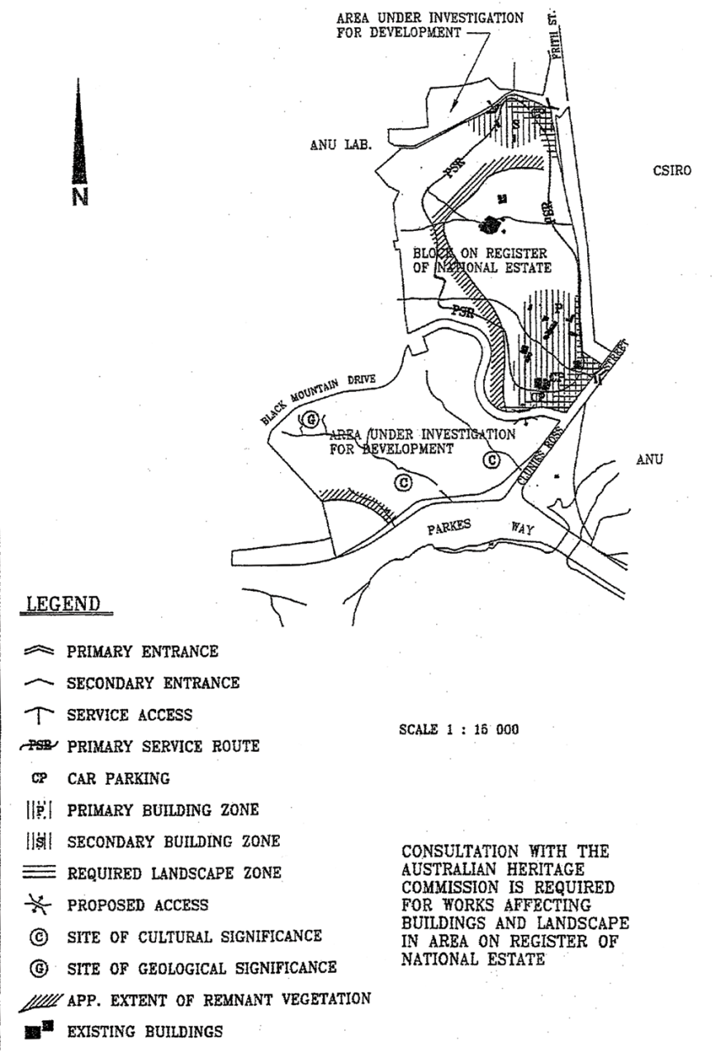
Figure 107: Australian National Botanic Gardens Master Plan

4.10.5 Detailed conditions of planning, design and development

Activity location
The location of activities within the Australian National Botanic Gardens has an impact on national significance. The following principles and policies for activity location should reinforce national significance and allow the unique qualities of the site to continue.

Principles
- The location of visitor orientated displays should encourage maximum utilisation of established infrastructure and relate to a clearly defined pedestrian system.
- Future development should consolidate similar uses into defined common activity zones located to minimise conflicts between visitors, staff and servicing activities so as to contain dispersion of uses, minimise functional conflicts, and improve the operational effectiveness while maximising visitor amenity.
- Service trades functions should be consolidated wherever possible and generally be located within the Secondary Building Zone with rear service access from the service road network.
- Major building development, redevelopment opportunities and the location of major structures should be carefully determined in relation to their built form, landscape and environmental impacts and should be within either the Primary or Secondary Building Zone.
- Provide and enhance a 'gateway' to the site that befits its location and national significance.

Policies
- Consultation with the relevant authority is required for works affecting the heritage values of that part of the Gardens entered on the Commonwealth Heritage List whether for works within that land or within its immediate surroundings.
- Generally, visitor access to the Gardens should be via the major or primary entrance from Clunies Ross Street while service access should be from Frith Street. Vehicle circulation for service vehicles only is to be facilitated by a primary service vehicle route.
- Car parking facilities will generally be provided in formal car parks in the Primary Building Zone on the basis of the current provision of 223 spaces for visitors and a further 28 spaces for staff and official use. In addition, there will be four designated coach parking spaces provided.
- Within the Secondary Building Zone, car parking will be provided on the basis of 40 spaces for staff and 40 spaces for visitors in a landscaped setting well screened from Frith Street. The design of the parking areas will be in accordance with the appropriate Australian Standard.
- Development of areas identified as ‘under investigation for development’ will be subject to the preparation of a plan setting out development concepts, impacts and proposal details to the satisfaction of the National Capital Authority. Such a plan may form the basis of an amendment to the Precinct Code.

Landscape
The overall landscape structure should assist the integration of the Gardens within the contextual landscape provided by Black Mountain and adjacent land uses, and should exhibit national significance. The landscape structure of the Gardens will be predicated on the following principles and policies.

Principles
- The Gardens should maintain and enhance the site's unique landscape and environmental character and exhibit support for ESD.
- Opportunities should be encouraged for the enhancement and reinforcement of the physical, symbolic and visual linkages to adjoining areas of the Inner Hills and the Central National Area.
- Future development should recognise and reinforce the visual landscape character of the site as an integral part of the Central National Area, by preserving and reinforcing where possible the Eucalyptus canopy which extends down Black Mountain.

Policies
- Landscape treatment within the required landscape zone where shown on Figure 107 should be planned, implemented and maintained to provide a visual screening of car parks and service roads and accentuate the national significance of the Australian National Botanic Gardens. Screening should generally achieve a minimum planting width of six metres.
- A clearly defined and signed pedestrian system should be provided that focuses on existing and planned facilities. The system should be developed which takes into account walking distances, gradients, and provides maximum accessibility to as many visitor attractions as possible.
- The topography of the Gardens offer a range of opportunities for the design of car parks exploiting changes in level. Preference will be given to the planting of appropriate trees, shrubs and cascading ground covers to assist in reducing the visual impact of retaining walls and other hard surfacing.
- Site furniture should be designed within a coordinated theme reflecting the Australian landscape, and utilising local materials wherever possible.
- A coordinated thematic signage system integrated with the site furniture should be implemented to provide locational, directional, thematic and interpretative information.
- Generally the colour scheme to be used throughout the Gardens should reflect natural colours reflecting the landscape of the Australian native flora.
- The sensitive siting of artworks will be encouraged in locations which offer opportunities for artistic expression and the creative interaction between art and the forms, textures, and colours of the landscape context.

Environment
The Gardens contain elements of cultural significance, remnant vegetation, and sites of geomorphological and geological significance (refer to Figure 107). Part of the Gardens have significant heritage values, and for this reason has been placed on the Commonwealth Heritage List.

Principles
- The identification, conservation and interpretation of sites or elements of cultural or natural significance will take place, and development will be in accordance with the conservation values of those identified sites and elements.
- Development of the Gardens is to conform to relevant Commonwealth and ACT environmental legislation.

Policies
- Sites of cultural significance within the Gardens should be identified and if necessary a cultural resource survey carried out to clarify status before any development occurs. The sites will not be disturbed. The opportunity for sites to be available as an educational resource should be investigated.
- In general, remnant forest should be retained and managed for conservation, education and wildlife habitat. Isolated trees should be retained wherever possible. Trees which are dead or dying or in the senile phase should be retained if they exhibit habitat value, are not hazardous to the public (or can be rendered safe), and do not unduly detract from the aesthetic appeal of horticultural displays or occupy growing space better utilised by living specimens.
- Water draining from propagation facilities and standing-out areas should not be channelled directly to the stormwater system. Such water is to be retained within the Gardens site in appropriate structures (for example, retention ponds), and/or intercepted on-site in effluent filters (for example, artificial wetlands). Water retention/interception structures are to be in place before the construction of new development commences, and consideration should be given to their visual integration in the surrounding landscape.
- Sites of geomorphological significance are to be treated as an educational and scientific resource, and maintained in a way which is consistent with these values (for example, minimal disturbance of exposures; periodic removal of colonising plants). Consideration should be given to interpreting these features through appropriate signage and educational materials.
- Sites of geological significance are to be maintained as an unobscured exposure to preserve the scientific and educational values. Consideration should be given to interpreting these features through appropriate signage and educational materials.

Building
Whilst buildings within the Gardens are considered to be secondary to plant material, it is important that they have a character and form that acknowledges their function, the site’s national significance and their location within the site. Therefore, built form should be sympathetic and planned to assist and complement the landscape structure of the Gardens.

Principles
- Buildings of similar character and function should be grouped generally within the Primary and Secondary Building Zones to create and define spaces and add to the site's overall landscape structure to create a sequence of built form elements that assist and complement visitor education.
- Buildings should demonstrate ecologically sustainable development through their planning and construction reflecting the conservation of energy and the environment and demonstrating their positive contribution to enhancing the landscape character within the opportunities and constraints of an Australian environment.
- Provide for the continued development of the Gardens in accordance with its national significance and agreed plan of priorities set out in the Plan of Management.

Policies
- The scale and external treatment of buildings, including materials, colours and general standards of finish should ensure that the buildings, walls, fences and other ancillary structures, support and do not detract from the national significance of the site and are within the unity of an overall design theme.
- A plan is required to be prepared to the satisfaction of the National Capital Authority for any proposed building development within the Primary and Secondary Building Zones. Such a plan will include details of development concepts and, linkages, together with environment, landscape and visual impacts and details of floor area, building footprints, materials, colours and any other matters the National Capital Authority considers necessary.
- Generally, buildings should be of a scale that does not result in the domination of built form over the natural environment. Materials should demonstrate a sympathetic integration of architecture and environmental design, and colours should generally be passive using colour schemes sympathetic to the Australian natural environment.
- The maximum height of buildings in the Gardens is restricted to the height of the contextual tree canopy to maintain the visual integrity of the Inner Hills. In order to ensure visual integrity is maintained, a visual assessment of the site as viewed from external public vantage points will be required for any building or dominant structure development. Buildings and other dominant structures should not be placed on or near prominent ridges.
- The erection of structures above roofs and signage should comply with the Design and Siting and Signs General Codes.

