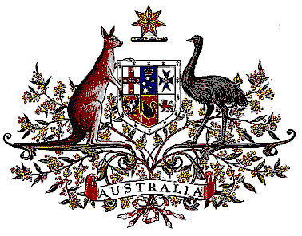

Veterans’ Entitlements Act 1986

Determination of Hazardous Service

I, Bruce Billson, Minister for Veterans’ Affairs, for the Minister for Defence:

  - revoke the Determination made under paragraph 120(7)(b) of the Veterans’ Entitlements Act 1986 (the Act) on 25 September 1992 in relation to service in Afghanistan with the United Nations Office for Co-ordinating Assistance to Afghanistan (UNOCA) or the United Nations Mine Clearing Training Team (UNMCTT) on or after 8 June 1991; and
  - determine that:
    - service rendered as a member of the Australian Defence Force with the United Nations Office for Co-ordinating Assistance to Afghanistan (UNOCA) or the United Nations Mine Clearing Training Team (UNMCTT) on or after 8 June 1992 in the specified area, is hazardous service for the purposes of the definition of “hazardous service” in paragraph 120(7) of the Act, and
    - the specified area comprises Afghanistan.
  - This Determination is taken to have commenced on 8 June 1992.

Dated 19 July 2006

BRUCE BILLSON
Minister for Veterans’ Affairs
for the Minister for Defence

