Vehicle Standard (Australian Design Rule 49/00 – Front and Rear Position (Side) Lamps, Stop Lamps and End Outline Marker Lamps) 2006
I, JAMES ERIC LLOYD, Minister for Local Government, Territories and Roads, determine this vehicle standard under subsection 7 (1) of the Motor Vehicle Standards Act 1989.

Dated 10 August 1905

[Signed]

James Eric Lloyd

Minister for Local Government, Territories and Roads

CONTENTS

0. legislative provisions 3
1. SCOPE 3
2. APPLICABILITY AND IMPLEMENTATION 3
3. DEFINITIONS 3
4. REQUIREMENTS 3
5. EXEMPTIONS AND ALTERNATIVE PROCEDURES 4
6. SUPPLEMENTARY GENERAL REQUIREMENTS 4
7. ALTERNATIVE STANDARDS 4
8. NOTES 5
APPENDIX A 6

- legislative provisions
  - NAME OF STANDARD
    - This Standard is the Vehicle Standard (Australian Design Rule 49/00 – Front and Rear Position (Side) Lamps, Stop Lamps and End Outline Marker Lamps) 2006.
    - This Standard may also be cited as Australian Design Rule 49/00 — Front and Rear Position (Side) Lamps, Stop Lamps and End Outline Marker Lamps.
  - COMMENCEMENT
    - This Standard commences on the day after it is registered.
  - REPEAL
    - This Standard repeals each vehicle standard with the name Australian Design Rule 49/00 — Front and Rear Position (Side) Lamps, Stop Lamps and End Outline Marker Lamps that is:
(a) made under section 7 of the Motor Vehicle Standards Act 1989; and
(b) in force at the commencement of this Standard.
    - This Standard also repeals each instrument made under section 7 of the Motor Vehicle Standards Act 1989 that creates a vehicle standard with the name Australian Design Rule 49/00 — Front and Rear Position (Side) Lamps, Stop Lamps and End Outline Marker Lamps, if there are no other vehicle standards created by that instrument, or amendments to vehicle standards made by that instrument, that are still in force at the commencement of this Standard.
- SCOPE
This Australian Design Rule (ADR) prescribes the photometric requirements for light-signalling devices which will indicate the presence, width and position of the vehicle when viewed from the front and from the rear.
- APPLICABILITY AND IMPLEMENTATION
  - The circumstances under which position, stop and end-outline marker lamps are mandatory, optional, or prohibited are set out in either ADRs 13/…, 19/… or 67/….
- DEFINITIONS
  - Refer to paragraph 1 of Appendix A.
- REQUIREMENTS
  - Devices complying with the technical requirements of Appendix A as varied by part 5 Exemptions and Alternative Procedures and part 6 Supplementary General Requirements shall be accepted as complying with this rule.
- EXEMPTIONS AND ALTERNATIVE PROCEDURES
  - The following provisions of Appendix A do not apply to this vehicle standard
    - Section 2 Application for approval
Section 3 Markings
Section 4 Approval
Section 9 Conformity of production – partial (for particular deletions to the section refer to paragraphs 5.1.2)
Section 10 Penalties for non conformity of production
Section 11 Production definitely discontinued
Section 13 Names and addresses of technical services responsible for conducting approval tests, and of administrative departments
Section 14 Transitional provisions
Annexes
Annex 2 Communication concerning the approval (or refusal or withdrawal of approval or production definitely discontinued) of a type of reflex reflecting device pursuant to Regulation No. 7
Annex 3 Examples of arrangements of approval marks
    - Paragraphs 2.3 and 3.3 in Annex 7
- SUPPLEMENTARY GENERAL REQUIREMENTS
The following general requirements are supplementary to the requirements of Appendix A:
  - The requirements and procedures set out in Annexes 6 and 7 of Appendix A are acceptable for the purposes of demonstrating compliance with the technical requirements of this standard.
  - The colour of emitted light shall be as indicated in Table 1 of paragraph 6.2 of ADR 13/00.
    - The colour of front end outline marker lamps may be amber in which case the following trichromatic coordinates apply:
Limit towards yellow: y ≤ 0.429
Limit towards red : y ≥ 0.398
Limit towards white: y ≤ 0.007
- ALTERNATIVE STANDARDS
  - The technical requirements of any of the editions of United Nations –Economic Commission (UN ECE) for Europe Regulation No. 7 - UNIFORM PROVISIONS CONCERNING THE APPROVAL OF FRONT AND REAR POSITION (SIDE) LAMPS, STOP LAMPS AND END-OUTLINE MARKER LAMPS FOR MOTOR VEHICLES (EXCEPT MOTOR CYCLES) AND THEIR TRAILERS, incorporating the 01 series of amendments up to and including the edition incorporating the 02 series of amendments are deemed to be equivalent to the technical requirements of this rule.
- NOTES
  - In place of Regulation No 48 where referenced in Appendix A, read ADR 13/00.
  - In place of Regulation No 37 where referenced in Appendix A, read ADR 51/00.
APPENDIX A

UN-ECE REGULATION NO. 7
UNIFORM PROVISIONS CONCERNING THE APPROVAL OF FRONT AND REAR POSITION (SIDE) LAMPS, STOP LAMPS AND END-OUTLINE MARKER LAMPS FOR MOTOR VEHICLES (EXCEPT MOTOR CYCLES) AND TRAILERS
Regulation No. 7
UNIFORM PROVISIONS CONCERNING THE APPROVAL OF FRONT AND REAR POSITION (SIDE) LAMPS, STOP-LAMPS AND END-OUTLINE MARKER LAMPS FOR MOTOR VEHICLES (EXCEPT MOTOR CYCLES) AND THEIR TRAILERS CONTENTS REGULATION

1. Definitions
2. Application for approval
3. Markings
4. Approval
5. General specifications
6. Intensity of light emitted
7. Test procedure
8. Colour of light emitted
9. Conformity of production
10. Penalties for non-conformity of production
11. Production definitely discontinued
12. Remarks concerning colours and particular devices
13. Names and addresses of technical services responsible for conducting approval tests, and of administrative departments
14. Transitional provisions
ANNEXES
Annex 1 - Front and rear position (side) lamps, end-outline marker lamps and stop-lamps: minimum angles required for light distribution in space of these lamps
Annex 2 - Communication concerning the approval (or refusal or extension or withdrawal of approval or production definitely discontinued) of a type of device pursuant to Regulation No. 7
Annex 3 - Arrangements of approval marks
Annex 4 - Photometric measurements
Annex 5 - Colours of lights
Annex 6 - Minimum requirements for conformity of production control procedures
Annex 7 - Minimum requirements for sampling by an inspector

Regulation No. 7
UNIFORM PROVISIONS CONCERNING THE APPROVAL OF FRONT AND REAR POSITION (SIDE) LAMPS, STOP-LAMPS AND END-OUTLINE MARKER LAMPS FOR MOTOR VEHICLES (EXCEPT MOTOR CYCLES) AND THEIR TRAILERS
1. DEFINITIONS
For the purposes of this Regulation,
1.1. "Front position (side) lamp" means the lamp used to indicate the presence and the width of the vehicle when viewed from the front;
1.2. "Rear position (side) lamp" means the lamp used to indicate the presence and the width of the vehicle when viewed from the rear;
1.3. "Stop-lamp" means the lamp used to indicate to other road-users to the rear of the vehicle that its driver is applying the service brake; the stop-lamps may be activated by the application of a retarder or a similar device;
1.4. "End-outline marker lamps" means a lamp fitted near to the extreme outer edges and as close as possible to the top of the vehicle and intended to indicate clearly the vehicle's overall width. In the case of certain power-driven vehicles and trailers, this lamp is intended to complement the vehicle's position (side) lamps and draw special attention to its outline;
1.5. Definitions of terms:
The definitions given in Regulation No. 48 and its series of amendments in force at the time of application for type approval shall apply to this Regulation.
1.6. "Front and rear position (side) lamps, stops lamps and end-outline marker lamps" means lamps which differ in each said category in such essential respects as:
The trade name or mark,
The characteristics of the optical system (levels of intensity, light distribution angles, type of filament lamp, etc.),
The system used to reduce illumination at night - in the case of stop-lamps with two levels of intensity.
2. APPLICATION FOR APPROVAL
2.1. The application for approval shall be submitted by the holder of the trade name or mark or by his duly accredited representative. It shall specify:
2.1.1. The purpose or purposes for which the device submitted for approval is intended and whether it may also be used in an assembly of two lamps of the same kind/type;
2.1.2. In the case of an end-outline marker lamp, whether it is intended to emit white or red light;
2.1.3. In the case of a front or rear position (side) lamp, whether it is intended to emit white, selective-yellow or red light.
2.2. For each type of device, the application shall be accompanied by:
2.2.1. Drawings, in triplicate, in sufficient detail to permit identification of the type of the device and showing in what geometrical position the device is to be mounted on the vehicle; the axis of observation to be taken as the axis of reference in the tests (horizontal angle H = 0 degrees, vertical angle V = 0 degrees); and the point to be taken as the centre of reference in the said tests. The drawings shall show the position intended for the approval number and the additional symbols in relation to the circle of the approval mark;
2.2.2. A brief technical description stating, in particular, with the exception of lamps with non- replaceable light sources; the category or categories of filament lamps prescribed; this filament lamp category shall be one of those contained in Regulation No. 37.
2.2.3. In the case of a stop-lamp with two levels of intensity, an arrangement diagram and a specification of the characteristics of the system ensuring the two levels of intensity;
2.2.4. Two samples; if the approval is applied for devices which are not identical but are symmetrical and suitable for mounting one on the left and one on the right side of the vehicle, the two samples submitted may be identical and be suitable for mounting only on the right or only on the left side of the vehicle; in the case of a stop-lamp with two levels of intensity, the application shall also be accompanied by two samples of the parts constituting the system which ensures two levels of intensity.
3. MARKINGS
Devices submitted for approval:
3.1. Must bear the trade name or mark of the applicant; this marking must be clearly legible and be indelible;
3.2. Must bear a clearly legible and indelible marking indicating the category or categories of filament lamps prescribed; this is not valid for lamps with non-replaceable light sources.
3.3. Must comprise a space of sufficient size for the approval marking and the additional symbols prescribed in paragraph 4.5 below; this space shall be shown in the drawings mentioned in paragraph 2.2.1 above.
3.4. In the case of lamps with non-replaceable light sources, must bear the marking of rated voltage and rated wattage.
4. APPROVAL
4.1. General
4.1.1. If the two devices which are submitted in pursuance of paragraph 2.2.4 above satisfy the provisions of this Regulation, approval shall be granted.
4.1.2. When two or more lamps are part of the same unit of grouped, combined or reciprocally incorporated lamps, approval may be granted only if each of these lamps satisfies the provisions set out in this Regulation or in another Regulation. Lamps not satisfying the provisions of any of those Regulations shall not be part of such unit of grouped, combined or reciprocally incorporated lamps.
This provision shall not apply to headlamps fitted with a double-filament bulb, where only one beam is approved.
4.1.3. An approval number shall be assigned to each type approved. Its first two digits (at present 02) shall indicate the series of amendments incorporating the most recent major technical amendments made to the Regulation at the time of issue of the approval. The same Contacting Party shall not assign the same number to another type of device covered by this Regulation, except in case approval is extended to a device which only differs from the already approved device by the colour of the light emitted.
4.1.4. Notice of approval or of extension or refusal or of withdrawal of approval or production definitely discontinued of a type of device pursuant to this Regulation shall be communicated to the Parties to the 1958 Agreement applying this Regulation, by means of a form conforming to the model in annex 2 to this Regulation.
4.1.5. Every device conforming to a type approved under this Regulation shall bear, in the space referred to in paragraph 3.3 above, and in addition to the markings prescribed in paragraphs 3.1 and 3.2 or 3.4 respectively, an approved mark as described in paragraphs 4.2 and 4.3 below.
4.2. Composition of the approval mark
The approval mark shall consist of:
4.2.1. An international approval mark, comprising:
4.2.1.1. a circle surrounding the letter "E" followed by the distinguishing number of the country which has granted approval; 1/
4.2.1.2. the approval number prescribed in paragraph 4.1.3 above.
4.2.2. The following additional symbol or symbols:
4.2.2.1. On devices meeting the requirements of this Regulation in respect of the front position (side) lamps, the letter "A";
4.2.2.2. On devices meeting the requirements of this Regulation in respect of the rear position (side) lamps, the letter "R";
4.2.2.3. On devices meeting the requirements of this Regulation in respect of the stop-lamps, the letter "S" followed by the figure:
"1" when the device has one level of illumination;
"2" when the device has two levels of illumination;
"3" when the device meets the specific requirements for category S3 stop lamps.
4.2.2.4. On devices comprising both a rear position (side) lamp and a stop lamp meeting the requirements of this Regulation in respect of such lamps, the letters "R" and "S1" or "S2" as the case may be, separated by a horizontal dash;
4.2.2.5. On front or rear position lights of which the visibility angles are asymmetrical with regard to the reference axis in a horizontal direction, an arrow pointing towards the side on which the photometric specifications are met up to an angle of 80 degrees H;
4.2.2.6. On lamps which may be used as single lamps and as part of an assembly of lamps, the additional letter "D" to the right of the symbol mentioned in paragraphs 4.2.2.1 to 4.2.2.4;
4.2.3. The two digits of the approval number (at present 02 corresponding to the 02 series of amendments which entered into force on 5 May 1991) which indicate the series of amendments incorporating the most recent major technical amendments made to the Regulation at the time of issue of the approval and, if necessary, the required arrow may be marked close to the above additional symbols.
4.3. Arrangement of the approval mark
4.3.1. Independent lamps
Annex 3, paragraphs 1 to 4, gives examples of arrangements of the approval mark with the above-mentioned additional symbols.
4.3.2. Grouped, combined or reciprocally incorporated lamps
4.3.2.1. Where grouped, combined or reciprocally incorporated lamps have been found to comply with the requirements of several Regulations, a single international approval mark may be affixed, consisting of a circle surrounding the letter "E" followed by the distinguishing number of the country which has granted the approval, and an approval number. This approval mark may be located anywhere on the grouped, combined or reciprocally incorporated lamps, provided that:
4.3.2.1.1. It is visible after their installation;
4.3.2.1.2. No part of the grouped, combined or reciprocally incorporated lamps that transmits light can be removed without at the same time removing the approval mark.
4.3.2.2. The identification symbol for each lamp appropriate to each Regulation under which approval has been granted, together with the corresponding series of amendments incorporating the most recent major technical amendments to the Regulation at the time of issue of the approval and, if necessary, the required arrow shall be marked:
4.3.2.2.1. Either on the appropriate light-emitting surface,
4.3.2.2.2. Or in a group, in such a way that each of the grouped, combined or reciprocally incorporated lamps may be clearly identified.
4.3.2.3. The size of the components of a single approval mark shall not be less than the minimum size required for the smallest of the individual marks under which approval has been granted.
4.3.2.4. An approval number shall be assigned to each type approved. The same Contracting Party may not assign the same number to another type of grouped, combined or reciprocally incorporated lamps covered by this Regulation.
4.3.2.5. Paragraph 5 of annex 3 to this Regulation gives examples of arrangements of approval marks for grouped, combined or reciprocally incorporated lamps with all the above- mentioned additional symbols.
4.3.3. Lamps reciprocally incorporated with a type of headlamp of which the lens is also used for other types of headlamps
The provisions laid down in paragraph 4.3.2 above are applicable.
4.3.3.1. However, if different types of headlamps or of units of lamps including a headlamp comprise the same lens, the latter may bear the different approval marks relating to these types of headlamps or units of lamps, provided that the main body of the headlamp, even if it cannot be separated from the lens, also comprises the space described in paragraph 3.3 above and bears the approval marks of the actual functions.
If different types of headlamps comprise the same main body, the latter may bear the different approval marks.
4.3.3.2. Paragraph 6 of annex 3 to this Regulation gives examples of approval marks relating to lamps which are reciprocally incorporated with a headlamp.
5. GENERAL SPECIFICATIONS
5.1. Each device supplied shall conform to the specifications set forth in paragraphs 6 and 8 below
5.2. The devices must be so designed and constructed that in normal conditions of use, and notwithstanding the vibrations to which they may be subjected in such use, their satisfactory operation remains assured and they retain the characteristics prescribed by this Regulation.
5.3. Lamps having been approved as front or rear position (side) lamps, are deemed being also approved end-outline marker lamps.
5.4. Front and rear position (side) lamps which are grouped or combined or reciprocally incorporated may also be used as end-outline marker lamps.
6. INTENSITY OF LIGHT EMITTED
6.1. In the reference axis, the light emitted by each of the two devices supplied must be of not less than the minimum intensity and of not more than the maximum intensity specified below:
6.1.1. Front position (side) lamps, front end-outline marker lamp
Minimum intensities cd | Maximum values in cd when used as
Minimum intensities cd | Single lamp | Lamp(single) marked "D" (paragraph 4.2.2.6) | Total for the assembly of two lamps (paragraph 4.2.2.6)
4 | 60 2/ | 42 ^{2/} | 84 ^{2/}
6.1.2. Front position (side) lamps incorporated in headlamp
Minimum intensities cd | Maximum values in cd when used as
Minimum intensities cd | Single lamp | Lamp(single) marked "D" (paragraph 4.2.2.6) | Total for the assembly of two lamps (paragraph 4.2.2.6)
4 | 100 ^{2/} | - | -
6.1.3. Rear position (side) lamps rear end-outline marker lamp
Minimum intensities cd | Maximum values in cd when used as
Minimum intensities cd | Single lamp | Lamp(single) marked "D" (paragraph 4.2.2.6) | Total for the assembly of two lamps (paragraph 4.2.2.6)
4 | 12 ^{2/} | 8.5 ^{2/} | 17 ^{2/}
6.1.4. Stop lamps 1/
6.1.4.1. with 1 level of intensity (category S1)
Minimum intensities cd | Maximum values in cd when used as
Minimum intensities cd | Single lamp | Lamp(single) marked "D" (paragraph 4.2.2.6) | Total for the assembly of two lamps (paragraph 4.2.2.6)
60 | 185 ^{2/} | 130 ^{2/} | 260 ^{2/}
6.1.4.2. With 2 levels of intensity (category S2)
6.1.4.2.1. by day
Minimum intensities cd | Maximum values in cd when used as
Minimum intensities cd | Single lamp | Lamp(single) marked "D" (paragraph 4.2.2.6) | Total for the assembly of two lamps (paragraph 4.2.2.6)
130 | 520 ^{2/} | 366 ^{2/} | 728 ^{2/}
6.1.4.2.2. by night
Minimum intensities cd | Maximum values in cd when used as
Minimum intensities cd | Single lamp | Lamp(single) marked "D" (paragraph 4.2.2.6) | Total for the assembly of two lamps (paragraph 4.2.2.6)
30 | 80 ^{2/} | 56 ^{2/} | 112 ^{2/}
6.1.4.3. stop-lamps of category S3
Minimum intensities cd | Maximum values in cd when used as
Minimum intensities cd | Single lamp | Lamp(single) marked "D" (paragraph 4.2.2.6) | Total for the assembly of two lamps (paragraph 4.2.2.6)
25 | 80 ^{2/} | 55 ^{2/} | 110 ^{2/}
6.2. Outside the reference axis and within the angular fields defined in the diagrams in annex 1 to this Regulation, the intensity of the light emitted by each of the two devices supplied must:
6.2.1. In each direction corresponding to the points in the light distribution table reproduced in annex 4 to this Regulation, be not less than the product of the minimum specified in paragraph 6.1 above by the percentage specified in the said table for the direction in question;
6.2.2. In no direction within the space from which the light-signalling device is visible, exceed the maximum specified in paragraph 6.1 above;
6.2.3. However, a luminous intensity of 60 cd shall be permitted for rear position (side) lamps reciprocally incorporated with stop-lamps (see paragraph 6.1.3 above) below a plane forming an angle of 5 degrees with and downward from the horizontal plane;
6.2.4. Moreover,
6.2.4.1. Throughout the fields defined in the diagrams in annex 1, the intensity of the light emitted must be not less than 0.05 cd for front and rear position (side) lamps and end- outline marker lamps, not less than 0.3 cd for stop-lamps with one level of intensity, and for stop-lamps with two levels of intensity 0.3 cd by day and 0.07 cd by night;
6.2.4.2. If a rear position (side) lamp is reciprocally incorporated with a stop-lamp, the ratio between the luminous intensities actually measured of the two lamps when turned on simultaneously at the intensity of the rear position (side) lamp when turned on alone should be at least 5 : 1 in the field delimited by the straight horizontal lines passing through +/- 5 degrees V and the straight vertical lines passing through +/- 10 degrees H of the light distribution table. If the stop-lamp has two levels of intensity, this requirement must be satisfied when the night condition is switched on;
6.2.4.3. The provisions of paragraph 2.2 of annex 4 to this Regulation on local variations of intensity must be observed.
6.3. The intensities shall be measured with the filament lamp(s) continuously alight and, in the case of devices emitting selective-yellow or red light, in coloured light.
6.4. In the case of a stop-lamp providing two levels of intensity the time that elapses between electrical supply being switched on and the light output measured on the reference axis to reach 90% of the value measured in accordance with paragraph 6.3 above shall be measured for both the day and the night conditions of use. The time measured for the night condition of use shall not exceed that measured for the day condition of use.
6.5. Annex 4, to which reference is made in paragraph 6.2.1 above, gives particulars of the methods of measurement to be used.
7. TEST PROCEDURE
7.1. All measurements shall be made with a white standard filament lamp of the category prescribed for the device, the supply voltage being so regulated as to produce the normal luminous flux prescribed for that category of lamp.
7.1.1. All measurements on lamps equipped with non-replaceable light sources (filament lamps and other) shall be made at 6.75 V, 13.5 V or 28.0 V respectively.
In the case of light sources supplied by a special power supply, the above test voltages shall be applied to the input terminals of that power supply. The test laboratory may require from the manufacturer the special power supply needed to supply the light sources.
7.2. However, in the case of a stop-lamp for which an additional system is used to obtain the night-time intensity, the voltage applied to the system for measuring the night-time intensity shall be that which was applied to the filament lamp for measuring the day-time intensity. 2/
7.3. Where a rear position (side) lamp is reciprocally incorporated with a dual-intensity stop- lamp and is designed to operate permanently with an additional system to regulate the intensity of the light emitted, measurement of the light emitted shall be performed with the same voltage applied to the system as would, if applied to the filament lamp, enable the lamp to produce the prescribed normal luminous flux.
7.4. The vertical and horizontal outlines of the illuminating surface of a light-signalling device (paragraph 1.6.2) shall be determined and measured in relation to the centre of reference (paragraph 1.6.5).
8. COLOUR OF LIGHT EMITTED
The colour of the light emitted shall be within the limits of the co-ordinates prescribed for the colour in question in annex 5 to this Regulation.
9. CONFORMITY OF PRODUCTION
The Conformity of Production procedures shall comply with those set out in the Agreement, Appendix 2 (E/ECE/324-E/ECE/TRANS/505/Rev. 2), with the following requirements:
9.1. Lamps approved under this Regulation shall be so manufactured as to conform to the type approved by meeting the requirements set forth in paragraphs 6 and 8 above.
9.2. The minimum requirements for Conformity of Production control procedures set forth in annex 6 to this Regulation shall be complied with.
9.3. The minimum requirements for sampling by an inspector set forth in annex 7 to this Regulation shall be complied with.
9.4. The authority which has granted type approval may at any time verify the conformity control methods applied in each production facility. The normal frequency of these verifications shall be once every two years.
10. PENALTIES FOR NON-CONFORMITY OF PRODUCTION
10.1. The approval granted in respect of a device may be withdrawn if the foregoing conditions are not satisfied.
10.2. If a Contracting Party to the Agreement applying this Regulation withdraws an approval it has previously granted, it shall forthwith so notify the other Contracting Parties applying this Regulation by means of a communication form conforming to the model in annex 2 to this Regulation.
11. PRODUCTION DEFINITELY DISCONTINUED
If the holder of the approval completely ceases to manufacture a device, approved in accordance with this Regulation, he shall so inform the authority which granted the approval. Upon receiving the relevant communication, that authority shall inform thereof the other Parties to the 1958 Agreement applying this Regulation, by means of a copy of a communication form conforming to the model in annex 2 to this Regulation.
12. REMARKS CONCERNING COLOURS AND PARTICULAR DEVICES
The Parties to the Agreement to which this Regulation is annexed are not precluded by article 3 of that Agreement from prohibiting, for devices installed on vehicles registered by them, certain colours for which provision is made in this Regulation, or from prohibiting for all categories or for certain categories of vehicles registered by them stop-lamps having only one level of luminous intensity.
13. NAMES AND ADDRESSES OF TECHNICAL SERVICES RESPONSIBLE FOR CONDUCTING APPROVAL TESTS, AND OF ADMINISTRATIVE DEPARTMENTS
The Parties to the Agreement applying this Regulation shall communicate to the United Nations secretariat the names and addresses of the technical services responsible for conducting approval tests and of the administrative departments which grant approval and to which forms certifying approval or extension or refusal or withdrawal of approval, issued in other countries, are to be sent.
14. TRANSITIONAL PROVISIONS
14.1. The Parties to the Agreement which apply this Regulation:
14.1.1. shall continue to recognize approvals issued in accordance with the unamended version (00 series) or the 01 series of amendments to this Regulation in respect of the fitting of devices intended as replacement for vehicles in use;
14.1.2. may issue approvals for devices on the basis of document E/ECE/324-E/ECETRANS/ 505/Add. 6 (unamended or 01 series of amendments) provided that the devices are intended as replacements for fitting to vehicles in use and that it would not be technically feasible for the devices in question to satisfy the new requirements contained in the 02 series of amendments;
14.1.3. may prohibit the fitting of devices which do not meet the requirements of this Regulation:
14.1.3.1. on vehicles for which type approval or individual approval was issued more than two years after the entry into force of the 02 series of amendments to the Regulation;
14.1.3.2. on vehicles first brought into use more than five years after the entry into force of the 02 series of amendments to the Regulation.
14.2. The provisions of this Regulation shall not prohibit the use of devices bearing the approval mark prescribed by this Regulation in its original form (00 series) or as amended by the 01 series, after the dates referred to in paragraphs 14.1.3.1 and 14.1.3.2.
14.3. Approvals in accordance with the 01 series of amendments may be granted during a period of 24 months after the date of entry into force of this series of amendments.
14.4. Approvals granted shall remain valid.
Annex 1
FRONT AND REAR POSITION (SIDE) LAMPS, END-OUTLINE MARKER LAMPS AND STOP- LAMPS: MINIMUM ANGLES REQUIRED FOR LIGHT DISTRIBUTION IN SPACE OF THESE LAMPS 1/
The minimum vertical angles of light distribution in space are 15 degrees above and 15 degrees below the horizontal for all categories of devices included in this Regulation except for category S3 stop lamp for which they are 10 degrees above and 5 degrees below the horizontal.
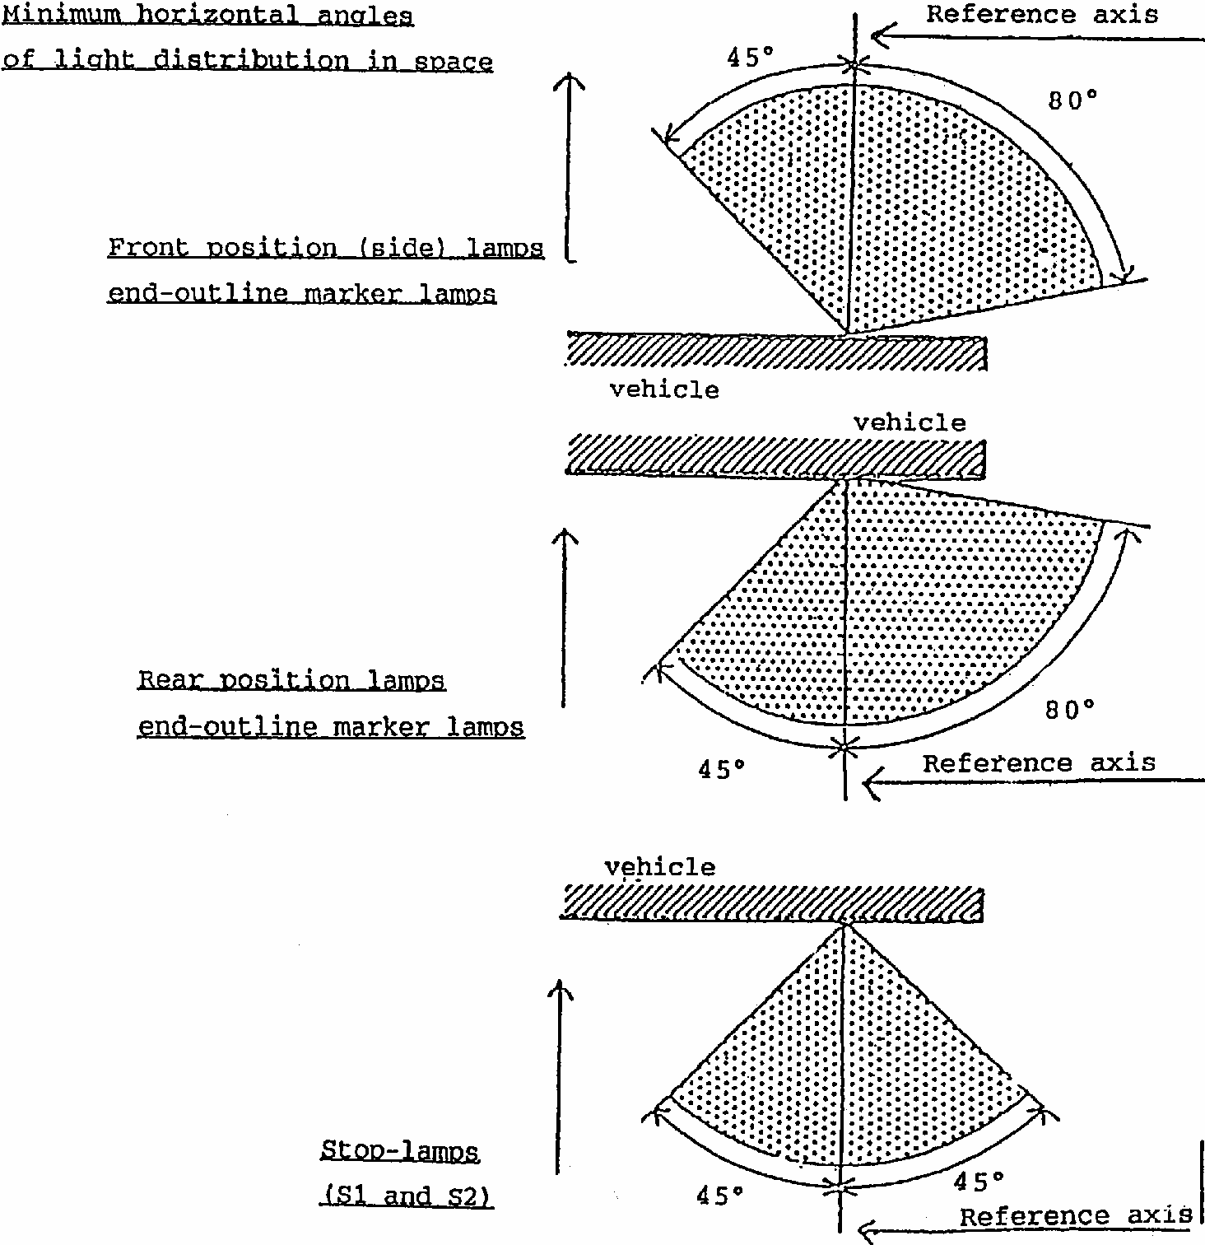
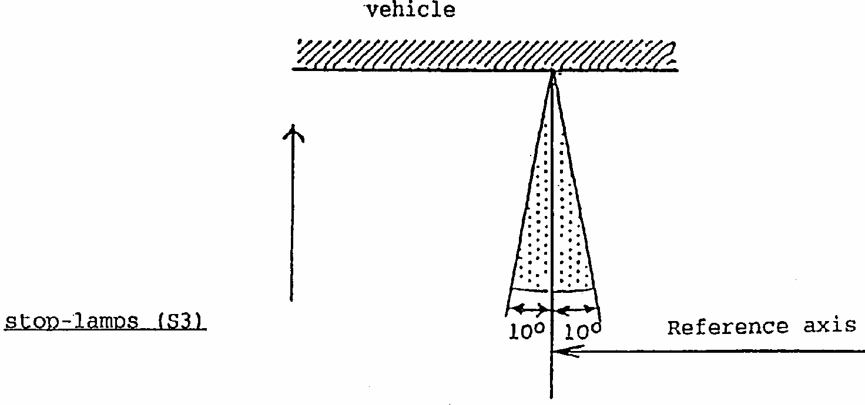
Annex 2 (to the Regulation)
COMMUNICATION
(maximum format: A4 (210 x 297 mm))
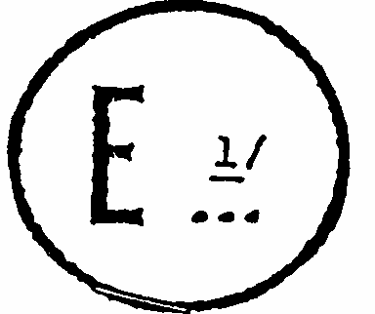
issued by: Name of administration:
..................................
..................................
..................................

concerning:2/ APPROVAL GRANTED
APPROVAL EXTENDED
APPROVAL REFUSED
APPROVAL WITHDRAWN
PRODUCTION DEFINITELY DISCONTINUED
of a type of: .............................................................
pursuant to Regulation No. 7
Approval No. .............. Extension No. ..............
1. Trade name or mark of the device:
2. Manufacturer's name for the type of device:
3. Manufacturer's name and address:
4. If applicable, name and address of the manufacturer's representative:
5. Submitted for approval on:
6. Technical service responsible for conducting approval tests:
7. Date of test report:
8. Number of test report:
9. Concise description:3/
By category of lamp:
Colour of light emitted: red/selective yellow/white ^{2/}
Number and category of filament lamp(s): (2 x P21W).
10. Position of the approval mark:
11. Reason(s) for extension (if applicable):
12. Approval granted/refused / extended/withdrawn: ^{2/}
13. Place:
14. Date:
15. Signature:
16. The list of documents deposited with the Administrative Service which has granted approval is annexed to this communication and may be obtained on request.
Annex 3
ARRANGEMENTS OF APPROVAL MARKS
1. Front position (side) lamp
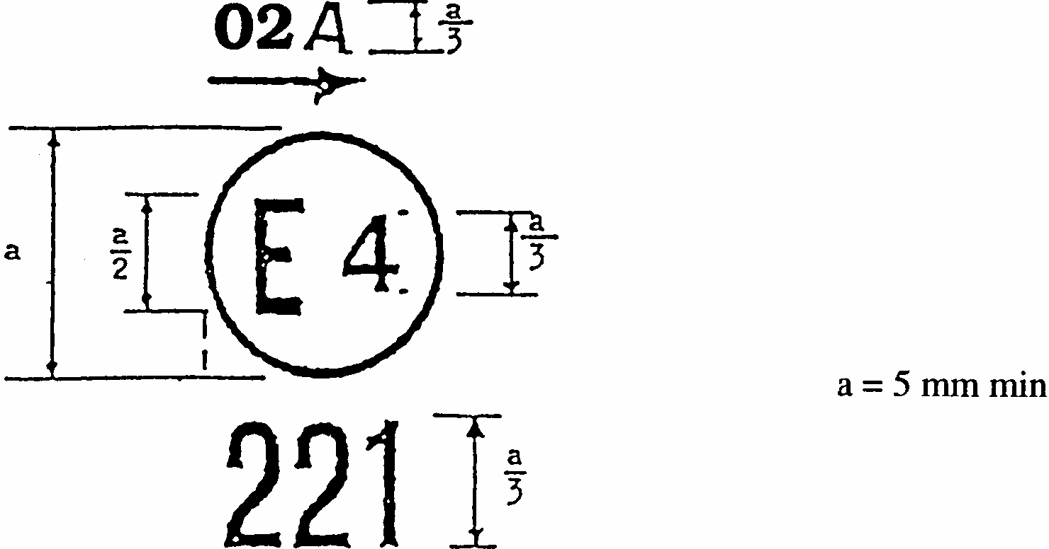
The device bearing the approval mark shown above is a front position (side) lamp approved in the Netherlands (E4), under approval number 221 pursuant to Regulation No. 7.
The number mentioned close to the symbol "A" indicates that approval was granted in accordance with the requirements of Regulation No. 7 as amended by the 02 series of amendments. The arrow indicates the side on which the required photometric specifications are met up to an angle of 80 degrees H.
2. Rear position (side) lamp
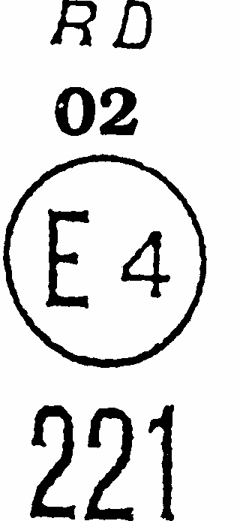
The device bearing the approval mark shown above is a rear position (side) lamp approved in the Netherlands (E4) under approval number 221 pursuant to Regulation No. 7, which may also be used in a unit of two rear position (side) lamps.
The number mentioned below the symbol "RD" indicates that approval was granted in conformity with the requirements of Regulation No. 7 as amended by the 02 series of amendments.
The absence of an arrow means that, both right and left, the required photometric specifications are met up to an angle of 80 degrees H.
3. Stop lamp
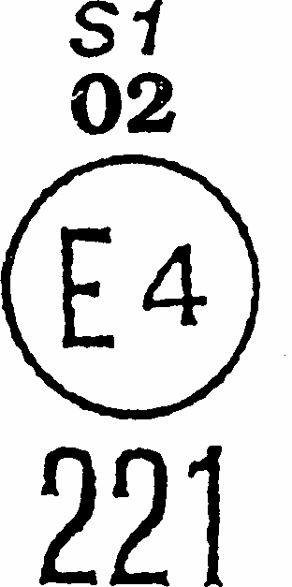
The device bearing the approval mark shown above is a stop lamp with one level of illumination approved in the Netherlands (E4) under approval number 221 pursuant to Regulation No. 7.
The number mentioned below the symbol "S1" indicates that the approval was granted in conformity with the requirements of Regulation No. 7 as amended by the 02 series of amendments.
4. Device comprising both a rear position lamp and a stop lamp
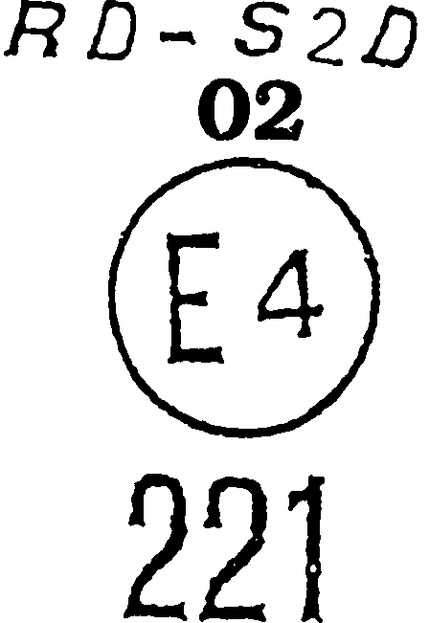
The device bearing the approval mark shown above is a device comprising both a rear (side) position lamp and a stop lamp with two levels of illumination, approved in the Netherlands (E4) under approval number 221 pursuant to Regulation No. 7.
The number mentioned below the symbol "RD-S2D" indicates that approval was granted in conformity with the requirements of Regulation No. 7 as amended by the 02 series of amendments. The rear position (side) lamp is incorporated into a stop lamp with two levels of illumination, which may also be used in a unit of two lamps.
The absence of an arrow means that, both right and left, the required photometric specifications are met up to an angle of 80 degrees H.
Note:
The approval number and the additional symbols shall be placed close to the circle and either above or below the letter "E", either to the right or to the left of that letter. The digits of the approval number shall be on the same side of the letter "E" and face the same direction. The approval number and the additional symbol including the number of the series of amendments to the Regulation in question, where applicable, shall be placed diametrically opposite to each other.
The competent authorities shall avoid using Roman numerals as approval numbers in order to prevent any confusion with other symbols.
5. Simplified marking of grouped, combined or reciprocally incorporated lamps when two or more lamps are part of the same unit
(The vertical and horizontal lines schematize the shape of the light-signalling device. These are not part of the approval mark.)
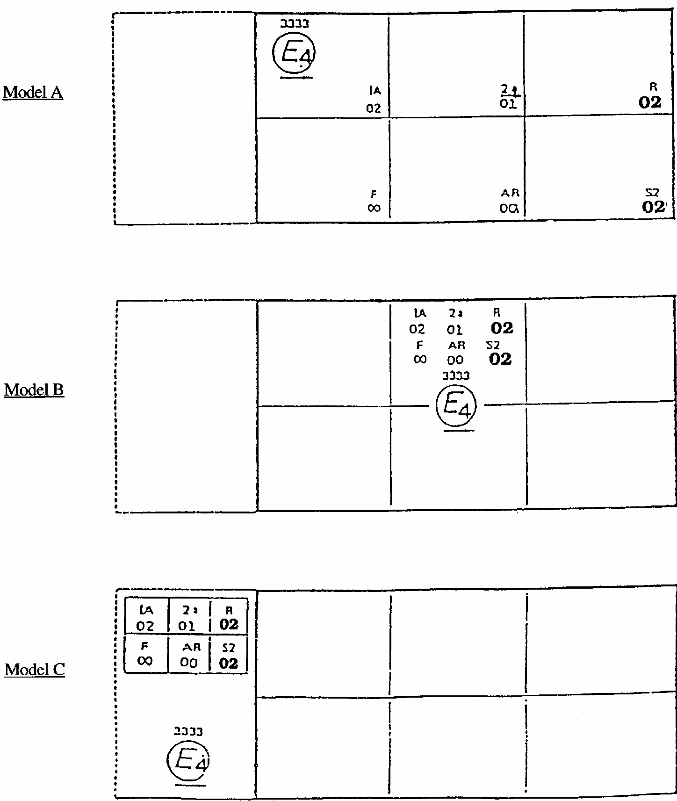
Note:
These three examples of approval marks (models A, B and C) represent three possible variables for the marking of a lighting device when two or more lamps are part of the same unit of grouped, combined or reciprocally incorporated lamps.
They indicate that the device was approved in the Netherlands (E4) under approval number 3333 and comprises:
A reflex-reflector of class 1A approved in accordance with the 02 series of amendments to Regulation No. 3,
A rear direction indicator lamp of category 2a approved in accordance with the 01 series of amendments to Regulation No. 6,
A red rear position (side) lamp (R) approved in accordance with the 02 series of amendments to Regulation No. 7,
A rear fog lamp (F) approved in accordance with Regulation No. 38 in its original version,
A reversing lamp (AR) approved in accordance with Regulation No. 23 in its original version.
A stop lamp with two levels of illumination (S2) approved in accordance with the 02 series of amendments to Regulation No. 7.
Note:
The three examples of approval marks (models D, E and F) below correspond to a lighting device bearing an approval mark comprising:
A front position (side) lamp approved in accordance with the 02 series of amendments to Regulation No. 7;
A headlamp with a passing beam designed for right- and left-hand traffic and a driving beam with a maximum intensity comprised between 86,250 and 111,250 candelas (indicated by the number "30"), approved in accordance with the 02 series of amendments to Regulation No. 20,
A front fog lamp approved in accordance with the 02 series of amendments to Regulation No. 19;
A front direction indicator lamp of category 1a approved in accordance with the 01 series of amendments to Regulation No. 6.
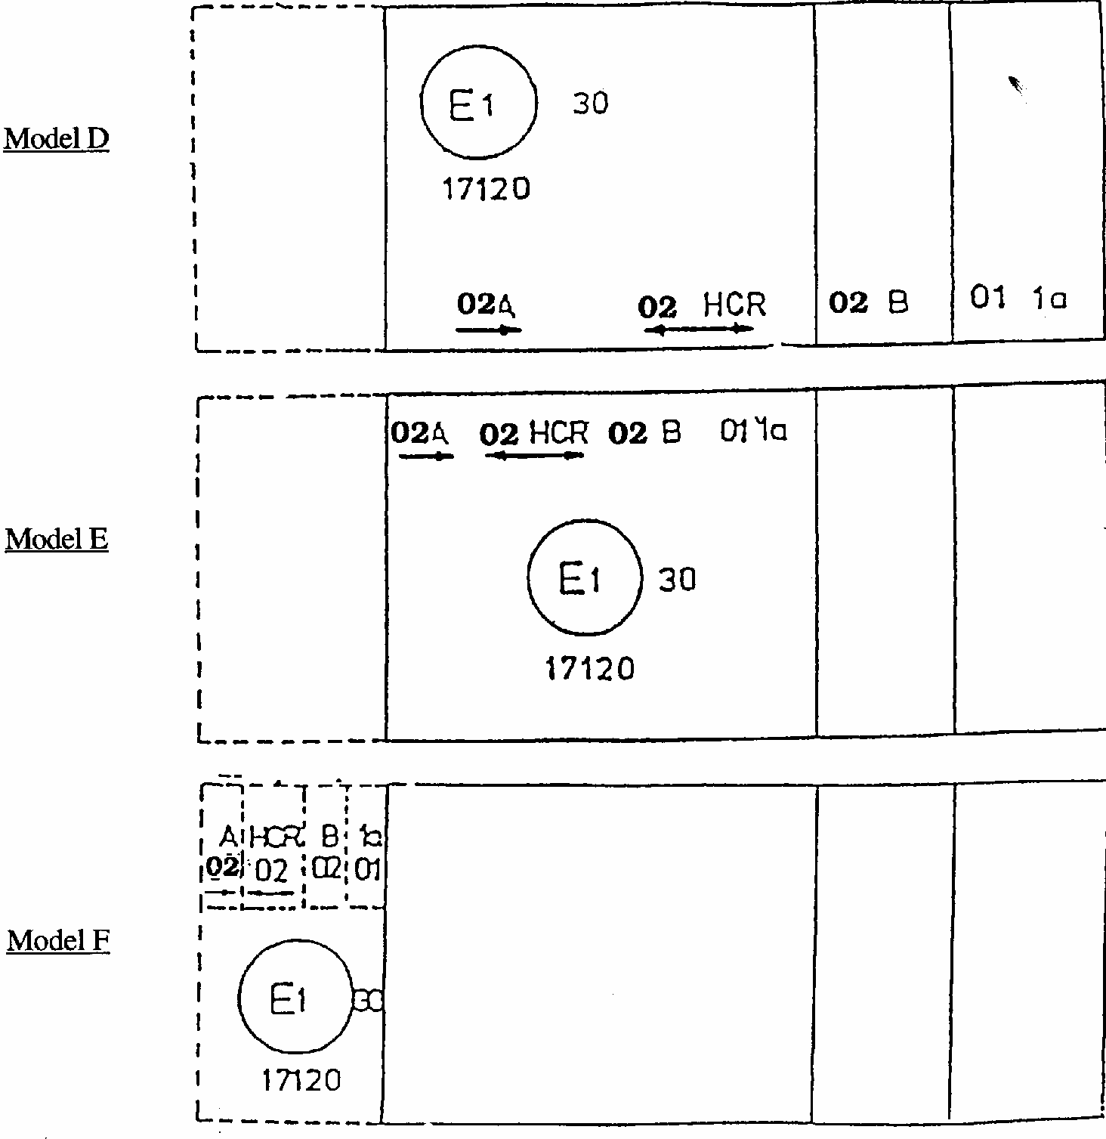
6. Lamp reciprocally incorporated with a headlamp
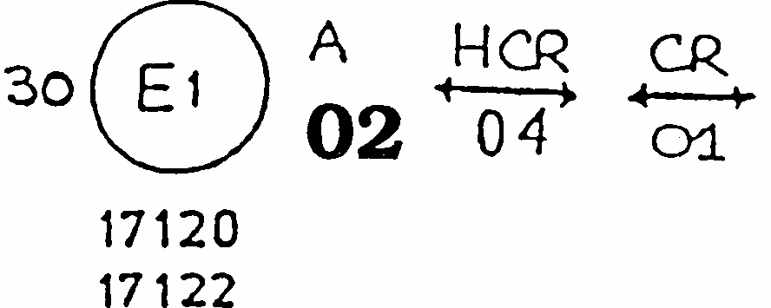
The above example corresponds to the marking of a lens intended to be used in different types of headlamps, namely:
Either
A headlamp with a passing beam designed for right- and left-hand traffic and a driving beam with a maximum intensity comprised between 86,250 and 111,250 candelas (indicated by the number 30) approved in the Federal Republic of Germany (E1) in accordance with the requirements of Regulation No. 8 as amended by the 04 series of amendments,
which is reciprocally incorporated with
A front position lamp approved in accordance with the 02 series of amendments to Regulation No. 7;

Or
A headlamp with a passing beam designed for right- and left-hand traffic and a driving beam, approved in the Federal Republic of Germany (E1) in accordance with the requirements of Regulation No. 1 as amended by the 01 series of amendments,
which is reciprocally incorporated with
The same front position lamp as above;
Or
even either of the above-mentioned headlamps approved as a single lamp.
The main body of the headlamp shall bear the only valid approval number, for instance:
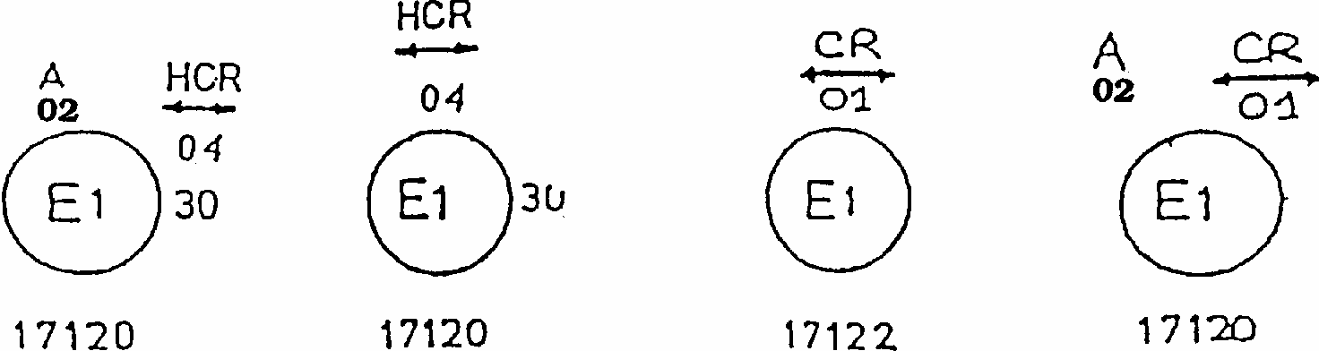
Annex 4
PHOTOMETRIC MEASUREMENTS
1. Measurement methods
1.1. During photometric measurements, stray reflections shall be avoided by appropriate masking.
1.2. In case the results of measurements should be challenged, measurements shall be carried out in such a way as to meet the following requirements:
1.2.1. The distance of measurement shall be such that the law of the inverse of the square of the distance is applicable;
1.2.2. The measuring equipment shall be such that the angular aperture of the receiver viewed from the reference centre of the light is comprised between 10 degrees and 1 degrees;
1.2.3. The intensity requirement for a particular direction of observation shall be deemed to be satisfied if that requirement is met in a direction deviating by not more than one-quarter of a degree from the direction of observation.
2. Table of standard light distribution
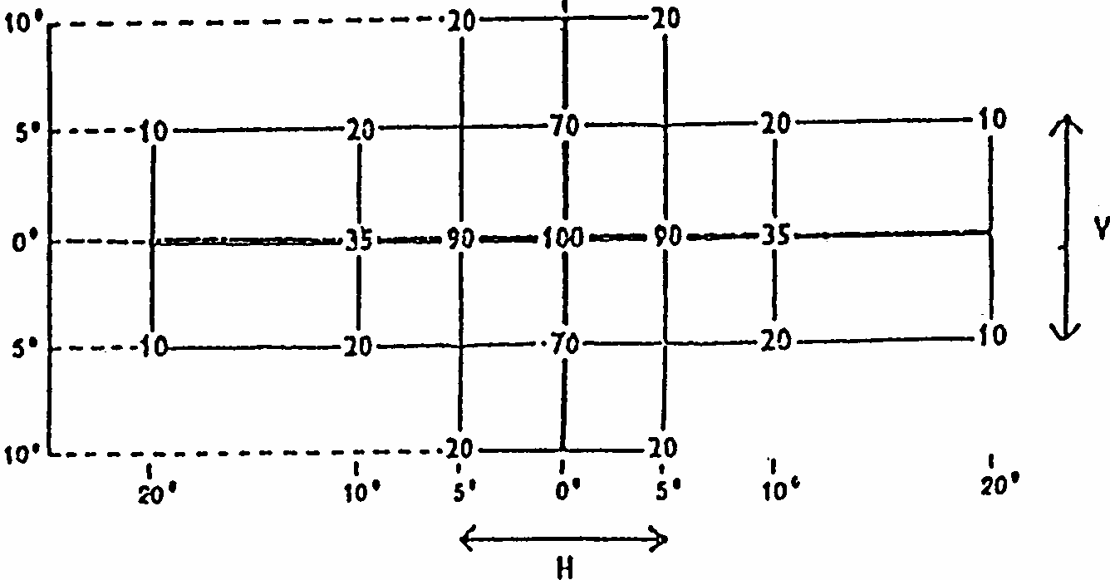
Table of light distribution for category S3 stop-lamp
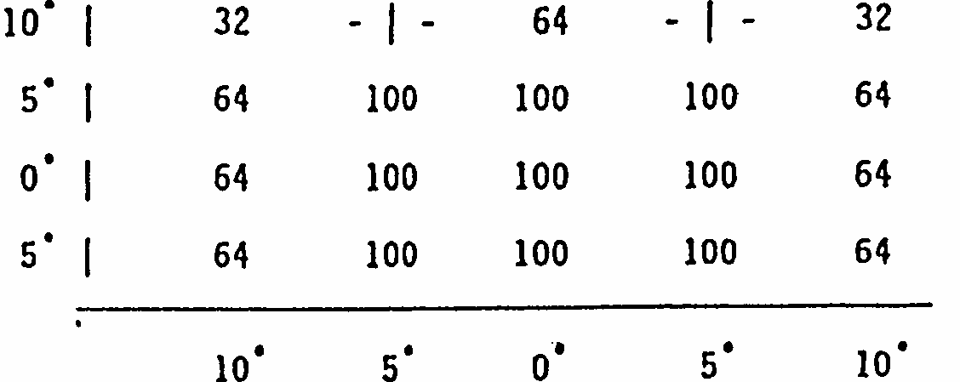
2.1. The direction H = 0 degrees and V = 0 degrees corresponds to the reference axis. (On the vehicle it is horizontal, parallel to the median longitudinal plane of the vehicle and oriented in the required direction of visibility.) It passes through the centre of reference. The values shown in the table give, for the various directions of measurement, the minimum intensities as a percentage of the minimum required in the axis for each light (in the direction H = 0 degrees and V = 0 degrees).
2.2. Within the field of light distribution of paragraph 2, schematically shown as a grid, the light pattern should be substantially uniform, i.e. the light intensity in each direction of a part of the field formed by the grid lines shall meet at least the lowest minimum value begin shown on the grid lines surrounding the questioned direction as a percentage.
3. Photometric measurement of lamps equipped with several light sources
The photometric performance shall be checked:
3.1. For non-replaceable light sources (filament lamps and other):
with the light sources present in the lamp, in accordance with paragraph 7.1.1 of this Regulation.
3.2. For replaceable filament lamps:
when equipped with mass production filament lamps at 6.75 V, 13.5 V or 28.0 V the luminous intensity values produced shall lie between the maximum limit given in this Regulation and the minimum limit of this Regulation increased according to the permissible deviation of the luminous flux permitted for the type of filament lamp chosen, as stated in Regulation No. 37 for production filament lamps; alternatively a standard filament lamp may be used in turn, in each of the individual positions, operated at its reference flux, the individual measurements in each position being added together.
Annex 5
COLOURS OF LIGHTS
TRICHROMATIC CO-ORDINATES
RED | Limit towards | yellow  purple | y  z | < 0.335  < 0.008
WHITE | Limit towards | blue  yellow  green  green  purple  red | x  x  y  y  y  y | > 0.310  < 0.500  < 0.150 + 0.640x  < 0.440  > 0.050 + 0.750x  > 0.382
SELECTIVE YELLOW | Limit towards | red  green  white | y  y  y | < 0.138 + 0.580x  < 1.29x - 0.100  >-x+ 0.966
SELECTIVE YELLOW | Limit towards spectral value |  | y | + 0.992
For checking these colorimetric characteristics, a source of light at a colour temperature of 2,856K corresponding to illuminant A of the International Commission on Illumination (CIE) shall be used. However, for lamps equipped with non-replaceable light sources (filament lamps and other), the colorimetric characteristics should be verified with the light sources present in the lamps, in accordance with paragraph 7.1.1 of this Regulation.
Annex 6
MINIMUM REQUIREMENTS FOR CONFORMITY OF PRODUCTION CONTROL PROCEDURES
1. GENERAL
1.1. The conformity requirements shall be considered satisfied from a mechanical and geometric standpoint, if the differences do not exceed inevitable manufacturing deviations within the requirements of this Regulation.
1.2. With respect to photometric performances, the conformity of mass-produced lamps shall not be contested if, when testing photometric performances of any lamp chosen at random and equipped with a standard filament lamp, or when the lamps are equipped with non-replaceable light sources (filament lamps or other), and when all measurements are made at 6.75 V, 13.5 V or 28.0 V respectively:
1.2.1. no measured value deviates unfavourably by more than 20% from the values prescribed in this Regulation.
1.2.2. If, in the case of a lamp equipped with a replaceable light source and if results of the test described above do not meet the requirements, tests on lamps shall be repeated using another standard filament lamp.
1.3. The chromaticity coordinates shall be complied with when the lamp is equipped with a standard filament lamp, or for lamps equipped with non-replaceable light sources (filament lamps or other), when the colorimetric characteristics are verified with the light source present in the lamp.
2. MINIMUM REQUIREMENTS FOR VERIFICATION OF CONFORMITY BY THE MANUFACTURER
For each type of lamp the holder of the approval mark shall carry out at least the following tests, at appropriate intervals. The tests shall be carried out in accordance with the provisions of this Regulation.
If any sampling shows non-conformity with regard to the type of test concerned, further samples shall be taken and tested. The manufacturer shall take steps to ensure the conformity of the production concerned.
2.1. Nature of tests
Tests of conformity in this Regulation shall cover the photometric and colorimetric characteristics.
2.2. Methods used in tests
2.2.1. Tests shall generally be carried out in accordance with the methods set out in this Regulation.
2.2.2. In any test of conformity carried out by the manufacturer, equivalent methods may be used with the consent of the competent authority responsible for approval tests. The manufacturer is responsible for proving that the applied methods are equivalent to those laid down in this Regulation.
2.2.3. The application of paragraphs 2.2.1 and 2.2.2 requires regular calibration of test apparatus and its correlation with measurements made by a competent authority.
2.2.4. In all cases the reference methods shall be those of this Regulation, particularly for the purpose of administrative verification and sampling.
2.3. Nature of sampling
Samples of lamps shall be selected at random from the production of a uniform batch. A uniform batch means a set of lamps of the same type, defined according to the production methods of the manufacturer.
The assessment shall in general cover series production from individual factories. However, a manufacturer may group together records concerning the same type from several factories, provided these operate under the same quality system and quality management.
2.4. Measured and recorded photometric characteristics
The sampled lamp shall be subjected to photometric measurements for the minimum values at the points listed in annex 4 and the chromaticity coordinates listed in annex 5, provided for in the Regulation.
2.5. Criteria governing acceptability
The manufacturer is responsible for carrying out a statistical study of the test results and for defining, in agreement with the competent authority, criteria governing the acceptability of his products in order to meet the specifications laid down for verification of conformity of products in paragraph 9.1 of this Regulation.
The criteria governing the acceptability shall be such that, with a confidence level of 95%, the minimum probability of passing a spot check in accordance with annex 7 (first sampling) would be 0.95.
Annex 7
MINIMUM REQUIREMENTS FOR SAMPLING BY AN INSPECTOR
1. GENERAL
The conformity requirements shall be considered satisfied from a mechanical and a geometric standpoint, in accordance with the requirements of this Regulation, if any, if the differences do not exceed inevitable manufacturing deviations.
1.2. With respect to photometric performance, the conformity of mass-produced lamps shall not be contested if, when testing photometric performances of any lamp chosen at random and equipped with a standard filament lamp, or when the lamps are equipped with non-replaceable light sources (filament lamps or other), and when all measurements are made at 6.75 V, 13.5 V or 28.0 V respectively:
1.2.1. no measured value deviates unfavourably by more than 20% from the values prescribed in this Regulation.
1.2.2. If, in the case of a lamp equipped with a replaceable light source and if results of the test described above do not meet the requirements, tests on lamps shall be repeated using another standard filament lamp.
1.2.3. Lamps with apparent defects are disregarded.
1.3. The chromaticity coordinates shall be complied with when the lamp is equipped with a standard filament lamp, or for lamps equipped with non-replaceable light sources (filament lamps or other), when the colorimetric characteristics are verified with the light source present in the lamp.
2. FIRST SAMPLING
In the first sampling four lamps are selected at random. The first sample of two is marked A, the second sample of two is marked B.
2.1. The conformity is not contested
2.1.1. Following the sampling procedure shown in Figure 1 of this annex the conformity of mass-produced lamps shall not be contested if the deviation of the measured values of the lamps in the unfavourable directions are:
2.1.1.1. sample A
A1: one lamp..................................................................................0%
one lamp not more than........................................................20%
A2: both lamps more than...............................................................0%
but not more than....................................................................20%
go to sample B
2.1.1.2. sample B
B1: both lamps.............................................................................. 0%
2.1.2. or, if the conditions of paragraph 1.2.2 for sample A are fulfilled.
2.2. The conformity is contested
2.2.1. Following the sampling procedure shown in Figure 1 of this annex the conformity of mass-produced lamps shall be contested and the manufacturer requested to make his production meet the requirements (alignment) if the deviations of the measured values of the lamps are:
2.2.1.1. sample A
A3: one lamp not more than .......................................................20%
one lamp more than .............................................................20%
but not more than .................................................................30%
2.2.1.2. sample B
B2: in the case of A2
one lamp more than ................................................................0%
but not more than ..................................................................20%
one lamp not more than ........................................................20%
B3: in the case of A2
one lamp...................................................................................0%
one lamp more than ................................................................20%
but not more than ...................................................................30%
2.2.2. or, if the conditions of paragraph 1.2.2 for sample A are not fulfilled.
2.3. Approval withdrawn
Conformity shall be contested and paragraph 10 applied if, following the sampling procedure in Figure 1 of this annex, the deviations of the measured values of the lamps are:
2.3.1. sample A
A4: one lamp not more than .........................................................20%
one lamp more than ...............................................................30%
A5: both lamps more than.............................................................20%
2.3.2. sample B
B4: in the case of A2
one lamp more than.................................................................0%
but not more than....................................................................20%
one lamp more than................................................................20%
B5: in the case of A2
both lamps more than.............................................................20%
B6: in the case of A2
one lamp...................................................................................0%
one lamp more than ................................................................30%
2.3.3. or, if the conditions of paragraph 1.2.2 for samples A and B are not fulfilled.
3. REPEATED SAMPLING
In the cases of A3, B2, B3 a repeated sampling, third sample C of two lamps and fourth sample D of two lamps, selected from stock manufactured after alignment, is necessary within two months' time after the notification.
3.1. The conformity is not contested
3.1.1. Following the sampling procedure shown in Figure 1 of this annex the conformity of mass-produced lamps shall not be contested if the deviations of the measured values of the lamps are:
3.1.1.1. sample C
C1: one lamp ..................................................................................0%
one lamp not more than..........................................................20%
C2: both lamps more than ............................................................. 0%
but not more than.....................................................................20%
go to sample D
3.1.1.2. sample D
D1: in the case of C2
both lamps ................................................................................0%
3.1.2. or, if the conditions of paragraph 1.2.2 for sample C are fulfilled.
3.2. The conformity is contested
3.2.1. Following the sampling procedure shown in Figure 1 of this annex the conformity of mass-produced lamps shall be contested and the manufacturer requested to make his production meet the requirements (alignment) if the deviations of the measured values of the lamps are:
3.2.1.1. sample D
D2: in the case of C2
one lamp more than..................................................................0%
but not more than.....................................................................20%
one lamp not more than .........................................................20%
3.2.1.2. or, if the conditions of paragraph 1.2.2 for sample C are not fulfilled.
3.3. Approval withdrawn
Conformity shall be contested and paragraph 10 applied if, following the sampling procedure in Figure 1 of this annex, the deviations of the measured values of the lamps are:
3.3.1. sample C
C3: one lamp not more than .........................................................20%
one lamp more than ...............................................................20%
C4: both lamps more than............................................................20%
3.3.2. sample D
D3: in the case of C2
one lamp 0 or more than...........................................................0%
one lamp more than.................................................................20%
3.3.3. or, if the conditions of paragraph 1.2.2 for samples C and D are not fulfilled.
Figure 1
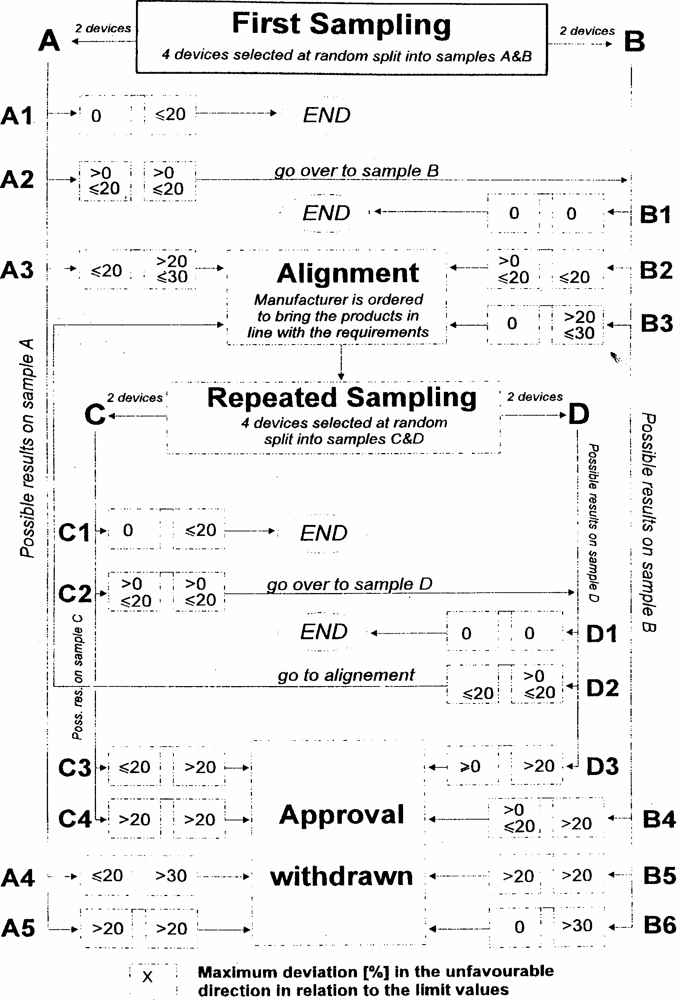

1/ 1 for Germany, 2 for France, 3 for Italy, 4 for the Netherlands, 5 for Sweden, 6 for Belgium, 7 for Hungary, 8 for the Czech Republic, 9 for Spain, 10 for Yugoslavia, 11 for the United Kingdom, 12 for Austria, 13 for Luxembourg, 14 for Switzerland, 15 (vacant), 16 for Norway, 17 for Finland, 18 for Denmark, 19 for Romania, 20 for Poland, 21 for Portugal, 22 for the Russian Federation, 23 for Greece, 24 (vacant), 25 for Croatia, 26 for Slovenia, 27 for Slovakia, 28 for Belarus, 29 for Estonia, 30-36 (vacant) and 37 for Turkey. Subsequent numbers shall be assigned to other countries in the chronological order in which they ratify or accede to the Agreement concerning the Adoption of Uniform Conditions of Approval and Reciprocal Recognition of Approval for Motor Vehicle Equipment and Parts and the numbers thus assigned shall be communicated by the Secretary-General of the United Nations to the Contracting Parties to the Agreement.
2When all light sources are illuminated the maximum intensity specified for a single lamp may be exceeded provided that the single lamp is not marked "D" and the maximum intensity specified for an assembly of two lamps (last column of the table) is not exceeded. 2/ The total value of maximum intensity for an assembly of two lamps is given by multiplying by 1.4 the value prescribed for a single lamp. When an assembly of two lamps having the same function is deemed to be, for the purpose of installation on a vehicle, a "single lamp" (following the definition of Regulation No. 48 and its series of amendments in force at the time of application for type approval) each individual lamp constituting the "single lamp" shall comply with the minimum intensity required and the two lamps together shall not exceed the admissible maximum intensity (last column of the table). In the case of a single lamp containing more than one light source: The lamp shall comply with the minimum intensity required when any one light source has failed, and
1/ The installation of the devices referred to above in power-driven vehicles and their trailers is provided for in the Regulations concerning the installation of lighting and light-signalling devices (Regulations Nos. 48 and 53).
2/ The functioning and installation conditions of these additional systems will be defined by special provisions.
1/ The angles shown in these diagrams are correct for devices to be mounted on the right side of the vehicle. The arrows point to the front of the vehicles.
2/ Strike out what does not apply.
3/ For lamps with non-replaceable light sources indicate the number and the total wattage of the light sources.

