COMMONWEALTH OF AUSTRALIA
A New Tax System (Commonwealth-State Financial Arrangements) Act 1999
DETERMINATION OF THE FINAL PER CAPITA RELATIVITIES FOR 2005-06 IN ACCORDANCE WITH THE A NEW TAX SYSTEM (COMMONWEALTH-STATE FINANCIAL ARRANGEMENTS) ACT 1999
WHEREAS Section 9 of the Act requires the Treasurer to make a determination in writing before 10 June in the current GST year of the relativities factor for a State;
NOW THEREFORE I, PETER HOWARD COSTELLO, Treasurer of the Commonwealth of Australia, hereby DETERMINE that the final GST per capita relativities factors for each State and Territory for 2005-06 are as follows:
2005-06 Relativities for a GST pool
Dated this 6 day of June 2006
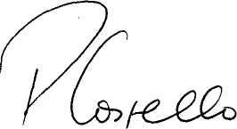
PETER HOWARD COSTELLO Treasurer

