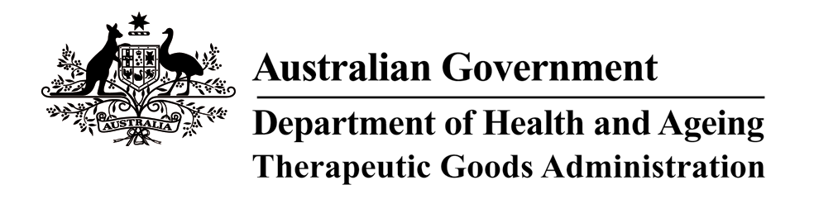

THERAPEUTIC GOODS ACT 1989

ORDER UNDER SUBSECTION 3(1) – DEFINITION OF BRITISH PHARMACOPOEIA

I, DAVID GRAHAM, delegate of the Minister for Health and Ageing for the purposes of the exercise of the Minister’s power under the definition of “British Pharmacopoeia” in subsection 3(1) of the Therapeutic Goods Act 1989 (“the Act”) and acting under that provision, HEREBY SPECIFY that on and from 1 July 2006 the definition of “British Pharmacopoeia” in the Act shall be the British Pharmacopoeia 2005.

Dated this 15th day of May 2006

DAVID GRAHAM
National Manager
Therapeutic Goods Administration
(Delegate of the Minister for Health and Ageing)

