Wine Equalisation Tax New Zealand Producer Rebate Claim Lodgment Determination 2006

Under subsection 17-10(2B) of the A New Tax System (Wine Equalisation Tax) Act 1999, I make the following determination:
Citation
- This determination may be cited as the Wine Equalisation Tax New Zealand Producer Rebate Claim Lodgment Determination 2006.
Commencement
- This determination commences on 1 July 2006 or the commencement of Schedule 4 to the Tax Laws Amendment (2005 Measures No. 4) Act 2005, whichever is the later.
Application of determination
- This determination applies to approved New Zealand participants entitled to claim the wine producer rebate and sets out the time when the claim for the rebate may be made.
Definitions
- Terms in this determination have the same meaning as in the A New Tax System (Wine Equalisation Tax) Act 1999.
When the claim may be lodged
- Where an approved New Zealand participant is entitled to make a producer rebate claim, the claim may be made at any time after the entitlement to the rebate arises and within 4 years after that entitlement arises.
Note: Entitlement to the producer rebate arises immediately before the end of the Australian financial year in which the relevant taxable dealing takes place.

Dated this 23rd day of March 2006
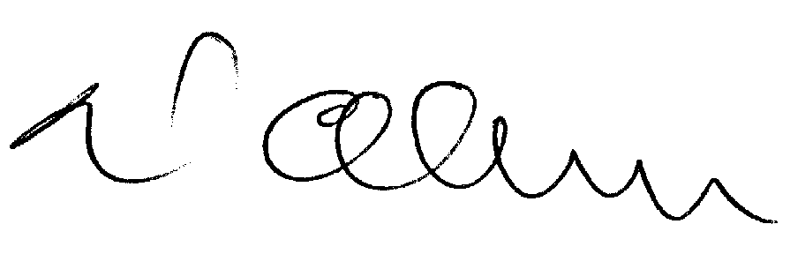
Stephen Neil Olesen
Deputy Commissioner and Delegate of the Commissioner

