Regulation impact statement | AASB 124  December 2005

Related Party Disclosures

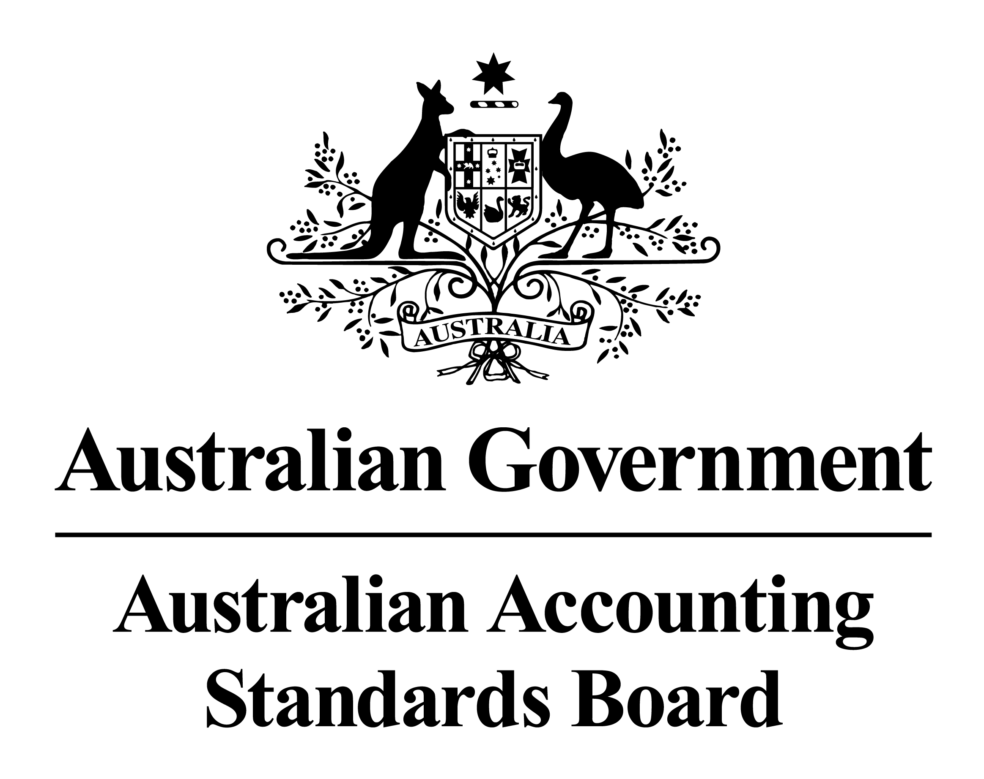
Regulation Impact Statement

AASB 124 Related Party Disclosures

Background

The Australian Accounting Standards Board (AASB) has implemented the Financial Reporting Council’s policy of adopting the Standards of the IASB for application to reporting periods beginning on or after 1 January 2005. The AASB’s Standards have been changed to adopt the IASB Standards effective at that date by replacing relevant existing AASB Standards with Australian Standards equivalent to the International Financial Reporting Standards (IFRSs) of the IASB.
As part of this process, AASB 124 Related Party Disclosures, the Australian equivalent to IAS 24 Related Party Disclosures, was issued in July 2004, to become effective for annual reporting periods beginning on or after 1 January 2005. AASB 124 provided relief to disclosing entities from the disclosures otherwise required in relation to key management personnel (KMP), because disclosing entities were required to comply with the more detailed disclosure regime in AASB 1046 Director and Executive Disclosures by Disclosing Entities, effective for reporting periods ending on or after 30 June 2004.
When AASB 1046 was issued, the Board was aware it would need revision before the end of 2005, since it refers to AASB Standards that will become ineffective at the end of 2005, when they are replaced by the Australian equivalents to IFRSs. In considering the revision of AASB 1046, the Board reached the conclusion that it would be preferable to include its requirements in AASB 124, rather than retaining AASB 1046 as a separate Standard. As a result, a revised AASB 124 would comply with IFRSs and include additional Australian requirements relating to disclosing entities.

1. Problem

The problem confronting the AASB was how it can best respond to questions as to how AASB 124 applies to registered managed investment schemes (MIS) and other similar entities and the amendments in 2004 and 2005 to the Corporations Act 2001 and Corporations Regulations affecting section 300A of the Act while removing duplication and uncertainty about the application of the requirements and achieving consistency with IFRSs.
The enactment of the CLERP 9 changes to section 300A of the Corporations Act was accompanied by the issue of the following Regulations referring to AASB 1046:
(a) Corporations Regulation 2M.3.03, issued in July 2004, required certain of the remuneration disclosures specified in AASB 1046 to be made by listed companies in the new section of the Directors’ Report (the Remuneration Report) in respect of those individuals specified in accordance with the revised section 300A(1)(c). This was seen to result in considerable duplication of remuneration disclosures for listed companies, with many disclosures being required in both the Remuneration Report and the financial report. Where there are differences between the law and the Accounting Standards, for example, in the basis for selecting executives to be subject to the enhanced disclosure, these are seen as likely to confuse users and increase preparation costs for listed companies; and
(b) Corporations Regulation 2005 (No. 4), issued in July 2005, sought to the duplication problem. It exempts a listed company that chooses to locate in its Remuneration Report the remuneration information otherwise required by AASB 1046 from providing remuneration disclosures about its directors and executives in its financial report.
Due to the similarity in definitions between section 300A in the Corporations Act and the definition of key management personnel (KMP) in AASB 124, the Board’s expectation was that the KMP group (or groups) for a listed company will generally include all executives identified by section 300A of the Corporations Act. However, some constituents take the view that consistency between the KMP concept and directors and executives referred to in AASB 1046 is unlikely. In addition, concerns about the interrelationship of the Corporations Regulations and AASB 1046 are amplified because the Corporations Regulations refer to a particular version of AASB 1046.
2. Objectives

The AASB’s objective in addressing the problem is to rationalise the location of requirements from two Standards into a single Standard with the purpose of facilitating clarity financial reporting and reducing duplication in Australia by disclosing entities.
3. Options

Option 1

Withdraw AASB 1046 and rely on the disclosure requirements of AASB 124 and the Corporations Law.

Option 2

Retain AASB 124 unamended and amend AASB 1046 to achieve consistency with Australian equivalents of IFRSs.

Option 3

Amend AASB 124 to incorporate the requirements of AASB 1046, as amended, to achieve consistency with Australian equivalents to IFRSs.

Option 4

Do not amend AASB 124 or AASB 1046.

Option 1 would mean that the quality of financial reporting by disclosing entities would be eroded because the existing requirements would no longer apply. Option 4 would mean that uncertainty about whether the financial reports of disclosing entities comply with IFRSs would still remain. Under Options 2 and 3 the objectives of clarifying the requirements and achieving consistency with IFRSs would be achieved.

The Board’s preferred approach of Option 3 was included in Exposure Draft ED 143 Director and Executive Disclosures by Disclosing Entities: Removal of AASB 1046 and Addition to AASB 124.

4. Impact Analysis
4.1 Affected Parties
Parties likely to be most directly affected by the Standard are:
(a) disclosing entities required to prepare general purpose financial reports;
(b) users of reports identified in (a) such as:
(i) resource providers (including fund managers, investors, creditors and employees);
(ii) recipients of goods and services;
(iii) parties performing a review or oversight function (including the Australian Securities and Investments Commission and the Australian Stock Exchange); and
(iv) management and governing bodies (including use of these reports in the discharge of accountability).
Parties likely to be indirectly or less directly affected by the Standard include:
(a) participants in the Australian capital markets; and
(b) the wider community affected by the efficiency of the Australian capital markets and their reputation inside Australia and overseas.
The changes to AASB 124 are unlikely to have a significant impact on small business as small business entities are not likely to be disclosing entities.

4.2 Effect on Existing Regulations
The impact of issuing a revised AASB 124 Related Party Disclosures to include the disclosure requirements of AASB 1046, as amended, will result in Regulation not being operative in respect of annual reporting periods ending on or after 31 December 2005.
4.3 Costs and Benefits
The AASB concluded that having related party disclosures located in one standard, rather than in two standards would provide a benefit to those using Accounting Standards. Because the information is already prepared there should be no additional costs of compliance other than the cost of becoming reacquainted with the location of some requirements.

5. Consultation

Exposure Draft ED 143 Director and Executive Disclosures by Disclosing Entities: Removal of AASB 1046 and Addition to AASB 124 was issued in September 2005 as part of the AASB’s due process in implementing the FRC’s directives. When issuing ED 143 the AASB requested comment on a number of issues relating to the application of the Standard and whether the proposals are in the best interests of the Australian economy. Twenty submissions, including one confidential submission, were received in respect of the proposals in ED 143. Submissions were received from preparers and preparer groups, major accounting firms, professional accounting bodies, entities in the funds management industry and a shareholder group. The submissions are published on the AASB’s website:www.aasb.com.au. There were mixed views on a number of issues including the removal of parent entity relief and the proposed amalgamation of AASB 124 and AASB 1046. Respondents supported the proposal to use the term KMP and the clarification of the requirements for disclosing entities. However, respondents from the funds management industry expressed the view that the proposals in respect of disclosures by Managed Investment Schemes (MIS) including those relating to KMP do not reflect the nature of the relationship between a MIS and its responsible entity. The Board took the view that whether a MIS has KMP is a matter for judgment in the light of the arrangements in each case.

6. Conclusion and Recommendation

The AASB decided to adopt Option 3 and locate the requirements of AASB 1046, as amended, in a revised AASB 124. In forming its conclusion, the AASB considered that, on balance, the benefits of removing uncertainty about the requirements and including them in AASB 124 outweighed the costs.

7. Implementation and Review

AASB 124 will be subject to review and revision taking account of international developments, particularly the processes for review and revision undertaken by the IASB, changes to the Corporations Law and Regulations and the experience of constituents in implementing the Standard.

