

Vehicle Standard (Australian Design Rule 34/01 - Child Restraint Anchorages and Child Restraint Anchor Fittings) 2005

Compilation: 1 (up to and including Vehicle Standard (Australian Design Rule 34/01 – Child Restraint Anchorages and Child Restraint Anchor Fittings) 2005 Amendment 1)

Compilation Date: 30/05/2012

Compiled by: Vehicle Safety Standards, Department of Infrastructure and Transport.

Enabling Legislation: Section 7
Motor Vehicle Standards Act 1989

CONTENTS

A.1. NAME OF STANDARD 3
A.2. COMMENCEMENT 3
A.3. REPEAL 3
B. SCOPE 3
C. APPLICABILITY AND IMPLEMENTATION 3
D APPLICABILITY TABLE 4
34.1. DEFINITIONS 5
34.2. GENERAL REQUIREMENTS 5
34.3. NOMINATED SEATING POSITIONS 6
34.4. ‘CHILD RESTRAINT ANCHORAGES’ 7
34.5. LOCATION REQUIREMENTS 7
34.6. ACCESSIBILITY TO ENGAGE ‘ATTACHING CLIP’ 8
34.7. STRENGTH OF ‘CHILD RESTRAINT ANCHORAGE(S)’ 8
34.8. ALTERNATIVE STANDARDS 10
NOTES 23

A.1. NAME OF STANDARD
A.1.1. This Standard is the Vehicle Standard (Australian Design Rule 34/01 - Child Restraint Anchorages and Child Restraint Anchor Fittings) Error: Reference source not found.
A.1.2. This Standard may also be cited as Australian Design Rule 34/01 - Child Restraint Anchorages and Child Restraint Anchor Fittings.
A.2. COMMENCEMENT
A.2.1. This Standard commences on the day after it is registered.
A.3. REPEAL
A.3.1. This Standard repeals each vehicle standard with the name Australian Design Rule 34/01 - Child Restraint Anchorages and Child Restraint Anchor Fittings that is:
(a) made under section 7 of the Motor Vehicles Standard Act 1989; and
(b) in force at the commencement of this Standard.
A.3.2. This Standard also repeals each instrument made under section 7 of the Motor Vehicles Standard Act 1989 that creates a vehicle standard with the name Australian Design Rule 34/01 - Child Restraint Anchorages and Child Restraint Anchor Fittings, if there are no other vehicle standards created by that instrument, or amendments to vehicle standards made by that instrument, that are still in force at the commencement of this Standard.
B. SCOPE
B.1. The function of this Australian Design Rule is to specify requirements for ‘Child Restraint Anchorages’ and ‘Child Restraint Anchor Fittings’ which provide for the connection of standard ‘Attaching Clips’ so that ‘Child Restraints’ may be adequately secured to the vehicle. It specifies a standard package of fitting hardware and accessibility requirements to facilitate correct installation and interchangeability of ‘Child Restraints’.
C. APPLICABILITY AND IMPLEMENTATION
C.1. This ADR applies to the design and construction of vehicles as set out in the table below.
C.2. For MD3, MD4, and ME vehicles the circumstances under which ‘Child Restraint Anchorages’ are mandatory are set out in A 68/.. .
C.3. Vehicles certified to ADR 34/02 or a later version need not comply with this rule.

D APPLICABILITY TABLE

Vehicle Category |  | ADR Category Code | UNECE Category Code | Manufactured on or After | Acceptable Prior Rules
Moped 2 wheels |  | LA | L1 | Not applicable
Moped 3 wheels |  | LB | L2 | Not applicable
Motor cycle |  | LC | L3 | Not applicable
Motor cycle and sidecar |  | LD | L4 | Not applicable
Motor tricycle |  | LE | L5
 |  | LEM |  | Not applicable
 |  | LEP |  | 1 Jan 1995 | Nil
 |  | LEG |  | Not applicable
Passenger car |  | MA | M1 | 1 Jan 1995 | Nil
Forward-control passenger vehicle |  | MB | M1 | 1 Jan 1995 | Nil
Off-road passenger vehicle |  | MC | M1 | 1 Jan 1995 | Nil
Light omnibus |  | MD | M2
 | up to 3.5 tonnes ‘GVM’ and up to 12 seats | MD1 |  | 1 July 1994 | Nil
 | up to 3.5 tonnes ‘GVM’ and more than 12 seats | MD2 |  | Not applicable
 | over 3.5 tonnes and up to 4.5 tonnes ‘GVM’ | MD3 |  | 1 July 1995*
 | over 4.5 tonnes and up to 5 tonnes ‘GVM’ | MD4 |  | 1 July 1995*
Heavy omnibus |  | ME | M3 | 1 July 1995*
Light goods vehicle |  | NA | N1 | Not applicable
Medium goods vehicle |  | NB | N2
 | over 3.5 tonnes up to 4.5 tonnes ‘GVM’ | NB1 |  | Not applicable
 | over 4.5 tonnes up to 12 tonnes ‘GVM’ | NB2 |  | Not applicable
Heavy goods vehicle |  | NC | N3 | Not applicable
Very light trailer |  | TA | O1 | Not applicable
Light trailer |  | TB | O2 | Not applicable
Medium trailer |  | TC | O3 | Not applicable
Heavy trailer |  | TD | O4 | Not applicable

- DEFINITIONS
Refer to Vehicle Standard (Australian Design Rule Definitions and Vehicle Categories) 2005
- GENERAL REQUIREMENTS
  - Every vehicle shall provide the facility to attach an ‘Attaching Clip’ to a ‘Child Restraint Anchor Fitting’ for each seating position nominated in clause 34.3 by either:
    - using the ‘Child Restraint Anchor Fitting Package’, in which case:
      - one ‘Child Restraint Anchor Fitting Package’ shall be installed in at least one seating position. This shall be in the centre rear seating position, if applicable; and
      - for other positions, one 5/16 inch UNC-2A hexagon headed bolt and appropriate ‘Spacer’ shall be supplied for each different variation from the standard ‘Attachment Bolt’ length and shall be placed in the vehicle’s glovebox; or
    - using a ‘Child Restraint Anchor Fitting’ and appropriate attaching hardware other than in the ‘Child Restraint Anchor Fitting Package’, in which case:-
      - a ‘Child Restraint Anchor Fitting’ shall be installed for at least one seating position. This shall be in the centre rear seating position, if applicable; and
      - for other positions, one 5/16 inch UNC-2A hexagon headed bolt and appropriate ‘Spacer’ shall be supplied for each different variation from the standard ‘Attachment Bolt’ length and shall be placed in the vehicle’s glovebox; or
    - a ‘Child Restraint Anchor Fitting’ shall be installed for each nominated seating position, in which case:
      - the ‘Child Restraint Anchor Fitting’ need only comply with Figure 2 in relation to the location and clearance of the ‘Child Restraint Anchor Fitting’ ’Interface Profile’.
    - Notwithstanding clauses 34.2.1.1.1 and 34.2.1.2.1 if the vehicle is fitted with a lap sash ‘Seatbelt Assembly’ in the centre rear seating position the ‘Child Restraint Anchor Fitting’ may be installed in another seating position.
      - For other positions, one 5/16 inch UNC-2A hexagon headed bolt and appropriate ‘Spacer’ shall be supplied for each different variation from the standard ‘Attachment Bolt’ length and shall be placed in the vehicle’s glovebox.
  - Information including either a photograph or a diagram regarding the location of each ‘Child Restraint Anchorage’ (if fitted), installation of ‘Child Restraint Anchor Fittings’ (if applicable), and installation of ‘Child Restraint’ ‘Attaching Clips’ shall be specified in the vehicle handbook or otherwise supplied with the vehicle. The information shall include:
    - “WARNING: child restraint anchorages are designed to withstand only those loads imposed by correctly fitted child restraints. Under no circumstances are they to be used for adult seatbelts, harnesses, or for attaching other items or equipment to the vehicle.”
    - details on the length of bolts and the thickness (and number) of ‘Spacers’ required at each ‘Child Restraint Anchorage’ (as applicable), location and correct method of installation and orientation of ‘Child Restraint Anchor Fitting(s)’ (as applicable), and method of attachment and orientation of ‘Attaching Clip(s)’. Orientation shall be shown relative to the front of the vehicle.
    - Details of the dedicated anchor fitting package in accordance with clauses 34.2.1.1.2, 34.2.1.2.2 and 34.2.1.4.1 and its location in the vehicle.
- NOMINATED SEATING POSITIONS
  - For LEP and MA vehicles:
    - Each seating position in the ‘Second Row Seats’ equipped with an adult ‘Seatbelt Assembly’, except the following ;
      - the middle seating position where the ‘Seat’ back is divided into two or more sections which may be folded independently of each other, and the division between two sections lies substantially along the ‘Seating Reference Plane’ of the middle seating position.
      - a seating position with a ‘Folding Seat’ where a ‘Child Restraint’ would bar access to the rear ‘Seats’, provided that this does not reduce the number of ’Child Restraint Anchorages’ that would otherwise be fitted to the vehicle.
    - Child Restraint Anchorages’ or ‘Child Restraint Anchor Fitting(s)’ may be installed in front seating positions other than the driver’s ‘Seat’.
  - For MB, MC and MD1 vehicles:
    - For vehicles with less than three seating positions in ‘Vehicle Rear Seat(s)’ each seating position in ‘Vehicle Rear Seat(s)’ equipped with an adult ‘Seatbelt Assembly’.
    - For vehicles with three or more seating positions in ‘Vehicle Rear Seat(s)’ any three seating positions in ‘Vehicle Rear Seat(s)’ equipped with an adult ‘Seatbelt Assembly’ except for ‘Folding Seats’ where a ‘Child Restraint’ would bar access to the rear ‘Seats’ and except the middle seating position where the ‘Seat’ back is divided into two or more sections which may be folded independently of each other, and the division between two sections lies substantially along the ‘Seating Reference Plane’ of the middle seating position.
    - ‘Child Restraint Anchorages’ or ‘Child Restraint Anchor Fitting(s)’ may be installed in front seating positions other than the driver’s ‘Seat’.
- ‘CHILD RESTRAINT ANCHORAGES’
  - Each ‘Child Restraint Anchorage’ provided in accordance with clauses 34.2.1.1 or 34.2.1.2 shall
    - provide clearance to enable the installation of the ‘Child Restraint Anchor Fitting’, ‘Spacer(s)’ and attaching hardware. For guidance to vehicle manufacturers the clearance parameters shown in Figure 7 are sufficient to demonstrate compliance with this clause.
    - incorporate a 5/16 inch - 18 UNC - 2B internal thread which will provide sufficient engagement of the ‘Attachment Bolt’ to meet the strength requirements of clause 34.7 when the ‘Attachment Bolt’ is retaining a ‘Child Restraint Anchor Fitting’, ‘Spacer(s)’, attaching hardware and any trim or other material present.
    - be so designed and located that no items need to be removed to gain access to it for the installation of the ‘Child Restraint Anchor Fitting’, except closure plugs, or other items, removable with the use of simple hand tools.
- LOCATION REQUIREMENTS
  - Each ‘Child Restraint Anchorage’ and ‘Child Restraint Anchor Fitting’ must comply with clause 34.5.2 and clause 34.5.3, or comply with clause 34.5.4.
    - In addition, each ‘Child Restraint Anchorage’ and ‘Child Restraint Anchor Fitting’ shall be located within the vehicle in a part of the body structure which would not normally be movable, or if movable would not alter the tension in any ‘Upper Anchorage Strap’ when moved.
      - The requirements of clause 34.5.1.1 do not apply if the 'Child Restraint Anchorage' and 'Child Restraint Anchor Fitting' are located on a ‘Seat’.
  - In the vertical plane, the entire ‘Interface Profile’ of each ‘Child Restraint Anchor Fitting’ shall be located within the shaded area shown in Figure 6 with :
    - the ‘Manikin’ to be positioned in the ‘Seating Reference Plane’ when the ‘Seat’ and the ‘Seat’ back are in the design position;
    - the ‘Manikin’s’ ‘H Point’ at the ‘Seating Reference Point’; and
    - the ‘Manikin’s’ ‘Torso Reference Line’ at the same angle from the vertical as the ‘Seat’ back.
  - In the horizontal plane, the centreline of the ’Interface Profile’ of each ‘Child Restraint Anchor Fitting’ shall lie within 40 mm of the ‘Seating Reference Plane’ of the seating position for which the ‘Child Restraint Anchor Fitting’ is provided.
  - Subject to Clause 34.5.4.1, the entire ‘Interface Profile’ of each ‘Child Restraint Anchor Fitting’ shall be located within the shaded zone shown in Figures 9 to 13. The zone is defined with reference to the ‘Seating Reference Point’. (For purposes of the figures, "H Point" is defined to mean ‘Seating Reference Point’.) The ‘Interface Profile’ may be recessed in the seat back, provided that it is not in the strap wrap-around area at the top of the vehicle seat back. For the area under the vehicle seat, the forward most edge of the shaded zone is defined by the ‘Torso Reference Line’.
    - The ‘Interface Profile’ may be located outside the shaded zone shown in Figures 9 to 13 if a location within that zone is not appropriate and the vehicle is equipped with a routing device that,
      - ensures that the ‘Upper Anchorage Strap’ functions as if the ‘Interface Profile’ were located within the shaded zone; and,
      - is at least 65 mm behind the ‘Torso Reference Line’, in case of a non-rigid webbing-type routing device or a deployable routing device, or at least 100 mm behind the ‘Torso Reference Line’, in the case of a fixed rigid routing device; and,
      - when tested after being installed as it is intended to be used, the device is of sufficient strength to withstand, with the 'Child Restraint Anchorage', the strength requirements specified in Clause 34.7, excluding sub-clauses 34.7.2.1 and 34.7.2.2.
- ACCESSIBILITY TO ENGAGE ‘ATTACHING CLIP’
  - Clearance shall be provided around each ‘Child Restraint Anchor Fitting’ to allow latching and unlatching, without the use of tools, of the ‘Attaching Clip’ to the ‘Child Restraint Anchor Fitting’ when it is installed in the vehicle.
  - For guidance to vehicle manufacturers the clearance parameters shown in Figure 8 are sufficient to demonstrate compliance with this clause.
- STRENGTH OF ‘CHILD RESTRAINT ANCHORAGE(S)’
  - For each ‘Child Restraint Anchorage’, static or dynamic testing shall be conducted at the vehicle ‘Manufacturer’s’ choice either to clause 34.7.2 or clause 34.7.3 as applicable - using ‘Child Restraint Anchor Fitting(s)’ provided in accordance with clause 34.2.
    - The static test load of 3.4 kN (clause 34.7.2) relates to the upper tether strap load of 7 kN in the dynamic test specified in Australian Standard AS 3629.3-1991 “Methods of Testing Child Restraints Part 3 Dynamic Testing of Upper Anchorage Components”.
  - Static Testing - All ‘Child Restraint Anchor Fittings’ shall be tested simultaneously when installed in the vehicle, and with the ‘Seat’ or ‘Seat’ back installed, by application of a test load of not less than 3.4 kN to each ‘Child Restraint Anchor Fitting’.
    - The direction of the test load shall be within 20° of the ‘Design Line of Action’ of the ‘Child Restraint Anchor Fitting’ and not more than 5° to the left or right of the direction of the longitudinal axis of the vehicle.
    - Where the ‘Design Line of Action’ is determined by the ‘Seat’ or ‘Seat’ back, and the ‘Child Restraint Anchor Fitting’ is located more than 100 mm below a horizontal plane tangential to the point on the top of the ‘Seat’ back longitudinally ‘Forward’ of the ‘Child Restraint Anchor Fitting’ then, with the ‘Seat’ or ‘Seat’ back installed, the load shall be applied ‘Forward’ of the ‘Seat’ back and not more than 5° above or below the horizontal and not more than 5° to the left or right of the direction of the longitudinal axis of the vehicle.
    - Each ‘Child Restraint Anchorage’ and ‘Child Restraint Anchor Fitting’ shall be capable of supporting the test load for a period of not less than one second.
  - Dynamic Testing - All ‘Child Restraint Anchor Fittings’ shall be tested simultaneously when installed in the test vehicle body, including the complete ‘Rear Seat’ assembly or ‘Vehicle Rear Seat’ assembly and with test dummies restrained in each seating position for which a ‘Child Restraint Anchor Fitting’ is provided.
    - The test dummies shall each have a mass of not less than 21.4 kg or shall comply with the requirements described in technical drawings produced by the TNO (Research Institute for Road Vehicles) - Netherlands# for a ‘50th Percentile 6 Year Old Child’.
    - The test dummies shall be restrained using suitable ‘Child Restraints’ comprising load bearing material having an elongation of not more than 25% when subjected to a load of 11 kN, and providing for pelvic and upper torso restraint. Each pelvic restraint portion shall be attached to the ‘Lap Anchorages’ for the adult ‘Seatbelt Assembly’ for the relevant ‘Seat’. The upper torso restraint portion shall be attached to the ‘Child Restraint Anchor Fitting’.
    - The pelvic and upper torso portions of the ‘Child Restraints’ shall be adjusted to eliminate slack.
    - The test rig shall have a mass of not less than 380 kg and shall meet the requirements of clause 34.7.3.5 for test rig calibration. It shall comprise trolley, the test vehicle body or part thereof, and the complete ‘Vehicle Rear Seat’ assembly.
    - In the case of calibration prior to ‘Child Restraint Anchor Fitting’ testing, the test rig, to which a mass of not less than 21.4 kg times the number of seating positions for which a ‘Child Restraint Anchor Fitting’ is provided is rigidly attached, when subject to a velocity change of not less than 49 km/h, shall achieve within 30 milliseconds a forward deceleration measured in the vicinity of the corresponding ‘Lap Anchorage’ within the range of 235 m/s² to 335 m/s² and shall maintain this deceleration, except for periods of less than one millisecond, for not less than 20 milliseconds.
    - For ‘Child Restraint Anchor Fitting’ testing, the test rig shall be operated in a manner identical in all operational aspects to that specified in clause 34.7.3.5 for rig calibration except that in this case the test dummies replace the inert mass. The test dummies shall be restrained in accordance with the requirements of clause 34.7.3.2.
    - Each ‘Child Restraint Anchorage’ and ‘Child Restraint Anchor Fittings’ shall withstand the loads imposed when tested in accordance with the dynamic test requirements of clause 34.7.3.6.
- ALTERNATIVE STANDARDS
  - Where a vehicle manufacturer elects to incorporate a specific vehicle child restraint in a vehicle, it must comply with the relevant general and particular technical specifications of United Nations Economic Commission for Europe Regulation (UNECE) No. 44 UNIFORM PROVISIONS CONCERNING THE APPROVAL OF RESTRAINING DEVICES FOR CHILD OCCUPANTS OF POWER-DRIVEN VEHICLES ("CHILD RESTRAINT SYSTEM"), incorporating the 04 series of amendments, provided;
    - the restraint is of the type corresponding to a forward facing booster cushion which utilises the existing lap/sash seatbelt to restrain the child occupant.

Dimensions in millimetres
(not to scale)

FIGURE 1 ‘ATTACHING CLIP’ PROFILE

FIGURE 2: 'CHILD RESTRAINT ANCHOR FITTING' PROFILE

FIGURE 2(C) ANCHOR FITTING ‘INTERFACE PROFILE’

FIGURE 3: TYPICAL ANCHOR FITTING ‘INTERFACE PROFILES’
Dimensions in millimetres (not to scale)

FIGURE 4 ‘SPACER’

FIGURE 5: A TYPICAL ‘CHILD RESTRAINT ANCHORAGE’ ASSEMBLY IN THE VEHICLE
R = ‘Shoulder Reference Point’
Dimensions in millimetres (not to scale)

FIGURE 6: SIDE VIEW - 'CHILD RESTRAINT ANCHOR FITTING' 'INTERFACE PROFILE' LOCATION
FIGURE 7: CLEARANCE SPACE REQUIRED WHERE ANCHORAGE ONLY IS PROVIDED
FIGURE 8: CLEARANCE AROUND ‘CHILD RESTRAINT ANCHOR FITTINGS’
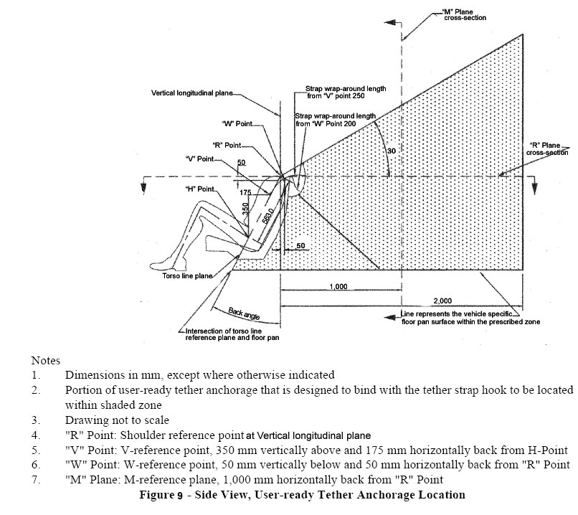
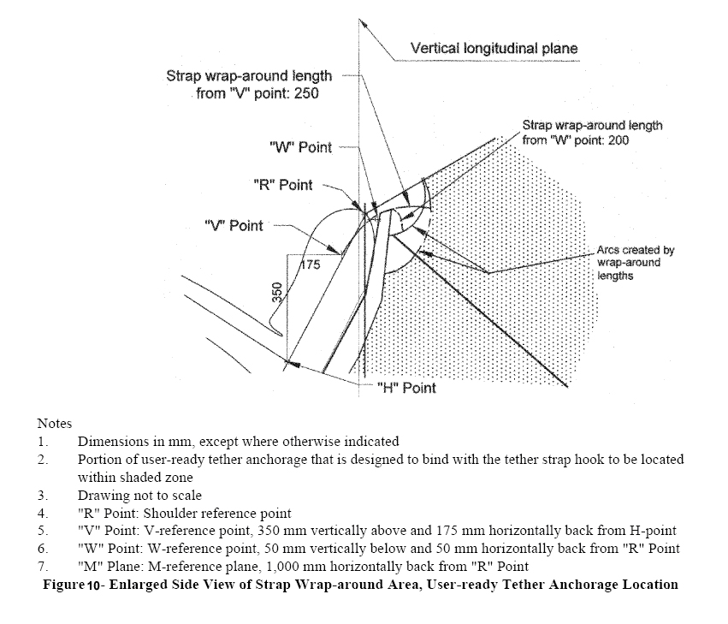
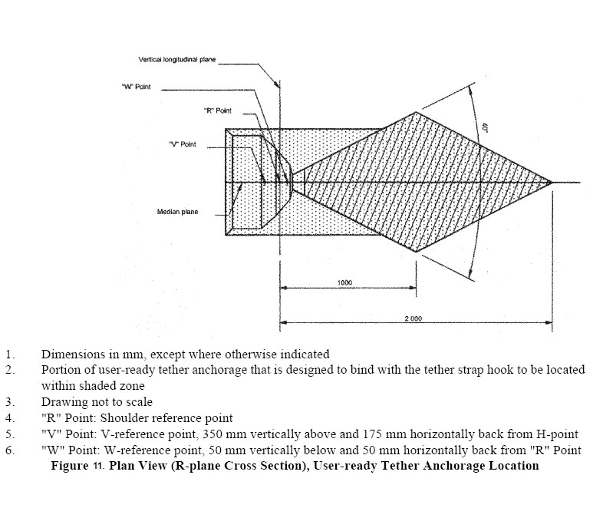
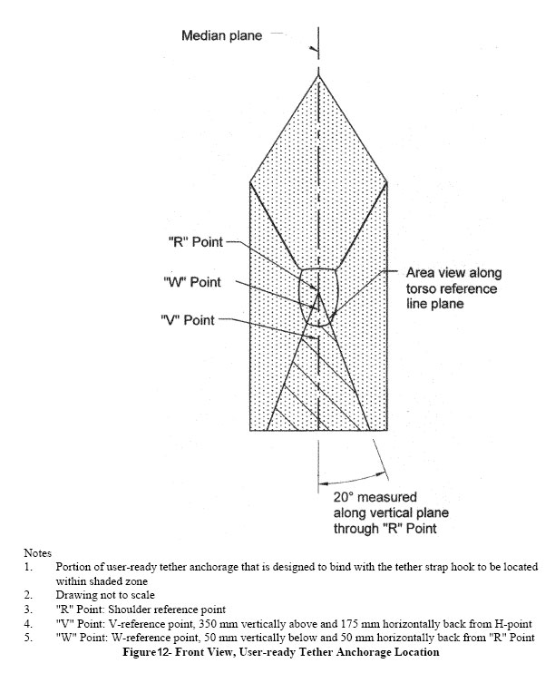
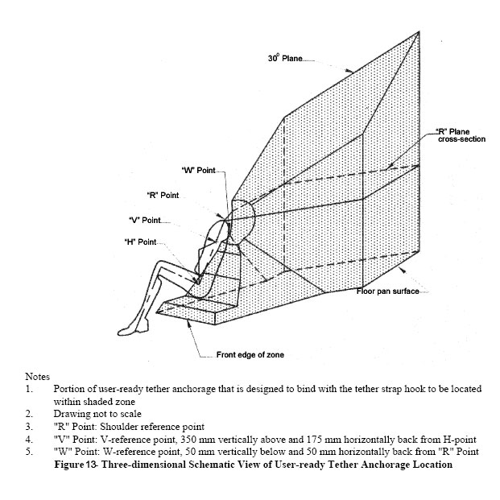

NOTES
This compilation of Vehicle Standard (Australian Design Rule 34/01 - Child Restraint Anchorages and Child Restraint Anchor Fittings) 2005 includes all the instruments set out in the Table of Instruments. The Table of Amendments provides a history of clauses that have been amended, inserted or deleted.

Table of Instruments
Name of Instrument | FRLI  Registration Date | Commencement Date
Vehicle Standard (Australian Design Rule 34/01 – Child Restraint Anchorages and Child Restraint Anchor Fittings) 2005 | 12/12/2005 (see F2005L03997) | 13/12/2005
Vehicle Standard (Australian Design Rule 34/01 – Child Restraint Anchorages and Child Restraint Anchor Fittings) 2005 Amendment 1 | 24/05/2012 (see F2012L01075) | 25/05/2012

Table of Amendments
Clause affected | How affected | Amending instrument
C.3 | ad | Amendment 1

ad = added or inserted
am = amended
del = deleted or removed
rr = removed and replaced
→ = clause renumbered. This takes the format of old no. → new no.

* See clause C.2.
# TNO address: Schoemaker Straat, 97; 2628 VK Delft, Netherlands.

