WHALE SHARK (Rhincodon typus)

RECOVERY PLAN

2005-2010

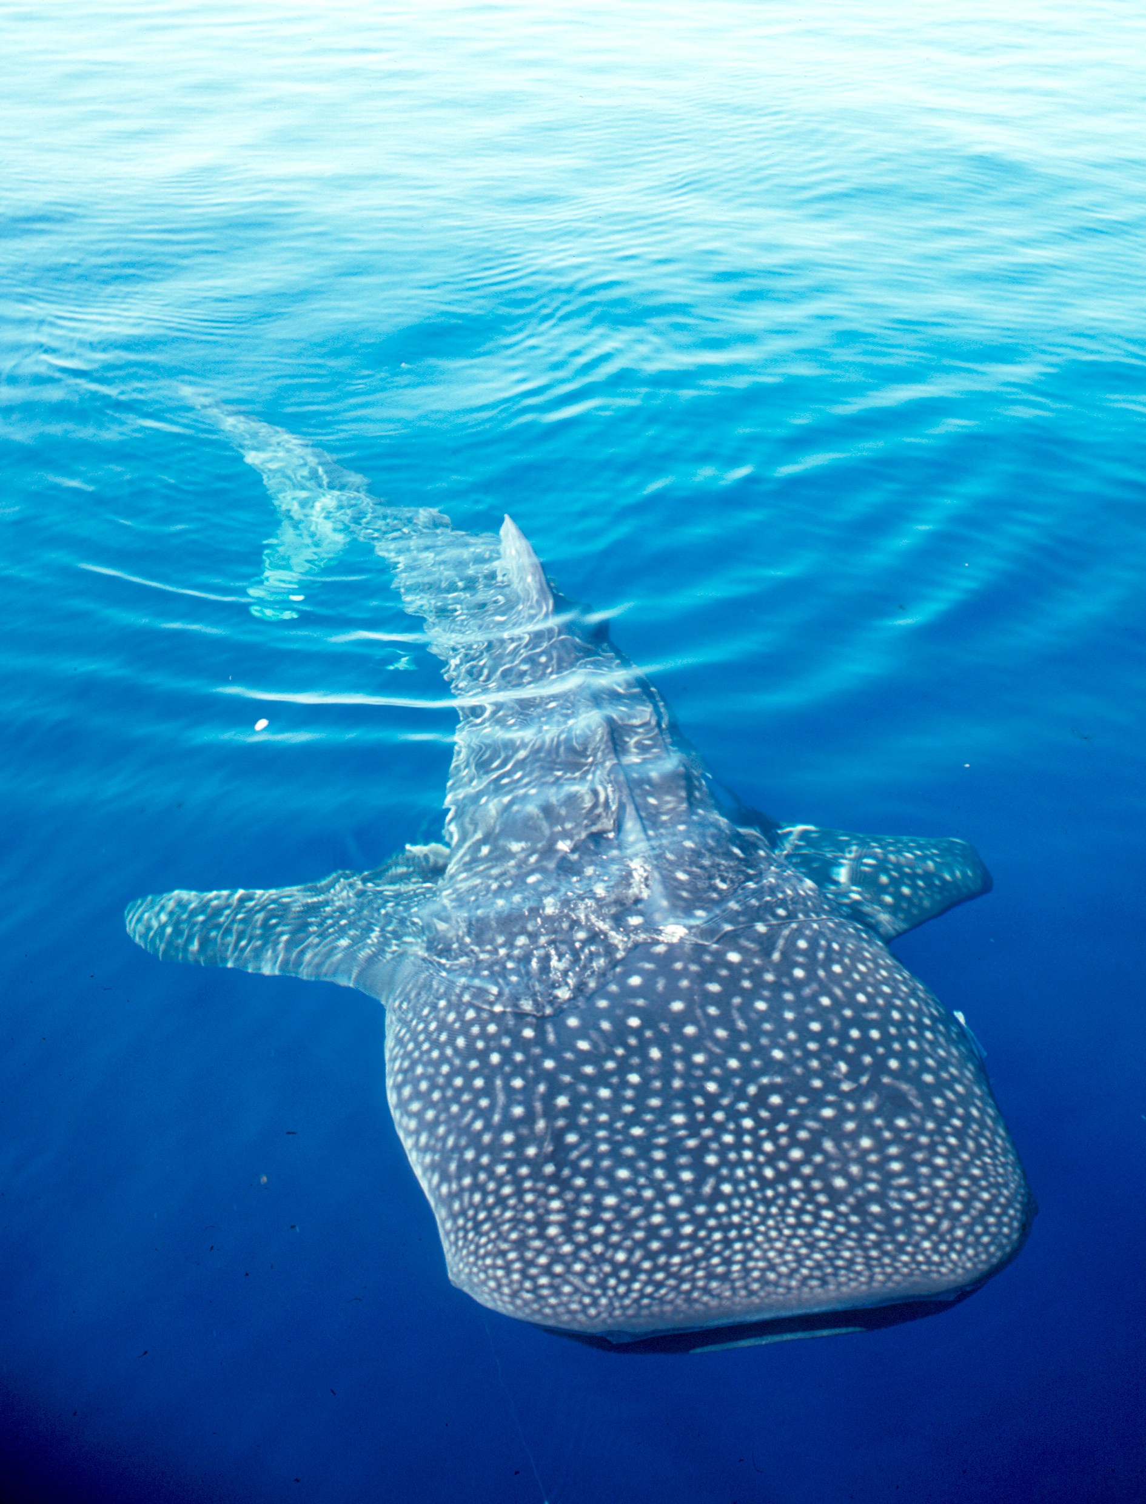
© Great Barrier Reef Marine Park Authority

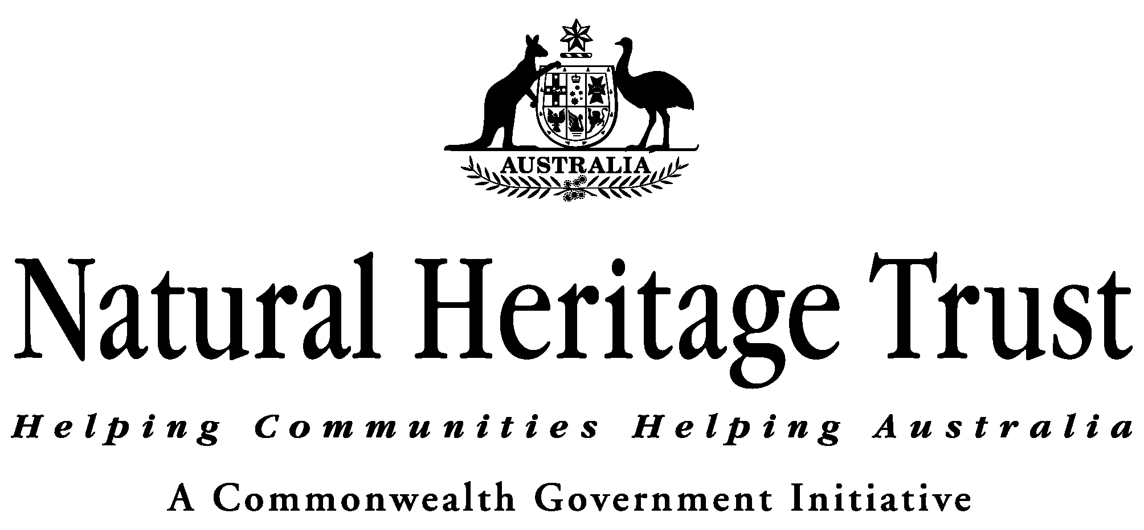

Background

The whale shark (Rhincodon typus) is the world’s largest fish, and one of only 3 filter-feeding shark species. Whale sharks have a broad distribution in tropical and warm temperate seas. In Australian waters, they are known to aggregate at Ningaloo Reef and in the Coral Sea. The whale shark is a highly migratory fish and only visits Australian waters seasonally. The whale shark was listed as vulnerable under the Environment Protection and Biodiversity Conservation Act 1999 (EPBC) in 2001.

The whale shark is also afforded a degree of international protection through its inclusion in Appendix II of the Convention for Migratory Species (CMS) and Appendix II of the Convention for International Trade in Endangered Species (CITES). Appendix II of CMS requires parties to cooperate to develop arrangements aimed at the protection and conservation of species listed on it such as the whale shark. Appendix II of CITES regulates international trade in whale Shark product so that any trade must not be detrimental to the survival of the species.

Detailed background information on the biology, population status and threats to the whale shark can be found at http://www.deh.gov.au/coasts/species/sharks/whaleshark/index.html.

The following sets out the Recovery Plan for the whale shark.

Objective (270(2)(a))

To maintain existing levels of protection for the whale shark in Australia while working to increase the level of protection afforded to the whale shark within the Indian Ocean and Southeast Asian region to enable population growth so that the species can be removed from the threatened species list of the EPBC Act.

Threats (270(2)(ca))

The main threat to the whale shark occurs outside Australian waters and is commercial harvest by a number of other range states of the whale shark.

The potential future threats to whale sharks visiting Australian waters are: competition with fisheries, habitat damage, pollution and marine debris, climatic and ocean change, predation, disease, and direct disturbance from tourism, research or interference. At present none of these potential threats appear to have an impact on the numbers of whale sharks visiting Australian waters.

This plan only addresses anthropogenic threats that can be effectively and realistically managed.

Populations under Particular Pressure of Survival and Protective Measures (270(2)(e))

Commercial harvest in range states, not including Australia, is a direct threat to the survival of Whale sharks. In Australia whale sharks are protected as both a listed threatened species and a migratory species under the EPBC Act. However, commercial harvest within other range states results in pressure being placed on the numbers of whale sharks visiting Australian waters.

Actions to Achieve the Objective/s (270(2)(c))

Given the absence of current anthropogenic threats to the whale shark in Australian waters, the only actions to be identified in this plan are to:

1. Increase the level of cooperation with other range states, particularly in the Indian Ocean and Southeast Asian region to protect the whale shark, through engagement in multilateral fora such as the CMS. Ideally increased cooperation will result in range state agreement to:
- reduce fishing pressures on the species in the waters of other regional range states; and
- halt the decline of the species in regional range states.

- Monitor numbers of the whale shark visiting Australian waters to:
- determine the rate of population change and population size by undertaking scientifically robust, regular and repeatable population surveys; and
- identify any emerging actual impacts that will have an immediate impact on the species and thus on its recovery, and to facilitate the development of appropriate responses.

Management Practices (EPBC Reg. 7.11(2)(b))

Management practices and measures other than those contained in this plan have been developed and are being implemented through, inter alia, State legislation, Marine Protected Area Management Plans, the Western Australian Department of Conservation and Land Management (WA CALM) Code of Conduct for Whale Shark tourism operations.

In addition, the EPBC Act provides protection for the whale shark through making it an offence to kill, injure, take, trade, keep, or move any member of a listed threatened species in a Commonwealth area without a permit. The EPBC Act also requires proponents of actions which have or are likely to have a significant impact on listed threatened species, to refer the proposed action to the Australian Government Department of the Environment and Heritage for assessment.

Internationally, any range state of the whale shark that is a party to CMS and/or CITES is required to undertake a number of activities to protect the whale shark. CMS requires range states to develop regional arrangements that may be legally or non-legally binding which will ensure the conservation of the whale shark. These arrangements generally include a number of targeted conservation initiatives such as habitat protect and protection from the identified threats impacting adversely on the species. Parties to CITES have agreed to regulate any trade in whale shark product so that such trade will not have a detrimental impact of the survival of the species.

Criteria to Measure Performance of the Plan against the Objective/s (270(2)(b))

The objective of this plan will be attained when:
- whale sharks visiting Australian waters are no longer under threat through actions taken outside of Australian waters such as commercial harvest, and
- if future major threats to numbers of whale sharks emerge, measures to minimise or mitigate them are identified and implemented as a priority.

Habitats Critical to the Survival of the Species and its Protection (270(2)(d))

Important habitat for the whale shark within the Australian jurisdiction are the known seasonal aggregation sites.

The whale shark seasonally aggregates in coastal waters off Ningaloo Reef between March and July each year, at Christmas Island between December and January, and in the Coral Sea between November and December. These Seasonal aggregations are thought to be linked to localised seasonal ‘pulses’ of food productivity.

It is not known if other habitat critical to the survival of the whale shark exists within Australian waters.

Known seasonal aggregations are known to occur outside Australian jurisdiction in a number of Range States such as the Philipines, Belize and the Maldives.

In Australian waters, Ningaloo Reef, Christmas Island and the area of the Coral Sea within the Coringa-Herald National Nature Reserve and the Lihou Reef National Nature Reserve are all afforded a high level of protection through their status as protected areas under the EPBC Act. Additional protection to Ningaloo Reef is afforded through its status as Marine Park under Western Australia’s Conservation and Land Management Act 1984.

Major Benefits to Other Native Species or Ecological Communities (270(2)(h))

As the recovery of this species will arise from co-operative activity at the international level, it is unlikely that the implementation of this recovery plan will benefit other native species or ecological communities. Research activities associated with monitoring will need to be undertaken in a manner that will ensure that disturbance to marine protected areas is minimised.

Duration and Cost of the Recovery Process (270(2)(f))

This plan should be reviewed five years after the date on which it is made by the Australian Minister for the Environment and Heritage. It should remain in place until such time that the number of sharks visiting Australian waters is no longer threatened by actions taken outside of Australian waters, and that numbers of whale sharks visiting Australian waters has improved to the point that the species can be removed from the EPBC threatened species list.
The cost of the recovery process is difficult to predict, as international negotiations can be substantially affected by unrelated developments in our international relationships. The domestic aspects of this plan should be covered under the core business expenditure of the affected organisations.

Affected Interests (270(2)(g)(i))

Organisations likely to be affected by the actions proposed in this plan include the following: the Australian Fisheries Management Authority; Department of Agriculture, Fisheries and Forestry; Department of the Environment and Heritage, Department of Foreign Affairs and Trade, Western Australian Department of Conservation and Land Management, Conservation groups, Wildlife interest groups, Tourism operators, and Recreational fishers.

Organisations/Persons Involved in Evaluating the Performance of the Plan (270(g)(ii))

The National Shark Recovery Group should evaluate the performance of this plan and report the results of their review to the Minister of the Environment and Heritage, through the Threatened Species Scientific Committee (TSSC).

Where to Get the Plan

This recovery plan is obtainable from:
http://www.deh.gov.au/biodiversity/threatened/publications/recovery/whale-shark/index.html

Migratory and Marine Species Section
Marine Environment Branch
Department of the Environment and Heritage
GPO Box 787
Canberra ACT 2601

